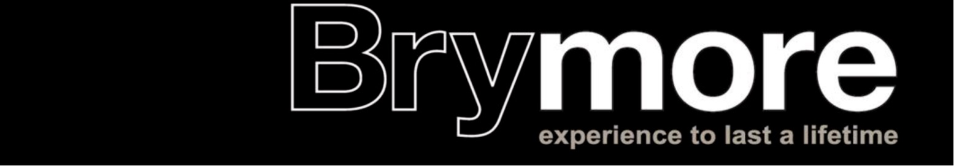

INFORMATION REGARDING CLAIMING BOARDING FEES AS CHILDCARE COSTS

At the moment the government provides financial help for working parents by allowing them to claim boarding fees as childcare costs up until their child is 16 years of age. (This may mean you will not receive funding when your son is in all of Year 11)

Therefore, if you are in receipt of Working Tax Credit you can apply to HM Revenue & Customs and claim the child care element of Working Tax Credit in respect of boarding fees. The childcare element is only available if the claimant is a lone parent who works at least 16 hours a week, or a member of a couple who both work at least 16 hours per week, or a member of a couple in which one partner works at least 16 hours per week and the other partner is incapacitated/a hospital in-patient/in prison.
The boarding fees at Brymore School can be regarded as child care costs, as none of the fees are for compulsory education. The childcare element of WTC is available for meeting up to 80% of the cost of childcare and in the case of Brymore School the child care is represented by the amount charged to you for your son’s boarding.

To claim this you need to contact HM Revenue and Customs on 0845 300 3900. They will ask for the School’s registration number and you should quote the School’s OFSTED number which is 123903 and inform them that all the boarding fees are for child care and no element is for education.

If you need any further information then please do not hesitate to contact the finance officer on 01278 655569.

