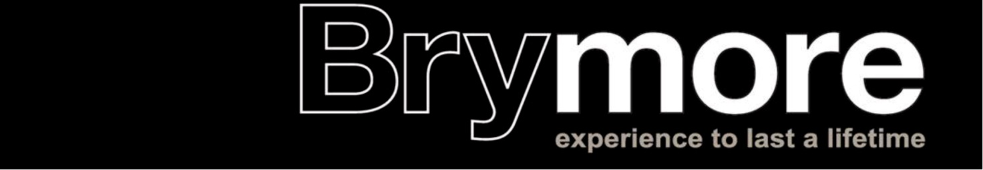
Please complete this form in BLACK INK.
Parent(s)/Carer(s) should complete part 1, then forward the form for part 2 to be completed by the Headteacher of the current school attended.
Part 1 - Application to be completed by Parent(s)/Carer(s) with Parental Responsibility
Student’s Legal Surname
Student’s Legal Forename/s
Preferred name (if applicable)
Date of Birth  Please enclose copy of applicant’s birth certificate | Current School

Parent/Carer 1) Surname |  | Parent/Carer 2) Surname
Initials | Mr/Mrs/Ms/Miss/other | Initials | Mr/Mrs/Ms/Miss/other
Relationship to child |  | Relationship to child

Address |  | Address
 | Post Code |  | Post Code
Home |  | Home
Work/Mobile Nos: |  | Work/Mobile Nos:
Email: |  | Email:
Type of place applied for (please tick) Boarding Day

Please list the students’ main interests

Why do you wish him to attend Brymore?

Has he suffered from any major illnesses? Please specify
DECLARATION: I am/We are legally responsible for the education of the child named above and understand that, where applicable, boarding fees are paid termly in advance.
Signed (parent/carer) | Date
Signed (parent/carer) | Date

CONFIDENTIAL - Student’s Name:

Part 2 - Current Headteacher’s report on applicant

Brymore offers students the chance to thrive in academic and practical lessons including Agriculture, Horticulture and Design Technology (including Engineering). Please bear this in mind when completing this form.

Pupil performance - please enter two grades under each curriculum area.

For ‘Effort’, please use the scale below to indicate the student’s attitude to the subject:

Grade | 1 | 2 | 3 | 4 | 5
Indicator | Always tries hard | Usually does his best | Satisfactory | Could try harder | Shows little effort

SUBJECT | ABILITY SCALE  (National curriculum  working at level) | EFFORT | COMMENTS
Art
Design & Technology
English
Geography
History
ICT
Mathematics
MFL
Music
PE/Games
R.E.
Science
Other

Please comment on the student’s individual qualities, under the following definitions:

PERSONAL CHARACTERISTICS
Social Maturity
Emotional Maturity
Initiative
Responsibility

Details of any standardised test results are essential

NAME OF TEST | DATE TESTED | Chronological age at test: | Information required:
Cognitive Ability Tests (CATs) |  |  | Standardised Scores:  Verbal -  Non-Verbal -  Quantitative -
Other Test (including reading/spelling) |  |  | Name of test:  Reading age:  Spelling age:
KS2 Sats Results |  |  | Eng: Ma: Sc:

Please comment on the following:
Attendance record (including %)

Punctuality

Any other information you deem relevant (for example safeguarding, home circumstances). [Please contact the Headteacher for a verbal report should you wish]

Please give details of any fixed term or permanent exclusions or behaviour concerns

Brymore is a boarding and day school for boys. Out-boarders are also expected to spend some time boarding alongside the other students for occasional duties during the year. What are your thoughts on this students’ suitability for boarding?

Should you wish to make further comments relevant to this application please do so here

Signed
Position | Date
School

When complete, please forward this application form to:
Mr Mark Thomas (Headteacher), Brymore Academy, Cannington, Somerset, TA5 2NB

To be completed if the student has Additional Educational Needs as defined by the Code of Practice 2014
SENCo name
Telephone | Email address

SEN Code:
1 K | Statemented (if so, please attach copy)
2 HN
Please outline the additional needs of the student

Please state what support the student is getting provided by the school
Wave One Wave Two Wave Three

Please detail any additional professionals connected with the student (current or recent, through school or home referral and include a copy of their reports)

Signed (SENCo)
Date

Please feel free to contact us if there is any further information that needs sharing.

Rebecca Jones - SENCo
RJones3@educ.somerset.gov.uk
Sam Austin - 2 i/c Learning Support (Transition and Inclusion)
SAustin@educ.somerset.gov.uk

