**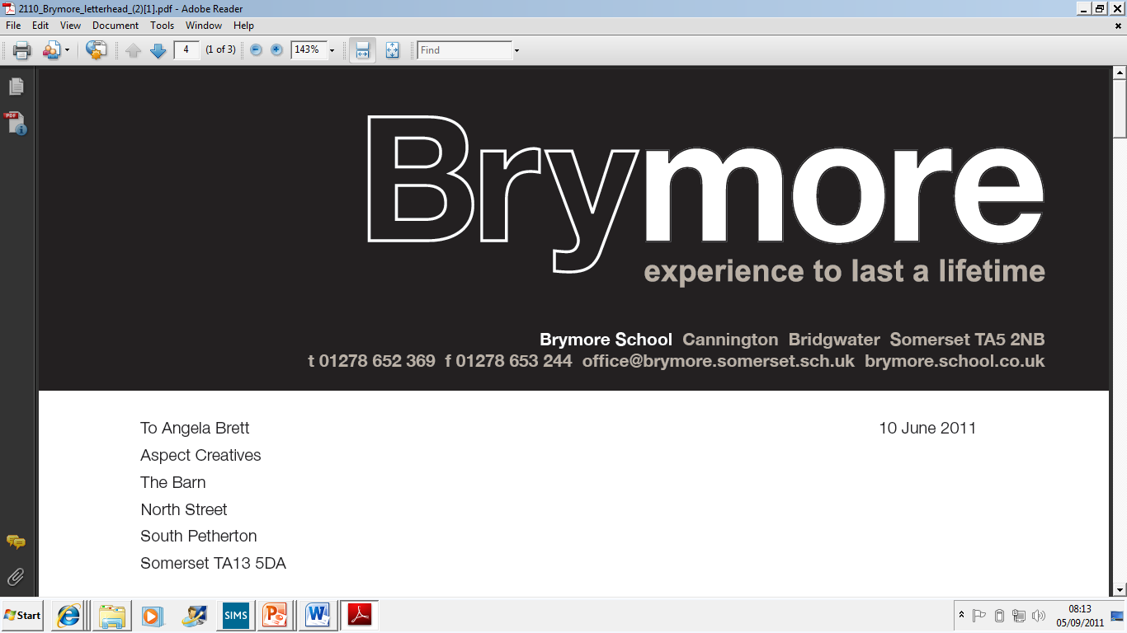**

**Brymore Handbook**

**2015/16**

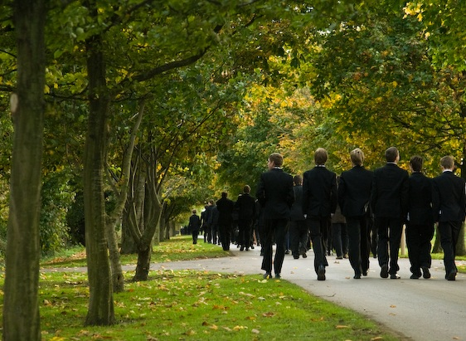

**A Welcome to Brymore**

We are delighted to welcome you and your son to Brymore. We encourage our boys to flourish and exceed expectations, both personally and academically and we hope your son will play a full and active part in every aspect of Brymore life. This is a unique opportunity for an exceptional education and an experience that will last a lifetime.

Boarding is at the heart of Brymore and, whether your son is a full time boarder or an ‘out-boarder’ (our term for day boys) the reality is, he will be part of a boarding environment in which he will be welcomed - and encouraged to participate as much as possible. Brymore boys are renowned for their ‘hands on’ approach to life. Boys are expected to show commitment in all areas, both in and outside the classroom, because this is what builds confidence and self-esteem. Boys are encouraged to become responsible, resilient and resourceful and all out-boarders join the boarding community for the time they spend on feeding duty.

This handbook is designed to provide as much information as possible about Brymore, for those who may be feeling nervous or unsure of what to expect. We aim to answer your questions, clarify our expectations and give practical advice.

Naturally, if you still have questions, you are welcome to ask us. In the meantime, we hope this guide will be of value, both now and in the future.

***Mark Thomas***

***Headteacher***

**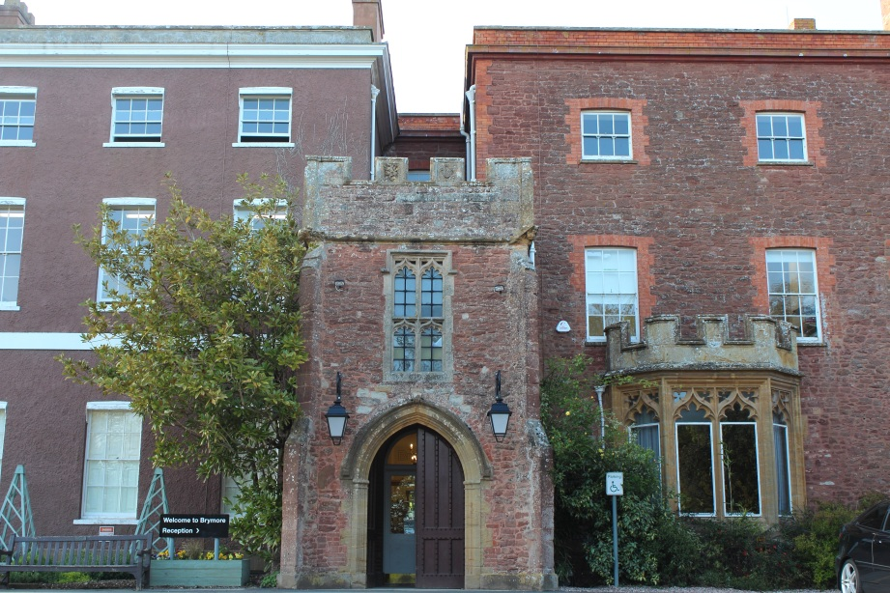**

**The Staff at Brymore (Day/Academy Staff)**

|  |  |  |
| --- | --- | --- |
| Mark Thomas | Headteacher | MThomas4@educ.somerset.gov.uk |
| Mrs Victoria Davis | Deputy Head (Curriculum, Teaching and Learning) | VDavis@educ.somerset.gov.uk |
| Luke Winter | Assistant Head (Student Achievement & Welfare) Designated Safeguarding Lead | LWinter@educ.somerset.gov.uk |
| Mrs Rebecca Jones | Assistant Head & SENCO | RJones3@educ.somerset.gov.uk |
| Robert Watts | Head of Boarding | Rwatts1@educ.somerset.gov.uk |
| Patrick Coll | Business Manager | PColl@educ.somerset.gov.uk |

|  |  |  |
| --- | --- | --- |
| Chris Adamson | Farm Agricultural Assistant | CAdamson@educ.somerset.gov.uk |
| David Allibone | Head of D&T | DAllibone@educ.somerset.gov.uk |
| Neil Andrews | Estates Assistant | NAndrews@educ.somerset.gov.uk |
| Ian Ashton | Head of Maths | IanAshton@educ.somerset.gov.uk |
| Mr Adam Atkins | Head of Science | Aatkins3@educ.somerset.gov.uk |
| Anton Austin | Excellent Teacher D&T | AAustin@educ.somerset.gov.uk |
| Mrs Sam Austin | 2 i/c Learning Support | SAustin@somerset.educ.gov.uk |
| Jon Ball | Teaching Assistant (D&T) | JBall1@educ.somerset.gov.uk |
| Mrs Pat Ball | Science Technician | PBall1@educ.somerset.gov.uk |
| Mrs Clare Bowley | Maths Teacher | CBowley@educ.somerset.gov.uk |
| Miss Helen Bradford | LRC Manager | HBradford@educ.somerset.gov.uk |
| Mr Bradley Brake | Environmental Services Apprentice | BBlake@educ.somerset.gov.uk |
| Ms Dawn Carter | LSA Science | DCarter4@educ.somerset.gov.uk |
| Mrs Sally Clark | Art Teacher | SClark3@educ.somerset.gov.uk |
| Mrs Michelle Craig | English Teacher | MCraig@educ.somerset.gov.uk |
| Mr Nicholas Craig | Science Teacher | NCraig@educ.somerset.gov.uk |
| Mrs Lindsay Eastham | Finance Officer | LEastham@educ.somerset.gov.uk |
| Ms Jackie Evans | Finance Manager | JEvans6@educ.somerset.gov.uk |
| Mrs Sally Finnis | Finance Assistant | SFinnis@educ.somerset.gov.uk |
| Robert Fowler | Caretaker | RFowler@educ.somerset.gov.uk |
| Mrs Eva Garrod | Head of Agriculture | EMGarrod@educ.somerset.gov.uk |
| Mr Ian Hildred | Maths Teacher | IHildred@educ.somerset.gov.uk |
| Mrs Helen Hill | Reception / Attendance | HHill3@educ.somerset.gov.uk |
| Mrs Nicola Jennings | Head of ICT | NAJennings@educ.somerset.gov.uk |
| Paul Kingston | Farm Manager | PKingston@educ.somerset.gov.uk |
| Miss Heather Lee-Joy | History/English Teacher | HLee-joy@educ.somerset.gov.uk |
| Mrs Jeannie Lillywhite | Director of Boarding | JLillywhite@educ.somerset.gov.uk |
| Robin Leighton | Estates Assistant | RLeighton@educ.somerset.gov.uk |
| Miss Kelly Markham | Counsellor | KMarkham@educ.somerset.gov.uk |
| Miss Sara Nash | Horticulture Technician | SNash@educ.somerset.gov.uk |
| Miss Laura Parker | LSA | LParker2@educ.somerset.gov.uk |
| Mrs Helen Porter | ICT Technician | HMPorter@educ.somerset.gov.uk |
| Terry Prosser | Health & Safety Adviser | TProsser@educ.somerset.gov.uk |
| Miss Amie Reed | Office Apprentice | AReed1@educ.somerset.gov.uk |
| Mrs Alison Richards | Teaching Assistant (Horticulture) | ARichards@educ.somerset.gov.uk |
| Miss Jo Rundle | HLTA (Maths) | JRundle@educ.somerset.gov.uk |
| James Ryan | Catering Manager | JRyan1@educ.somerset.gov.uk |
| Tom Sawyer | Geography, History, Science Teacher | TSawyer@educ.somerset.gov.uk |
| Miss Clare Scott-Ison | HLTA (English) | CScott-Ison@educ.somerset.gov.uk |
| John Sharp | Network Manager | JSharp@educ.somerset.gov.uk |
| Roger Sherlock | D&T Technician | RWSherlock@educ.somerset.gov.uk |
| Gary Simmons | Learning Support Assistant | GSimmons@educ.somerset.gov.uk |
| Brian Spridgens | PE Teacher | BPSpridgens@educ.somerset.gov.uk |
| Mrs Fiona Stanley | Senior Horticulture Technician | FMStanley@educ.somerset.gov.uk |
| Mrs Jayne Taylor-Lane | Head of English | JTaylor-Lane@educ.somerset.gov.uk |
| Mrs Julie Vearncombe | PA to the Head / Admissions | JVearncombe@educ.somerset.gov.uk |
| Mrs Clare Wallace | Office Manager / Exams Officer | CWallace1@educ.somerset.gov.uk |
| Philip Ward | Learning Support Assistant | PWard@educ.somerset.gov.uk |
| Ms Lorraine Warren | Marketing & Communications Manager | LWarren2@educ.somerset.gov.uk |
| Reuben Willcocks | Head of Horticulture | RSWillcocks@educ.somerset.gov.uk |
| Lloyd Williams | PE and Maths Teacher | LWilliams5@educ.somerset.gov.uk |
| Mrs Kate Whyte | Farm Technician | JKWhyte@educ.somerset.gov.uk |

**Safeguarding**

Pupil Concerns

As a school we take child protection and safeguarding extremely seriously and work hard to ensure that we are working with the latest legislation and that all staff are trained on this important subject. If there is any concern or worry about anyone’s welfare then it is highly appropriate for parents or boys to talk about it with a designated adult; Mr Winter is Brymore Academy’s Designated Safeguarding Lead Officer with Mrs Lillywhite and Mrs Austin also being part of the Safeguarding Team. Alternatively every member of staff has received training to deal with safeguarding and can then discuss concerns with the Designated Safeguarding Lead.

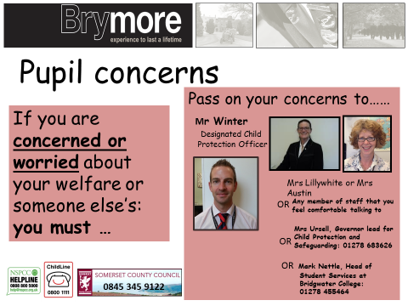

**A Day at Brymore**

Times of the day

|  |  |  |  |  |  |  |  |  |  |  |  |  |  |  |  |  |  |  |  |  |  |  |  |  |  |  |  |  |  |  |  |  |  |  |  |  |  |  |  |  |  |  |  |  |  |  |  |  |  |  |  |  |  |  |  |  |  |  |  |  |  |  |  |  |  |  |  |  |  |  |  |  |  |  |  |  |  |  |
| --- | --- | --- | --- | --- | --- | --- | --- | --- | --- | --- | --- | --- | --- | --- | --- | --- | --- | --- | --- | --- | --- | --- | --- | --- | --- | --- | --- | --- | --- | --- | --- | --- | --- | --- | --- | --- | --- | --- | --- | --- | --- | --- | --- | --- | --- | --- | --- | --- | --- | --- | --- | --- | --- | --- | --- | --- | --- | --- | --- | --- | --- | --- | --- | --- | --- | --- | --- | --- | --- | --- | --- | --- | --- | --- | --- | --- | --- | --- |
| **The School Day**   |  |  | | --- | --- | | **8.55am - 9.10am** | Assembly | | **9.15am - 10.15am** | Lesson 1 | | **10.20am - 11.20am** | Lesson 2 | | **11.20am - 11.40am** | **Break** | | **11.40am - 12.40pm** | Lesson 3 | | **12.40pm - 1.35pm** | **Lunch** | | **1.35pm - 2.35pm** | Lesson 4 | | **2.40pm - 3.45pm** | Lesson 5 |   **Saturday**     |  |  | | --- | --- | | **1.35pm - 3.45pm** | Saturday Activities | | **4.00pm** | Home for those leaving | | **Week days**   |  |  | | --- | --- | | **6.30am** | Feeding | | **7.15am** | Rising bell | | **7.45am** | Breakfast | | **8.30am** | Back to boarding house / equipment check | | **8.45am** | Out-boarders arrive | | **9.00am** | Assembly | | **3.45pm** | End of school day / start of boarding day | | **4.00pm - 5.25pm** | Duties /activities/  free time | | **5.00pm- 5.25pm** | Year 7s & 8s Tea | | **5.25pm- 5.50pm** | Year 9s & 10s Tea | | **5.50pm -6.10pm** | Year 11s Tea | |  |  | | **6.30pm - 7.30pm** | Prep | | **7.30pm - 9.00pm** | Activities / free time / clubs | | **8.30 pm** | Bedtime procedures for Year 7 start | | **9.00pm** | Bedtime procedures start |   **Saturday bedtime procedures differ - Year groups to be ready for bed by 9.55pm and in bed at 10.00pm.** | **Sundays**   |  |  | | --- | --- | | **7.00am** | Feeding | | **8.30am** | Rising bell | | **8.45am-9.30am** | Breakfast | | **9.30am** | Activities / free time / trips | | **12.55pm** | Lunch bell | | **1.00pm** | Lunch | | **1.30pm** | Activities / free time / trips | | **4.00pm** | Feeding duties | | **5.55pm** | Tea bell | | **6.00pm** | Tea | | **6.30pm** | Activities / free time | | **9.00pm\*** | All returners to have signed in and bed time procedures to begin. |   **\* Bedtime procedure for Year 7 boys is 8.30pm** |

**Pastoral Houses**

Like many schools, Brymore runs a House system during the day, with one tutor group for each of the three houses. New students will be allocated to Galsworthy, Taylor or Walker house. Each Year 9 tutor group is led by the Head of House, allowing boys to form close bonds with others in their tutor group and get to know the member of staff who will be monitoring their academic progress, their behaviour in school and contacting home when appropriate. Currently, Heads of House are as follows:

Taylor - Mr Winter

Galsworthy - Mr Ashton

Walker - Mrs Garrod

Each tutor group consists of boys from all year groups. Boys from all year groups will be allocated a tutor group creating a ‘vertical’ tutor group consisting of all ages. Each tutor group will still represent a house.

As tutors, they take a special interest in each boy and will be the first to contact home, should there be any concerns or successes in school. In addition, boys learn to work as part of a team, competing for their house in sporting events and school competitions.

**Classroom Groups**

At Brymore, we make every effort to ensure boys are grouped carefully for each subject, to maximise their potential in every area. In English, Maths and Science, boys are set according to ability. Other subjects, such as Agriculture, Technology and Horticulture also group boys carefully, with the aim to create the best possible mix for that subject. At times boys may be taught in tutor groups and again, this is to ensure they build strong relationships with their peers.

**Discipline and Rewards**

Brymore prides itself on a strict code of discipline that is firm but fair and which has at its core a strong emphasis on rewarding boys for every success. The school operates a system of 'consequences'. In cases where students fail to meet expectations in class, they will be issued with a warning, a second warning, which may include being moved, spoken to or asked to stay behind at the end of the lesson. In the rare cases where boys continue to misbehave in spite of this, they will be 'referred'. This means being sent to another classroom, the incident is written up and passed to the Head of House for monitoring. Heads of House keep track of the number of referrals received by each boy and parents will be contacted in each case when a referral is issued. It must be emphasised that this is a serious issue and that boys who receive three referrals in one half term will face exclusion for persistent disruption. Again, this rarely happens and in each case parents will be contacted and pupils given fair warning when they are close to their third referral.

The Reward system operates through merits, commendations and certificates. Boys collect merits in their tutor groups and again, this is monitored by Heads of House. Boys receive certificates and badges in assembly for reaching specific milestones.

**Reporting/Mentoring System**

Brymore boys are encouraged to strive for academic success and we believe it is vital that parents are kept informed of their son's academic progress at regular intervals. Each boy will receive an annual report from all subjects. In addition, interim reports are issued each half term, including levels achieved in each subject area, matched against their target grades. Boys are issued with their target grades and currently working at grades each half term and are encouraged to keep these in their planners, so that they can keep track of their progress. Boys at risk of underachieving are highlighted by this process and it is our aim to intervene early so that we can help them to stay on track. Every boy will also have a staff mentor, who will meet with him every half term to discuss their progress and well-being.

**Special Needs Information**

Brymore Academy is committed to ensuring that boys of all abilities can achieve in all subject areas. We have a highly skilled and dedicated Learning Support Team, many of whom are attached to individual curriculum areas, who work with students in lessons. We also run several interventions tailored to develop a range of skills including: literacy, numeracy, language and communication and social skills. Parents are encouraged to talk to Mrs Jones (SENCo) or Mrs Austin (interim 2 i/c Learning Support) about their son’s individual needs as he starts at Brymore.

**Expectations of boys at Brymore**

**Uniform at Brymore**

A high standard of personal appearance is expected of all students and body piercing and jewellery are strictly forbidden. Boys are not allowed to have dyed hair, gelled hair or extreme haircuts. Short, neat hair is expected. All uniform (clothing and footwear) must be named. It is expected that all workshop overalls, games clothes, rugby shirts, rugby shorts and towels will be names with extra-large name tapes (black on white). There is a useful diagram on the next page to help.

Essential school uniform/clothing/equipment

* 1 Black blazer with Brymore badge
* 1 Brymore rain jacket
* 5 grey shirts (white shirts for Year 11)
* 2 black Brymore sweatshirts with logo
* 6 pairs of grey or black socks
* 2 pairs of black trousers
* 1 school tie (specific to Day House)
* 1 pair of black shoes/smart boots **NOT steel toe-capped** that can be polished (for use during the day)
* 8 pairs of boxers/pants
* 3 vests or plain white t-shirts
* 1 pair of overalls or boiler suit for the farm
* 1 canvas laundry bag
* Waterproof coat, trousers, hat, gloves and old clothes for the farm
* 1 pair of safety wellington boots (name painted on outside)
* 1 pair of safety boots - can be steel toe-capped (for use in the gardens) (name painted on outside)
* 1 pair swimming trunks
* Black belt for school trousers
* 1 wellington boot bag for storage

PE Uniform

* 1 pair of gym shoes or trainers
* Drawstring PE bag - boarders
* Bag for out-boarders to leave PE uniform and farm overalls in changing rooms and of a suitable size to fit inside locker (300mm (w), 890 (h), 415 (d))
* 2 pairs PE shorts
* 2 school fitness t-shirts
* 2 pairs of rugby shorts
* 2 reversible rugby jerseys
* 1 pair of rugby boots (named)
* 2 pairs of black and white football socks
* Track suit and jogging bottoms
* 1 white cricket shirt and 1 pair white cricket trousers (summer term)
* Mouth guards for rugby/hockey
* Shinpads
* Any other old games kit for practice sessions

Brymore boys are frequently described as exemplary advocates for the Academy. Outside the Academy, whether in Cannington or on a trip, any boy who wears our uniform is expected to do so with pride. Boys should be smart and well-mannered and remember that they carry the Brymore reputation with them at all times.

**Where to attach large name labels.**

j0308034

NAME

Please attach name tag here, above the band on the rugby shirt.

Also attach another on the inside of the shirt in a similar position so that the shirt can be worn 'inside out'.

bd07453_

Drawstring PE bag.



NAME

BRYMORE



Name

Please attach name tag here, above the logo on the T-shirt

On the overalls please attach the name tag above the breast pocket.

Label towels along the edge

Rugby boots, work boots and wellington boots - name to be painted on the outside

NAME

Name

**J. Smith**



NAME

**Farm and Garden Duties**

One of the things that makes Brymore unique is the chance to work in real life situations, with equipment and animals which ensures that the boys can truly develop the three Rs of responsibility, resourcefulness and resilience. As part of this it is vital that all boys carry out the Farm and Garden duties required of them and this applies to both out-boarders and boarders.

All duties are a higher priority than every other activity and it is important to remember that these are real working situations where the production of a profit is essential. Boys know they must take this distinctive opportunity seriously and work safely at all times. All boys, including out-boarders must complete Farm and Garden duties. Failure to do so could mean the boy will be asked to leave the Academy as they no longer meet our admission criteria.

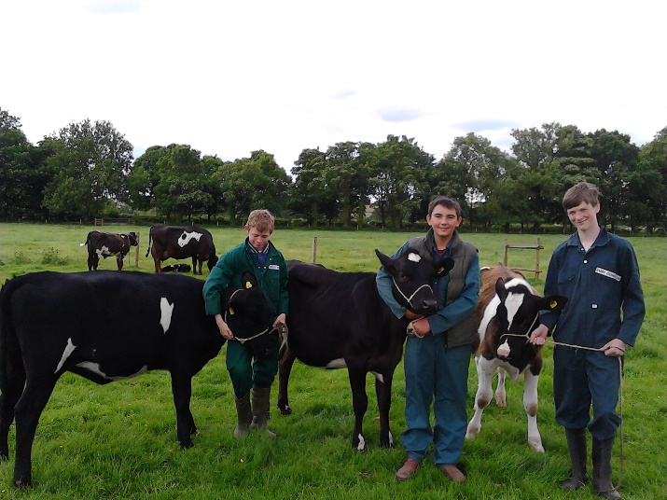 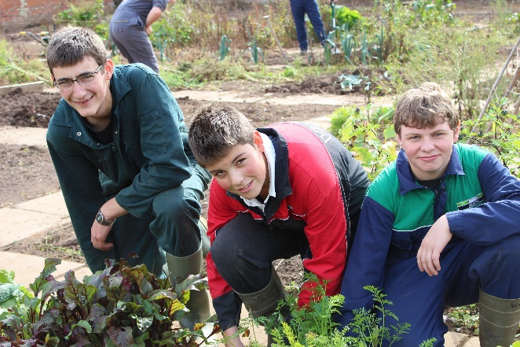

Year 7

Boys in Years 7 and 8 who want to do feeding duty for a week can opt into the rota by seeing Mrs Garrod. Boys may also be able to experience duties as an ‘extra’ *by arrangement* after school, and must also see Mrs Garrod. Garden duties are yet to be finalised.

Year 9

For both Garden and Farm duties it is important to adhere to these expectations to ensure the job is well done.

**What is expected?** A good attitude, hard work, care for others, tools, plants and animals, finishing the job and working as part of a team is a must, it is important to wash all tools and return to the tool shed.

**What is worn?** No school uniform, only overalls and steel toe capped boots, wet weather clothing and warm clothes for winter and no torn or baggy clothes which could get caught in machinery.

**Rules:** It is important for boys to be on time and to listen carefully and follow instructions. There is to be no eating, throwing or causing any damage to property, plants or animals and breakages must be reported.

**Peer assessment:** Older students hold roles of Heads of Department (HoD) and it is their job to assess and grade boys working with them, alongside the teaching staff.

**Registration:** It is vital for boys to line up quietly outside the changing rooms and wait for a member of staff. Boys should not leave practical lessons without asking the member of staff.

**Who helps?** HoDs (responsible Year 11s) are chosen to help Year 9 pupils with the tasks.

**Garden Duties:**

**When?** 4.00 pm - 5.00 pm on either Monday, Tuesday, Wednesday or Thursday.

**How long?** Right the way through Year 9.

**Who is in charge?** Mrs Stanley (Head Technician in Horticulture).

**What is done?** A variety of jobs essential to the running of the department and all of which is a foundation for your BTEC course.

**What time?** 4.00 pm prompt.

**Farm Duties - feeding:**

**Who is in charge?** Members of staff: Mr Kingston (Farm Manager), Mr Adamson (Farm Agricultural assistant)

**When?** 7 or 10 days over a weekend, it is important to note that the boys must stay as boarders throughout the whole time and that out-boarders will board during this period.

**How often?** During Year 9 and 10 there will be seven whole duties.

**Can parents visit?** Yes, parents are welcome to visit over the weekend but boys may not leave as it is important to be on site the whole time in case of a farm emergency (this includes out-boarders).

**What is done?** Feeding stock and looking after all their needs before and after school every day and on Sunday.

**What if the weekend clashes with a special celebration at home?**

It would be important to discuss with Mrs Garrod and arrange a weekly swap. Day swaps are not optional.

**Boarding at Brymore**

**A Warm Welcome from the Head of Boarding**

Boarding at Brymore is firmly based on the core principles of family living. We strive for an open, inclusive and purposeful atmosphere in which pupils are encouraged to fulfill their academic and personal potential; where individual needs are addressed and achievements within all areas of the school are celebrated.

We are fortunate enough to have a broad mixture of backgrounds among the boarding community; we pride ourselves on drawing on the best of this rich variety and creating an environment that values individuals but offers an experience that is all the better for its sense of collaboration.

As an Academy, Brymore sets out high expectations of its pupils and carefully ensures that the structures are in place to allow pupils to meet these expectations. It is a model that has been proven to work, and one which boarders will find puts them in a great position for when they leave us.

As a former Brymore pupil myself, I am able to speak with confidence and certainty of the positive impact it is able to deliver to each and every pupil. I, and hundreds of former pupils, owe a debt of gratitude to Brymore and the dedicated staff that work here, who continuously strive to make each individual’s experience as unique and positive as possible. I can honestly say that Brymore is unlike any other school that I have attended as a pupil, or have worked in as a teacher throughout my profession, it is truly one of a kind. Boarding has played an important part in the history of Brymore School. Many of our greatest alumni were indeed boarders themselves. For those of us who have lived and worked in the boarding environment, whether currently or in the past, boarding at Brymore has a special atmosphere and character that embraces the qualities of the individuals who pass through our houses.

I and all the dedicated pastoral team here at Brymore extend a warm welcome to all boarders and their parents and carers. We look forward to meeting you in due course and welcoming you to the Brymore family.

**Robert Watts**

**Head of Boarding**

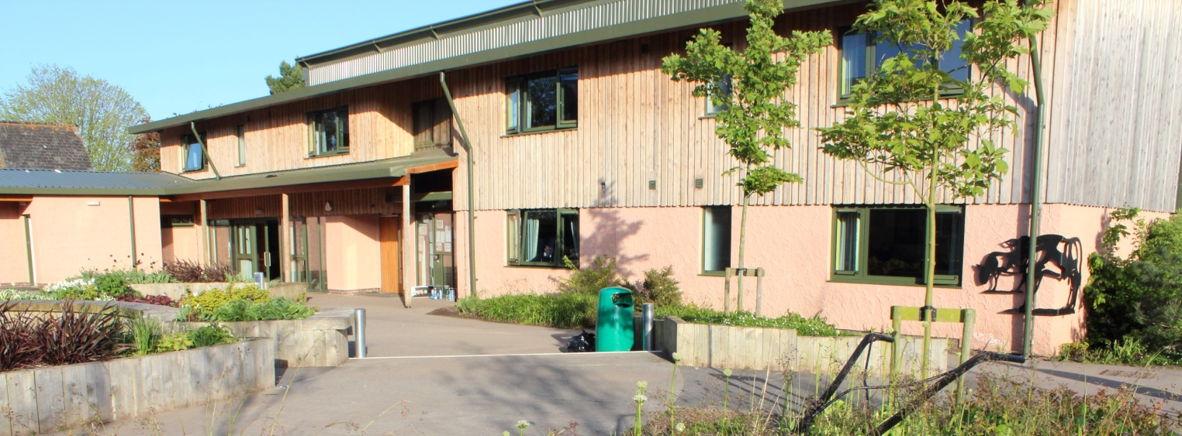

**Statement of Principles and Practice**

*“To ensure that the students of Brymore achieve by providing an outstanding learning experience, insisting upon high expectations, effective partnerships and creating a safe and supporting environment”*

Our aims for the Boarding Community

We believe that boys should be exposed to a breadth of education that only a boarding environment can provide, with the values, self-confidence and personality gained in a caring family atmosphere. The pastoral team endeavour to create a nurturing and supportive environment that allows pupils to grow and develop emotionally, physically, morally, socially and educationally.

Objectives of Boarding

* To create an environment that supports learning, developing and achievement for all regardless of background or ability
* To develop the whole person, and instill a desire for truth and a respect for others in a caring and happy atmosphere
* To provide high quality accommodation that is comfortable and homely for each pupil
* To develop a sense of self-responsibility and community spirit
* To help prevent all aspects of bullying and educate pupils on its impact
* To develop self-esteem, self-discipline and positive relationships based on respect
* To encourage qualities of leadership and team work
* To encourage each boarder to appreciate his corporate responsibility to the welfare of the house as a whole
* To ensure a fair and consistent approach is achieved for all pupils
* To provide an outstanding wide range of activities that caters for all pupils interests and personal development
* To work closely and effectively with parents and other agencies in ensuring the best boarding practice is achieved
* To support the individual in a comforting and supportive environment

Safeguarding of Boarders

We operate a number of policies regarding the school’s careful safeguarding of all the children in the Academy, both day and boarding. We take security very seriously.

Direct access to the Boarding Houses is reserved for pupils and staff only, and electronic key fob systems operate on all external doors.

We therefore ask that parents, carers or adult friends of the family, do not enter the Boarding Houses without first speaking with the member of staff on duty. Even though many parents and carers are ‘familiar faces’ to staff and some pupils, they may still be unknown to others, and if all adults enter the Houses only via staff contact, then we will ensure full security and avoid the entry into any rooms or bedrooms that may be inappropriate.

Bedtime procedures in all houses - these must be followed

|  |  |
| --- | --- |
| **Time** | **Action** |
| **8.30pm** | **Year 7 register in their boarding house**  **Year 7 to be ready for bed** |
| **8.45pm** | **Year 7 in dormitories with night lights on** |
| **9.00pm** | **Year 7 lights out**  **Years 8/9/10/11 register in their boarding house**  **Year 8/9 to be ready for bed** |
| **9.15pm** | **Year 8/9 in dormitories with night lights on**  **Year 10 getting ready for bed** |
| **9.30pm** | **Year 8/9 lights out completely**  **Year 10 in dormitories with night lights on**  **Year 11 getting ready for bed** |
| **9.45pm** | **Year 10 lights out completely**  **Year 11 in dormitories with night lights on** |
| **10.00pm** | **Year 11 light out completely** |

However daunting they may at first appear, most of the systems will become very familiar to boarders surprisingly quickly. There will be urgent issues at the beginning such as uniform, timetable, layout of the Academy and the daily routine, which will be covered in induction sessions in the first few days. Each new boy will also be given a mentor to whom he can go with any queries in the first few weeks.

The structure of boarding at Brymore Academy

Brymore Academy has three boarding houses, all based on site, which have all been recently updated and refurbished.

* **Reid House**
* **Kemp House**
* **School House**

Within both Reid and School House there is a combination of Years 8, 9, 10, 11 and 13, and Kemp House, accommodates the year 7 junior boarders alongside selected Year 8 and 10 Mentors. Year groups are not mixed in dormitory; boys are grouped within year clusters throughout each of the houses and with no more than 50 in each house it makes for a comfortable and caring atmosphere.

Out-boarders in Boarding Houses

Out-boarders are allocated to a boarding house, so that they each have a common room which they can use at lunchtimes and know that there is a place where they belong on evenings when they stay at the Academy for activities, prep or farm duties. This is also where they go to sign out at the end of each day.

**ALL OUT-BOARDERS MUST SIGN OUT IN THEIR BOARDING HOUSES AT THE END OF THE DAY.**

As an out-boarder, we believe it is vital that boys feel fully included in Brymore life. To this end, Houseparent’s and boarders welcome them into the boarding house. In return, we encourage out-boarders to take full advantage of evening activities on offer, so that they can get the fullest experience during their time with us. As ever, you get out what you put in and the happiest boys are always the ones who make the fullest commitment to their life at Brymore.

Out-boarders and boarders will be provided with a personal locker, which will require a £5 deposit for the padlock and key. All practical and sports clothing needs to be stored within the lockers within the appropriate bags. In addition, they can store their DT overalls in the mezzanine and their wellington boots can be stored in the boot store when not being worn or in their locker within a wellington boot bag which can be bought through Miss Gardner.

Houseparent

Each house has a full time House parents who lives within the building, in their own separate flat. The role of the Houseparent is to be responsible for the care, welfare and behaviour of the boarders within their house and to ensure this overall care is continued throughout the Academy by liaising with other staff members. All of our Houseparents have extensive experience within their role and at all times their primary concern is the wellbeing of the boarders. The Houseparents report to the Director of Boarding, and it is the Head of Boarding who is ultimately responsible for the pastoral care within our boarding provision. We also have four Gap Tutors who work with us for a year as part of their gap year from the southern hemisphere, who support the boys and Houseparents.

Duty Master

On a daily basis there will always be a team of staff, made up of the teaching and support staff, who are on ‘duty’. Their role is to support the Houseparents, Head of Boarding and the Director of Boarding before and after school and at weekends with activities, prep and other undertakings. In addition to this a member of the Senior Leadership Team is on site, day and night, to support all of the staff and students.

Matron

The Matron is there as the students’ first point of contact in a wide range of important areas, which directly affect their welfare. Pupils consult their Matron when feeling unwell and she treats any minor illnesses and injuries, or administers repeat prescriptions as required. In turn she will refer pupils to the local Medical Centre where necessary. Pupils will be able to refer to Matron over any concerns over laundry, bedding, uniform or cleaning of rooms. Above all the Matron plays an essential role in the pastoral life of the House and keeps a close eye on the emotional as well as the physical well-being of the boys, liaising regularly with Houseparents and the Director of Boarding over any concerns which may arise. We have a team of four Matrons and there is always at least one available from 7.30am until 9.00pm every day. We also have a dedicated team of cleaners and laundry assistants that will, no doubt, become very familiar to everyone after a while.

Boarding House Staff Information

|  |  |  |
| --- | --- | --- |
| Mr Robert Watts | Head of Boarding | RWatts1@educ.somerset.gov.uk |
| Mrs Jeannie Lillywhite | Director of Boarding | JLillywhite@educ.somerset.gov.uk |
| Mr Brian Spridgens | Senior Housemaster | BPSpridgens@educ.somerset.gov.uk |
| Mr Duncan Bagshaw | Houseparent of Reid House | DBagshaw@educ.somerset.gov.uk |
| Mr Justin Fewtrell | Houseparent of Kemp House | JFewtrell2@educ.somerset.gov.uk |
| Miss Lisa Gardner | Houseparent of School House | LGardner1@educ.somerset.gov.uk |
| Mrs Alison Roberts | Senior Matron | AJRoberts@educ.somerset.gov.uk |
| Mrs Dawn Gardner | Matron | dgardner@educ.somerset.gov.uk |
| Mrs Jayney Hall | Matron | jhall@educ.somerset.gov.uk |
| Mrs Samantha Brind | Matron | TBC |
| Liam Chellew | Gap Tutor | LChellew@educ.somerset.gov.uk |
| Samuel Crow | Gap Tutor | SCrow@educ.somerset.gov.uk |
| Ben Wood | Gap Tutor | BWood2@educ.somerset.gov.uk |
| Duncan Whittaker | Gap Tutor | DWhittaker@educ.somerset.gov.uk |
| Harry Orr | Gap Tutor | TBC |

Contact Information for Boarding Houses

Houseparents can be contacted through their boarding house offices between 3.45pm and 9.00pm.

Kemp House 01278 655564 / 07733 937409

Reid House 01278 655563 / 07765 551324

School House 01278 655568 / 07767 869828

Head of Boarding 07912 180117

Director of Boarding 07730 218893

Matrons Office 01278 655585

School Reception 01278 652369

**The Fabric of the House**

Accommodation

Great effort is taken to ensure the room allocation is fair, to provide the best environment for all concerned. If there are concerns they should be expressed to the Houseparents.

Each boy is allocated an area in his room that includes:

* A bed
* A bedside light
* A desk
* Combination safe
* Storage space for books and clothes
* Personal belongings etc.
* Lockable cupboard/drawer (£5 deposit required)
* Damages will be charged to individuals when caused deliberately or by inappropriate behaviour.

Boarders should change for games in their designated changing rooms. Rugby boots and other dirty sports/farm/garden clothes must not be worn inside the House.

Communal Areas and Facilities

The Boarding Houses have the following facilities:

* A kitchen that is equipped with hobs, microwave, fridge, toaster, kettle and sink.
* There is a selection of miscellaneous cooking equipment available for use, as long as it is cleaned and returned to the correct stowage after use.
* Each house is supplied with a daily delivery of bread, milk, juices, fruit, tea, coffee and spreads for boys to enjoy light refreshments throughout the evening.

Boys are encouraged to tidy up and wash up their own dirty dishes. Social rooms have a variety of leisure activities available such as TVs and DVDs, board games, comfortable sofas / seating, air hockey, table tennis and pool tables. Newspapers and magazine are provided daily.

Clothes and Laundry

Boarders do not require huge amounts of clothing in addition to their uniform.

Boys are recommended to have the following plus the uniform listed previously.

* 10 pairs of socks and underpants
* Enough own clothes to wear in the evenings and at weekends if necessary (but please not so much that it cannot be stored)
* 2 pairs of pyjamas
* A dressing gown and slippers
* 3 bath towels and personal toiletries
* Swimming trunks and goggles
* An outdoor waterproof coat
* Warm hat and gloves (during winter)

**All clothes should be named** and the Matron informed of any clothes that are new or unnamed. Matron undertakes the organisation of the boarder’s laundry and this is done on a regular basis.

Cleaning

We have a hardworking and committed team of staff who clean the House daily during the week. Beds are to be made, areas are to be tidied and floors are to be kept clear every day so that cleaning can take place. We ask that boys do not leave possessions lying around in the common areas 'to be picked up later' and use the litter bins and keeping the kitchens clean and tidy, washing up dishes and clearing up is an essential part of boarding life.

Bed Linen

We provide a duvet, pillow and fire blanket for each student and bed linen. However, if your son would prefer to bring their own duvet cover in then this is fine under the following agreements;

You must have your name label clearly visible on the outside of your duvet and pillow case and bring two sets. If you wish to have more than one pillow you will need to provide this.

Health

Matron is responsible for the health of the boarders. If your son is ill during term time, Matron or another member of staff will contact you by telephone, particularly if your son has had to go to sick bay. You will always be informed of an accident involving your son, or any visit(s) he makes to health professionals, including the treatment prescribed and administered.

Parents are asked to fill out a medical form before their son’s arrival at the Academy and to keep us abreast of any developments with their health. The Matron/First-Aider on duty administers and records any medicines or treatments that may be prescribed by a doctor or other medical professional such as a physiotherapist or counsellor. Parents must sign a consent form indicating that they give their permission for the Academy to administer non-prescription medicines such as simple linctus or paracetamol. An up-to-date summary of the parents’ consent or otherwise is listed in individual medical files; this will be referred to before any treatment is given. Unless a parent is able to accompany a boy to a doctor’s appointment, or a visit to Accident and Emergency, the Matron will accompany the boy and act on their behalf, if necessary.

Risk Assessments, Qualified Supervision and Health and Safety

The member of staff in charge of an activity will conduct a risk assessment before any outing or off-site activity. As part of this assessment they will ensure that the supervisors of the activity are appropriately qualified and licensed and that the appropriate safety procedures are adhered to at all times.

Should boys wish to bring in electrical equipment (such as laptops) then these will have an electrical PAT test during the first week by our Health and Safety Adviser.

**Code of Conduct for Boarding**

Here is an outline of the expectations that the Academy has for behaviour from each pupil.

* **Consideration for others**

Consider the interests of those around them. Noise during prep is forbidden. Personal property should never be interfered with without the owner’s permission. Each student should have their own private space - this includes desk space and tuck boxes.

* **Illegal substances**

The possession of illegal and banned substances is forbidden at Brymore. This includes alcohol, tobacco, cannabis and related equipment to using cannabis. Failure to adhere to this may result in a boy being asked to leave the Academy as they will be deemed unsuitable for boarding.

* **Rooms**

It is also not permitted to have fizzy drinks at Brymore or tuck is to be stored in a sealed container.

* **Personal property**

It is the students’ responsibility to ensure that money and other valuable items are not left unattended and deposited in the safety deposit box or with the House parents for safe keeping. Students should not borrow or lend money.

* **Offensive weapons**

It is not permissible to bring offensive weapons of any sort into the Academy, including firearms, ammunition, fireworks and all forms of knives.

Exeats

Exeats are agreed leaves of absence. There are three types of Exeats:

Cannington Exeats - agreed visits to Cannington (between 4.00pm - 5.00pm) by the Academy. Five students from each boarding house are permitted to sign out and in with the house parent. (parental permission form must be signed)

School Day Exeats - to be agreed by a member of the Senior Leadership Team and only in exceptional circumstances. (term time leave forms can be found on our website)

Weekend Exeats - notification of a student’s absence over the weekend after activities have finished at 4.00pm on Saturday. Students can return on Sunday before 9.00pm and Monday after 8.30am, but before 8.45am.

On drop off and pick up days, in order to ease the flow of traffic, we respectfully request that you utilise the one way system that is coming in through the main drive and exiting down the back drive.

Boarding Fees

Boarding fees are for each academic year and for the most up to date information on this please contact the Academy. An invoice for the full amount will be sent during the summer term with a form to complete regarding the payment options, which are:

A ‘one off’ payment for the full amount

Ten monthly payments by standing order

Three equal payments which are payable on 1 September, 1 January and 1 April.

Payment can be made by cheque, BACS or online through Parentpay, please contact Mrs Eastham for further information and account details.

Late / Non-payment of fees

*As an Academy, we are reliant on prompt payment, therefore if there is a* ***non-payment*** *by the end of the first week of term parents will be asked to make payment immediately or collect their son.*  Non-payment of fees at any time could result in the withdrawal of a boarding place and possible legal action.

Should you find yourself having difficulties with regards to fees at any time then please consult Ms Evans who is the Finance Manager and can discuss this with you.

Out-boarders will need to pay (£125) to board when on their feeding week; this is a weekly payment and should be made by cheque or cash to the Academy.

Money Issues

Boarders have two ‘accounts’ within their banking system - an activity account and a pocket money account to allow them some financial freedom within a safe system. Parents can top up one, or both accounts, by posting in a cheque (stating the name of the boarder and what the amounts are for) or by contacting the Finance Assistant at the Academy during the week between 8.30am - 4.30pm. The boarders’ balances can also be checked with the Finance Assistant and members of staff need to authorise some transactions. The ‘bank’ is open for the boys during the week at break times and directly after lessons have finished.

Pocket Money Account - This allows boys to withdraw small sums of money from the ‘bank’ in the Finance Office.

Activity Account - This allows boys to attend evening and weekend activities (some of which are charged for such as cinema trips, paintballing and fishing).

Communication

Undoubtedly, good communication is the key to a positive and effective working relationship between a pupil, the Academy and parents/carers. This is particularly the case for boarders whose parents are set at a distance from the daily workings of the Academy and who rely on this triangular communication.

From the Academy’s perspective the chances of a pupil being able to make a really positive contribution to the Academy is vastly enhanced by maintaining fluent and co-operative communication with him and his parents. All boarders have a choice of ways to keep in contact with their parents:

* E-mail
* Social Media (Facebook, Twitter, FaceTime)
* Mobile phones are permitted at all times except during lesson time, prep or after lights out.
* Payphones in the boarding house.

Technology- mobile phones, iPad, iPod, laptop, kindle, etc!

The school is not liable of any intentional or unintentional damage to property or any loss or theft- all items are at your own risk.

Prep

Prep is simply our version of homework that is done at a set time within the school classrooms. All boys are required to complete a minimum of 1 hours’ prep during the evening Monday-Friday (6.30pm - 7.30pm) to complete work set by their class teachers during the week. Prep is monitored by Houseparents and the duty team, allowing support to individuals if required. Boys are encouraged to work independently but are equally encouraged to ask for assistance when unsure about a particular subject or topic. Pupils are free to continue with their prep if more time is required with the continued support of the duty team.

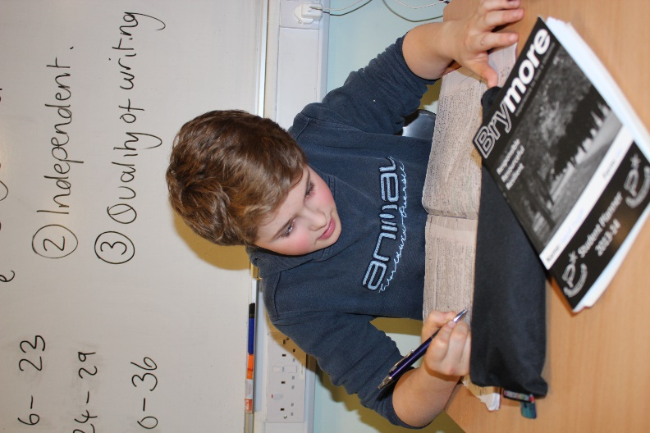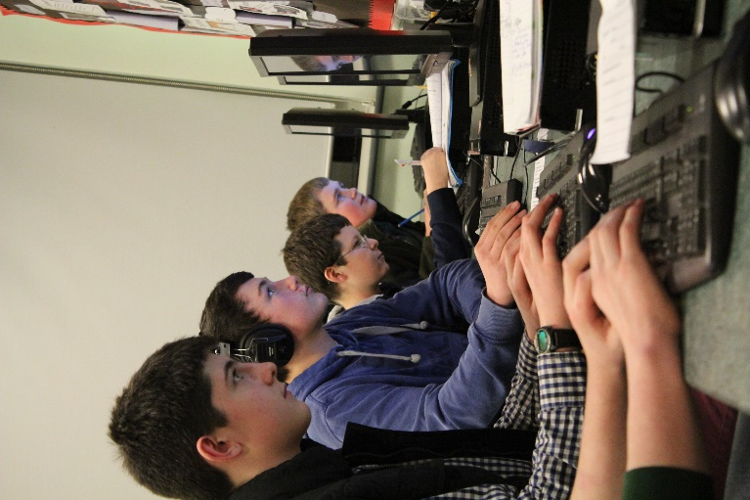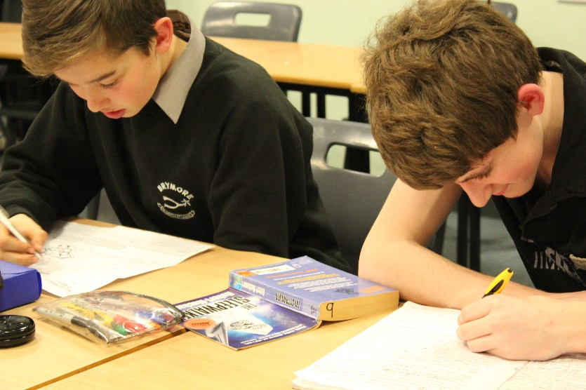

Nutrition

As a boarder all meals are included in the cost of the boarding provision both during the week and at weekends. We believe that hardworking boys need enough food to sustain them through the day so our dedicated kitchen staff are always on hand with a full menu and a caring attitude. We are determined to provide meals and snacks that are nutritionally balanced along with being fulfilling and try to work closely with the boarders to ensure that their views are listened to and accommodated, where possible.

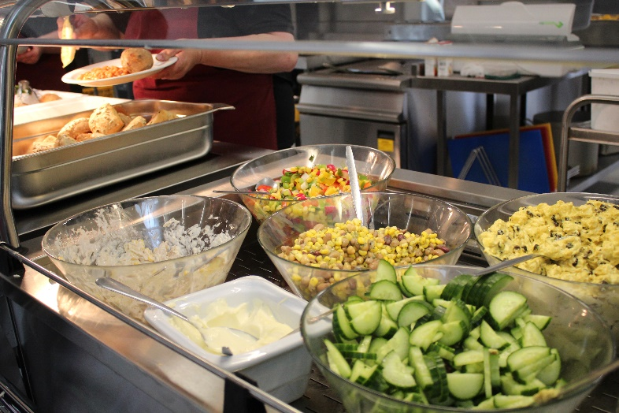



Alongside the catering provision of meals all boarding houses contain basics such as tea, coffee, milk, water, squash and bread and there is also the addition of a tuck shop which is open at 3.45pm - 4.15 pm and 7.45pm - 8.15pm.

Boys are all welcome to bring in their own tuck to school; however this must be stored in a sealed container.

There is a salad bar available for lunch and tea along with water being available at all meals.

An example of one of our menus is shown below; please note menus are changed weekly to encourage diversity.

|  |  |  |  |
| --- | --- | --- | --- |
|  | **Breakfast** | **Lunch** | **Tea** |
| **Monday** | Selection of cereals / yoghurt and granola /  Scrambled egg with baked beans and waffles / breakfast bap  Fruit juice, tea and coffee | a Pasta bolognaise and pomodorro  b Chicken fajita  c Salad bar  Flapjack | a Chicken and bacon pie  b Macaroni cheese & garlic bread  Boiled potatoes / peas / roast parsnips    Apple pie and custard |
| **Tuesday** | Selection of cereals / porridge / bacon served with poached eggs and tomatoes / toast and preserves  Fruit juice, tea and coffee | a Chicken tikka & rice  b Chicken korma & rice  c Vegetable korma & rice  d Salad bar  Lemon drizzle cake | a Sausage wellington  b Chilli con carne  Corn bread / Rice or new potatoes / braised red cabbage / sweetcorn    Chocolate fudge pudding |
| **Wednesday** | Selection of cereals / yoghurt and granola / melon kebabs / sausages served with hash browns and beans / breakfast bap  Fruit juice, tea and coffee | a Sausage and bean wrap  b Ham and coleslaw wrap  c Cheese and bean wrap  d Salad bar    Shortbread | a Roast turkey  b Honey roast gammon  Parsley sauce / roast potatoes / cauliflower cheese / kale  Bread and butter pudding |
| **Thursday** | Selection of cereals / toast / porridge / scrambled egg served with herb potatoes and beans  Fruit juice, tea and coffee | a Breakfast panini  b Honey tuna melt panini  c Spicy cheese panini  Flapjack | a Chicken and vegetable stew  b Braised steak  Mashed potatoes / spring greens / braised carrots  Australian crunch |
| **Friday** | Selection of cereals / yoghurt and granola / bacon served with hash brown nuggets and toast  Fruit juice, tea and coffee | a Fish and chips  b Chicken nuggets  c Jacket potato  d Salad bar  Lemon drizzle cake | a Sausage and bean cassoulet  b Sweet and sour pork  Rice / sugar snap peas / sweetcorn  Doughnuts |
| **Saturday** | Selection of cereals / porridge / sausage and egg bagels / toast and preserves  Fruit juice, tea and coffee | Choice of homemade baguettes  Shortbread | Jumbo hotdog with onions  Spicy wedges / BBQ beans / salad bar  Trio of ice cream |
| **Sunday** | Selection of cereals / pastries / toast and preserves / full English breakfast  Fruit smoothie, tea and coffee | Roast lamb / roast potatoes / cabbage / parsnips / cauliflower cheese  Flapjack | Sausage pasta bake / garlic bread / salad  Muffins |

Activities

Extra-curricular activities are an essential part of what make Brymore unique and it is through these activities that boys learn self-confidence and self-esteem. We work extremely hard to ensure that there are numerous and varied activities available to all of the boys, whether out-boarders or boarders. A large variety of pursuits are put on throughout the evenings and weekends at various times in the academic year to ensure the best experience of Brymore is open to all. Examples of the options open to them are listed:

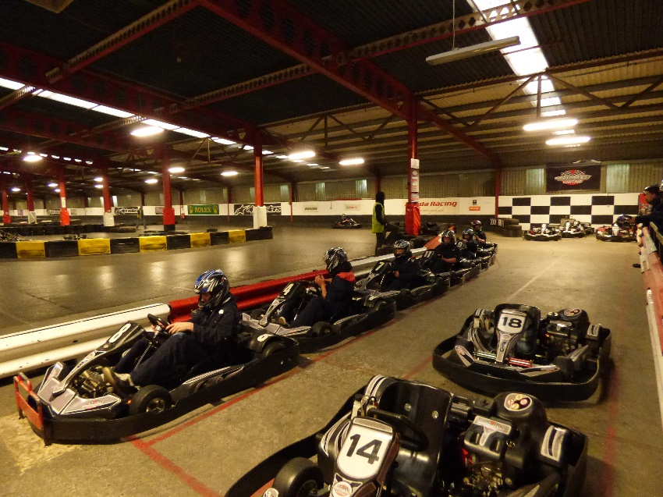

* Fishing
* Go karting
* Cinema
* Blacksmithing
* Dry slope skiing
* Athletics
* Cricket
* Rugby
* Drums
* Guitar
* Rugby
* Young Farmers Club
* Chads run
* Woodwork
* Hockey
* Cooking
* 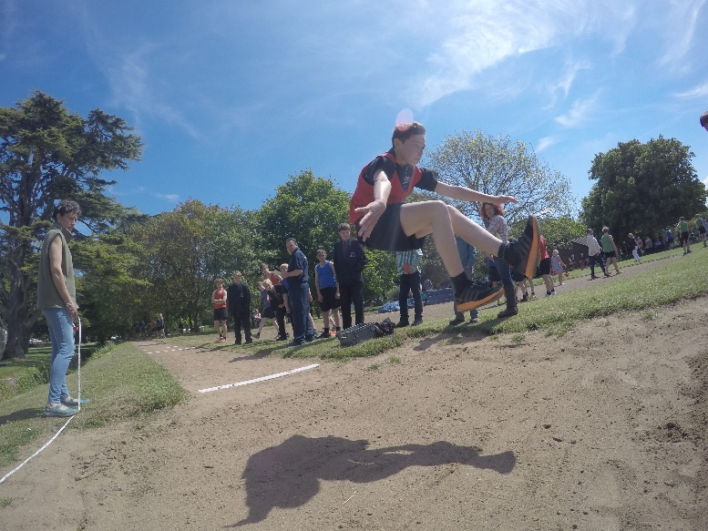Arboriculture (tree climbing)
* Day trips

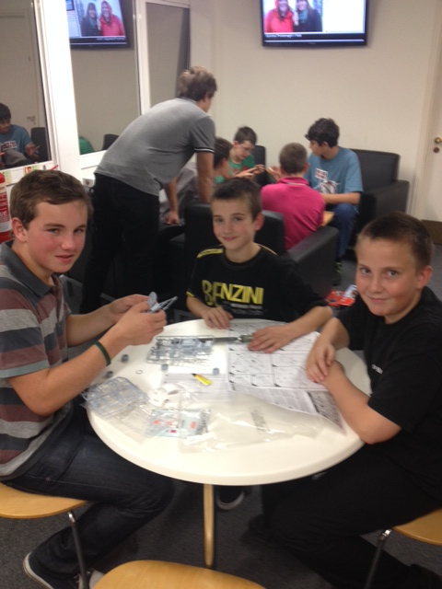

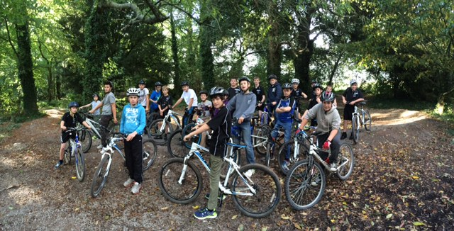

Help and Counselling

We all have times when we need to talk to someone about issues in our lives that worry us. Some like to share them with friends or family. Others might have a prefect, tutor or member of staff whom they trust. Any of these people will be sympathetic and supportive and may be able to offer practical advice, or just put problems into perspective. It is important that boys do not suffer in silence and often there are people out there who can help and there are also many other people who feel similarly either now or in the past so it is important that we offer support to boys feeling this way.

**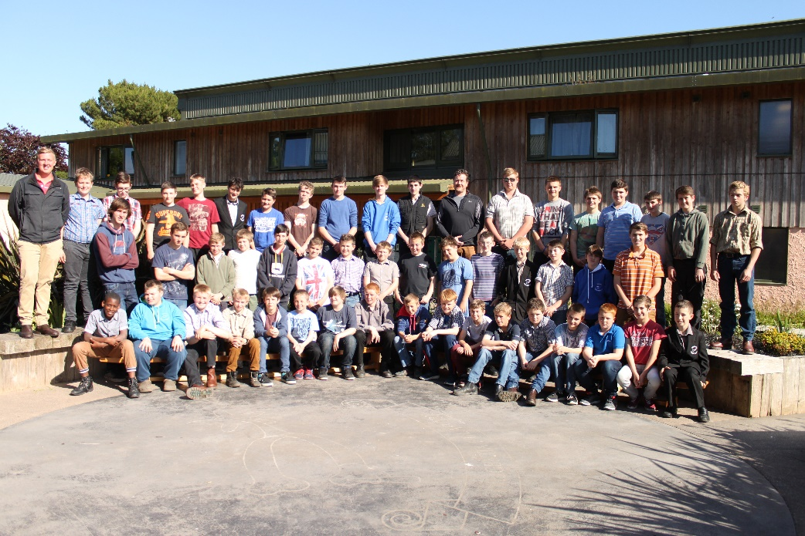**We also have the services of a qualified and trained counsellor who visits the school on a twice weekly basis and she can offer advice and support in a confidential and relaxed environment within the school grounds.

**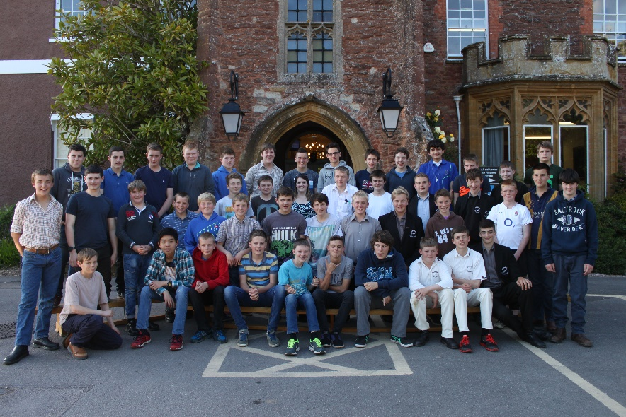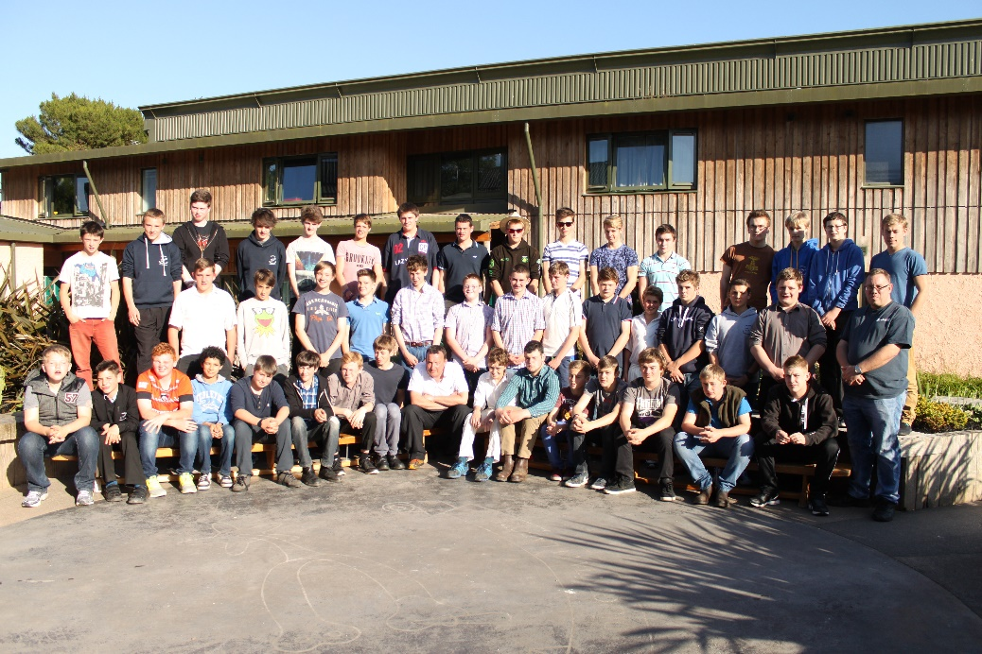The fire alarm is always tested on Tuesday at 10.00 am**

|  |  |
| --- | --- |
| **During the school day (9.00am - 3.45pm)**  If a continuous bell rings, the staff with their students should make their way to the necessary fire point on the grass area outside of the main school  Students must walk in silence  They must line up in their tutor groups, where a member of staff will register them.  The office will have the exeat boards to check for absentees  Whilst this is happening the designated person will check to see where the fire is (if at all) and be responsible for calling the fire brigade.  The all clear will be given and students will be directed back to class in silence. | **After the school day (3.45pm - 9.15am)**  If a continuous bell rings, the staff with their students should make their way to the necessary fire point on the grass area outside of the main school  Students must walk in silence  They must line up in their dormitory groups, where a member of staff will register them.  The house parents will have the exeat boards to check for absentees  Whilst this is happening the designated person will check to see where the fire is (if at all) and be responsible for calling the fire brigade.  The all clear will be given and students will be directed back to boarding houses in silence. |

*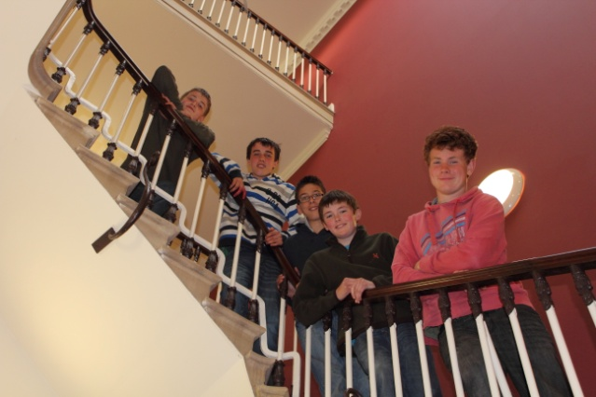*

To conclude

Starting at a new school can be a nervous time for parents as well as boys. As we tell the boys, it is very important that, if you are unsure about anything at all, you should ask somebody. We will always be happy to answer any queries that any parent, carer or boy has and for boarders their Houseparents are often the first port of call for this. Alternatively, more important issues should be referred to a member of the Senior Leadership Team or boarding issues would be better referred to the Head of Boarding or Director of Boarding. Life as a Brymore boy offers a great opportunity for personal and academic growth and maturity and allows young people a chance to discover the best in other people and enables independence. It is very much our hope that your son’s time at Brymore will be as enjoyable for you as it will be for him.