**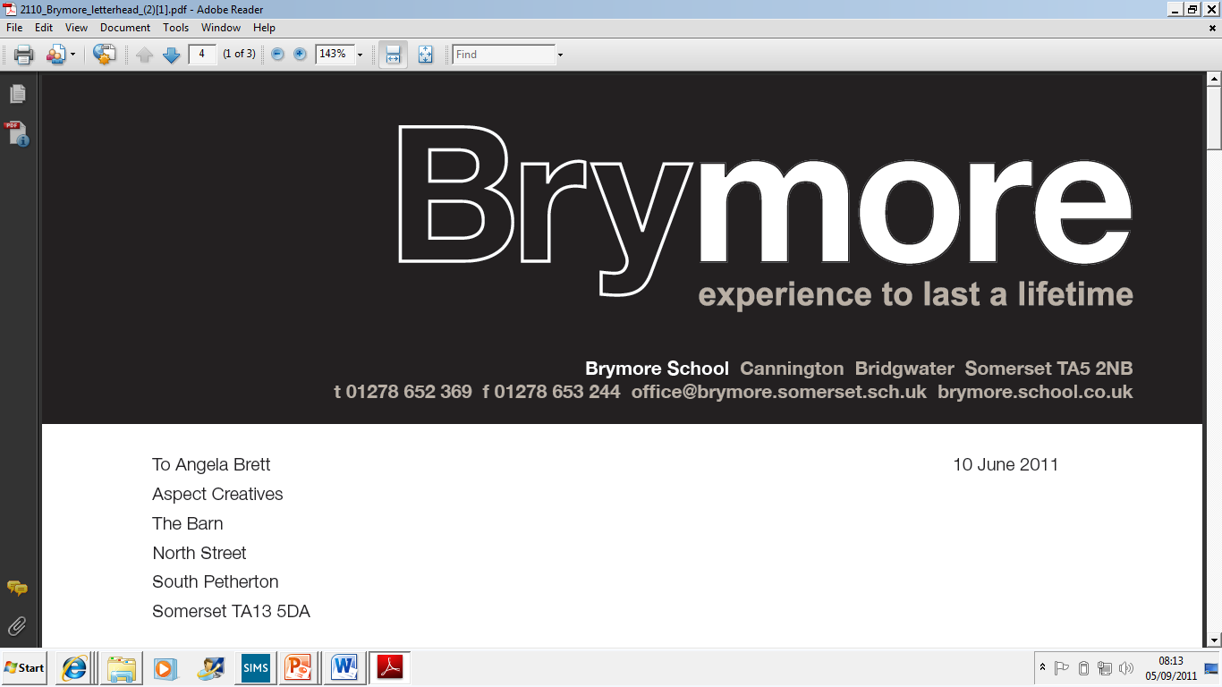**

**Parent/Student Handbook**

**2016/17**

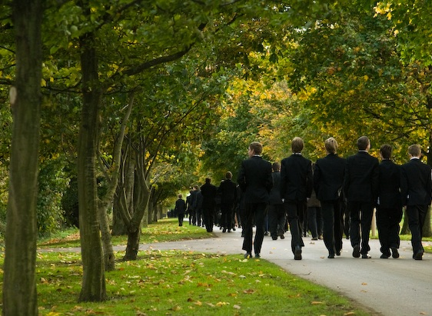

**A Welcome to Brymore**

We are delighted to welcome you and your son to Brymore. We encourage our boys to flourish and exceed expectations, both personally and academically and we hope your son will play a full and active part in every aspect of Brymore life. This is a unique opportunity for an exceptional education and an experience that will last a lifetime.

Boarding is at the heart of Brymore and, whether your son is a full time boarder or an ‘out-boarder’ (our term for day boys) the reality is, he will be part of a boarding environment in which he will be welcomed - and encouraged to participate as much as possible. Brymore boys are renowned for their ‘hands on’ approach to life. Boys are expected to show commitment in all areas, both in and outside the classroom, because this is what builds confidence and self-esteem. Boys are encouraged to become responsible, resilient and resourceful and all out-boarders join the boarding community for the time they spend on feeding duty.

This handbook is designed to provide as much information as possible about Brymore, for those who may be feeling nervous or unsure of what to expect. We aim to answer your questions, clarify our expectations and give practical advice.

Naturally, if you still have questions, you are welcome to ask us. In the meantime, we hope this guide will be of value, both now and in the future.

***Mark Thomas***

***Headteacher***

**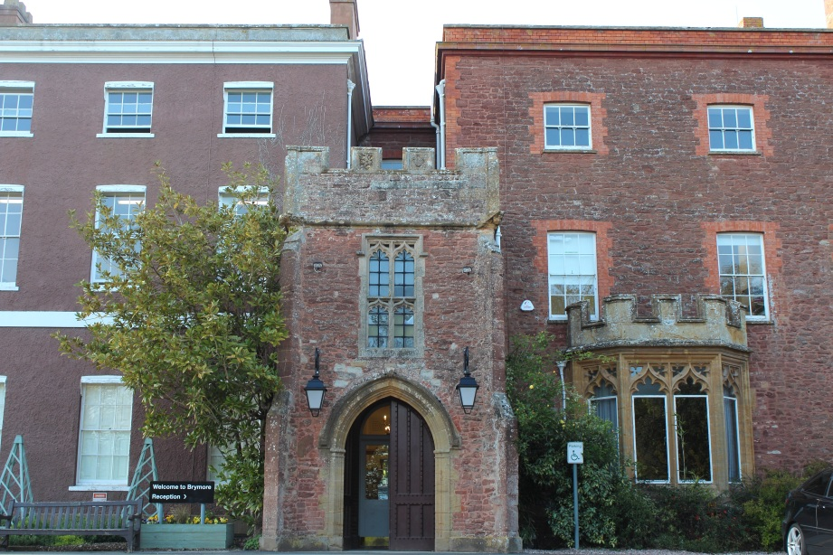**

**Communication with parents**

It is important to us that parents feel part of the school and that the responsibility for welfare and progress of the boys is viewed very much as a partnership. That is why we have included the e-mail address of all key staff below and overleaf so that parents can contact them directly. There is a weekly parent bulletin posted on our website each Friday highlighting the key activities and events for the week ahead and we produce a newsletter every half term. In addition our Facebook and twitter pages are updated three or four times a week with news about the school and the boys themselves.

There are occasions when we may need to get messages to parents quickly, such as a cancelled sporting match or a change to timings of a key event. We would therefore be grateful if you could provide the school with a mobile phone number so that we can text you any urgent messages.

We would also appreciate it if you could ensure we have an e-mail address and let the school know if this is your preferred method of communication. This not only makes communication more efficient, but can save the school significantly in printing costs.

**Key Events**

We hold a number of key events throughout the year where parents are invited to share the Brymore experience with their son. These include Harvest Festival, Cross Country, the Christmas Carol Service, Open Day, Sports Day, Swimming Gala and presentation afternoon in addition to many sporting events. We deliberately try and hold these at the end of a half term so that parents who live some distance away, do not have to make additional journeys to school. We also feel these events provide an opportunity for parents to get to know staff, further strengthening the communication between school and home. All boys and parents are very much part of the Brymore family, and we strongly encourage parents to get involved with the school. Often at these events refreshments are provided by FOBSA (Friends of Brymore School Association) who are parents who help raise money for the school. They welcome any support, even if it can only be once a year. If you feel you can help please contact Julia Birchall-Mann (Chair of FOBSA) on [fobsachair@hotmail.com](mailto:fobsachair@hotmail.com)

**The Staff at Brymore (Day/Academy Staff)**

|  |  |  |
| --- | --- | --- |
| Mr Mark Thomas | Headteacher | MThomas4@educ.somerset.gov.uk |
| Mrs Victoria Davis | Deputy Head (Curriculum, Teaching and Learning) | VDavis@educ.somerset.gov.uk |
| Mr Luke Winter | Assistant Head (Student Achievement & Welfare) Designated Safeguarding Lead  Head of Taylor House | LWinter@educ.somerset.gov.uk |
| Mrs Rebecca Jones | Assistant Head & SENCO | RJones3@educ.somerset.gov.uk |
| Mr Robert Watts | Head of Boarding | RWatts1@educ.somerset.gov.uk |
| tbc | Business and Estates Manager |  |

|  |  |  |
| --- | --- | --- |
| Mr Chris Adamson | Farm Agricultural Assistant | CAdamson@educ.somerset.gov.uk |
| Mr Neil Andrews | Estates Assistant | NAndrews@educ.somerset.gov.uk |
| Mr James Armstrong | Teacher of D&T | JArmstrong1@educ.somerset.gov.uk |
| Mr Ian Ashton | Head of Maths  Head of Galsworthy House | IanAshton@educ.somerset.gov.uk |
| Mr Anton Austin | Head of D&T | AAustin@educ.somerset.gov.uk |
| Mrs Sam Austin | 2 i/c Learning Support | SAustin@educ.somerset.gov.uk |
| Mr Jon Ball | Teaching Assistant (D&T) | JBall1@educ.somerset.gov.uk |
| Mrs Pat Ball | Science Technician | PBall1@educ.somerset.gov.uk |
| Mrs Clare Bowley | Maths Teacher | CBowley@educ.somerset.gov.uk |
| Miss Helen Bradford | LRC Manager | HBradford@educ.somerset.gov.uk |
| Mr Bradley Blake | Premises Assistant | BBlake@educ.somerset.gov.uk |
| Miss Victoria Buckler | Volunteer Counsellor | VBuckler@educ.somerset.gov.uk |
| Ms Dawn Carter | LSA Science | DCarter4@educ.somerset.gov.uk |
| Mrs Sally Clark | Art Teacher | SClark3@educ.somerset.gov.uk |
| Mrs Michelle Craig | English Teacher | MCraig@educ.somerset.gov.uk |
| Mr Nicholas Craig | Head of Science | NCraig@educ.somerset.gov.uk |
| Mrs Lindsay Eastham | Finance Officer | LEastham@educ.somerset.gov.uk |
| Ms Jackie Evans | Finance Manager | JEvans6@educ.somerset.gov.uk |
| Mrs Joanne Farr | Part Time D&T Teacher | JFarr3@educ.somerset.gov.uk |
| Mrs Sally Finnis | Finance Assistant | SFinnis@educ.somerset.gov.uk |
| Mr Robert Fowler | Caretaker | RFowler@educ.somerset.gov.uk |
| Ms Tanya Hawes | LSA | thawes@educ.somerset.gov.uk |
| Mrs Helen Hill | Reception / Attendance | HHill3@educ.somerset.gov.uk |
| Mrs Nicola Jennings | Head of ICT (maternity leave) | NAJennings@educ.somerset.gov.uk |
| Mr Paul Kingston | Farm Manager | PKingston@educ.somerset.gov.uk |
| Miss Heather Lee-Joy | History/English Teacher | HLee-joy@educ.somerset.gov.uk |
| Mrs Jeannie Lillywhite | Director of Boarding | JLillywhite@educ.somerset.gov.uk |
| Mr Robin Leighton | Estates Assistant | RLeighton@educ.somerset.gov.uk |
| Miss Kelly Markham | Counsellor | KMarkham@educ.somerset.gov.uk |
| Miss Kerry Marks | Teacher of Agriculture | tbc |
| Miss Sara Nash | Horticulture Technician | SNash@educ.somerset.gov.uk |
| Mrs Clare Popham | Literacy Coordinator | CPopham@educ.somerset.gov.uk |
| Mrs Helen Porter | ICT Technician | HMPorter@educ.somerset.gov.uk |
| Mr Terry Prosser | Health & Safety Adviser,  Estates Assistant | TProsser@educ.somerset.gov.uk |
| Miss Amie Reed | Office Apprentice | AReed1@educ.somerset.gov.uk |
| Mrs Alison Richards | Teaching Assistant (Horticulture) | ARichards@educ.somerset.gov.uk |
| Ms Jo Rundle | HLTA (Maths)  Head of Walker House | JRundle@educ.somerset.gov.uk |
| Mr James Ryan | Catering Manager | JRyan1@educ.somerset.gov.uk |
| Mr Tom Sawyer | Geography, History, Science Teacher | TSawyer@educ.somerset.gov.uk |
| Mr John Sharp | Network Manager | JSharp@educ.somerset.gov.uk |
| Mr Gary Simmons | LSA | GSimmons@educ.somerset.gov.uk |
| Mr Brian Spridgens | PE Teacher | BPSpridgens@educ.somerset.gov.uk |
| Mrs Fiona Stanley | Senior Horticulture Technician | FMStanley@educ.somerset.gov.uk |
| Mrs Jayne Taylor-Lane | Head of English | JTaylor-Lane@educ.somerset.gov.uk |
| Mrs Claire Truman | Teacher of Maths | CTruman@educ.somerset.gov.uk |
| Mrs Julie Vearncombe | PA to the Head / Admissions | JVearncombe@educ.somerset.gov.uk |
| Mrs Clare Wallace | Office Manager / Exams Officer | CWallace1@educ.somerset.gov.uk |
| Mr Philip Ward | LSA | PWard@educ.somerset.gov.uk |
| Ms Lorraine Warren | Marketing Manager | LWarren2@educ.somerset.gov.uk |
| Mr Jonathan Watts | LSA | jwatts@educ.somerset.gov.uk |
| Mr Alastair Weldon | DT Technician | aweldon@educ.somerset.gov.uk |
| Mr Reuben Willcocks | Head of Horticulture | RSWillcocks@educ.somerset.gov.uk |
| Mr Lloyd Williams | Head of Agriculture and  Teacher of PE | LWilliams5@educ.somerset.gov.uk |
| Mr Bryan White | Teacher of Science | bwhite1@educ.somerset.gov.uk |
| Mrs Kate Whyte | Farm Technician | JKWhyte@educ.somerset.gov.uk |

**Timings of the week**

|  |  |  |  |  |  |  |  |  |  |  |  |  |  |  |  |  |  |  |  |  |  |  |  |  |  |  |  |  |  |  |  |  |  |  |  |  |  |  |  |  |  |  |  |  |  |  |  |  |  |  |  |  |  |  |  |  |  |  |  |  |  |  |  |  |  |  |  |  |  |  |  |  |  |  |  |  |
| --- | --- | --- | --- | --- | --- | --- | --- | --- | --- | --- | --- | --- | --- | --- | --- | --- | --- | --- | --- | --- | --- | --- | --- | --- | --- | --- | --- | --- | --- | --- | --- | --- | --- | --- | --- | --- | --- | --- | --- | --- | --- | --- | --- | --- | --- | --- | --- | --- | --- | --- | --- | --- | --- | --- | --- | --- | --- | --- | --- | --- | --- | --- | --- | --- | --- | --- | --- | --- | --- | --- | --- | --- | --- | --- | --- | --- |
| **The School Day**   |  |  | | --- | --- | | **8.55am - 9.10am** | Assembly\* | | **9.15am - 10.15am** | Lesson 1 | | **10.20am - 11.20am** | Lesson 2 | | **11.20am - 11.40am** | **Break** | | **11.40am - 12.40pm** | Lesson 3 | | **12.40pm - 1.35pm** | **Lunch** | | **1.35pm - 2.35pm** | Lesson 4 | | **2.40pm - 3.45pm** | Lesson 5 |   **\* Tutorial on Tuesdays and Thursdays**  **Saturday**     |  |  | | --- | --- | | **1.35pm - 3.45pm** | Compulsory Saturday Activities | | **4.00pm** | Home for those leaving | | **Weekdays**   |  |  | | --- | --- | | **6.30am** | Feeders wake for duty | | **7.15am** | Rising bell | | **7.50am** | Breakfast | | **8.30am** | Back to boarding house / equipment check | | **8.45am** | Out-boarders arrive | | **8.55am** | Assembly | | **3.45pm** | End of school day / start of boarding day | | **4.00pm - 5.00pm** | Duties /activities/  free time | | **5.00pm - 5.40pm** | Tea Serving Times for Year 7, 8 & 9 | | **5.40pm - 6.05pm** | Tea Serving Times for 10 & 11 | | **6.30pm - 7.30pm** | Prep | | **7.30pm - 8.30pm** | Supper / activities / free time / clubs | | **8.30 pm** | Bedtime procedures for Year 7 start | | **9.00pm** | Bedtime procedures for Years 8-11 |   **Saturday bedtime procedures differ -**  **All year groups to be ready for bed by 9.55pm and in bed at 10.00pm.** | **Sundays**   |  |  | | --- | --- | | **7.00am** | Feeders wake for duty | | **8.30am** | Rising bell | | **8.45am** | Breakfast | | **9.30am** | Activities /  free time / trips | | **12.55pm** | Lunch bell | | **1.00pm** | Lunch | | **1.30pm** | Activities /  free time / trips | | **4.00pm** | Feeding duties | | **5.55pm** | Tea bell | | **6.00pm** | Tea | | **6.30pm** | Activities /  free time | | **8.30pm** | Yr7 boarders must return | | **9.00pm\*** | All returners to have signed in |   **\* Bedtime procedure for**  **Year 7 boys is 8.30pm** |

**Pastoral Houses**

Like many schools, Brymore runs a House system during the day, with a vertical tutor system comprising of five tutor groups per house, with boys from all five year groups in each tutor group. New students will be allocated to Galsworthy, Taylor or Walker house. Tutor groups are led by the tutor, allowing boys to form close bonds with others in their tutor group and get to know the member of staff who will be monitoring their academic progress, their behaviour in school and contacting home when appropriate.

As tutors, they take a special interest in each boy and will be the first to contact home, should there be any concerns or successes in school. In addition, boys learn to work as part of a team, competing for their house in sporting events and school competitions.

Currently, Heads of House are as follows:

Galsworthy - Mr Ashton

Taylor - Mr Winter

Walker - Ms Rundle

**Responsibility for Pastoral Care**

It cannot be over-stressed that the pastoral care of all our students is the responsibility of the whole community. The way we treat, talk to, interact with and indeed teach students, will all contribute to the quality of our pastoral care. However, the main focus for Pastoral Care for particular students will be their Tutor. At Brymore Academy the pastoral and academic oversight of every student is primarily the responsibility of his or her tutor. **All issues regarding a particular student should, in the first instance, be directed through their tutor.** Tutors will then discuss important issues with the Head of House. Mr Winter, Assistant Headteacher, will meet each Head of House every week, where student and parent concerns can be raised.

**The Pastoral Team**

|  |  |  |
| --- | --- | --- |
|  | **Mr Winter**  **Assistant Head Teacher** |  |
|  | **Heads of House** |  |
| **Mr Ashton**  **Head of Galsworthy** | **Mr Winter**  **Head of Taylor** | **Ms Rundle**  **Head of Walker** |
|  | **Tutors** |  |
| **G1 Mrs Truman**  **G2 Mr Austin**  **G3 Mr Ashton**  **G4 Miss Lee-Joy**  **G5 Mrs Taylor-Lane** | **T1 Mr Williams**  **T2 Mr Craig**  **T3 Mr White**  **T4 Mr Willcocks**  **T5 Ms Carter** | **W1 Mr Armstrong**  **W2 Mrs Craig**  **W3 Ms Rundle**  **W4 Mr Sawyer**  **W5 Miss Bradford/**  **Ms Warren** |

**Student Planner**

Each student will be issued with a planner to help organise their Prep/Homework and it contains lots of useful information that a Brymore boy would need to know. Merits and Commendations are recorded in the planner, so it is essential that the planner is looked after and treated with respect. The expectation is that boys will bring the planner to every lesson. Each week the tutor will check the planner to ensure boys are recording their prep and monitor how many house points they have received.

**Classroom Groups**

At Brymore, we make every effort to ensure boys are grouped carefully for each subject, to maximise their potential in every area. In English, Maths and Science, boys are often set according to ability. Other subjects, such as Agriculture, Technology and Horticulture also group boys carefully, with the aim to create the best possible mix for that subject. At times boys may be taught in streamed groups (B, R and Y) and again, this is to ensure they build strong relationships with their peers.

**Discipline and Rewards**

Brymore prides itself on a strict code of discipline that is firm but fair and which has at its core a strong emphasis on rewarding boys for every success. The school operates a system of 'consequences'. In cases where students fail to meet expectations in class, they will be issued with a warning, then a second warning, which may include being moved, spoken to or asked to stay behind at the end of the lesson. In the rare cases where boys continue to misbehave in spite of this, they will be 'referred'. This means being sent to another classroom, the incident is written up and passed to the Head of House for monitoring. Heads of House keep track of the number of referrals received by each boy and parents will be contacted in each case when a referral is issued. It must be emphasised that this is a serious issue and that boys who receive three referrals in one half term will face exclusion for persistent disruption. Again, this rarely happens and in each case parents will be contacted and students given fair warning when they are close to their third referral.

The Reward system operates through merits, commendations and certificates. Boys collect merits in their tutor groups and again, this is monitored by Heads of House. Boys receive certificates and badges in assembly for reaching specific milestones.

**Reporting/Mentoring System**

Brymore boys are encouraged to strive for academic success and we believe it is vital that parents are kept informed of their son's academic progress at regular intervals. Each boy will receive an annual report from all subjects. In addition, interim reports are issued regularly, including levels achieved in each subject area, matched against their target grades. Boys are issued with their target grades and currently working at grades and are encouraged to keep these in their planners, so that they can keep track of their progress. Boys at risk of underachieving are highlighted by this process and it is our aim to intervene early so that we can help them to stay on track. Every boy will also have a staff mentor, who will meet with him regularly to discuss his progress and well-being.

**Special Needs Information**

Brymore Academy is committed to ensuring that boys of all abilities can achieve in all subject areas. We have a highly skilled and dedicated Learning Support Team, many of whom are attached to individual curriculum areas, who work with students in lessons. We also run several interventions tailored to develop a range of skills including: literacy, numeracy, language and communication and social skills. Parents are encouraged to talk to Mrs Jones (SENCo) or Mrs Austin (2 i/c Learning Support) about their son’s individual needs as he starts at Brymore.

**Expectations of boys at Brymore**

**Uniform at Brymore**

A high standard of personal appearance is expected of all students and body piercing and jewellery are strictly forbidden. Boys are not allowed to have dyed hair, gelled hair or extreme haircuts. Short, neat hair is expected. All uniform (clothing and footwear) must be named. It is expected that all workshop overalls, games clothes, rugby shirts, rugby shorts and towels will be named with extra-large name tapes (black on white). There is a useful diagram on the next page to help.

Essential school uniform/clothing/equipment

* 1 Black blazer with Brymore badge
* 1 Brymore rain jacket
* 5 grey shirts (white shirts for Year 11)
* 2 black Brymore sweatshirts with logo
* 6 pairs of grey or black socks
* 2 pairs of black trousers
* 1 school tie (specific to Day House)
* 1 pair of black shoes/smart boots **NOT steel toe-capped** that can be polished for use during the day (Not trainers)
* 8 pairs of boxers/pants
* 3 vests or plain white t-shirts
* 1 pair of overalls or boiler suit for the farm
* 1 canvas laundry bag
* Mesh bag 40cm x 30cm for sock washing
* Waterproof coat, trousers, hat, gloves and old clothes for the farm
* 1 pair of safety wellington boots (name painted on outside)
* 1 pair of safety boots - can be steel toe-capped (for use in the gardens) (name painted on outside)
* 1 pair swimming trunks
* Black belt for school trousers
* 1 wellington boot bag for storage

PE Uniform

* 1 pair of gym shoes or trainers
* Drawstring PE bag - boarders
* Bag for out-boarders to leave PE uniform and farm overalls in changing rooms and of a suitable size to fit inside locker (300mm (w), 890 (h), 415 (d))
* 2 pairs PE shorts
* 2 school fitness t-shirts
* 2 pairs of rugby shorts
* 2 reversible rugby jerseys
* 1 pair of rugby boots (named)
* 2 pairs of black and white football socks
* Track suit and jogging bottoms
* 1 white cricket shirt and 1 pair white cricket trousers (summer term, those representing the school only)
* Mouth guards for rugby/hockey
* Shinpads
* Any other old games kit for practice sessions

Brymore boys are frequently described as exemplary advocates for the Academy. Outside the Academy, whether in Cannington or on a trip, any boy who wears our uniform is expected to do so with pride. Boys should be smart and well-mannered and remember that they carry the Brymore reputation with them at all times.

**Where to attach large name labels.**

j0308034

NAME

Please attach name tag here, above the band on the rugby shirt.

Also attach another on the inside of the shirt in a similar position so that the shirt can be worn 'inside out'.

bd07453_

Drawstring PE bag.



NAME

BRYMORE



Name

Please attach name tag here, above the logo on the T-shirt

On the overalls please attach the name tag above the breast pocket.

Label towels along the edge

Rugby boots, work boots and wellington boots - name to be painted on the outside

NAME

Name

**J. Smith**



NAME

**Farm and Garden Duties**

One of the things that makes Brymore unique is the chance to work in real life situations, with equipment and animals which ensures that the boys can truly develop the three Rs of responsibility, resourcefulness and resilience. As part of this it is vital that all boys carry out the Farm and Garden duties required of them and this applies to both out-boarders and boarders.

All duties are a higher priority than every other activity and it is important to remember that these are real working situations where the production of a profit is essential. Boys know they must take this distinctive opportunity seriously and work safely at all times. All boys, including out-boarders must complete Farm and Garden duties. Failure to do so could mean the boy will be asked to leave the Academy as they no longer meet our admission criteria.

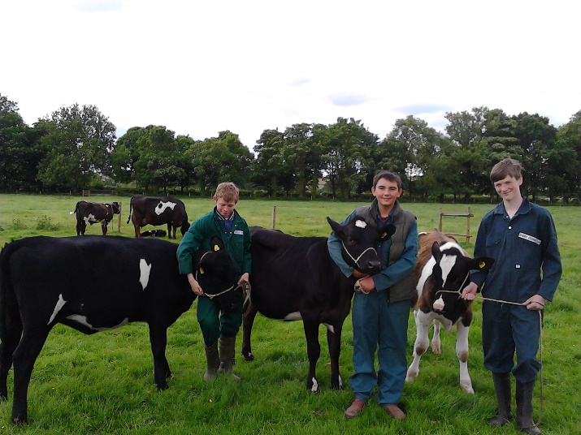 

Year 7

Boys in Years 7 and 8 who want to do feeding duty for a week can opt into the rota by seeing Mrs Garrod. Boys may also be able to experience duties as an ‘extra’ *by arrangement* after school, and must also see Mrs Garrod. Garden duties are yet to be finalised.

Year 9

For both Garden and Farm duties it is important to adhere to these expectations to ensure the job is well done.

**What is expected?** A good attitude, hard work, care for others, tools, plants and animals, finishing the job and working as part of a team is a must, it is important to wash all tools and return to the tool shed.

**What is worn?** No school uniform, only overalls and steel toe capped boots, wet weather clothing and warm clothes for winter and no torn or baggy clothes which could get caught in machinery.

**Rules:** It is important for boys to be on time and to listen carefully and follow instructions. There is to be no eating, throwing or causing any damage to property, plants or animals and breakages must be reported.

**Peer assessment:** Older students hold roles of Heads of Department (HoD) and it is their job to assess and grade boys working with them, alongside the teaching staff.

**Registration:** It is vital for boys to line up quietly outside the changing rooms and wait for a member of staff. Boys should not leave practical lessons without asking the member of staff.

**Who helps?** HoDs (responsible Year 11s) are chosen to help younger boys with the tasks.

**Garden Duties:**

**When?** 4.00 pm - 5.00 pm on either Monday, Tuesday, Wednesday, Thursday or Friday.

**How long?** Right the way through Years 7, 8 and 9.

**Who is in charge?** Mrs Stanley (Senior Technician in Horticulture).

**What is done?** A variety of jobs essential to the running of the department and all of which is a foundation for your BTEC course.

**What time?** 4.00 pm prompt.

**What to wear?** Change out of school clothes, wear overalls and steel toe capped boots

**Who will help?** Year 10 and 11 Head of Departments are in charge of a small group of boys to ensure that the tasks are completed safely

**Exactly when?** Week 1 - Year 7’s Tuesday to Friday

Week 2 - Year 9’s Monday to Thursday

Year 8’s are spread throughout both weeks, about 6 boys per duty

**Farm Duties - feeding:**

**Who is in charge?** Members of staff: Mr Kingston (Farm Manager), Mr Adamson (Farm Agricultural Assistant)

**When?** 7 or 10 days over a weekend, it is important to note that the boys must stay as boarders throughout the whole time and that out-boarders will board during this period.

**How often?** During Year 9 and 10 there will be seven whole duties.

**Can parents visit?** Yes, parents are welcome to visit over the weekend but boys may not leave as it is important to be on site the whole time in case of a farm emergency (this includes out-boarders).

**What is done?** Feeding stock and looking after all their needs before and after school every day and on Sunday.

**What if the weekend** It would be important to discuss with Mr Williams and arrange a weekly swap. Day

**clashes with a** swaps are not optional.

**special celebration**

**at home?**

**Attendance**

**Research shows that there is a direct link between good attendance and achievement in school. Poor attendance can have a direct effect on a student’s attainment and their future life chances.**

For example, 90% attendance might sound quite acceptable but what that means in reality is….

* You are absent **one day every fortnight**.
* It adds up to **four weeks absence out of every year**.
* In five years this would add up to **half of a school year missed.**
* This results in having only a 75% chance of getting 5 A\*-C at GCSE.
* Also achieving all other qualifications will be affected in a similar way.

If you are **absent one day a week** this means you have an attendance of 80%. Your chances of getting 5 A\*-C at GCSE are down to 20%.

**(Figures based on a 5 day week)**

**Habits of poor attendance and lateness in school can be repeated in working life which is why employers do ask the school for such information as part of references.**

Brymore believes in the academic and social development of all its students. We feel passionate for the school to be successful a student must be at school.

**Term time leave and the Government regulations we follow:**

The School follows the Government regulations amended in September 2013. Absence as a result of holidays taken during term time will not be authorised unless there are exceptional circumstances. Parents/Guardians need to apply for holiday absence before going on holiday and need to explain the specific exceptional circumstances that the Assistant Head teacher and Head teacher may consider. Parents will be notified that taking unauthorised leave/holiday may result in a penalty warning or fine being issued.

**Procedure for requesting term time leave**

**A “Term Time Leave Request Form” needs to be filled in at least two weeks before the proposed dates for leave, you can access the form on our website and send an electronic copy to reception or send a paper copy to reception**



**Term Time Leave Request Form**

**From September 2013 the Government has said schools may NOT grant ANY leave of absence during term time unless there are EXCEPTIONAL circumstances.**

**PLEASE SEE OVERLEAF**

**If the school refuses your request and the child is still taken out of school, this will be recorded as an unauthorised absence and noted on your child’s attendance record.**

**Name of Child / Children Tutor Group**

**1 ………………………………….….……………………………………………. ……..………**

**2 …………………………………….………………………………………….…. ………..……**

**a request to be authorised as being absent from school**

**dates: from …………………………………to………………………………… (inclusive)**

**Exceptional Circumstances (please tick one)**

**Emergency service / forces personnel with proof of enforced holiday period**

**Holiday industry employees with proof of this being the ONLY time period allowed by employer**

**One transcontinental leave request per Key Stage for a very significant extended family event, including seeing and elderly/ seriously ill relative**

**Signature Parent/Guardian …………………………..…………………….. Date ….……………..………**

**Please return this form to school at least two weeks in advance of your proposed absence**

**Important Changes in Attendance Regulations**

From 1st September 2013, any holidays taken during term time will NOT be authorised by the school.

This is because the Government has recently changed the law with regard to granting term time leave of absence, replacing the 2006 regulation that allowed schools to grant up to 10 days leave of absence at their discretion.

This means that from September 2013, schools may NOT grant ANY leave of absence during term time unless there are EXCEPTIONAL circumstances.

**Exceptional Circumstances does NOT include**

* **Cheap holiday cost**
* **Getting personal paperwork, visa’s updated (this should be planned into holiday periods)**
* **Visiting relatives (this should be planned into holiday periods)**

**Exceptional Circumstances MAY include**

* **Emergency service / forces personnel with proof of enforced holiday period**
* **Holiday industry employees with proof of this being the ONLY time period allowed by employer**
* **One transcontinental leave request per Key Stage for a very significant extended family event, including seeing and elderly/ seriously ill relative**

Regular time off for illness will be challenged, requiring not only medical evidence but also medical guidance on how schools can best support and ‘manage’ those children in school. Saying a child is “unwell” will no longer be enough, parents will need to be specific.

Any time away from school can have a significant impact on educational attainment, success in later life and longer term health and well-being. In law, parents and guardians are committing an offence if they fail to ensure the regular and punctual attendance of their child at school.

Therefore, any unauthorised absence in term time can result in the issuing of a Fixed Term Penalty Notice by the Education Attendance Service. Parents will have 21 days to pay this £60 fine, after which it goes up to £120.

**Examples of Penalty Fines**

**One parent, one child £60**

**One parent, two children £120**

**Two parents, one child £120**

**Two parents, two children £240**

**Failure to pay a Fixed Term Penalty Notice within 28 days may result in a criminal conviction and a fine in the Magistrate’s Court of up to £1,000.**

**A fixed Penalty Notice might also be issued if a child’s attendance falls below 92% with 10 sessions or more missed and no satisfactory reason or explanation is given.**

**Where an absence is considered to be completely unavoidable, a term time leave request form is available from the office which must be completed and returned to Mr Winter as far in advance as possible.**

**If you have any concerns about the contents of this reply, please contact the School.**

**Somerset County Council will be supporting all schools in ensuring the law is upheld.**

**Safeguarding**

Student Concerns

As a school we take child protection and safeguarding extremely seriously and work hard to ensure that we are working with the latest legislation and that all staff are trained on this important subject. If there is any concern or worry about anyone’s welfare then it is highly appropriate for parents or boys to talk about it with a designated adult; Mr Winter is Brymore Academy’s Designated Safeguarding Lead Officer with Mrs Lillywhite and Mrs Austin also being part of the Safeguarding Team. Alternatively every member of staff has received training to deal with safeguarding and can then discuss concerns with the Designated Safeguarding Lead.



Student concerns

If you are **concerned or worried** about your welfare or someone else’s:

**You must …**

Pass on your concerns to……

**Mr Winter**

Designated Child

Protection Officer

OR

**Mrs Lillywhite**

**Mrs Austin**

OR Any member of staff you feel comfortable talking to

OR Mrs Dyer, Chair of Governors 01278 653442

OR Mark Nettle, Head of Student Services at Bridgwater

College. 01278 455464







|  |  |  |  |
| --- | --- | --- | --- |
| Problem?  Not sure who to turn to?  why not whisper it?  Whisper is our school’s confidential system for reporting problems at school or at home  Who is it for?  You, your friends or family    Click where you see this button  © Powered by BOOST from South West Grid for Learning |  |  | Link  Click on where you see the link:  [www.swgflwhisper.org.uk/report/bry1](http://www.swgflwhisper.org.uk/report/bry1)  button  Click on the button on your school website:    text  Send an anonymous text to:  BRY1 + your message to  07860  021 584 |

**Boarding at Brymore**

**A Warm Welcome from the Head of Boarding**

Boarding at Brymore is firmly based on the core principles of family living. We strive for an open, inclusive and purposeful atmosphere in which students are encouraged to fulfill their academic and personal potential; where individual needs are addressed and achievements within all areas of the school are celebrated.

We are fortunate enough to have a broad mixture of backgrounds among the boarding community; we pride ourselves on drawing on the best of this rich variety and creating an environment that values individuals but offers an experience that is all the better for its sense of collaboration.

As an Academy, Brymore sets out high expectations of its students and carefully ensures that the structures are in place to allow students to meet these expectations. It is a model that has been proven to work, and one which boarders will find puts them in a great position for when they leave us.

As a former Brymore student myself, I am able to speak with confidence and certainty of the positive impact it is able to deliver to each and every student. I, and hundreds of former students, owe a debt of gratitude to Brymore and the dedicated staff that work here, who continuously strive to make each individual’s experience as unique and positive as possible. I can honestly say that Brymore is unlike any other school that I have attended as a student, or have worked in as a teacher throughout my profession, it is truly one of a kind. Boarding has played an important part in the history of Brymore. Many of our greatest alumni were indeed boarders themselves. For those of us who have lived and worked in the boarding environment, whether currently or in the past, boarding at Brymore has a special atmosphere and character that embraces the qualities of the individuals who pass through our houses.

I, and all the dedicated pastoral team here at Brymore extend a warm welcome to all boarders and out-boarders, their parents and guardians. We look forward to meeting you in due course and welcoming you to the Brymore family.

**Robert Watts**

**Head of Boarding**

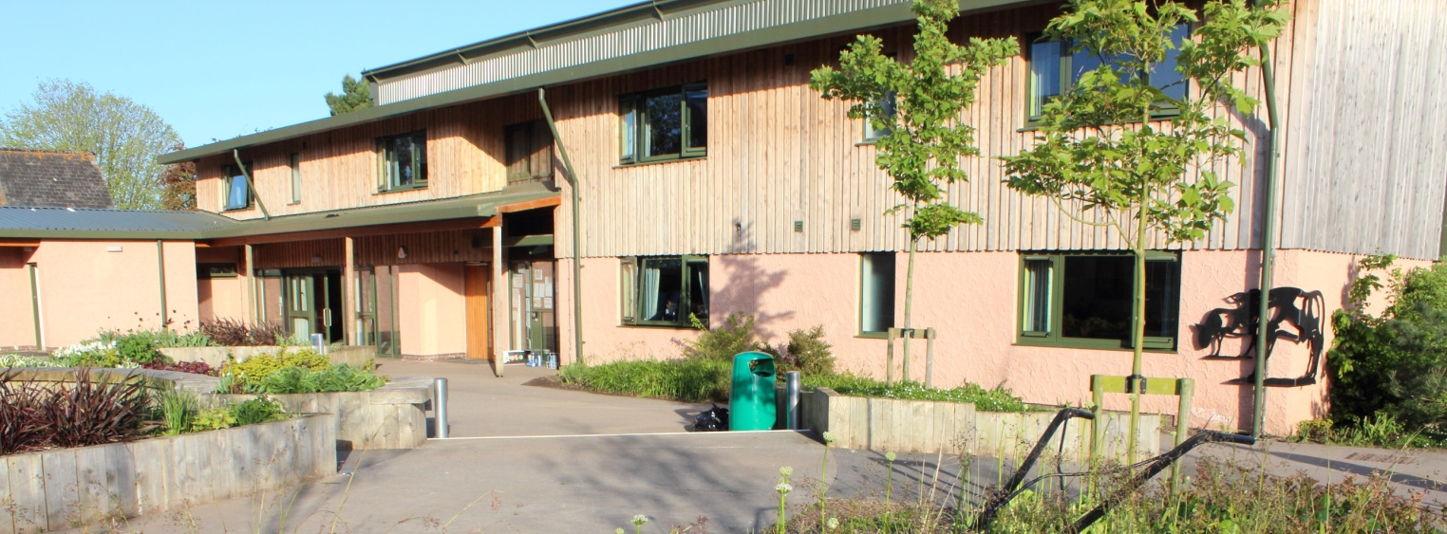

**Statement of Principles and Practice**

*“To ensure that the students of Brymore achieve by providing an outstanding all-round experience, insisting upon high expectations, effective partnerships and creating a safe and supporting environment”*

Our aims for the Boarding Community

We believe that boys should be exposed to a breadth of education that only a boarding environment can provide, with the values, self-confidence and personality gained in a caring family atmosphere. The pastoral team endeavour to create a nurturing and supportive environment that allows students to grow and develop emotionally, physically, morally, socially and educationally.

Objectives of Boarding

* To provide a happy, safe secure environment for our boarders to live in and thrive.
* Encouraged to understand the needs of other boarders as well as their own.
* Treated by other boys and staff with respect and dignity.
* Helped to realise their ambitions and goals to attain personal fulfilment.
* All to be treated as individuals.
* All helped to develop independence and self-reliance while being safe and secure.
* To ensure a fair and consistent approach is achieved across all houses.
* To develop the whole person regardless of ability or background.

Safeguarding of Boarders

We operate a number of policies regarding the school’s careful safeguarding of all the children in the Academy, both day and boarding. We take security very seriously.

Direct access to the Boarding Houses is reserved for students and staff only, and electronic key fob systems operate on all external doors.

We therefore ask that parents, guardians or adult friends of the family, do not enter the Boarding Houses without first speaking with the member of staff on duty. Even though many parents and guardians are ‘familiar faces’ to staff and some students, they may still be unknown to others, and if all adults enter the Houses only via staff contact, then we will ensure full security and avoid the entry into any rooms or bedrooms that may be inappropriate.

Bedtime procedures in all houses - these must be followed

|  |  |
| --- | --- |
| **Time** | **Action** |
| **8.30pm** | **Year 7 register in their boarding house**  **Year 7 to be ready for bed** |
| **8.45pm** | **Year 7 in dormitories with night lights on** |
| **9.00pm** | **Year 7 lights out**  **Years 8/9/10/11 register in their boarding house**  **Year 8/9 to be ready for bed** |
| **9.15pm** | **Year 8/9 in dormitories with night lights on**  **Year 10 getting ready for bed** |
| **9.30pm** | **Year 8/9 lights out completely**  **Year 10 in dormitories with night lights on**  **Year 11 getting ready for bed** |
| **9.45pm** | **Year 10 lights out completely**  **Year 11 in dormitories with night lights on** |
| **10.00pm** | **Year 11 lights out completely** |

However daunting they may at first appear, most of the systems will become very familiar to boarders surprisingly quickly. There will be urgent issues at the beginning such as uniform, timetable, layout of the Academy and the daily routine, which will be covered in induction sessions in the first few days. Each new boy will also be given a mentor to whom he can go to with any queries or problems to help him settle in.

The structure of boarding at Brymore Academy

Brymore Academy has three boarding houses, all based on site, which have all been recently updated and refurbished.

* **Reid House**
* **Kemp House (Junior Boarding House)**
* **School House**

Within both Reid and School House there is a combination of Years 8, 9, 10, 11 and 12, and Kemp House, accommodates the year 7 junior boarders alongside selected Year 8 and 9 Mentors. Year groups are not mixed in dormitories boys are grouped within year clusters throughout each of the houses and with no more than 50 in each house it makes for a comfortable and caring atmosphere.

Out-boarders in Boarding Houses

Out-boarders are allocated to a boarding house, so that they each have a common room which they can use at lunchtimes and know that there is a place where they belong on evenings when they stay at the Academy for activities, prep or farm duties. This is also where they go to sign out at the end of each day.

**ALL OUT-BOARDERS MUST SIGN OUT IN THEIR BOARDING HOUSES AT THE END OF THE DAY.**

As an out-boarder, we believe it is vital that boys feel fully included in Brymore life. To this end, Houseparent’s and boarders welcome them into the boarding house. In return, we encourage out-boarders to take full advantage of evening activities on offer, so that they can get the fullest experience during their time with us. As ever, you get out what you put in and the happiest boys are always the ones who make the fullest commitment to their life at Brymore.

Out-boarders and boarders will supply their own padlock for their personal locker which can be either a combination or key lock. All practical and sports clothing needs to be stored within the lockers within the appropriate bags. Wellington boot bags can be purchased from Miss Gardner. In addition, they can store their DT overalls in the mezzanine.

Houseparent

Each house has a full time Houseparent who lives within the building, in their own separate flat. The role of the Houseparent is to be responsible for the care, welfare and behaviour of the boarders within their house and to ensure this overall care is continued throughout the Academy by liaising with other staff members. All of our Houseparents have extensive experience within their role and at all times their primary concern is the wellbeing of the boarders. The Houseparents report to the Director of Boarding, and it is the Head of Boarding who is ultimately responsible for the pastoral care within our boarding provision. We also have five Gap Tutors who work with us for a year as part of their gap year, some from the southern hemisphere, who support the boys and Houseparents.

Duty Master

On a daily basis there will always be a team of staff, made up of the teaching and support staff, who are on ‘duty’. Their role is to support the Houseparents, Head of Boarding and the Director of Boarding before and after school and at weekends with activities, prep and other undertakings. In addition to this a member of the Senior Leadership Team is on site, day and night, to support all of the staff and students.

Matron

The Matron is there as the students’ first point of contact in a wide range of important areas, which directly affect their welfare. Students consult Matron when feeling unwell and she treats any minor illnesses and injuries, or administers repeat prescriptions as required. In turn she will refer students to the local Medical Centre where necessary. Students will be able to refer to Matron over any concerns over laundry, bedding, uniform or cleaning of rooms. Above all the Matron plays an essential role in the pastoral life of the House and keeps a close eye on the emotional as well as the physical well-being of the boys, liaising regularly with Houseparents and the Director of Boarding over any concerns which may arise. We have a team of four Matrons and there is always at least one available from 7.30am until 9.00pm every day. We also have a dedicated team of cleaners and laundry assistants that will, no doubt, become very familiar to everyone after a while.

Boarding House Staff Information

|  |  |  |
| --- | --- | --- |
| Mr Robert Watts | Head of Boarding | RWatts1@educ.somerset.gov.uk |
| Mrs Jeannie Lillywhite | Director of Boarding | JLillywhite@educ.somerset.gov.uk |
| Mr Brian Spridgens | Senior Housemaster | BPSpridgens@educ.somerset.gov.uk |
| Mr Ellis Holt | Houseparent of Reid House | eholt@educ.somerset.gov.uk |
| Mr Justin Fewtrell | Houseparent of Kemp House | JFewtrell2@educ.somerset.gov.uk |
| Miss Lisa Gardner | Houseparent of School House | LGardner1@educ.somerset.gov.uk |
| Miss Kirsty Tatum | Pastoral Manager | ktatum@educ.somerset.gov.uk |
| Mrs Dawn Gardner | Senior Matron (Pastoral) | dgardner@educ.somerset.gov.uk |
| Mrs Vicky Phillips | Senior Matron (Medical) | vphillips@educ.somerset.gov.uk |
| Mrs Samantha Brind | Matron | sbrind@educ.somerset.gov.uk |
| Mrs Susan Heath | Matron | sdheath@educ.somerset.gov.uk |
| Mr Lachlan Florance | Gap Tutor | lflorance@educ.somerset.gov.uk |
| Mr Daniel Neate | Gap Tutor | dneate@educ.somerset.gov.uk |
| Mr William Olson | Gap Tutor | wolson@educ.somerset.gov.uk |
| Mr George Sedgwick | Gap Tutor | gsedgwick@educ.somerset.gov.uk |

Contact Information for Boarding Houses

Houseparents can be contacted through their boarding house offices between 3.45pm and 9.00pm.

Kemp House 01278 655564 / 07733 937409

Reid House 01278 655563 / 07765 551324

School House 01278 655568 / 07767 869828

Head of Boarding 07912 180117

Director of Boarding 07730 218893

Matrons Office 01278 655585

School Reception 01278 652369

**The Fabric of the House**

Accommodation

Great effort is taken to ensure that room allocation is fair, to provide the best environment for all concerned. If there are concerns they should be expressed to the Houseparents.

Each boy is allocated an area in his room that includes:

* A bed
* A bedside light
* A desk
* Combination safe
* Storage space for books and clothes
* Personal belongings etc.
* Lockable cupboard/drawer (£5 deposit required)
* Damages will be charged to individuals when caused deliberately or by inappropriate behaviour.

Boarders should change for games in their designated changing rooms. Rugby boots and other dirty sports/farm/garden clothes must not be worn inside the House.

Communal Areas and Facilities

The Boarding Houses have the following facilities:

* A kitchen that is equipped with hobs, microwave, fridge, toaster, kettle and sink.
* There is a selection of miscellaneous cooking equipment available for use, as long as it is cleaned and returned to the correct stowage after use.
* Each house is supplied with a daily delivery of bread, milk, juices, fruit, tea, coffee and spreads for boys to enjoy light refreshments throughout the evening.

Boys are encouraged to tidy up and wash up their own dirty dishes. Social rooms have a variety of leisure activities available such as TVs and DVDs, board games, comfortable sofas / seating, air hockey, table tennis and pool tables. Newspapers and magazine are provided daily.

Clothes and Laundry

Boarders do not require huge amounts of clothing in addition to their uniform.

Boys are recommended to have the following plus the uniform listed previously.

* 10 pairs of socks and underpants
* Enough own clothes to wear in the evenings and at weekends if necessary (but please not so much that it cannot be stored)
* 2 pairs of pyjamas
* A dressing gown and slippers
* 3 bath towels and personal toiletries
* Swimming trunks and goggles
* An outdoor waterproof coat
* Warm hat and gloves (during winter)

**All clothes should be named** and the Matron informed of any clothes that are new or unnamed. Matron undertakes the organisation of the boarder’s laundry and this is done on a regular basis.

Cleaning

We have a hardworking and committed team of staff who clean the House daily during the week. Beds are to be made, areas are to be tidied and floors are to be kept clear every day so that cleaning can take place. We ask that boys do not leave possessions lying around in the common areas 'to be picked up later' and use the litter bins. Keeping the kitchens clean and tidy, washing up dishes and clearing up is an essential part of boarding life.

Bed Linen

We provide a duvet, pillow and fire blanket for each student and bed linen. However, if your son would prefer to bring their own duvet cover in then this is fine under the following agreements;

You must have your name label clearly visible on the outside of your duvet and pillow case and bring two sets. If you wish to have more than one pillow you will need to provide this. It must also be fire retardant.

Health

Matron is responsible for the health of the boarders. If your son is ill during term time, Matron or another member of staff will contact you by telephone, particularly if your son has had to go to sick bay. You will always be informed of an accident involving your son, or any visit(s) he makes to health professionals, including the treatment prescribed and administered.

Parents are asked to fill out a medical form before their son’s arrival at the Academy and to keep us abreast of any developments with their health. The Matron/First-Aider on duty administers and records any medicines or treatments that may be prescribed by a doctor or other medical professional such as a physiotherapist or counsellor. Parents must sign a consent form indicating that they give their permission for the Academy to administer non-prescription medicines such as simple linctus or paracetamol. An up-to-date summary of the parents’ consent or otherwise is listed in individual medical files; this will be referred to before any treatment is given. Unless a parent is able to accompany a boy to a doctor’s appointment, or a visit to Accident and Emergency, the Matron will accompany the boy and act on their behalf, if necessary. Boys who are deemed emotionally mature enough (Gillick competent) may be permitted to attend a doctor’s appointment on his own with parents’ permission.

Risk Assessments, Qualified Supervision and Health and Safety

The member of staff in charge of an activity will conduct a risk assessment before any outing or off-site activity. As part of this assessment they will ensure that the supervisors of the activity are appropriately qualified and licensed and that the appropriate safety procedures are adhered to at all times.

Should boys wish to bring in electrical equipment (such as laptops) then these will have an electrical PAT test during the first week by our Health and Safety Adviser.

**Code of Conduct for Boarding**

Here is an outline of the expectations that the Academy has for behaviour from each student.

* **Consideration for others**

Consider the interests of those around them. Noise during prep is forbidden. Personal property should never be interfered with without the owner’s permission. Each student should have their own private space - this includes desk space and tuck boxes.

* **Illegal substances**

The possession of illegal and banned substances is forbidden at Brymore. This includes alcohol, tobacco, legal highs or drugs and related equipment to using drugs. Failure to adhere to this may result in a boy being asked to leave the Academy as they will be deemed unsuitable for boarding.

* **Rooms**

It is also not permitted to have fizzy drinks or energy drinks at Brymore. Tuck is to be stored in a sealed container.

* **Personal property**

It is the students’ responsibility to ensure that money and other valuable items are not left unattended and deposited in the safety deposit box or with the House parents for safe keeping. Money should be kept in the boy’s bank. Students should not borrow or lend money.

* **Offensive weapons**

It is not permissible to bring offensive weapons of any sort into the Academy, including firearms, ammunition, fireworks and all forms of knives.

Exeats

Exeats are agreed leaves of absence. There are three types of Exeats:

Cannington Exeats - agreed visits to Cannington (between 4.00pm - 5.00pm) by the Academy. Eight students from each boarding house are permitted to sign out and in with the house parent. (parental permission form must be signed)

School Day Exeats - to be agreed by a member of the Senior Leadership Team and only in exceptional circumstances and submitted at least two weeks in advance. (Term time leave forms can be found on our website)

Weekend Exeats - notification of a student’s absence over the weekend after activities have finished at 4.00pm on Saturday. Students can return on Sunday before 9.00pm and Monday after 8.30am, but before 8.45am.

On drop off and pick up days, in order to ease the flow of traffic, we respectfully request that you utilise the one way system that is coming in through the main drive and exiting down the back drive.

Boarding Fees

Boarding fees are for each academic year and for the most up to date information on this please contact the Academy. An invoice for the full amount will be sent during the summer term with a form to complete regarding the payment options, which are:

A ‘one off’ payment for the full amount

Ten monthly payments by standing order

Three equal payments which are payable on 1 September, 1 January and 1 April.

Payment can be made by cheque, BACS or online through Parentpay, please contact Mrs Eastham for further information and account details.

Late / Non-payment of fees

*As an Academy, we are reliant on prompt payment, therefore if there is a* ***non-payment*** *by the end of the first week of term parents will be asked to make payment immediately or collect their son.*  Non-payment of fees at any time could result in the withdrawal of a boarding place and possible legal action. No boy is permitted, by law, to start a new term if fees are still outstanding.

Should you find yourself having difficulties with regards to fees at any time then please consult Mrs Eastham who is the Finance Officer and can discuss this with you.

Out-boarders will need to pay (£125) to board when on their feeding week; this is a weekly payment and should be made by cheque or cash to the Academy.

Money Issues

Boarders have two ‘accounts’ within their banking system - an activity account and a pocket money account to allow them some financial freedom within a safe system. Parents can top up one, or both accounts, by posting in a cheque (stating the name of the boarder and what the amounts are for) or by contacting the Finance Assistant at the Academy during the week between 8.30am - 4.30pm. The boarders’ balances can also be checked with the Finance Assistant and members of staff need to authorise some transactions. The ‘bank’ is open for the boys during the week at break times and directly after lessons have finished.

Pocket Money Account - This allows boys to withdraw small sums of money from the ‘bank’ in the Finance Office.

Activity Account - This allows boys to attend evening and weekend activities (some of which are charged for such as cinema trips, paintballing and blacksmithing).

Communication

Undoubtedly, good communication is the key to a positive and effective working relationship between a student, the Academy and parents/guardians. This is particularly the case for boarders whose parents are set at a distance from the daily workings of the Academy and who rely on this triangular communication.

From the Academy’s perspective the chances of a student being able to make a really positive contribution to the Academy is vastly enhanced by maintaining fluent and co-operative communication with him and his parents. All boarders have a choice of ways to keep in contact with their parents:

* E-mail
* Social Media (Facebook, Twitter, FaceTime)
* Mobile phones are permitted at all times except during lesson time, prep or after lights out.
* Payphones in the boarding house.
* Parent bulletin/website/Facebook

Technology- mobile phones, iPad, iPod, laptop, kindle, etc!

The school is not liable of any intentional or unintentional damage to property or any loss or theft- all items are at your own risk.

Prep

Prep is simply our version of homework that is done at a set time within the school classrooms. All boys are required to complete a minimum of one hours’ prep during the evening Monday-Friday (6.30pm - 7.30pm) to complete work set by their class teachers during the week. Prep is monitored by Houseparents and the duty team, allowing support to individuals if required. Boys are encouraged to work independently but are equally encouraged to ask for assistance when unsure about a particular subject or topic. Students are free to continue with their prep if more time is required with the continued support of the duty team.

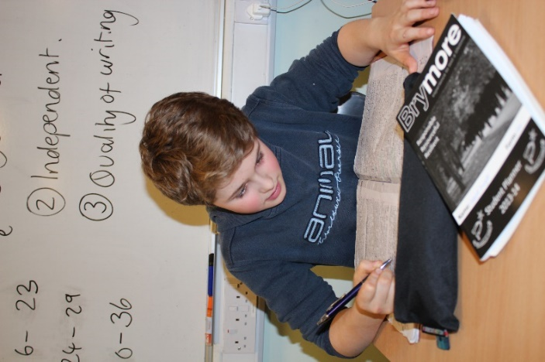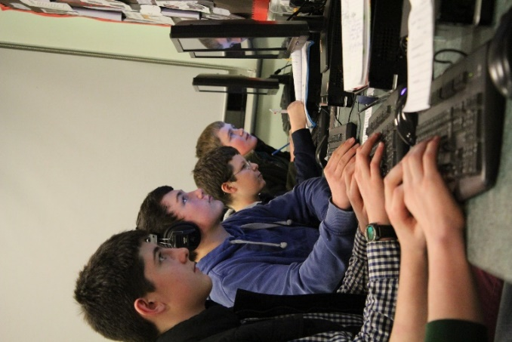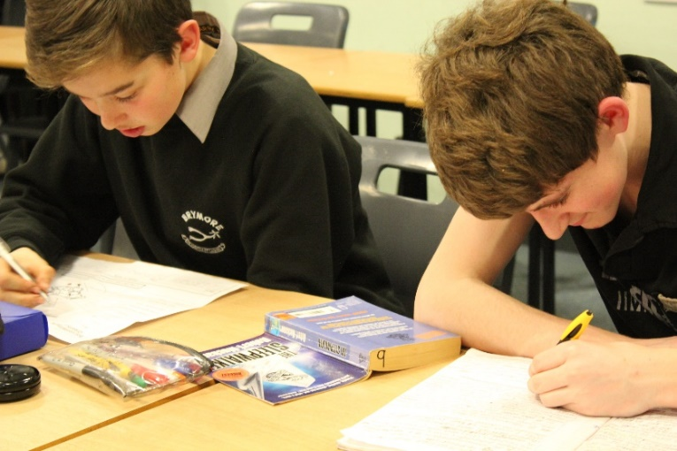

Nutrition

As a boarder all meals are included in the cost of the boarding provision both during the week and at weekends. We believe that hardworking boys need enough food to sustain them through the day so our dedicated kitchen staff are always on hand with a full menu and a caring attitude. We are determined to provide meals and snacks that are nutritionally balanced along with being fulfilling and try to work closely with the boarders to ensure that their views are listened to and accommodated, where possible.

If a parent wishes to pay for their child to have cooked meals from the dining hall then they may do so by filling out a weekly form and sending it with correct payment to the finance office on a Monday morning. The form is available on the school website under "important information" and will also be available from your son's tutor every Thursday. It is important that this is done at the start of the week in order to allow the kitchen to plan in advance

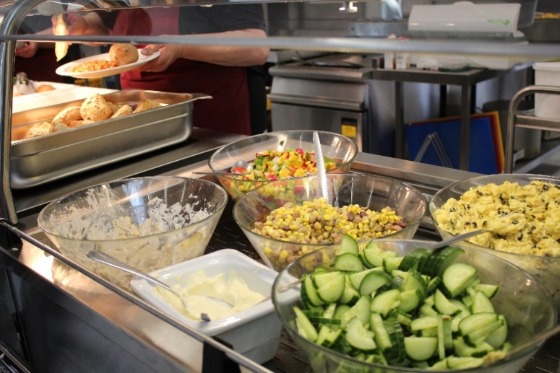



Alongside the catering provision of meals all boarding houses contain basics such as tea, coffee, milk, water, squash and bread and there is also the addition of a tuck shop which is open at 3.45pm - 4.15 pm and 7.45pm - 8.15pm.

Boys are all welcome to bring in their own tuck to school; however this must be stored in a sealed container.

There is a salad bar available for lunch and tea along with water being available at all meals.

An example of one of our menus is shown below; please note menus are changed weekly to encourage diversity.

|  |  |  |  |
| --- | --- | --- | --- |
|  | **Breakfast** | **Lunch** | **Tea** |
| **Monday** | Selection of cereals / yoghurt  Scrambled egg with baked beans and waffles / breakfast bap  Fruit juice, tea and coffee | a Pasta pots  b Chicken fajita  c Salad bar  Flapjack | a Chicken and bacon pie  b Macaroni cheese & garlic bread  Boiled potatoes / peas / roast parsnips    Apple pie and custard |
| **Tuesday** | Selection of cereals / porridge / bacon served with poached eggs and tomatoes / toast and preserves  Fruit juice, tea and coffee | a Chicken tikka & rice  b Vegetable korma & rice  c Salad bar    Lemon drizzle cake | a Sausage wellington  b Chilli con carne  Rice or new potatoes / sweetcorn    Chocolate fudge pudding |
| **Wednesday** | Selection of cereals / yoghurt / melon kebabs / sausages served with hash browns and beans / breakfast bap  Fruit juice, tea and coffee | a Cheese and bean wrap  b Salad bar  c Pasta pots      Shortbread | a Roast turkey  b Honey roast gammon  Parsley sauce / roast potatoes / cauliflower cheese / kale  Bread and butter pudding |
| **Thursday** | Selection of cereals / toast / porridge / scrambled egg served with herb potatoes and beans  Fruit juice, tea and coffee | a Breakfast panini  b Honey tuna melt panini  c Spicy cheese panini  Flapjack | a Chicken and vegetable stew  b Braised steak  Mashed potatoes / spring greens / braised carrots  Australian crunch |
| **Friday** | Selection of cereals / yoghurt / bacon served with hash brown nuggets and toast  Fruit juice, tea and coffee | a Fish and chips  b Chicken nuggets  c Jacket potato  d Salad bar  Lemon drizzle cake | a Braised beef  b Sweet and sour pork  Rice / sugar snap peas / sweetcorn / creamy mash  Doughnuts |
| **Saturday** | Selection of cereals / porridge / sausage and egg bagels / toast and preserves  Fruit juice, tea and coffee | Choice of homemade baguettes  Shortbread | Jumbo hotdog with onions  Spicy wedges / BBQ beans / salad bar  Trio of ice cream |
| **Sunday** | Selection of cereals / pastries / toast and preserves / full English breakfast  Fruit smoothie, tea and coffee | Roast beef / roast potatoes / cabbage / parsnips / cauliflower cheese  Flapjack | Sausage pasta bake / garlic bread / salad  Muffins |

Activities

An extensive extra-curricular program is available to all boys, ranging from paid engineering and blacksmithing to free of charge activities such as mountain biking and Lego club. Both staff and boys have worked together to create and continuously develop a program that allows boys with varied interests to experience and enjoy everything Brymore has to offer outside of the classroom. Participation in a number of activities will require an additional cost to be covered by those undertaking in it, this is to cover costs such as the requirement for an external tutor to be employed, purchasing and maintenance of specialist equipment or travel costs. An activities booklet containing all relevant information for paid activities will be sent to you at the start of the year, detailing activity content, cost, number of weeks the activity runs and the staff involved. If you are wanting to participate within any of the paid activates you must indicate this on the booklet and return it to school reception with full payment for the activity. Individuals who have indicated they want to participate in a paid activity along with full payment will be informed of the times and dates they must attend throughout the term. A program for free activities is available on the school website and within the house common rooms, which are changed on a termly basis, with no sign up required for these activities.

Examples of the options open to them are:

* 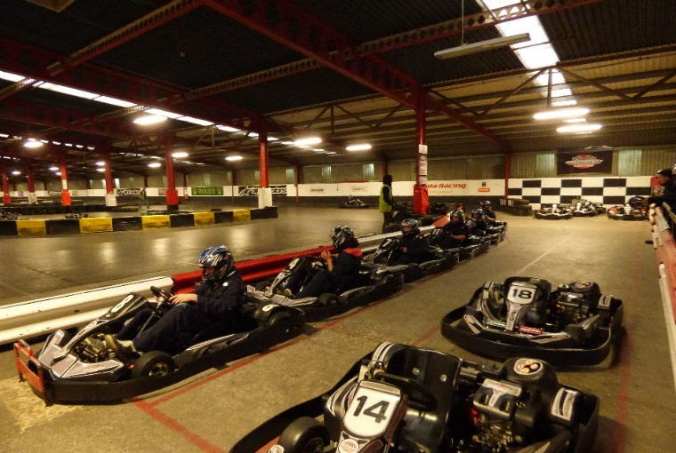Fishing
* Go karting
* Cinema
* Blacksmithing
* Dry slope skiing
* Athletics
* Cricket
* Rugby
* Drums
* Guitar
* Rugby
* Young Farmers Club
* Chads run
* 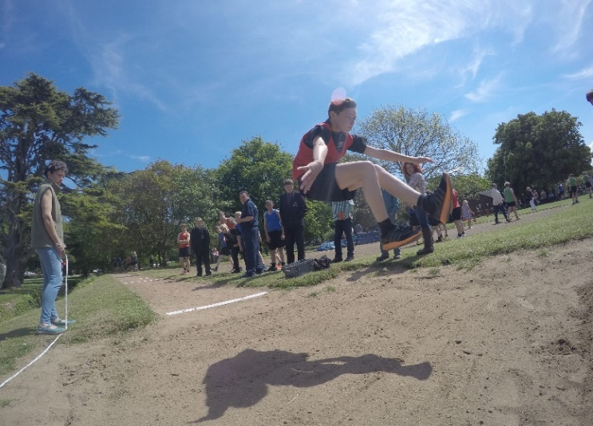Woodwork
* Hockey
* Cooking
* Arboriculture (tree climbing)
* Day trips

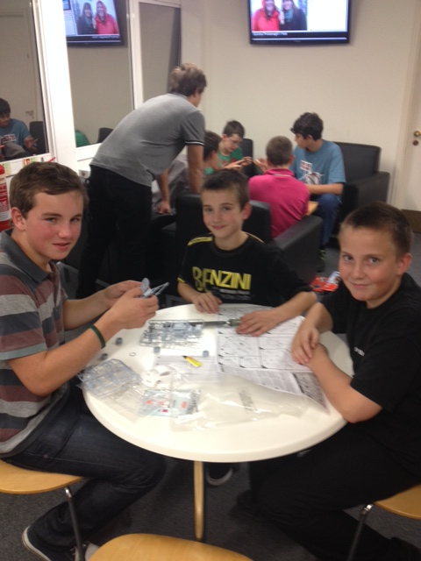

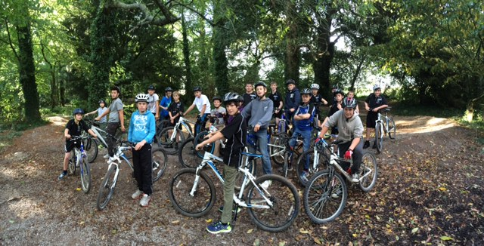

Help and Counselling

We all have times when we need to talk to someone about issues in our lives that worry us. Some like to share them with friends or family. Others might have a prefect, tutor or member of staff whom they trust. Any of these people will be sympathetic and supportive and may be able to offer practical advice, or just put problems into perspective. It is important that boys do not suffer in silence and often there are people out there who can help and there are also many other people who feel similarly either now or in the past so it is important that we offer support to boys feeling this way.

We also have the services of a qualified and trained counsellor who visits the school on a twice weekly basis and she can offer advice and support in a confidential and relaxed environment within the school grounds.

**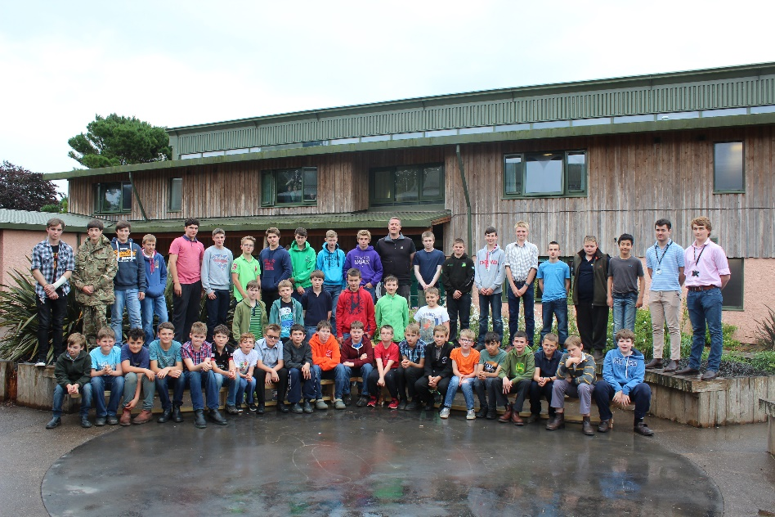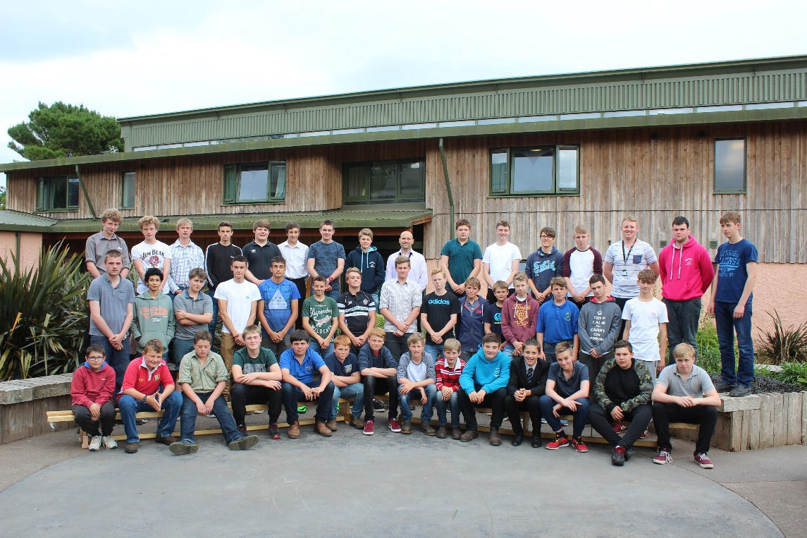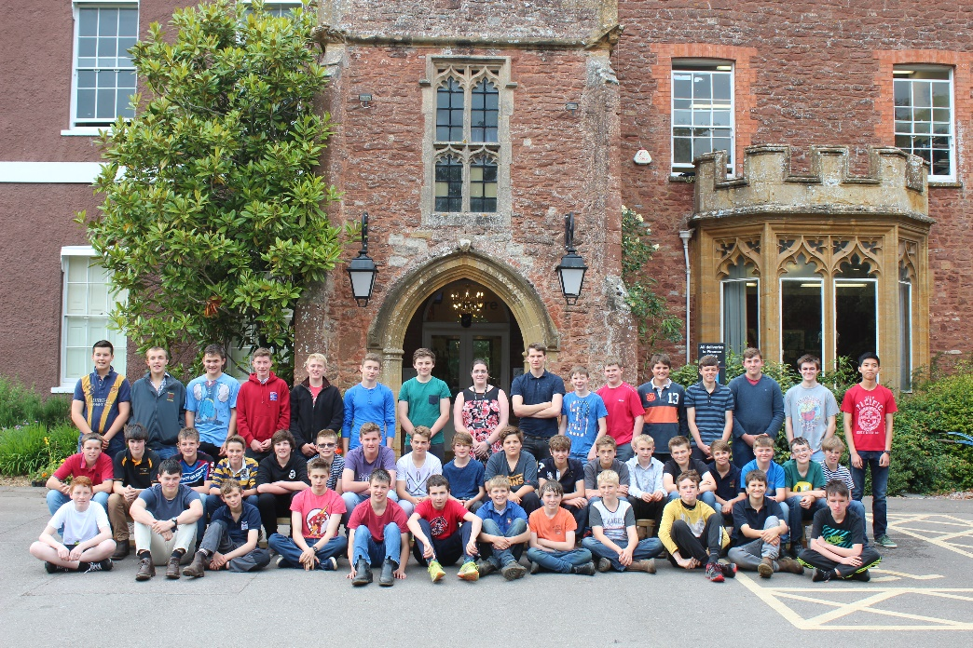The fire alarm is always tested on Tuesday at 10.00 am**

|  |  |
| --- | --- |
| **During the school day (9.00am - 3.45pm)**  If a continuous bell rings, the staff with their students should make their way to the necessary fire point on the grass area outside of the main school  Students must walk in silence  They must line up in their tutor groups, where a member of staff will register them.  The office will have the exeat boards to check for absentees  Whilst this is happening the designated person will check to see where the fire is (if at all) and be responsible for calling the fire brigade.  The all clear will be given and students will be directed back to class in silence. | **After the school day (3.45pm - 9.15am)**  If a continuous bell rings, the staff with their students should make their way to the necessary fire point on the grass area outside of the main school  Students must walk in silence  They must line up in their dormitory groups, where a member of staff will register them.  The house parents will have the exeat boards to check for absentees  Whilst this is happening the designated person will check to see where the fire is (if at all) and be responsible for calling the fire brigade.  The all clear will be given and students will be directed back to boarding houses in silence. |

*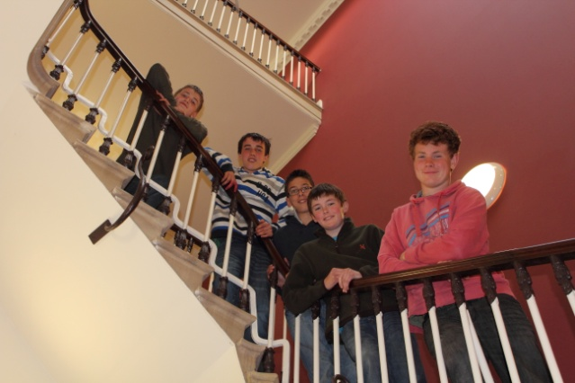*

To conclude

Starting at a new school can be a nervous time for parents as well as boys. As we tell the boys, it is very important that, if you are unsure about anything at all, you should ask somebody. We will always be happy to answer any queries that any parent, guardian or boy has and for boarders their Houseparents are often the first port of call for this. Alternatively, more important issues should be referred to a member of the Senior Leadership Team or boarding issues would be better referred to the Head of Boarding or Director of Boarding. Life as a Brymore boy offers a great opportunity for personal and academic growth and maturity and allows young people a chance to discover the best in other people and enables independence. It is very much our hope that your son’s time at Brymore will be as enjoyable for you as it will be for him.

|  |
| --- |
| **BRYMORE ACADEMY**  **SCHOOL TERMS AND HOLIDAYS - 2016/17 ACADEMIC YEAR** |

|  |  |  |  |  |  |  |  |  |  |  |  |  |  |  |  |  |  |  |
| --- | --- | --- | --- | --- | --- | --- | --- | --- | --- | --- | --- | --- | --- | --- | --- | --- | --- | --- |
| **SEPTEMBER 2016** | | | | | | **OCTOBER 2016** | | | | | | | **NOVEMBER 2016** | | | | | |
| **S** |  | 4 | 11 | 18 | 25 | **S** |  | 2 | 9 | 16 | 23 | 30 | **S** |  | 6 | 13 | 20 | 27 |
| **M** |  | 5 | 12 | 19 | 26 | **M** |  | 3 | 10 | 17 | 24 | 31\* | **M** |  | 7 | 14 | 21 | 28 |
| **T** |  | 6 | 13 | 20 | 27 | **T** |  | 4 | 11 | 18 | 25 |  | **T** | 1 | 8 | 15 | 22 | 29 |
| **W** |  | 7 | 14 | 21 | 28 | **W** |  | 5 | 12 | 19 | 26 |  | **W** | 2 | 9 | 16 | 23 | 30 |
| **T** | 1 | 8 | 15 | 22 | 29 | **T** |  | 6 | 13 | 20 | 27 |  | **T** | 3 | 10 | 17 | 24 |  |
| **F** | 2 | 9 | 16 | 23 | 30 | **F** |  | 7 | 14 | 21 | 28 |  | **F** | 4 | 11 | 18 | 25 |  |
| **S** | 3 | 10 | 17 | 24 |  | **S** | 1 | 8 | 15 | 22 | 29 |  | **S** | 5 | 12 | 19 | 26 |  |
| **DECEMBER 2016** | | | | | | **JANUARY 2017** | | | | | | | **FEBRUARY 2017** | | | | | |
| **S** |  | 4 | 11 | 18 | 25 | **S** | 1 | 8 | 15 | 22 | 29 |  | **S** |  | 5 | 12 | 19 | 26 |
| **M** |  | 5 | 12 | 19 | 26 | **M** | 2 | 9 | 16 | 23 | 30 |  | **M** |  | 6 | 13 | 20\* | 27 |
| **T** |  | 6 | 13 | 20 | 27 | **T** | 3\* | 10 | 17 | 24 | 31 |  | **T** |  | 7 | 14 | 21 | 28 |
| **W** |  | 7 | 14 | 21 | 28 | **W** | 4 | 11 | 18 | 25 |  |  | **W** | 1 | 8 | 15 | 22 |  |
| **T** | 1 | 8 | 15 | 22 | 29 | **T** | 5 | 12 | 19 | 26 |  |  | **T** | 2 | 9 | 16 | 23 |  |
| **F** | 2 | 9 | 16 | 23 | 30 | **F** | 6 | 13 | 20 | 27 |  |  | **F** | 3 | 10 | 17 | 24 |  |
| **S** | 3 | 10 | 17 | 24 | 31 | **S** | 7 | 14 | 21 | 28 |  |  | **S** | 4\* | 11 | 18 | 25 |  |
| **MARCH 2017** | | | | | | **APRIL 2017** | | | | | | | **MAY 2017** | | | | | |
| **S** |  | 5 | 12 | 19 | 26 | **S** |  | 2 | 9 | 16 | 23 | 30 | **S** |  | 7 | 14 | 21 | 28 |
| **M** |  | 6 | 13 | 20 | 27 | **M** |  | 3 | 10 | 17 | 24 |  | **M** | 1 | 8 | 15 | 22 | 29 |
| **T** |  | 7 | 14 | 21 | 28 | **T** |  | 4 | 11 | 18\* | 25 |  | **T** | 2 | 9 | 16 | 23 | 30 |
| **W** | 1 | 8 | 15 | 22 | 29 | **W** |  | 5 | 12 | 19 | 26 |  | **W** | 3 | 10 | 17 | 24 | 31 |
| **T** | 2 | 9 | 16 | 23 | 30 | **T** |  | 6 | 13 | 20 | 27 |  | **T** | 4 | 11 | 18 | 25 |  |
| **F** | 3 | 10 | 17 | 24 | 31 | **F** |  | 7 | 14 | 21 | 28 |  | **F** | 5 | 12 | 19 | 26 |  |
| **S** | 4 | 11 | 18 | 25 |  | **S** | 1 | 8 | 15 | 22 | 29\* |  | **S** | 6 | 13 | 20 | 27 |  |
| **JUNE 2017** | | | | | | **JULY 2017** | | | | | | | **AUGUST 2017** | | | | | |
| **S** |  | 4 | 11 | 18 | 25 | **S** |  | 2 | 9 | 16 | 23 | 30 | **S** |  | 6 | 13 | 20 | 27 |
| **M** |  | 5 | 12 | 19 | 26 | **M** |  | 3 | 10 | 17 | 24 | 31 | **M** |  | 7 | 14 | 21 | 28 |
| **T** |  | 6 | 13 | 20 | 27 | **T** |  | 4 | 11 | 18 | 25 |  | **T** | 1 | 8 | 15 | 22 | 29 |
| **W** |  | 7 | 14 | 21 | 28 | **W** |  | 5 | 12 | 19 | 26 |  | **W** | 2 | 9 | 16 | 23 | 30 |
| **T** | 1 | 8 | 15 | 22 | 29 | **T** |  | 6 | 13 | 20 | 27 |  | **T** | 3 | 10 | 17 | 24 | 31 |
| **F** | 2 | 9 | 16 | 23 | 30 | **F** |  | 7 | 14 | 21 | 28 |  | **F** | 4 | 11 | 18 | 25 |  |
| **S** | 3 | 10 | 17 | 24 |  | **S** | 1 | 8 | 15 | 22 | 29 |  | **S** | 5 | 12 | 19 | 26 |  |

**KEY:**

Term time Bank Holiday School Holiday

**Staff Inset Days:**

**5 September, 31 October, 3 January, 20 February & 18 April**

**Ideally, boarders should return between 6.00 pm - 9.00 pm on these dates.**

**However, if returning earlier, tea MUST be booked with the School Office by the preceding Friday please.**

**\* Parent Consultations:**

**31 October 2016 Years 7 3.30 pm - 5.00 pm**

**House parents, Heads of House and Registration Group Tutors Only**

**Year 11 3.30 pm - 5.00 pm**

**Academic Progress with Senior Leadership Team (Selected students only)**

**3 January 2017 Year 11 3.30 pm - 5.00 pm**

**4 February 2017 Year 8 1.00 pm - 3.30 pm (12.00 pm departure for Years 7, 9, 10 & 11)**

**20 February 2017 Year 10 3.30 pm - 5.00 pm**

**18 April 2017 Year 9 3.30 pm - 5.00 pm**

**29 April 2017 Year 7 1.00 pm - 3.30 pm (12.00 pm departure for Years 8, 9, 10 & 11)**

**Bank and Public Holidays 2016/17**

Boxing Day 26 December 2016 Easter Monday 17 April 2017

Christmas Day Bank Holiday 27 December 2016 May Day Holiday 1 May 2017

New Year’s Day Bank Holiday 2 January 2017 Spring Bank Holiday 29 May 2017

Good Friday 14 April 2017 Summer Bank Holiday 28 August 2017