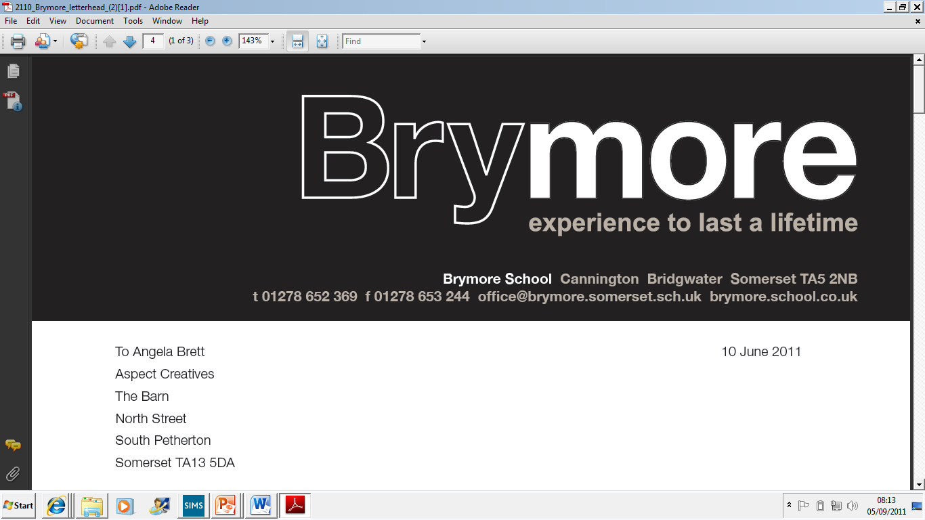

Application Pack

For post of General Assistant

APPLICANT INFORMATION PACK

- Brymore School - Background Information

- Letter

- Job Description

- Terms and Conditions

BACKGROUND INFORMATION

Brymore is a state boarding academy for boys situated in its own beautiful grounds of 60 acres in Cannington, near Bridgwater. In 1951 Somerset County Council purchased the estate at Brymore for £6,600 and following extensive repairs and alterations it was opened as a Secondary Technical School in September 1952 for boys aged 13 -17. Today, Brymore is a sponsored academy and is part of the Bridgwater College Multi-Academy Trust. From September 2014, the academy extended its age range to admit boys from the age of 11 and we reached capacity in September 2015.

Brymore is at an exciting period in its history. There has been a rapid rise in examination results over the past four years with Brymore moving from the bottom 5% nationally to the top 5% in value added terms. Maths and English have achieved value added scores placing in the top 15% of the country with DT results also exceptionally high. There has been considerable investment with £7 million going into new buildings - £3 million into new boarding houses which opened in January 2009, over £1.5 million into new classrooms and laboratories which opened in September 2008, a further £2 million refurbishment project of the main boarding house and over £0.5 million in a new dining hall and kitchens, which opened in April 2015. It is a delightful and special place to work with young people and we are now over-subscribed.

The four corner stones of the Brymore experience are the farm, gardens, workshops and sport - plus, of course, the fact that it is a boarding school. Brymore has excellent facilities. It has a 110 acre farm including its own dairy herd, beef, pigs, sheep and chickens. It has extensive horticultural facilities including a one acre walled garden, glasshouses and each boy has access to his own plot. We have three workshops, a forge and a CAD/CAM room so that boys can work with a variety of materials. Boys enjoy a wide range of sports including the traditional rugby, hockey, cricket and athletics. They also have access to an outdoor pool, nine-hole golf course and driving range, activity centre and take part in country sports such as fishing and shooting.

There are currently over 272 boys on roll, as of September 2016. Over 140 of these are boarders but even the out-boarders board when on a “duty” week. (This involves milking or feeding at 6.30 am, then School, then duties again at 4.00 pm). All the boys help on the farm and in the gardens. Up to half of the boys come from a land based background. As a State Boarding School parents pay modest boarding fees and the state pays for the education. We complete our 190 teaching days within thirty-two weeks by working a full day on a Saturday. This results in twenty weeks holiday per year.

The pastoral system at Brymore comprises three houses, Galsworthy, Taylor and Walker. Each has a Head of House and tutors who lead Vertical tutor groups. The rewards system is well established and is of great importance to the ethos of the school. We have an assembly four days a week, with two tutorials and the Saturday gathering is chiefly given over to the embodiment of the reward system - certificates and awards are presented along with sports results and items of good news. Each term the results of inter-house fixtures are added to merits, commendations, attendance and other data to produce the result for the FOBSA Trophy (Friends of Brymore School Association). Through this, and other means, we actively seek to reward each boy for their endeavour and skill. We do not give rewards for the sake of it, but the system is remarkably good at finding something to celebrate in each boy.

Brymore is also about student development as well as academic success, so the context is one of encouraging the best in boys who, frequently, have not thought of themselves as successful at school. We change that by finding out what they are good at, by building self-esteem and confidence and by encouraging them to live by our own three Rs - Resilience, Resourcefulness and Responsibility. We expect boys to be polite, courteous, to be able to hold a conversation and to mix well with people they do not know.

At present there are three classes in each Year Group of approximately 60 students, giving class sizes of 15-20 boys. Most boys study Agriculture, Horticulture and Resistant Materials/Engineering at Key Stage 4. However, we will also allow boys to meet the requirements of the English Baccalaureate and follow a more academic should they wish. Results have traditionally been high in value added terms, with a number of departments performing in the top five in Somerset.

The school comprises of three boarding houses, each holding up to 50 students. Two staff are assigned to, and live in each house, with duty staff and Gap Tutors running activities and Prep in the evenings. A senior member of staff is always on call, including overnight. The Head of Boarding oversees the school’s boarding facility. Many activities are run in the evenings, so that boys are occupied at all times. Saturday afternoons are taken up with activities, including rugby, hockey, farm, gardens, golf, Duke of Edinburgh, photography and a cookery class. Many boys go home on Saturday evening, usually leaving a maximum of 40 boys who remain in on a Sunday before all boys return Sunday night/Monday morning.

The School has also undergone almost a complete change in Senior Leadership Team over the past five years and is making significant changes to improve the attainment of the boys. The focus is very much on Raising Achievement and we are proud of the consistently high value added scores produced by the boys. In 2015 Ofsted rated the school as ‘good’ in all areas and highlighted leadership as a strength, in recognition of the rapid progress and pace of change. Results at the academy have improved exponentially, with good data and in many areas, outstanding achievement. Meanwhile, the support of parents is exceptional, with 99% recommending the school in a recent Ofsted survey. As a member of staff you will get to know parents well through many of our functions held throughout the years such as the Harvest festival service, Christmas carol service, sports day and swimming gala.

Brymore Academy and Bridgwater College Trust

Brymore converted to an Academy in September 2013. This formed part of our drive to continually improve the future of the school, which opened in 1952 as one of the first ‘Technical Schools’ in the country. Our aim is to be a centre of excellence, both vocationally and academically, building on the legacy of the past, whilst delivering the innovative education of the future.

Brymore is part of the Bridgwater College Trust which consists of a group of schools, both primary and secondary, from the Sedgemoor area sponsored by Bridgwater College, who are working together to maximise effectiveness, and benefit from the support of the College and of each other. The Bridgwater College Trust plays a key role in challenging and supporting each Academy. It provides stability, direction and accountability, whilst enabling Brymore to play to its strengths. Our emphasis on traditional values and the development of resilience, resourcefulness and responsibility continues to be at the heart of all that we do. At the same time, the Academy structure provides us with an opportunity to work in partnership with Bridgwater College and other schools, share resources and expertise and strive to get the best for all our boys. We are able to draw on the skills and experience developed at Bridgwater College, through being rated as an ‘outstanding’ college by Ofsted for the past 12 years and the College is also able to offer support to the curriculum through the Cannington Centre, as well as the college as a whole. The School and College already have a working relationship and the Trust is enhancing the synergy between them. The distance between the School and the Cannington Centre means that there is huge potential to ensure best use of all resources. The College can provide support to develop teaching and learning, extend curriculum opportunities for the students and build partnerships for staff development.

Academy status gives Brymore the freedom to be innovative and creative with the curriculum, timetabling, staffing and governance. It is an exciting opportunity to build on recent successes and create an inspirational school that will transform learning, extend opportunity and raise expectations. We have the freedom to focus teaching and resources where improvements are really needed. Thus, we set the highest aspirations for student achievement providing a curriculum that is challenging, relevant, innovative and sufficiently flexible to engage pupils of all abilities. The Academy is responsible to the Academy Trust which ultimately answers to the Secretary of State for Education. The Trust provides a structural solution that helps to build capacity, providing opportunities for both staff and students. It is building on the improvements already made by strengthening governance, broadening leadership and management and providing a framework for long-term support.

Together we aim to build a Centre of Excellence, specialising in academic achievement, innovative technology and Land Based Studies.

June 2017

Dear Applicant

Thank you for your interest in the position of Chef at Brymore Academy. It really is a fantastic and unique place to work and I hope having read all of the information, and maybe visited us, you will feel it is the right school for you. If not, then I wish you luck in any future applications.

Brymore is about to enter the most exciting phase of its development, which I know sounds like spin for it has had a difficult time in the past, which is true, but I genuinely believe it has the potential to thrive and become one of the most successful academies in the country. The boys themselves make the Academy what it is, and you will find them polite, well-mannered and motivated to do well and I am also lucky to have loyal and hard -working staff. The governors and trustees have a wealth of experience and play an exceptionally active and supportive role within the Academy. The grounds, brand new teaching block and boarding accommodation, 110 acre farm, one acre walled garden, workshops, forge, outdoor pool and the excellent views of the Quantocks are all added bonuses.

I took over as Headteacher at Brymore in 2010, following the retirement of Malcolm Lloyd who had been at the school for seven years. He was responsible for £6 million worth of development, creating excellent facilities. In September 2011 I was able to appoint virtually a brand new leadership team, who embraced the challenge of transforming the school with vigour and enthusiasm. Vicky Davis is the Deputy Headteacher, in charge of teaching and learning/ curriculum; Luke Winter is the Assistant Head for Pastoral. Rob Watts joined the school in April 2012 and is Head of Boarding, while Rebecca Jones is the SENCo. Staff describe the ‘buzz’ of Brymore, the sense that we are moving forward and building our own future. In the last four years the school has moved from the 96th percentile for pupil progress to the top 5% of schools nationally. English consistently has the best progress in Somerset and has regularly been in the top 5% of schools nationally, with Maths also in the top 5%. Results in Agriculture, Technology, Science and Horticulture have also been outstanding.

2

June 2017

In September 2014, the academy admitted Year 7 boys for the first time, reaching our capacity in September 2015. In fact, we are now oversubscribed, with more than double the number of applicants than we have places. This is a unique opportunity to join a successful team of staff with a proven track record of school improvement. I am looking for people with drive and determination, who demand high standards from themselves and others and who share my vision that there is no ceiling to the success that the boys at Brymore can achieve.

We are looking to employ a General Assistant who can assist in the delivery of quality cooking for the boys of Brymore and the primary schools we serve. The boys and staff have three meals a day which includes breakfast and tea for the 150 boarders and staff who live on site and around 450 lunches as we also produce meals for three local primary schools. The role encompasses working as part of a team often in pressured situations. You will need to ensure all health and hygiene standards are met and occasionally working on commercial/high profile events including weddings. You will be led by the newly appointed catering manager Nigel Isaacs who has a wealth of experience and is building a strong team around him.

If you wish to apply for this exciting post then please complete the application form. The closing date for applications is Wednesday 5th July at 1pm and interviews will take place during week beginning 10th July.

Should you wish to visit the school at any time then please contact Mrs Julie Vearncombe at the School who can arrange a visit. Should you wish to discuss this post further, you can contact me on 07730 218898.

Yours sincerely
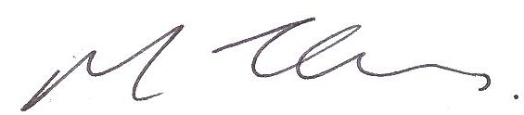

MARK THOMAS
Headteacher

JOB DESCRIPTION

Post: General Assistant

Grade: Grade 17

Hours: 32.5 hours per week, 38 weeks of the year (term time for primary schools)

Responsible to: Catering Manager

- MAJOR TASKS

- To provide high quality, customer friendly front of house service including hospitality, serving students, staff and visitors.

- To ensure serving areas run smoothly and efficiently, paying particular attention to students, staff and customers’ requirements.

- To maintain careful portion controls, food hygiene standards and reduce waste.

- To replenish counters and machines to ensure areas are appealing.

- To clean up dining areas, counters, washing-up and keep surfaces clean and tidy.

- To maintain high standards of cleanliness in all areas.

- To assist in food preparation as required.

- To undertake any general duties commensurate with this post as required.

- ADDITIONAL TASKS

- To maintain the cleanliness of all kitchen and display equipment, so as to adequately meet food hygiene regulations by using prescribed cleaning products and methods as not to contravene C.O.S.H.H regulations.

- Maintain all vertical and horizontal surfaces again to prescribed requirements.

- All heavy duty washing up in addition to helping with all other forms of washing up that is required to be done.

- Maintain in part the extraction system within the main kitchen canopy, this would include periodical removal and cleaning of filters and any obvious stain and grease removal from both inside and outside of canopy (annual ‘deep clean’ is undertaken by kitchen staff).

- Deep Fat Fryers cleaning (weekly) stain oil (daily).

- Maintain all other areas that in total go to make up the Catering Department, i.e. weekly cleaning of office/staff room.

- Assist with deliveries of stock, checking off and storage.

- Undertake staff development as required to meet service needs.

- Undertake any other general kitchen duties commensurate with this post as necessary.

- To support and promote equality & diversity at Brymore Academy to ensure equality of opportunity for all students, visitors and staff and the elimination of discriminatory practices.

- To maintain and promote a healthy and safe environment at Brymore Academy to ensure students, staff and visitors are safe from harm.

- To support and promote the safeguarding policy at Brymore Academy to ensure students, staff and visitors are safeguarded.

- PERSONAL PROFILE

The success of Brymore Academy rests on a very strongly felt and shared set of values which determine its strategic direction. It is absolutely crucial that the successful candidate shares our values of student-centeredness, equality of opportunity and parity of esteem for staff and students. S/he must enjoy working within the team philosophy that has evolved in Brymore in recent years. This post is about espousing and promoting corporateness and working collaboratively.

We are looking for an individual who:

- Has a real commitment to education and training.

- Can work flexibly to meet customer demands.

- Have a commitment and enthusiastic approach to continuous self-development and drive to achieve high quality.

- Can be dynamic.

- Able to work flexibly, which may include evening or weekend work.

Heads\brymore\jobdesc\GeneralAssistant

