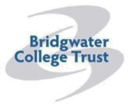
Brymore Academy
Cannington
Somerset
TA5 2NB

Brymore is a State Boarding School for boys aged 11 – 17 set in its own 60 acre site with a working farm, gardens, workshops and sports facilities. The school is currently expanding and this is an exciting time in Brymore’s development.
Head Caretaker

Full time, permanent.
Salary: Grade 12 (points 22 to 26)
Actual starting salary (point 22): £20,661 per annum
37 hours per week
There may be a requirement to work weekends

At Brymore Academy we endeavour to provide an outstanding education to all of our students, and we believe this ambition for excellence is driven by our talented and exceptional staff.
The core purpose of this position is to lead a team to ensure the Academy’s site, buildings and furnishings are safe, secure, cleaned and maintained to standards defined by legal requirements, Health and Safety regulations and the Academy management.

Ideally you will have experience of leading a team, an understanding of health and safety and manual handling, and will have basic IT skills. You will need to have a pleasant, courteous manner, with the ability to work in often reactive situations to meet the needs of the Academy.
There is a practical element to this role, where experience of carrying out simple repairs, maintenance and decorating are required.

Further details and application form for this post are available to download from our website www.brymoreacademy.co.uk or email bctrecruitment@educ.somerset.gov.uk or telephone 01278 652369. Please ensure you return this completed application form with your request for consideration for the post.
Closing date: Noon, Friday 8th December 2017
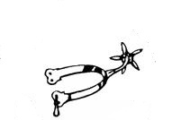
Brymore Academy is committed to safeguarding and promoting the welfare and safety of children and therefore this post requires a criminal background check via the disclosure procedure.

