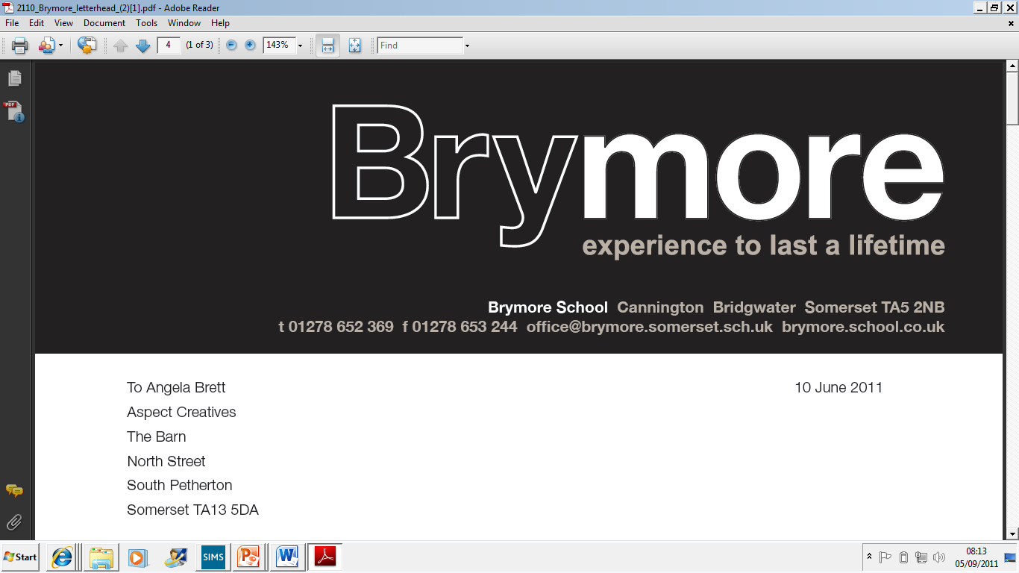

Application Pack

For post of Assistant Houseparent (Non-residential)

APPLICANT INFORMATION PACK

- Brymore Academy - Background Information
- Bridgwater College Trust information
- Letter
- Advert
- Job description
- Person specification
- Terms and Conditions

BACKGROUND INFORMATION

Brymore is a state boarding academy for boys situated in its own beautiful grounds of 60 acres in Cannington, near Bridgwater. In 1951 Somerset County Council purchased the estate at Brymore for £6,600 and following extensive repairs and alterations it was opened as a Secondary Technical School in September 1952 for boys aged 13 -17. Today, Brymore is a sponsored academy and is part of the Bridgwater College Multi-Academy Trust. From September 2014, the academy extended its age range to admit boys from the age of 11 and we reached capacity in September 2015.

Brymore is at an exciting period in its history. There has been a rapid rise in examination results over the past four years with Brymore moving from the bottom 5% nationally to the top 5% in value added terms. Maths and English have achieved value added scores placing in the top 15% of the country with DT results also exceptionally high. There has been considerable investment with £7 million going into new buildings - £3 million into new boarding houses which opened in January 2009, over £1.5 million into new classrooms and laboratories which opened in September 2008, a further £2 million refurbishment project of the main boarding house and over £0.5 million in a new dining hall and kitchens, which opened in April 2015. It is a delightful and special place to work with young people and we are now over-subscribed.

The four corner stones of the Brymore experience are the farm, gardens, workshops and sport - plus, of course, the fact that it is a boarding school. Brymore has excellent facilities. It has a 110 acre farm including its own dairy herd, beef, pigs, sheep and chickens. It has extensive horticultural facilities including a one acre walled garden, glasshouses and each boy has access to his own plot. We have three workshops, a forge and a CAD/CAM room so that boys can work with a variety of materials. Boys enjoy a wide range of sports including the traditional rugby, hockey, cricket and athletics. They also have access to an outdoor pool, nine-hole golf course and driving range, activity centre and take part in country sports such as fishing and shooting.

There are currently over 300 boys on roll, as of September 2017 and the school is heavily oversubscribed, with a waiting list. 140 of the boys are boarders but even the out-boarders board when on a “duty” week. (This involves milking or feeding at 6.30 am, then School, then duties again at 4.00 pm). All the boys help on the farm and in the gardens. Up to half of the boys come from a land based background. As a State Boarding School parents pay modest boarding fees and the state pays for the education. We complete our 190 teaching days within thirty-two weeks by working a full day on a Saturday. This results in twenty weeks holiday per year.

The pastoral system at Brymore comprises three houses, Galsworthy, Taylor and Walker. Each has a Head of House and tutors who lead Vertical tutor groups. The rewards system is well established and is of great importance to the ethos of the school. We have an assembly four days a week, with two tutorials and the Saturday gathering is chiefly given over to the embodiment of the reward system - certificates and awards are presented along with sports results and items of good news. Each term the results of inter-house fixtures are added to merits, commendations, attendance and other data to produce the result for the FOBSA Trophy (Friends of Brymore School Association). Through this, and other means, we actively seek to reward each boy for their endeavour and skill. We do not give rewards for the sake of it, but the system is remarkably good at finding something to celebrate in each boy.

Brymore is also about student development as well as academic success, so the context is one of encouraging the best in boys who, frequently, have not thought of themselves as successful at school. We change that by finding out what they are good at, by building self-esteem and confidence and by encouraging them to live by our own three Rs - Resilience, Resourcefulness and Responsibility. We expect boys to be polite, courteous, to be able to hold a conversation and to mix well with people they do not know.

At present there are three classes in each year group of approximately 60 students, giving class sizes of 15-20 boys. Most boys study Agriculture, Horticulture and Resistant Materials/Engineering at Key Stage 4. However, we will also allow boys to meet the requirements of the English Baccalaureate and follow a more academic pathway should they wish. Results have traditionally been high in value added terms, with a number of departments performing in the top five in Somerset.

The school comprises of three boarding houses, each holding up to 50 students. Two staff are assigned to, and live in each house, with duty staff and Assistant House Parents running activities and Prep in the evenings. A senior member of staff is always on call, including overnight. The Head of Boarding oversees the school’s boarding facility. Many activities are run in the evenings, so that boys are occupied at all times. Saturday afternoons are taken up with activities, including rugby, hockey, farm, gardens, golf, Duke of Edinburgh, photography and a cookery class. Many boys go home on Saturday evening, usually leaving a maximum of 40 boys who remain in on a Sunday before all boys return Sunday night/Monday morning.

The School has also undergone almost a complete change in Senior Leadership Team over the past five years and is making significant changes to improve the attainment of the boys. The focus is very much on Raising Achievement and we are proud of the consistently high value added scores produced by the boys. In 2015 Ofsted rated the school as ‘good’ in all areas and highlighted leadership as a strength, in recognition of the rapid progress and pace of change. Results at the academy have improved exponentially, with good data and in many areas, outstanding achievement. Our Progress 8 score is currently 0.3, with no group of students gaining a negative score in any area. Meanwhile, the support of parents is exceptional, with 99% recommending the school in a recent Ofsted survey. As a member of staff you will get to know parents well through many of our functions held throughout the years such as the Harvest festival service, Christmas carol service, sports day and swimming gala.

Brymore Academy and Bridgwater College Trust

Brymore converted to an Academy in September 2013. This formed part of our drive to continually improve the future of the school, which opened in 1952 as one of the first ‘Technical Schools’ in the country. Our aim is to be a centre of excellence, both vocationally and academically, building on the legacy of the past, whilst delivering the innovative education of the future.

Brymore is part of the Bridgwater College Trust which consists of a group of schools, both primary and secondary, from the Sedgemoor area sponsored by Bridgwater College, who are working together to maximise effectiveness, and benefit from the support of the College and of each other. The Bridgwater College Trust plays a key role in challenging and supporting each Academy. It provides stability, direction and accountability, whilst enabling Brymore to play to its strengths. Our emphasis on traditional values and the development of resilience, resourcefulness and responsibility continues to be at the heart of all that we do. At the same time, the Academy structure provides us with an opportunity to work in partnership with Bridgwater College and other schools, share resources and expertise and strive to get the best for all our boys. We are able to draw on the skills and experience developed at Bridgwater College, through being rated as an ‘outstanding’ college by Ofsted for the past 12 years and the College is also able to offer support to the curriculum through the Cannington Centre, as well as the college as a whole. The School and College already have a working relationship and the Trust is enhancing the synergy between them. The distance between the School and the Cannington Centre means that there is huge potential to ensure best use of all resources. The College can provide support to develop teaching and learning, extend curriculum opportunities for the students and build partnerships for staff development.

Academy status gives Brymore the freedom to be innovative and creative with the curriculum, timetabling, staffing and governance. It is an exciting opportunity to build on recent successes and create an inspirational school that will transform learning, extend opportunity and raise expectations. We have the freedom to focus teaching and resources where improvements are really needed. Thus, we set the highest aspirations for student achievement providing a curriculum that is challenging, relevant, innovative and sufficiently flexible to engage pupils of all abilities. The Academy is responsible to the Academy Trust which ultimately answers to the Secretary of State for Education. The Trust provides a structural solution that helps to build capacity, providing opportunities for both staff and students. It is building on the improvements already made by strengthening governance, broadening leadership and management and providing a framework for long-term support.

Together we aim to build a Centre of Excellence, specialising in academic achievement, innovative technology and Land Based Studies.



December 2017

Dear Applicant

Thank you for your interest in the position of Assistant House Parent at Brymore Academy. It really is a fantastic and unique place to work and I hope having read all of the information, and maybe visited us, you will feel it is the right school for you. If not, then I wish you luck in any future applications.

Brymore is about to enter the most exciting phase of its development, which I know sounds like spin for it has had a difficult time in the past, which is true, but I genuinely believe it has the potential to thrive and become one of the most successful academies in the country. The boys themselves make the Academy what it is, and you will find them polite, well-mannered and motivated to do well and I am also lucky to have loyal and hard working staff. The newly appointed governors and trustees have a wealth of experience and play an exceptionally active and supportive role within the Academy. The grounds, brand new teaching block and boarding accommodation, 110 acre farm, one acre walled garden, workshops, forge, outdoor pool and the excellent views of the Quantocks are all added bonuses.

I took over as Headteacher at Brymore in 2010, following the retirement of Malcolm Lloyd who had been at the school for seven years. He was responsible for £6 million worth of development, creating excellent facilities. In September 2011 I was able to appoint virtually a brand new leadership team, who embraced the challenge of transforming the school with vigour and enthusiasm. Vicky Davis is the Deputy Headteacher, in charge of teaching and learning/ curriculum; Luke Winter is the Deputy Headteacher for Pastoral. Rob Watts joined the school in April 2012 and is Head of Boarding, while Michelle Craig is the SENCo. Staff describe the ‘buzz’ of Brymore, the sense that we are moving forward and building our own future. In the last four years the school has moved from the 96th percentile for pupil progress to the top 5% of schools nationally. English consistently has the best progress in Somerset and has regularly been in the top 15% of schools nationally, with Maths in the top 13%. Results in Agriculture, Technology, Science and Horticulture have also been outstanding.

…../
2

December 2017

In September 2014, the academy admitted Year 7 boys for the first time, reaching our capacity in September 2015. In fact, we are now oversubscribed, with more than double the number of applicants than we have places. This is a unique opportunity to join a successful team of staff with a proven track record of school improvement. I am looking for people with drive and determination, who demand high standards from themselves and others and who share my vision that there is no ceiling to the success that the boys at Brymore can achieve.

The main purpose of the Assistant House Parent role is to support both boys and other boarding staff within the houses on a day to day basis. The support provided can come in many different forms from guiding boys with academic work and any concerns they may have, to supporting them with their organisation and social development and awareness as any parent would. No one day is the same working within a boarding house, and this is one of the main reasons the role requires someone who is both flexible and able to adapt to the individual needs of boys on a day to day basis. A personable approach is key, with the ability to spend time with boys in a social environment getting to know them and being comfortable in their company being at the top of the list.

It is a chance to have a significant impact and a strong voice in driving a successful future at Brymore.

If you wish to apply for this exciting post then please complete the application form, accompanied by a letter of application. The closing date for applications is Tuesday January 2nd at 1pm and interviews will take place on Wednesday January 10th.

Should you wish to visit the school at any time then please contact Mrs Julie Vearncombe at the School who can arrange a visit. Should you wish to discuss this post further, please contact Rob Watts (Head of Boarding) on 07912180117.

Yours sincerely
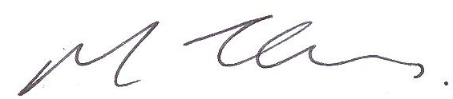

MARK THOMAS
Headteacher

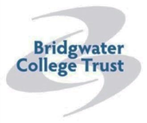
Brymore Academy
Cannington
Somerset
TA5 2NB

Brymore is a State Boarding School for boys aged 11 – 17 set in its own 60 acre site with a working farm, gardens, workshops and sports facilities. The school is currently expanding and this is an exciting time in Brymore’s development.
Assistant House Parent
Required for January 2018
33.5 hours per week, 32 weeks per year (Term time only)

Working Hours: 3.45pm to 10pm, Monday to Friday (plus one weekend cover per half term)
Salary Grade 14, points 13 to 17 Actual Salary: £10,400 - £11,208 per annum
- The potential for a job share between suitable candidates would be considered if appropriate (eg candidate A 3 days per week and candidate B 2 days per week). Please make this clear on application if you wish to be considered for this)

We are looking for a well organised, practical and understanding individual to join the Academy as a Assistant House Parent. The main purpose of the Assistant House Parent role is to support both boys and other boarding staff within the houses on a day to day basis. The support provided can come in many different forms from guiding boys with academic work and any concerns they may have, to supporting them with their organisation and social development and awareness as any parent would. A personable approach is key, with the ability to spend time with boys in a social environment getting to know them and being comfortable in their company being at the top of the list.
We are looking for an outstanding individual to ensure the wellbeing of all the boys is at the heart of what we do, and to be part of a successful team.
Further details and application form for this post are available to download from our website www.brymoreacademy.co.uk or email bctrecruitment@educ.somerset.gov.uk or telephone 01278 652369. Please ensure you return this completed application form with your request for consideration for the post.
Closing date: 1pm Tuesday January 2nd 2018
Potential Interview: Wednesday 10th January 2018
Brymore Academy is committed to safeguarding and promoting the welfare and safety of children and therefore this post requires a criminal background check via the disclosure procedure

JOB DESCRIPTION

Post: Assistant House Parent (Non-residential)

Grade: 14 (points 13 to 17)

Responsible to: Director of Boarding & Head of Boarding (in the first instance)

Responsible for: Students, and support staff working in the Boarding house

Start Date: January 2018

Working Hours (Term time only; paid all year round)

Monday - Friday:
- 3.45 pm - 10.00 pm

One 30 minute break will be provided during tea (5.00 pm - 6.10 pm)

Weekends
- Will be required to support house staff during one weekend per half term
- Weekend ( Saturday 3.45pm – 10pm + Sunday 8.45am – 10pm)
- During the week leading to weekend support you will be given a night off during the week

Additional hours

- To attend a one 45 minute meeting each week with the Director and Head of Boarding and boarding staff (Tuesday 3pm – 3.45pm)
- All parental correspondence that is not possible during normal working hours
- To attend all staff INSET days

Key Performance Indicators

- To ensure over 90% of students report that the boarding house is a happy, caring and supportive place to live and work
- To contribute to boarding at Brymore being graded at least good by internal or external inspections including Ofsted

Key duties
- To be responsible for the care, welfare and support of all students within the boarding houses
- To assist the House Parents with the smooth running of the boarding house, providing a homely and welcoming environment for all students, staff and parents.
- To take an active role in ensuring that students have a full, stimulating and regular programme of activities
- To supervise prep each evening for all students and offer assistance and support to students experiencing difficulties. Where necessary offer additional assistance outside of prep hours (particularly exam revision periods)
- To instruct and communicate with students regularly on the day’s issues, forthcoming events, reminders and matters relating to School and the boarding house
- To maintain regular contact with parents where necessary.
- To liaise effectively and fully with House Parents, Head of Boarding and Director of Boarding over any problems, concerns or issues arising
- To ensure that individual circumstances, needs, strengths and the areas of development of each boarder are identified and known by staff, so that the individual opportunities, talents and potential are developed and maximised
- To be completely familiar with all standards, regulations and rules governing the pastoral supervision of students resident at Brymore (Ofsted/Fire/Health & Safety/Safeguarding/LA/ National Minimum Standards, all school and School policies).
- To ensure that boarding and school policies are consistently adhered to by all boarding staff and students.
- To attend where appropriate meetings with parents, schools, visitors, services and with other members of staff to liaise on important issues
- To disseminate all relevant information relating to child welfare to the Head of Boarding and Director of Boarding or Assistant Headteacher responsible for safeguarding
- To ensure there is an appropriate level and culture of confidentiality within the boarding house and between the staff, working closely with Director of Boarding, and Senior Lead Team at School
- To work within professional boundaries with children and young people and to communicate effectively whilst in the vicinity of students
- To attend appropriate training sessions for the purposes of maintaining quality, safe practice in the boarding environment, to understand the needs and legal obligations of boarding schools, and for potentially developing new working practices. To appreciate that these training sessions may need to take place on rare occasion out of term time or duty time

PERSON SPECIFICATION – Assistant Houseparent

Factors | Essential | Desirable | How identified
Qualifications | - Desire to take on further responsibility Evidence of professional development | - First Aid Certificate  - Mini bus certificate/ clean driving licence  - Level 1 safeguarding training  - Trained in restorative justice  - Boarding Qualification ( or willingness to work towards this) | Application form  Verification and demonstration of knowledge at interview
Professional Experience/ Knowledge and Skills | - Experience of working with children in a caring environment  - Evidence of continuing professional development  - Able to manage pupils fairly, consistently and according to the school’s expectations | - Belief in the value of boarding education  - Experience of working with colleagues from other schools  - Familiarity with and ability to use data and tracking information  - Knowledge and understanding of the National Minimum Standards for Boarding Schools & an ability to ensure they are met | Application form  Selection procedure  Interview questions  Performance in selection methods  Interview by demonstration of ability to display knowledge and skills  References

Personal Qualities | - High expectations of students  - Able to motivate, influence and inspire others  - Able to engender a safe and caring boarding community  - Able to work as part of a team  - Understands the needs of children aged 13 to 17  - Recognises individuality in children  - Excellent communication skills  - Flexible approach  - Ability to relate to students and adults at all levels  - Approachable, sensitive with excellent interpersonal skills  - Ability to set targets, meet deadlines and to work under pressure  - Attentive to detail  - Understands the need for confidentiality  - Positive leadership qualities; an ability to lead by example and display a strong presence in the school | - Sense of humour  - Positive leadership qualities; an ability to lead by example and display a strong presence in the school | Application form  Selection procedure  References  Interview  Performance in related selection exercises
Commitment | - Commitment to the boarding ethos at Brymore  - Commitment to and a desire to make boarding at Brymore ‘outstanding’  - Commitment to ensuring that every student is cared for, treated as an individual and given the best opportunities to flourish and succeed  - Commitment to establishing a ‘homely’ environment designed to make all students feel comfortable  - Commitment to promoting the raising of standards and ensuring that all students fulfil their potential both personally and academically  - Commitment to Brymore and its links with the wider community  - Commitment to equality of opportunity and inclusion  - Willingness to contribute to extra-curricular activities  - Recognition that the role of Assistant House Parent requires flexibility with regard to working hours - ability to respond to need as appropriate to ensure proper care is given |  | Application form  Selection procedure  References  Interview  Performance in related selection exercises

BRYMORE SCHOOL

Terms and Conditions

Conditions of Service

Full conditions of employment are set out in a Statement of Terms and Conditions of Employment which will be issued to the successful candidates.

Fitness for Employment

The successful candidate will be required to complete a medical questionnaire which may result in a check by the Occupational Health Physician. A criminal record check is also required via the disclosure procedure.

Salary

Salary is paid on the last working day of each month.

Responsible to: Director of Boarding & Head of Boarding (in the first instance)

Responsible for: Students, and support staff working in the Boarding house

Start Date: January 2018

Working Hours (Term time only; paid all year round)

Monday - Friday:
- 3.45 pm - 10.00 pm

One 30 minute break will be provided during tea (5.00 pm - 6.10 pm)

Weekends
- Will be required to support house staff during one weekend per half term
- Weekend ( Saturday 3.45pm – 10pm + Sunday 8.45am – 10pm)
- During the week leading to weekend support you will be given a night off during the week

Annual Leave

This is a term time post plus INSET days. (Brymore is in session for 32 weeks per year). No annual leave will be granted during term-time.

Equal Opportunities

Brymore School is committed to the promotion of equal opportunities and is dedicated to non discriminatory policies and practices and to eliminate unfair discrimination on any basis. Therefore, no candidates will be discriminated against on the grounds of age, gender, marital status, racial origin, disability, sexual origin or religious or political beliefs.

Safe Recruitment

The school is committed to safeguarding and promoting the welfare of children and young people and expects all staff and visitors to share this commitment. This post requires a criminal record check via the disclosure procedure.

Any persons residing at the property with you will also be required to undertake a criminal record check via the disclosure procedure and sign a boarding agreement.

Criminal Record Check

The Rehabilitation of Offenders Act 1974 gives individuals the right not to disclose details of certain old offences when asked about their criminal record as they maybe defined as ‘spent’.

