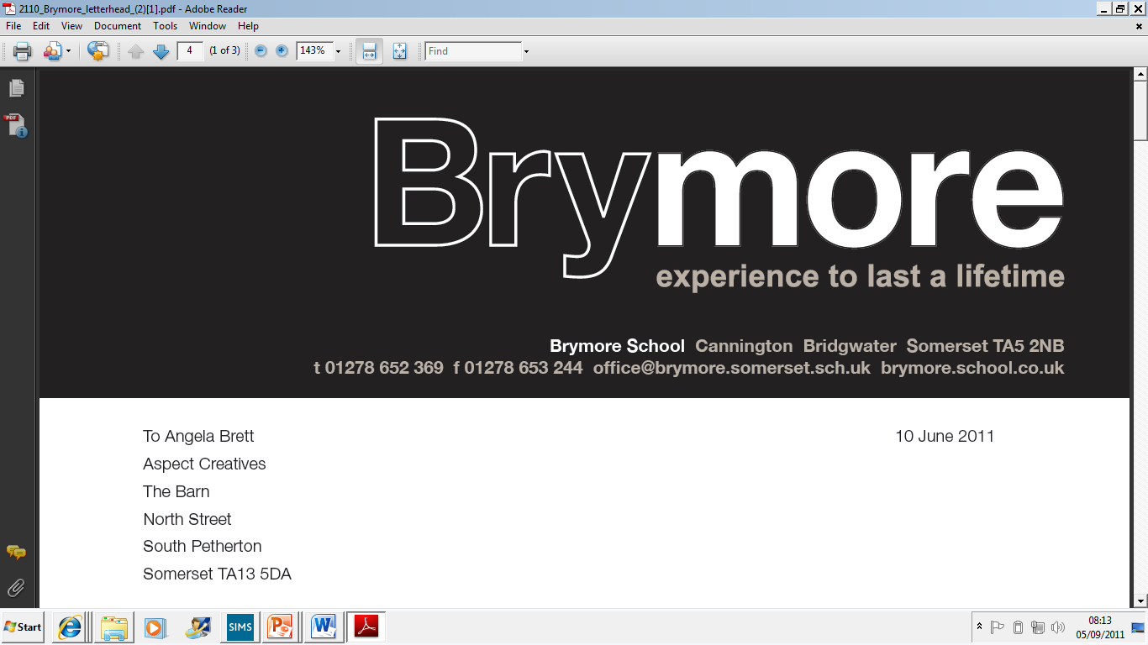

Application Pack

For post of Horticulture Teaching Assistant

APPLICANT INFORMATION PACK

- Brymore Academy - Background Information
- Bridgwater College Trust information
- Letter
- Job description
- Person specification
- Terms and Conditions

BACKGROUND INFORMATION

Brymore is a state boarding academy for boys situated in its own beautiful grounds of 60 acres in Cannington, near Bridgwater. In 1951 Somerset County Council purchased the estate at Brymore for £6,600 and following extensive repairs and alterations it was opened as a Secondary Technical School in September 1952 for boys aged 13 -17. Today, Brymore is a sponsored academy and is part of the Bridgwater and Taunton College Multi-Academy Trust. From September 2014, the academy extended its age range to admit boys from the age of 11 and we reached capacity in September 2015.

Brymore is at an exciting period in its history. There has been a rapid rise in examination results over the past six years with Brymore moving from the bottom 5% nationally to the top 15% in value added terms. Maths and English regularly achieve value added scores placing in the top 5%-15% of the country with DT results also exceptionally high. There has been considerable investment over the past ten years with £8 million going into new buildings - £3 million into new boarding houses which opened in January 2009, over £1.5 million into new classrooms and laboratories which opened in September 2008, a further £2 million refurbishment project of the main boarding house and over £0.5 million in a new dining hall and kitchens, which opened in April 2015. The horticulture facilities received £0.25 million of investment in 2016 with a new £0.6 million farm building, milking parlour and purpose built classroom are due to open in October 2019. It is a delightful and special place to work with young people and we are now heavily over-subscribed with over two applications for every place in Year 7.

The four corner stones of the Brymore experience are the farm, gardens, workshops and sport - plus, of course, the fact that it is a boarding school. Brymore has excellent facilities. It has a 110 acre farm including its own dairy herd, beef, pigs, sheep and chickens. It has extensive horticultural facilities including a one acre walled garden, glasshouses and each boy has access to his own plot. We have three workshops, a forge and a CAD/CAM room so that boys can work with a variety of materials. Boys enjoy a wide range of sports including the traditional rugby, hockey, cricket and athletics. They also have access to an outdoor pool, mountain bike track (which they built themselves) and they are offered over seventy different activities a week after school and at weekends.

There are currently over 320 boys on roll, as of September 2019 and 128 of these are boarders. However, even the out-boarders board when on a “duty” week. (This involves milking or feeding at 6.30 am, then School, then duties again at 4.00 pm). All the boys help on the farm and in the gardens. Around half of the boys come from a land based background. As a State Boarding School parents pay modest boarding fees and the state pays for the education. Our half terms are kept short (six weeks maximum) to ensure that boarders – and staff - get adequate rest and time at home. From September 2018, we have moved from a six to a five day week, with lessons taught on a Monday to Friday, with six Saturdays a year, for ‘special’ events such as the Harvest Festival. Teaching time is concentrated over 34 weeks, giving eighteen weeks holiday a year, in line with many independent schools and more than other state schools. This pattern of short, focused terms, with longer holidays works well for families.

The pastoral system at Brymore comprises three houses, Galsworthy, Taylor and Walker. Each has a Head of House and tutors who lead Vertical tutor groups. The rewards system is well established and is of great importance to the ethos of the school. We have an assembly three days a week, with two tutorials and with the Friday gathering is chiefly given over to the embodiment of the reward system - certificates and awards are presented along with sports results and items of good news. Each term the results of inter-house fixtures are added to merits, commendations, attendance and other data to produce the result for the FOBSA Trophy (Friends of Brymore School Association). Through this, and other means, we actively seek to reward each boy for their endeavour and skill. We do not give rewards for the sake of it, but the system is remarkably good at finding something to celebrate in each boy.

Brymore is also about student development as well as academic success, so the context is one of encouraging the best in boys who, frequently, have not thought of themselves as successful at school. We change that by finding out what they are good at, by building self-esteem and confidence and by encouraging them to live by our own three Rs - Resilience, Resourcefulness and Responsibility. We expect boys to be polite, courteous, to be able to hold a conversation and to mix well with people they do not know.

At present there are three classes in each year group of approximately 70 students, giving class sizes of 20-25 boys. Most boys study Land based studies and Resistant Materials/Engineering at Key Stage 4. However, we will also allow boys to meet the requirements of the English Baccalaureate and follow a more academic pathway should they wish. Results have traditionally been high in value added terms, with a number of departments performing in the top five in Somerset.

The school comprises of three boarding houses, each holding up to 50 students. Two staff are assigned to, and live in each house, with duty staff and assistant houseparents running activities and Prep in the evenings. A senior member of staff is always on call, including overnight. The Head of Boarding oversees the school’s boarding facility. Many activities are run in the evenings, so that boys are occupied at all times. Friday afternoons are taken up with activities, including rugby, hockey, farm, gardens, golf, hill walking, photography and a cookery class. Many boys go home on Friday afternoon, leaving a maximum of 30 boys who remain in on a Saturday and Sunday before all boys return Sunday night/Monday morning.

The School has had a fairly settled Senior Leadership Team over the past few years and is making significant changes to improve the attainment of the boys. The focus is very much on Raising Achievement and we are proud of the consistently high value added scores produced by the boys. In 2018 Ofsted rated the school as ‘good’ in all areas and highlighted leadership as a strength, in recognition of the rapid progress and pace of change. Results at the academy have improved exponentially, with good data and in many areas, outstanding achievement. Our Progress 8 score has always been positive. In 2019 the boarding provision was also rated good at Brymore with safeguarding, the range of activities and the way boys are listened to were said to be outstanding. Meanwhile, the support of parents is exceptional, with over 95% recommending the school in a recent Ofsted survey. As a member of staff you will get to know parents well through many of our functions held throughout the years such as the Harvest festival service, Christmas carol service, sports day and swimming gala which are always well attended.

Brymore Academy and Bridgwater and Taunton College Trust

Brymore converted to an Academy in September 2013. This formed part of our drive to continually improve the future of the school, which opened in 1952 as one of the first ‘Technical Schools’ in the country. Our aim is to be a centre of excellence, both vocationally and academically, building on the legacy of the past, whilst delivering the innovative education of the future.

Brymore is part of the Bridgwater and Taunton College Trust which consists of a group of schools, both primary and secondary, from across Somerset sponsored by Bridgwater College, who are working together to maximise effectiveness, and benefit from the support of the College and of each other. The Bridgwater and Taunton College Trust plays a key role in challenging and supporting each Academy. It provides stability, direction and accountability, whilst enabling Brymore to play to its strengths. The trust is well established with a team of staff, led by the CEO who provide support in terms of teaching and learning, staff development, HR, premises, safeguarding, health and safety, ICT and financial management. Our emphasis on traditional values and the development of resilience, resourcefulness and responsibility continues to be at the heart of all that we do. At the same time, the Academy structure provides us with an opportunity to work in partnership with other schools, share resources and expertise and strive to get the best for all our boys.

Academy status gives Brymore the freedom to be innovative and creative with the curriculum, timetabling, staffing and governance. It is an exciting opportunity to build on recent successes and create an inspirational school that will transform learning, extend opportunity and raise expectations. We have the freedom to focus teaching and resources where improvements are really needed. Thus, we set the highest aspirations for student achievement providing a curriculum that is challenging, relevant, innovative and sufficiently flexible to engage pupils of all abilities. The Academy is responsible to the Academy Trust which ultimately answers to the Secretary of State for Education. The Trust provides a structural solution that helps to build capacity, providing opportunities for both staff and students. It is building on the improvements already made by strengthening governance, broadening leadership and management and providing a framework for long-term support.

June 2019

Dear Applicant

Thank you for your interest in the position of Horticulture Teaching Assistant. It really is a fantastic and unique place to work and I hope having read all of the information, and maybe visited us, you will feel it is the right school for you. If not, then I wish you luck in any future applications.

Having experienced difficulties around ten years ago Brymore is currently in the most exciting phase of its development. Results have risen rapidly over the past eight years and we have consistently delivered positive value added/Progress 8 scores. We are heavily over-subscribed, benefit from the stability and economies of scale of being part of a MAT and have strong Ofsted reports for both the school and the boarding provision. The boys themselves make the Academy what it is, and you will find them polite, well-mannered and motivated to do well. I am also lucky to have loyal and hard-working staff. The governors and trustees have a wealth of experience and play an exceptionally active and supportive role within the Academy. The grounds, the mix of historic and brand new buildings, 110 acre farm, one acre walled garden, workshops, forge, outdoor pool and the excellent views of the Quantocks are all added bonuses.

I took over as Headteacher at Brymore in 2010, following the retirement of Malcolm Lloyd who had been at the school for seven years. He was responsible for £6 million worth of development, creating excellent facilities. In September 2011 I was able to appoint virtually a brand new leadership team, who embraced the challenge of transforming the school with vigour and enthusiasm. Vicky Davis is the Deputy Headteacher, in charge of teaching and learning/ curriculum; Luke Winter is the Deputy Head for Pastoral and Rob Watts joined the school in April 2012 and is Head of Boarding. The leadership team has therefore been stable for a number of years. Staff describe the ‘buzz’ of Brymore, the sense that we are moving forward and building our own future. In the last eight years the school has moved from the 96th percentile for pupil progress to consistently placing in the top 5%-15% of schools nationally. English consistently has the best progress in Somerset and has regularly been in the top 5% of schools nationally, with Maths also performing well. Results in agriculture, horticulture, PE, DT and engineering regularly being outstanding.
In September 2014, the academy admitted Year 7 boys for the first time, reaching our capacity in September 2015. In fact, we are now oversubscribed, with more than double the number of applicants than we have places. This is a unique opportunity to join a successful team of staff with a proven track record of school improvement. I am looking for people with drive and determination, who demand high standards from themselves and others and who share my vision that there is no ceiling to the success that the boys at Brymore can achieve.

The Learning Support Department is a vibrant and thriving part of the school. It prides itself on providing students with the support they need to be happy and nurtured learners. The team is headed by Michelle Craig (SENCo) who is passionate and determined to secure the best possible outcomes for all our SEN boys. Second in department is Dawn Carter, who has strong relationships with the boys and experience of working with students with complex needs and supporting students with social and emotional needs. With regard to the rest of the team, in all honesty, we have some of the best TAs I have ever worked with, who are thoroughly respected by all the boys and staff and who are committed to putting the boys first.

Your role will be to deliver inspirational learning support to the boys. As an integral part of the Learning Support team you are at the heart of the boys’ experience at Brymore. You will have a passion for improving student’s learning experiences and a determination that every single boy should achieve his best, by whatever means necessary. You will have the ability to inspire students to deliver the best they are capable of. You will need to be prepared to give time to mentor students, acting as a role model in proving the value of a positive work ethic and above all, showing that you care. You should also have the potential to be an outstanding practitioner who consistently adds value to the students you work with.

We are looking to employ a Horticulture Teaching Assistant who can support the Head of Horticulture in ensuring the delivery of the curriculum alongside literacy. The role encompasses working as part of a team and instructing small groups of boys during lesson time. You will need to ensure all health, safety and hygiene standards are met. You will be led by a Head of Department, Reuben Willcocks who has a wealth of experience and is building a strong team around him.

If you wish to apply for this exciting post then please complete the application form, accompanied by a letter of application. The closing date for applications is Thursday 11th July at Midday and interviews will take place on Wednesday 17th July 2019.

Should you wish to visit the school at any time then please contact Mrs Julie Vearncombe at the School who can arrange a visit. Should you wish to discuss this post further, you can contact me on 07730 218898.
Yours sincerely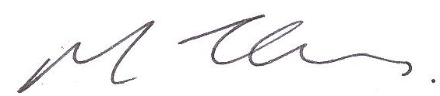

MARK THOMAS
Headteacher

JOB DESCRIPTION

Post: Horticulture Teaching Assistant

Hours: 37 hours a week, 36 weeks a year including ISET day and 5 Saturdays

1. RELATIONSHIPS: As the post holder you will: -

- be responsible to the SENCo and work in co-operation with other teachers and support staff:
- make and maintain productive, professional relationships with all members of Academy staff.

2. YOUR GENERAL DUTIES INCLUDE:

- providing personalised support for students with special educational needs
- providing support that enables students to access the curriculum and make good progress
- to support the Academy in its overall responsibility for the health and welfare of the students in its care.

3. SPECIFIC TASKS RELATING TO THE DUTIES ABOVE:

Supporting SEN students personalised learning:

- to develop knowledge of a range of learning support needs and an understanding of the specific needs of the students being supported:
- to develop methods of promoting and reinforcing students’ self-esteem:
- taking into account the learning support required, to assist students to learn as effectively as possible both in class and independently:
- support students in their reflection of their own learning
- to establish a supportive relationship with the students concerned
- to adapt and customise curriculum resources as appropriate
- work closely with classroom teachers to support planning
- To take small groups of boys and deliver lesson content within horticulture lessons

Meeting students’ additional needs:

- to support the learning and emotional well-being of SEN students
- contribute to the management of SEN students’ behaviour
- to provide regular feedback about the students to the subject teacher and SENCo
- support SEN students in accessing extended curriculum where appropriate
- to assist the SENCo (and other professionals as appropriate) in the development of a suitable programme of support and personalised targets for students:
- to participate in the evaluation of the support programme:
- to carry out small group intervention during English lessons as directed by the Head of English
- in liaison with the SENCo support the emotional and social well-being of key students through individual mentoring

Providing pastoral support:

- safeguard the welfare of SEN students
- support the transfer and transition of SEN students
- support designated students through academic mentoring in line with the Academy’s half termly Mentoring Week programme
- supervise the boarding house common room one lunchtime per week

Supporting the wider work of the academy:

- to be aware of academy procedures:
- to be aware of confidentiality issues and to keep confidences appropriately:
- support teachers in the administration of examinations and Controlled Assessments
- when required, act as a reader and/or scribe for students completing assessments or examinations

Working with colleagues:

- support and maintain collaborative, productive working relationships with Academy staff and professionals from external agencies
- contribute to and support the work of the Learning Support team and attend weekly Learning Support meetings
- to contribute to reviews of students’ progress as appropriate; liaising with students, their parents/carers, teachers and practitioners from external agencies where appropriate
- to attend relevant in-service training
- take responsibility in developing your own continuing professional development

4. REVIEW:

The post holder may be asked to carry out other tasks, as directed by the Headteacher, which fall within the purview of this post. In addition, it is not intended that this job description defines in detail all the duties and responsibilities of the post and it may be reviewed at the request of the post-holder or the Headteacher and amended upon the agreement of both.

Heads\brymore\jobdesc\Learning Support

PERSON SPECIFICATION – Learning Support Assistant
Factors | Essential | Desirable | How identified
Qualifications | - GCSE English and Maths, grade C or equivalent  - A commitment to undertaking whatever qualifications are required to carry out the role effectively | - Evidence of relevant professional development | Application form  Verification and demonstration of knowledge at interview
Professional Experience/ Knowledge and Skills | - A caring practitioner  - High expectations of students  - Ability to prioritise and manage a varied workload  - Good administration skills to maintain up to date files and records  - Competent in Microsoft Office  - Reliable and committed | - Belief in the value of boarding education  - Experience of working with colleagues from other schools and support services  - Knowledge of literacy needs and intervention programmes  - Evidence of continuing professional development  - Knowledge and understanding of the effective use of data to monitor and improve outcomes for all students  - Experience of working with children with literacy difficulties  - A good knowledge of Horticulture and associated fields. | Application form  Selection procedure  Interview questions  Performance in selection methods  Interview by demonstration of ability to display knowledge and skills  References
Personal Qualities | - Able to motivate, influence and inspire others  - Sense of humour  - Proactive self-starter who enjoys working under own initiative  - Good communication skills  - Flexible approach  - Ability to relate to students and adults at all levels  - Approachable, sensitive with excellent interpersonal skills  - Ability to meet deadlines and to work under pressure  - Attentive to detail  - The ability to understand confidentiality |  | Application form  Selection procedure  References  Interview  Performance in related selection exercises
Commitment | - Commitment to promoting the raising of standards  - Commitment to school and its links with the wider community  - Commitment to equality of opportunity and inclusion  - Willingness to contribute to extra-curricular activities  - An ability to keep a healthy work/life balance |  | Application form  Selection procedure  References  Interview  Performance in related selection exercises

BRYMORE Academy

Terms and Conditions

Conditions of Service
Full conditions of employment are set out in a Statement of Terms and Conditions of Employment which will be issued to the successful candidates.

Fitness for Employment
The successful candidate will be required to complete a medical questionnaire which may result in a check by the Occupational Health Physician. A criminal record check is also required via the disclosure procedure.

Salary
Salary is paid on the last working day of each month.

Annual Leave
This is a term time post plus INSET days and five Saturdays. (Brymore is in session for 34 weeks per year). No annual leave will be granted during term-time.

Equal Opportunities
Brymore Academy is committed to the promotion of equal opportunities and is dedicated to non discriminatory policies and practices and to eliminate unfair discrimination on any basis. Therefore, no candidates will be discriminated against on the grounds of age, gender, marital status, racial origin, disability, sexual origin or religious or political beliefs.

Safe Recruitment
The school is committed to safeguarding and promoting the welfare of children and young people and expects all staff and visitors to share this commitment. This post requires a criminal record check via the disclosure procedure.

Criminal Record Check
The Rehabilitation of Offenders Act 1974 gives individuals the right not to disclose details of certain old offences when asked about their criminal record as they maybe defined as ‘spent’.

Applications
Applicants for the post need to write a letter of application and complete an application form and submit by midday on Thursday 11th July 2019.

Interviews
Interviews will be held on Wednesday 17th July 2019.

