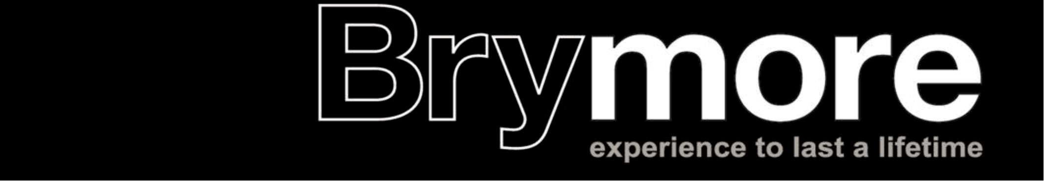
Brymore Open Day
Saturday 27th June 2020 // 10.30 am - 5.00 pm // Brymore
Trade Exhibitor Form
Please complete and return this form with payment to:
Lorraine Warren, Brymore, Cannington, Somerset, TA5 2NB by 1 June 2020
 | Title | First Name | Surname

Name
Address

Town & County
Post Code
Email
Telephone Number
Name of your stand/business and brief description:
Number of stands required @ £35 per stand (please note tables will not be supplied as standard):
Confirmation of setting up time
Friday 26th June 4.00 pm - 6.00 pm Saturday 27th June // 8.00am - 10.00 am

………/
Should you require electricity please tick this box, please note that you will need to provide your own extension cable and that we will do our best to accommodate this but due to the location of trade stands we cannot guarantee this. Outdoor stands do not come with electricity.
Most of the inside craft will be in the school hall but depending on numbers we may extend to a marquee – location CANNOT be guaranteed but we will do our best to accommodate should you indicate a desired location. Should you wish to be outside and bring your own gazebo/stand then this will also be accomodated as best we can, however we cannot supply gazebos.
Please state area for your stand:
Inside Craft Outside Trade (with own gazebo)
Please indicate advertising options should you require them in our A5 Open Day colour brochure (charges are to cover printing costs and over 600 programmes are sold on the day).
Full page £40
Half page £25
Quarter page £20
Tables are not supplied as standard with a pitch due to the cost of hiring them in. Should you require a table (at a cost of £5 for hire during the day) then please tick here and add this to the total of your payment:
Please note:
- All indoor stands are 6ft and outdoor stands are 3m x 3m. Should you require more then please request a double or triple stand and include additional payment to cover this.
- The £35 minimum fee per 6ft (indoor) or 3m x 3m (outdoor) stand covers the stand only. Please enclose cheques for the full amount, plus any advertising, payable to Brymore Academy.
- All stands must be set-up by opening at 10.00 am. For health and safety reasons the set-up times must be adhered to, please indicate on this form your chosen timings.
- Please ensure you include a copy of your Public Liability Insurance with this form on return.
- For advertising please ensure a JPEG/PDF is emailed to LWarren2@educ.somerset.gov.uk by 1 June 2020.
- Vehicles will not be permitted to leave the site until 5.15pm at the earliest or until the main ring has completed all activities; whichever is later.
- Please enclose a copy of a risk assessment for your stand/exhibit on return of this form.
Please sign in this box to confirm you have read and agree to adhere to the above conditions:
- Cancellations after 31st March 2020 are non-refundable.

Risk Assessment
Please send in your own Risk Assessment should you already one or if not please complete the below form.
Overall risk: low Medium High
(please delete as appropriate)
High Risk Description:

Medium Risk Description:

Low Risk Description:

For any questions please contact Lorraine Warren: LWarren2@educ.somerset.gov.uk

