Logging onto your new myBrymore email and One Drive
Using a single sign on for Show My Homework

The best browser to use for MS 365 is Microsoft Edge. If you are still using an older version of Explorer you should update it to the latest version of Edge.
You can also use Google Chrome but all the features of products such as Teams might not work correctly.
First log out of your existing @brymore.somerset.sch.uk account

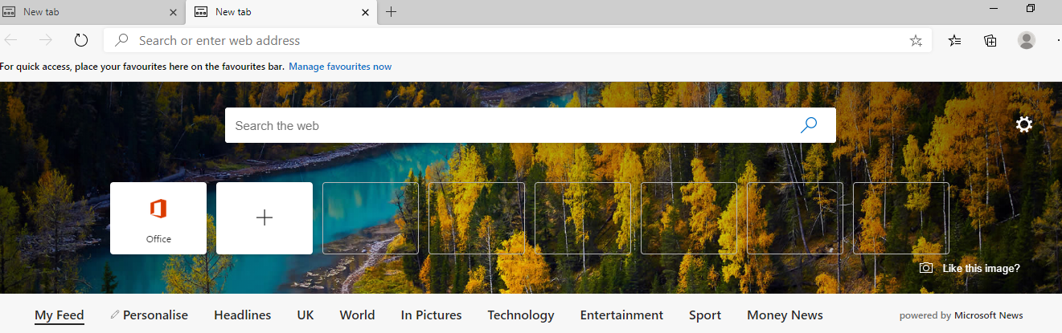
Click on the Office icon in MS Edge if it isn’t there search for MS 365
In Chrome you will need to search for MS 365

You will then see this screen.
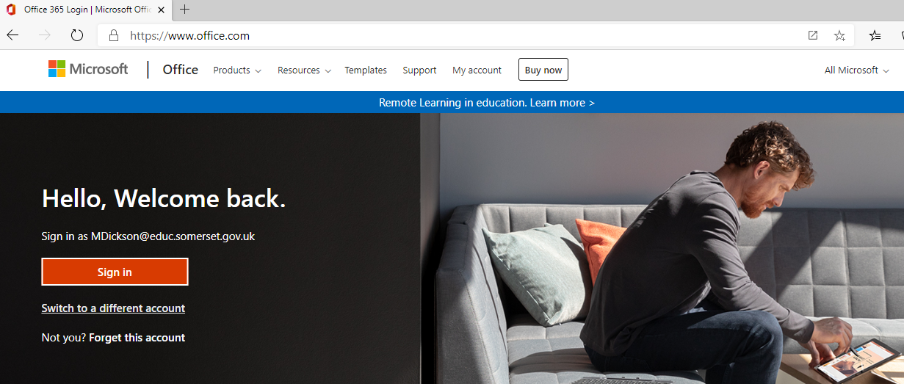
You might share the computer with another family member who also uses and Outlook email. If this is the case you will need to click on switch to a different account.

Or you might see this screen
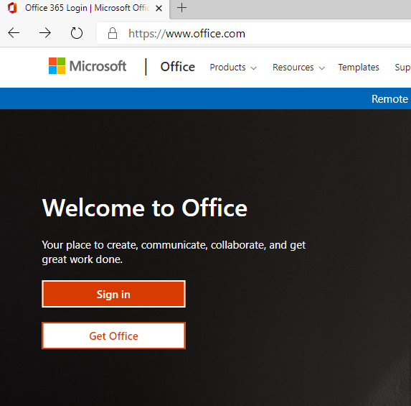

You might see the same screen that you see at school (depending on the browser you are using)
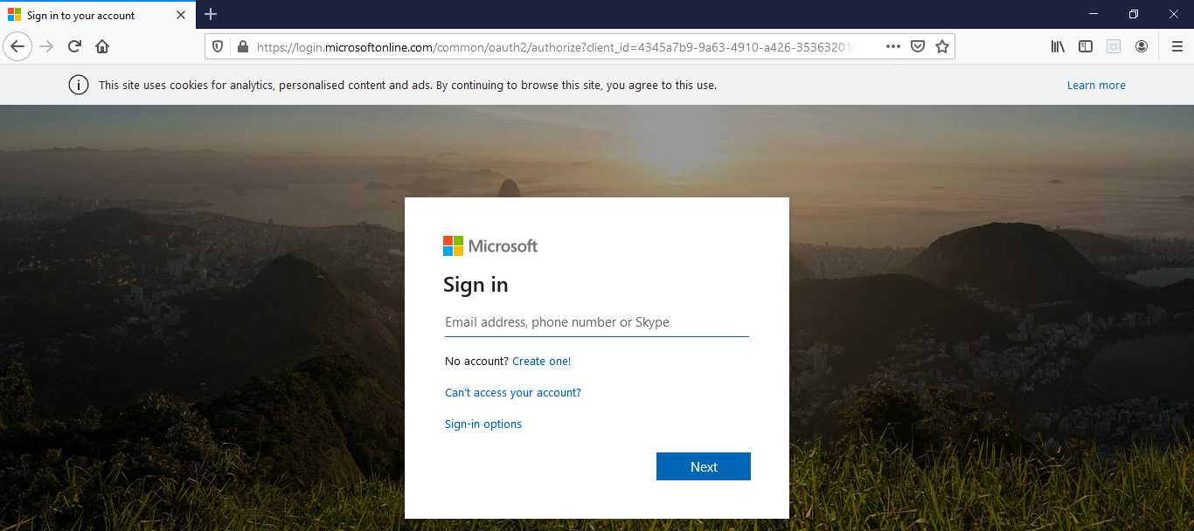
Log in with your new user name and password.
13 – Year 7 eg. 13BloggsJ@mybrymore.school
12 – Year 8 eg. 12BloggsJ@mybrymore.school
11 – Year 9 eg. 11BloggsJ@mybrymore.school
10 – Year 10 eg. 10BloggsJ@mybrymore.school
09 – Year 11 eg. 09BloggsJ@mybrymore.school
Remember to use your new password in the format Bry.dob!
Dob = date of birth in the format ddmmyy!

You can now access your emails and One Drive and Office applications in the cloud.
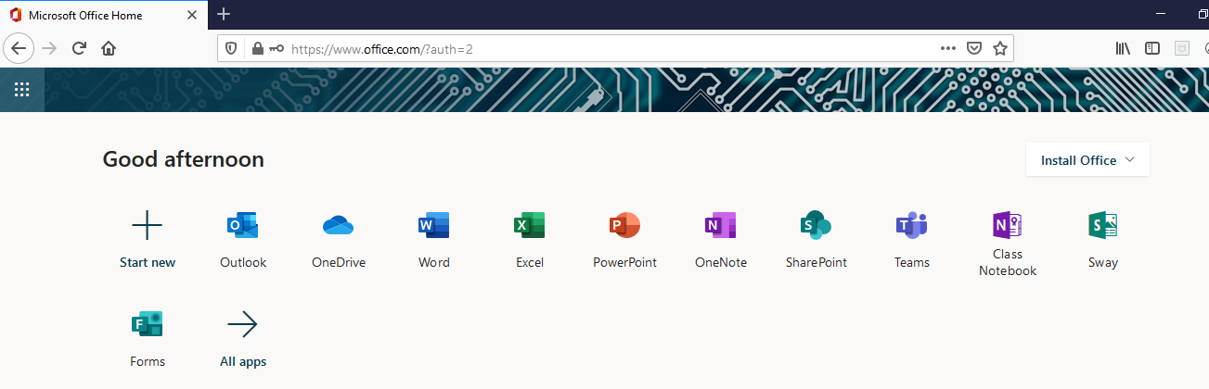
Open a new tab in your web browser and search for show my homework

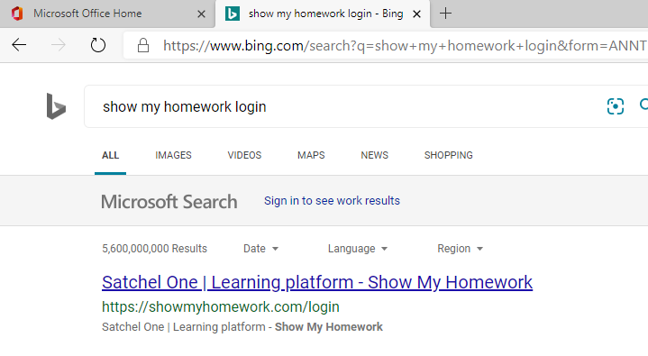
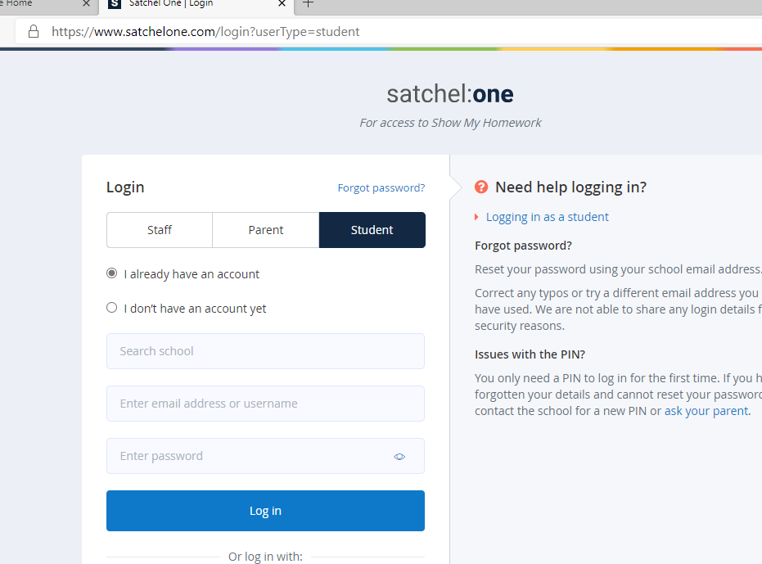
Search for Brymore Academy

Click on sign in with Office 365.
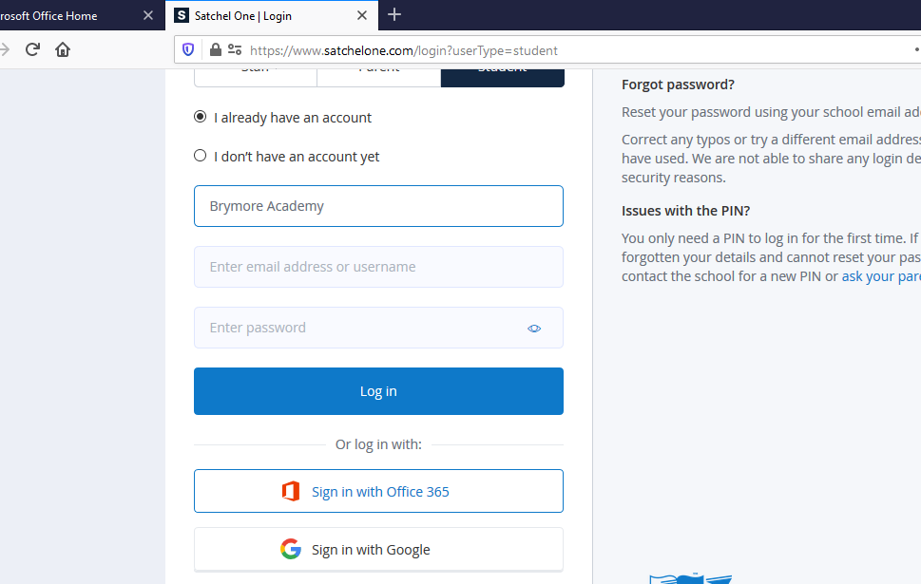
Because you are already logged on to your Email and Office 365, you will be logged into Show my homework automatically.
If you have a problem it might be because you have the Show my homework app on your phone and have used a different email address to your school one. The single sign on process with MS 365 requires you to use your school email address for both. Show my homework have reset all your passwords to the new ones so you will need to use the new email and password to access it.

Initial reports from users show that this single sign on method works. If you are having problems getting into Show My Homework and only use the phone app or a tablet, check the settings in the app and make sure the email has been updated to your son’s new school email.

Launching a new system like this without having lessons, or parent meetings is always going to be difficult challenge. Thank you for your patience and perseverance during this difficult time.

Mr M Dickson
Mrs C Wallace

