28th September 2020

Dear Parent/Guardian of Year 7, 8 and 9

We hope that you and your son have settled back into school life and have enjoyed the first few weeks of term. We have now managed to STAR test all of Year 7, 8 and 9. This test provides us with a reading age for your son as well as a Z.P.D (the level of book that he should be reading for his ability to ensure that he is making the progress that he needs). The results of this test we have included to help you support your son. As a school our aim is to ensure that we do everything that we can to close any gaps between students’ chronological age and their reading age. If you are new to the Brymore family, or would simply like a re-cap, the information below outlines our systems and expectations surrounding reading at Brymore. If you would prefer to watch a presentation of the information below, you can find it available on our website.

Reading at Brymore Academy

Why we place such an importance on reading for pleasure:

Google, ‘statistics linked to the importance of reading,’ and a lot of scary looking data appears linking low levels of literacy to unemployment, low income, crime, poor mental health and even a lower life expectancy. However, out of those scary statistics, two stand out to us and were found from the research of the National Literacy Trust. Firstly, did you know that reading for pleasure is more important for children's cognitive development than their parents' level of education and is a more powerful factor in life achievement than socio-economic background? Secondly, there is a difference in reading performance equivalent to just over a year's schooling between young people who never read for enjoyment and those who read for up to 30 minutes per day. This could equate to one or two grades at GCSE; the opportunities this could equate to could be life changing.

At Brymore we are passionate about improving the literacy of all regardless of their starting point. We do this through quality first teaching in our English classrooms, targeted literacy interventions and ensuring that our students are reading independently. Not only does reading for pleasure bring a wealth of benefits (improving literacy being just one), it helps them prepare for what is to come: students cannot escape the qualifications they will have to sit. You actually need a higher reading age to access the maths paper than you do the English language paper!

Historically, just over 50% of our Year 7 intake will have a reading age lower than their chronological age (the national average is 20%). Our goal, by the end of key stage 3, is to close this gap as much as possible, ensuring that students have a reading age that matches or exceeds their chronological age. With the help of Accelerated reader, the dedication of our staff and support of our parents, we are now in a position where over 70% of each year group are making accelerated progress and closing that gap; this figure is improving year on year.

……../

Expectations surrounding reading at Brymore:

- All students will have a reading book with them as part of their school equipment at all times.
- All students will read for a minimum of 20 minutes a day - this is calculated by Accelerated Reader based on their quiz activity.
- Students must log their reading on our online reading journal ‘Reading Rewards.’ https://www.reading-rewards.com/
- Students must show they are making adequate progress towards their personal annual target (passing quizzes). So by the end of the autumn term they should be at approximately 30% of their target; by the end of the spring term they should be at approximately 66% of their target and 85%+ by May half term. You can check your son’s progress towards his target by logging on to Home Connect (details below)

How we support your son:

- Students have a weekly reading lesson where their progress is monitored, those who need a bit more support staying on track will be set weekly targets by their teachers. They may also receive support through a literacy intervention, we also run break time support sessions for those who need them. If a student falls behind these sessions are a requirement. There is also designated time for reading for boarders in prep. We reward, praise, encourage and talk about books - a lot!

How you can support your son:

- Encourage - the more they read, the more they can read.
- Students who read daily for at least 20 minutes make the most progress - enforce this expectation at home.
- Be reading role-models.
- When you can, listen to them read aloud - help them self-correct, re-read focussing on fluency and intonation.
- Ask about what they’re reading.
- Discuss books.
- Buy them books - they don’t have to be expensive, I personally love raiding my local charity shops!
- Take them to the library.
- Log on to Home Connect (details below) so your son knows he is being held to account both at school and at home.

Rewards and sanctions:

Much like farm and garden duties, reading is not an optional activity at Brymore. It is heavily rewarded and students receive house points weekly for staying on track. Reading commendations worth 5 house points are awarded for every quiz passed within a students’ ZPD AT 80% or higher. Not reading is essentially not completing their prep which would accrue weekly behaviour points and possible detentions. Students take part in class and house reading competitions and there are reward lessons and reward trips that are held throughout the year to celebrate the reading achievements of all. Students can also work towards achieving reading badges.

…../

What is Accelerated Reader?

The Accelerated Reader program is a computerized program that tests reading comprehension. Students select books based on their reading level, read independently and take an independent comprehension test on the computer. Each book is worth a certain number of points based on its length and reading level. Every student has an annual target to achieve a certain number of points based on their ability. For example, we have students who have annual targets of over 200 points; we have students with targets of 15. Students are rewarded for progress towards their target, not on how many books or words they have read. Every student has a target that is achievable for them.

How does it work?

- Accelerated Reader uses a Star reading assessment which is a computer-adaptive test used to assess reading ability.
- The outcome of this test provides students with a personalised reading range called a ZPD (zone of proximal development).
- Once a student knows their ZPD they can then select books that are suitable for them. This is the important bit: students make the most progress when they read books with 90-95% accuracy. If the book is too hard they won’t achieve this level of accuracy, won’t understand it, switch off and lose confidence. If the book is too easy they don’t expose themselves to any unfamiliar words and therefore don’t move themselves forward. The ZPD of a book ensures students are reading within that 90-95% range. ZPDs range from 0.5-13.5, every student will be given a range for example, 4.1-4.9 and they should try and read and quiz on books within this range.
- Students take a STAR test 3 times a year which allows staff to monitor progress and track reading growth. Each time they take a test, if they have been reading daily, they will be issued with progressively higher ZPD ranges thereby encouraging them to read more complex books and continue to make progress.

How can I find out what level a book is?

If you go to www.arbookfind.co.uk you can search for any book to find out its level and points value. If you look at the example below, the BL figure is the ZPD, in this case 6.7.

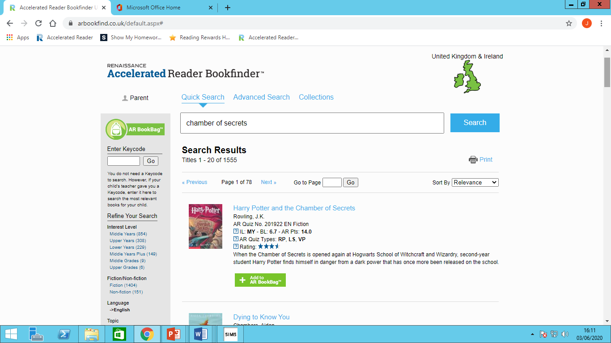

How can I check my son’s progress towards his target?

- You can log onto ‘Home Connect’ by using the following link:
https://Ukhosted85.renlearn.co.uk/2259563/HomeConnect . The username and password is the same as your son’s. You will be able to see what books he is reading and if they are suitable for his ability, his average pass rate (should aim for 85%+) and how well he is progressing towards his target.

- 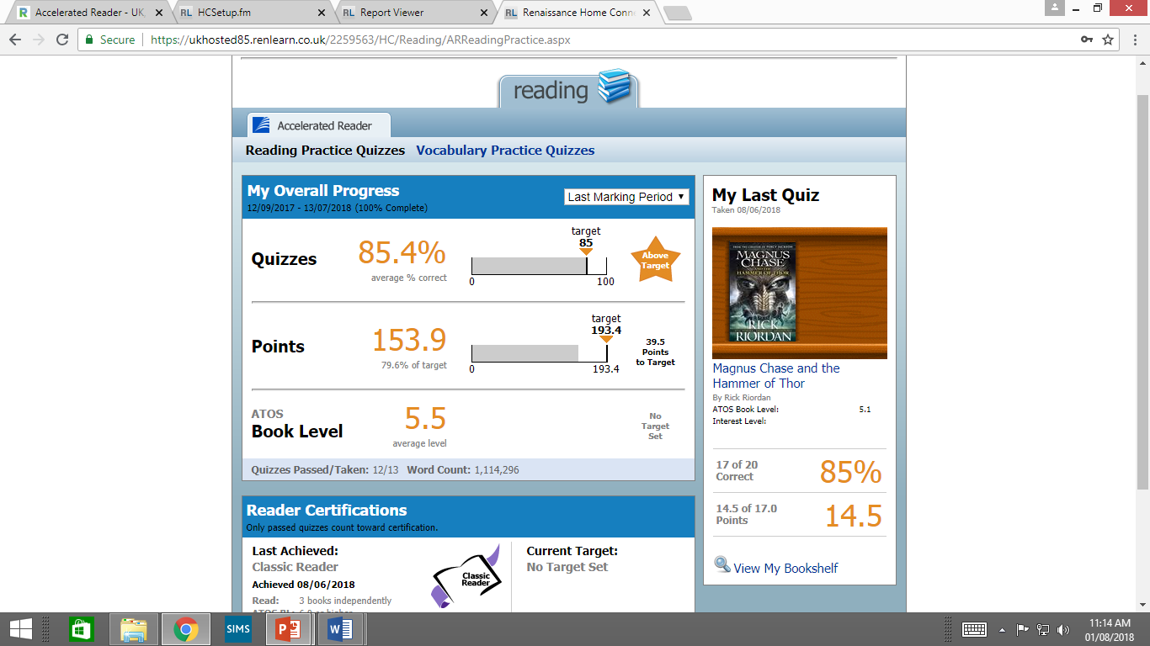

How does my get started and take a quiz?

- Once your son has taken his STAR test, he will be issued with his ZPD.
- Find some excellent stories and check they are suitable using AR book finder (address above).
- Read and enjoy.
- Once your son has finished a book and is ready to quiz he logs onto the Accelerated Reader website (as if he was taking a STAR test, see previous step by step guide).
- Instead of clicking the blue button, he clicks the orange one.

……/
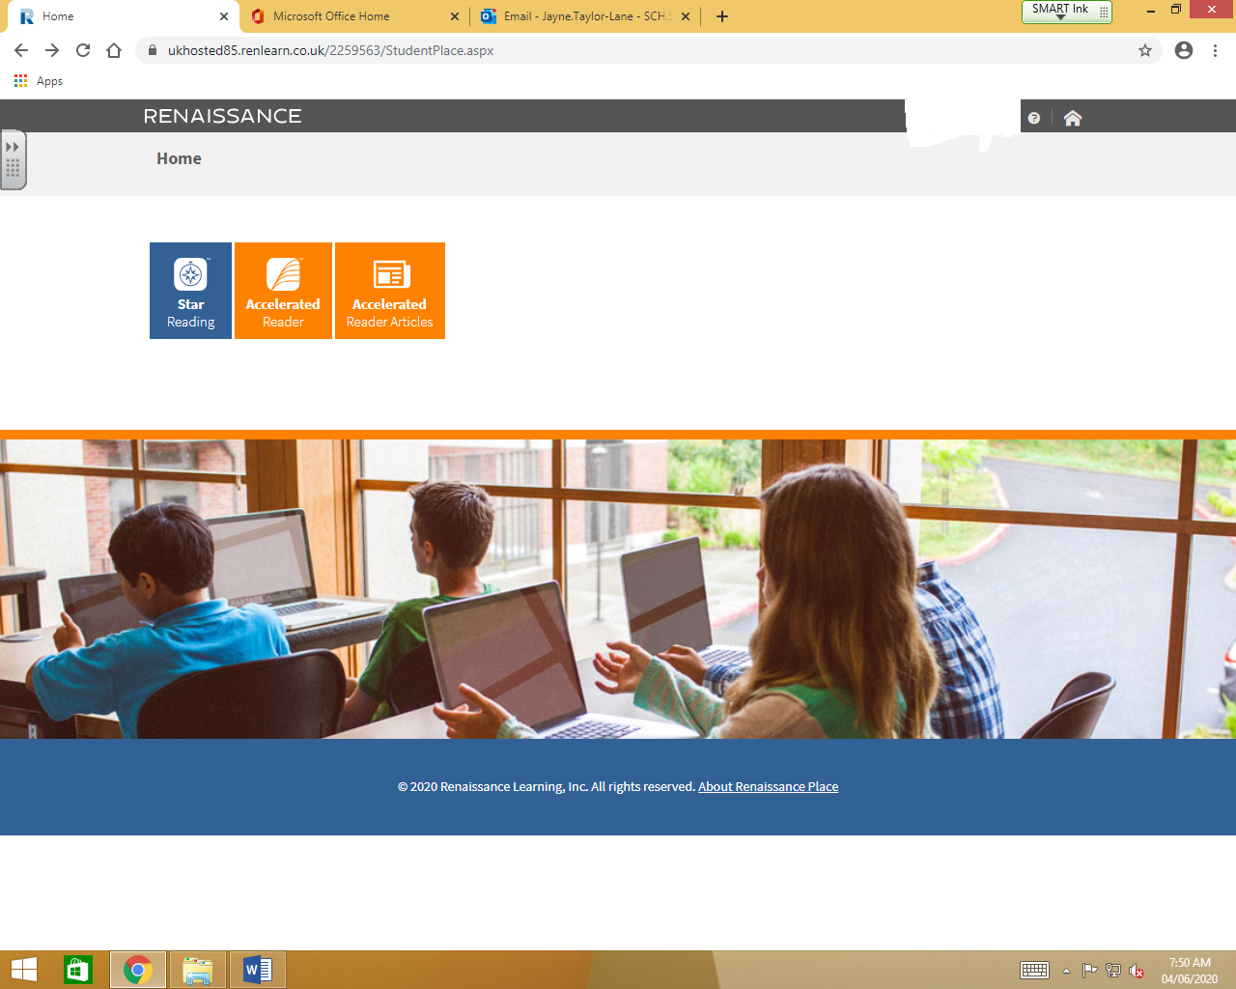

- Then type in the name of the book and select ‘Take Quiz’

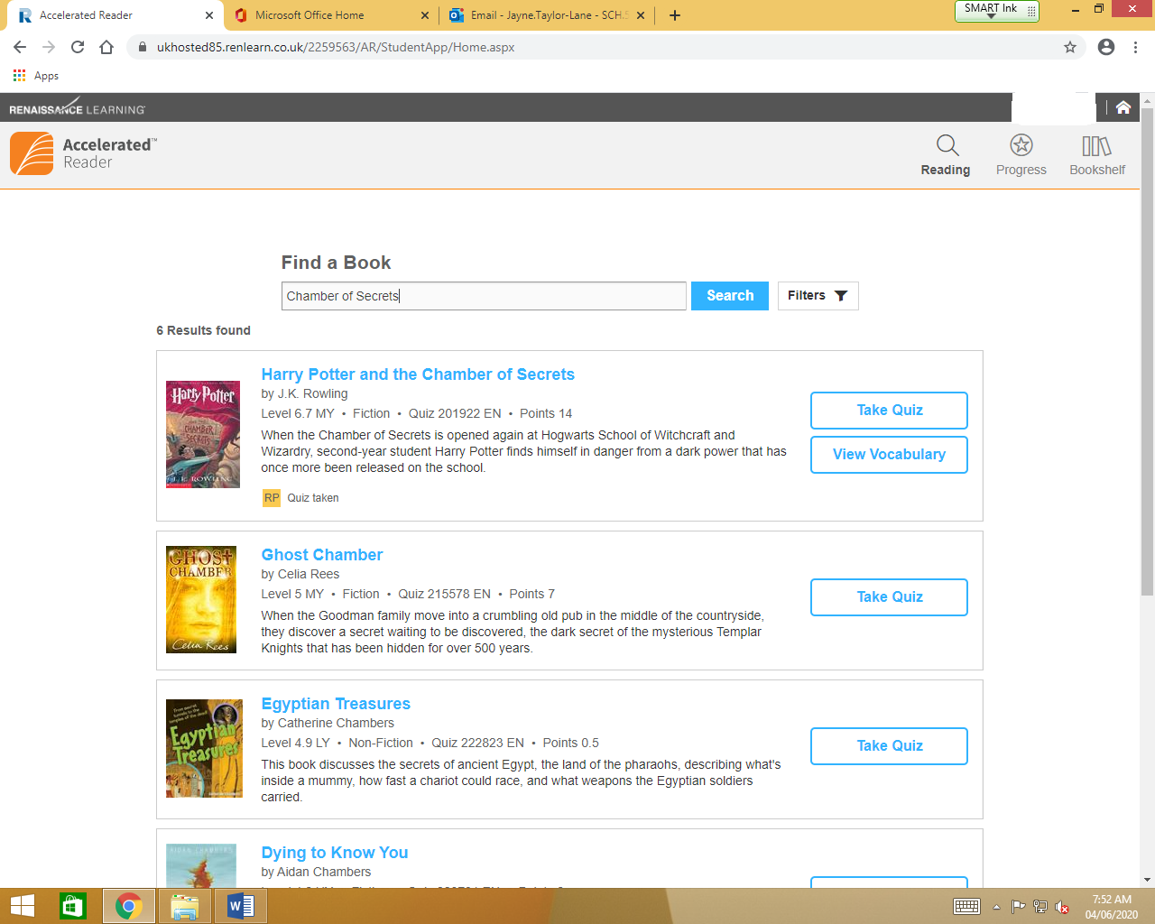

- Select ‘Literacy Skills’
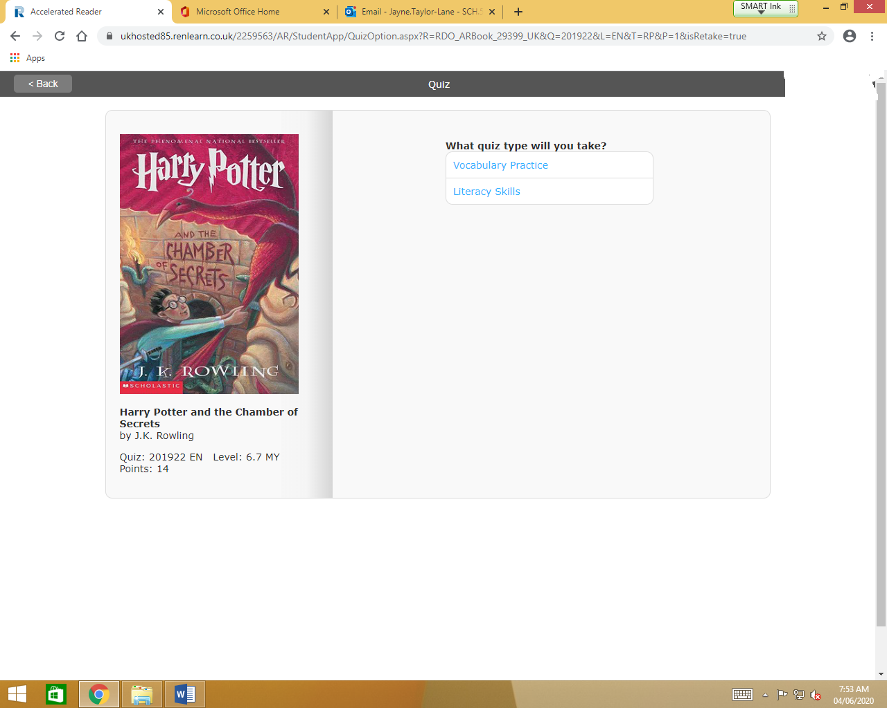
- Take the quiz!
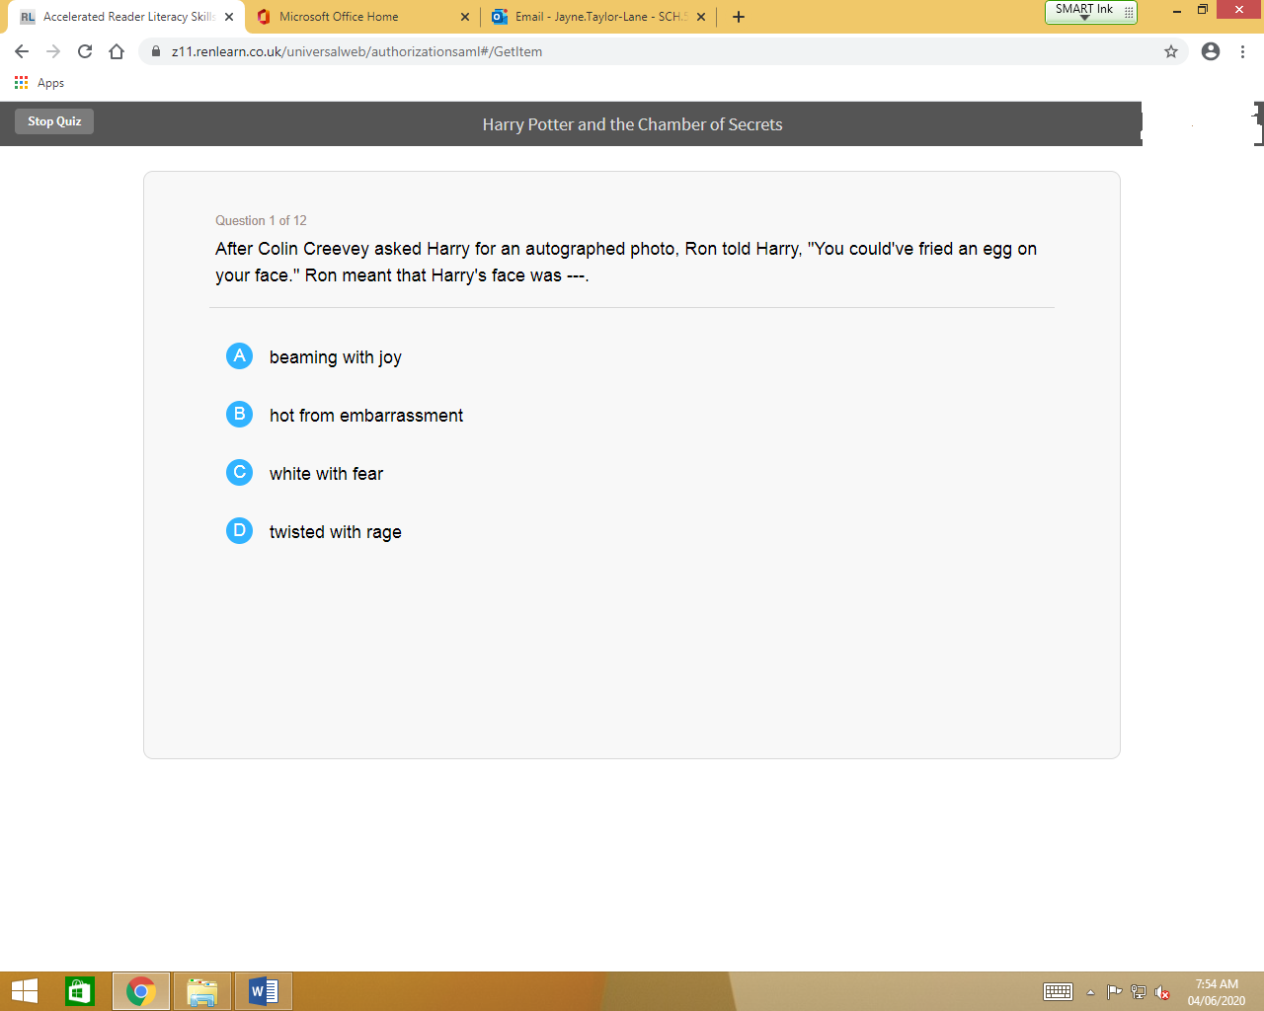

…/

Thank you for taking the time to read this information, and for any support you can offer your son with his reading, it really does make the world of difference to his academic progress and life chances. If you have any questions, please do not hesitate to conact me.

Happy reading!

Jayne Taylor-Lane
Head of English

