23rd November 2020

Dear Parents/Guardians
Each year Brymore holds our Smiles for Christmas campaign where boys are encouraged to bring in hamper food stuffs and toys for the Salvation Army in Bridgwater. Each Boarding House traditionally makes a Brymore themed hamper too, which is judged by Captain Mark Godwin from the local Salvation Army. However due to Covid -19 we need to do this a little differently this year.
We would like to hold a non-uniform day with each boy contributing a suggested donation of £1. The total will go towards vouchers for a supermarket that Captain Mark Godwin from the Salvation Army can then use to purchase food items and toys, for local families.
At this particular time, we feel it is more important than ever to do this for those who are less fortunate than ourselves and we look forward to putting smiles on the faces of those in need this Christmas.
The proposed date is Tuesday 1st December 2020 where money will be collected during tutor time.
Stay safe
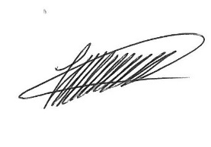

Mr Fewtrell

