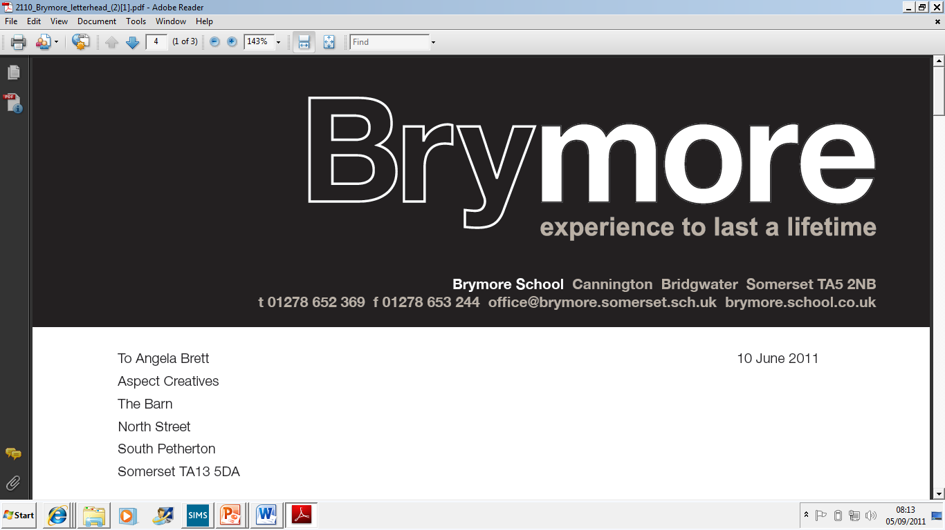6th January 2021

Dear Parent/Guardian

I hope this letter finds you and your family well as you, yet again, adjust to a national lockdown. I am writing to clarify how we are able to support you and your son over the coming weeks.

**Home Schooling / Online Learning**

As a parent of an 8 year old boy myself, I remember only too well the stresses of home schooling. At Brymore we are also well aware of how the boys learn best and it is with this in mind that we have devised our online learning programme. As outlined in the letter from Mrs Davis, we will deliver up to four taught “live” lessons a day on Microsoft Teams (MS TEAMS). Boys respond well to contentbeing delivered by a teacher and it is also hoped that this will take some of the pressure off you as parents, as all we ask is that you ensure your son is logged on each day. Of course some staff may also ask boys to complete tasks, however, they will be mindful of the fact that boys will be receiving other lessons that day. Please be aware that on some days there may not be four lessons as boys are following their normal timetable and lessons such as Drama and PSHRE are not being delivered online. Staff will go through with the boys in each lesson how work is to be submitted and marked but please be aware that staff will be delivering four lessons a day to approximately 100 students and may not be able to respond to work submitted immediately.

Instructions how to access MS TEAMS via an Xbox or PlayStation are shown on the final page of this letter.

**Additional Support**

We will aim to telephone home regularly to every parent and boy, with a view to keeping in touch and supporting families during this difficult time. Staff will let you know if your son has not been engaging in lessons and it is also an opportunity for you to raise any concerns you have. Please be aware that this lockdown is very different to the last one, in that teachers will now be teaching lessons to all boys up to four times a day and therefore will not have time to make these phone calls. It will, therefore, be the support staff that make these phone calls and each member of staff will have more calls to make this time around.

**Tutorials**

We are planning to run a tutorial once a week on a Friday at 12.35 pm which will replace the lesson that was timetabled at that time. Please note that for **this week only** tutorial is on Thursday at 2.45 pm. I am well aware that many boys struggled with their mental health and with being in isolation during the last lockdown and I feel that the tutorial is an important strategy in trying to combat this. Many boys have a good relationship with their tutor and it is hoped that this will continue during lockdown.

**Boarders**

I will be writing to parents of boarders shortly to outline the position regarding fees and I would like to thank you for your patience as we try to resolve this issue.

**Paid Activities**

All those that have signed up for a paid activity this term have had their activity account reimbursed. When we return, we will automatically transfer those that were signed up this term to the new term, unless we are notified otherwise.

**Year 11**

The Secretary of State announced the new arrangements for examinations today, however, we are still awaiting further detail. I realise that this will be a worrying time for boys and parents of Year 11, therefore Mrs Davis and I will give a presentation to all boys and parents on Thursday 7th January 2021 at 5.30 pm via MS TEAMS. An invite will be sent out to all boys shortly and there will also be an opportunity for boys and parents to ask any questions about how GCSE grades will be awarded this year. At this stage it is more important than ever that the boys continue to work hard and do everything that teachers are asking of them because there is a real possibility that staff may be asked for an estimated grade or indeed to rank students in order of what their estimated grade will be. The Secretary of State today announced that estimated grades would be based on teacher assessments. However, it is unclear at this time exactly what that means. So I would reiterate boys need to continue to work hard now to ensure they achieve the grade that they desire. Please do not contact staff and ask them for an estimated grade as this is not information we are able to release until the Government have provided clarity to schools.

**Contacting Staff**

We have now moved to a new email system and a list of the new email addresses of all staff is on the next page.

If you need passwords reset to log into Hegaty Maths (Mr Ashton/Mrs Truman/Mr Williams), Educake (Mr Craig/Mr Lines) or Accelerated Reader (Miss Webber/Mrs Taylor-Lane) please contact the relevant member of staff shown in the brackets.

**Interventions**

Some boys receive additional support from the Learning Support Team and in most cases these will continue via MS TEAMS. Staff will contact those concerned to set up these sessions.

We are all now more aware of the likely challenges that we will face during lockdown and please be assured that we will do all that we can to support you and the boys during this time. I am well aware that many of my staff will also be home schooling their own children, so please be patient with them as they also adjust to online learning. Throughout the last year I have been incredibly proud of the way we have continued to work together as a Brymore family and I have every confidence we will come through this difficult period together, yet again.

Thank you for your continued support and understanding in what is clearly difficult times for all concerned.

Yours faithfully

MARK THOMAS

Headteacher

**The Staff at Brymore (Day/Academy Staff)**

|  |  |  |
| --- | --- | --- |
| Mr Mark Thomas | Headteacher | mark.thomas@brymoreacademy.co.uk |
| Mrs Victoria Davis | Senior Deputy Head  (Curriculum, Teaching and Learning) | vicky.davis@brymoreacademy.co.uk |
| Mr Luke Winter | Deputy Head  (Student Achievement & Welfare) & Designated Safeguarding Lead | luke.winter@brymoreacademy.co.uk |
| Mrs Jayne Taylor-Lane | Head of English / Leader of Year 7  Member of SLT | jayne.taylor@brymoreacademy.co.uk |
| Mr Robert Watts | Head of Boarding | robert.watts@brymoreacademy.co.uk |
| Mrs Michelle Craig | SENCo & Teacher of English | michelle.craig@brymoreacademy.co.uk |
| Mr Steve Western | Premises Manager | steven.western@brymoreacademy.co.uk |
| Lady Lorraine Warren | Marketing and Communications Manager | lorraine.warren@brymoreacademy.co.uk |

|  |  |  |
| --- | --- | --- |
| Mr Neil Andrews | Caretaker | neil.andrews@brymoreacademy.co.uk |
| Mr James Armstrong | Teacher of D&T | james.armstrong@brymoreacademy.co.uk |
| Mr Ian Ashton | Head of Maths / Head of Galsworthy House | ian.ashton@brymoreacademy.co.uk |
| Mr Anton Austin | Head of D&T | anton.austin@brymoreacademy.co.uk |
| Mr Jon Ball | Teaching Assistant (D&T) & Forest School Leader | jon.ball@brymoreacademy.co.uk |
| Mrs Pat Ball | Science Technician | pat.ball@brymoreacademy.co.uk |
| Mr Gary Boult | Mini-bus driver | gary.boult@brymoreacademy.co.uk |
| Miss Helen Bradford | LRC Manager / Work experience Administrator | helen.bradford@brymoreacademy.co.uk |
| Rev Mia Briggs | Teaching Assistant (Behaviour) &  Teacher of PSHRE | mia.briggs@brymoreacademy.co.uk |
| Ms Dawn Carter | 2 i/c Learning Support / Head of Taylor House | dawn.carter@brymoreacademy.co.uk |
| Mrs Jenna Catley-Day | Office Administration Assistant | jenna.catleyday@brymoreacademy.co.uk |
| Mr Arthur Chandler | Caretaker | arthur.chandler@brymoreacademy.co.uk |
| Mr Nicholas Craig | Head of Science | nicholas.craig@brymoreacademy.co.uk |
| Ms Jo Crossman | Teaching Assistant (Science) | jo.crossman@brymoreacademy.co.uk |
| Mr Malcolm Dickson | Head of ICT | malcolm.dickson@brymoreacademy.co.uk |
| Mrs Debbie Duck | Safeguarding Officer /  Deputy Designated Safeguarding Lead | debbie.duck@brymoreacademy.co.uk |
| Miss Lauren Eastham | Safeguarding admin assistant | lauren.eastham@brymoreacademy.co.uk |
| Mrs Lindsay Eastham | Finance Officer | lindsay.eastham@brymoreacademy.co.uk |
| Mr Matt Ellis | Director of Geography (BTCT) | matthew.ellis@brymoreacademy.co.uk |
| Mrs Joanne Farr | Teacher of D&T (part-time) | joanne.farr@brymoreacademy.co.uk |
| Mrs Jo Franks | Learning Support Assistant (Horticulture) | jo.franks@brymoreacademy.co.uk |
| Miss Lisa Gardner | Exams Assistant / Learning Support Assistant | lisa.gardner@brymoreacademy.co.uk |
| Mr James Grant | Teaching Assistant | james.grant@brymoreacademy.co.uk |
| Mrs Jo-Anne Harding | ICT Technician | jo.harding@brymoreacademy.co.uk |
| Mrs Tracey Harris | SEN Admin Assistant/ SEMH Teaching Assistant | tracey.harris@brymoreacademy.co.uk |
| Mrs Marianne Hendry | Counsellor | marianne.hendry@brymoreacademy.co.uk |
| Miss Louise Howell | Teaching Assistant | louise.howell@brymoreacademy.co.uk |
| Mr Julian Ingham | Caretaker | julian.ingham@brymoreacademy.co.uk |
| Mr Paul Kingston | Farm Manager | paul.kingston@brymoreacademy.co.uk |
| Mr Mark Lambert | Caretaker | mark.lambert@brymoreacademy.co.uk |
| Miss Beth Parker | Assistant Farm Manager & Leader of YFC | beth.parker@brymoreacademy.co.uk |
| Mrs Gemma Legg | Teacher of Art | gemma.legg@brymoreacademy.co.uk |
| Miss Annabel Light | Minibus driver | annabel.light@brymoreacademy.co.uk |
| Mr Tom Lines | Teacher of Science | tom.lines@brymoreacademy.co.uk |
| Mrs Vickie McFall | Literacy Co-ordinator | vickie.mcfall@brymoreacademy.co.uk |
| Miss Kerry Marks | Head of Agriculture | kerry.marks@brymoreacademy.co.uk |
| Mr Martin Nurton | Caretaker | martin.nurton@brymoreacademy.co.uk |
| Mrs Sue Nutt | Parent Family Support Advisor (PFSA) | sue.nutt@brymoreacademy.co.uk |
| Mrs Melissa Osborne | Learning Support Assistant | melissa.osborne@brymoreacademy.co.uk |
| Miss Samantha Owen | Teacher of History | samantha.owen@brymoreacademy.co.uk |
| Mr Stephen Miller | Agricultural Teaching Assistant/technician | stephen.miller@brymoreacademy.co.uk |
| Mrs Penny Perry | Pastoral Manager (Day) | penny.perry@brymoreacademy.co.uk |
| Ms Jo Rundle | HLTA (Maths) / Head of Walker House | jo.rundle@brymoreacademy.co.uk |
| Mr Tom Sawyer | Teacher of Geography & Science | tom.sawyer@brymoreacademy.co.uk |
| Mr Brian Spridgens | Teacher of PE / Senior Duty Master | brian.spridgens@brymoreacademy.co.uk |
| Mrs Fiona Stanley | Senior Horticulture Technician | fiona.stanley@brymoreacademy.co.uk |
| Mrs Sheena Taylor | Learning Support Assistant | sheena.taylor@brymoreacademy.co.uk |
| Dr Sally Templeman | Teacher of English | sally.templeman@brymoreacademy.co.uk |
| Miss Alice Stepney | 1:1 Learning Support Assistant | alice.stepney@brymoreacademy.co.uk |
| Mrs Claire Truman | Teacher of Maths | claire.truman@brymoreacademy.co.uk |
| Mrs Julie Vearncombe | Head’s Secretary / Admissions | julie.vearncombe@brymoreacademy.co.uk |
| Mrs Samantha Vowles | Exams Officer / Office Admin | sam.vowles@brymoreacademy.co.uk |
| Mrs Clare Wallace | Office Manager | clare.wallace@brymoreacademy.co.uk |
| Mr Jonathan Watts | SEMH Co-ordinator | jonathan.watts@brymoreacademy.co.uk |
| Miss Alice Webber | Speech & Language Co-ordinator | alice.webber@brymoreacademy.co.uk |
| Mr Alastair Weldon | DT Technician | alastair.weldon@brymoreacademy.co.uk |
| Mrs Alison Wilkinson | Reception / Attendance | alison.wilkinson@brymoreacademy.co.uk |
| Mr Reuben Willcocks | Head of Horticulture | reuben.willcocks@brymoreacademy.co.uk |
| Mr Lloyd Williams | Teacher of PE | lloyd.williams@brymoreacademy.co.uk |
| Mrs Zoe Williams | Teaching Assistant | zoe.williams@brymoreacademy.co.uk |
| Miss Charlotte Young | Teacher of English (maternity cover) | charlotte.young@brymoreacademy.co.uk |

