Weekend Activities Term 1a 2021
Friday 10th Sept  Quiz Night  Reid House  7pm  £0  Ms Eastham |  |  |  | Sunday 12th Sept  Heritage Open Day  Pumping Station  1:30 to 4:30pm  £2  Mrs Webb | 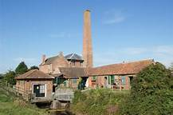
Friday 17th Sept  Tuck Shopping  Bridgewater  £1 + Spending  6:15 to 8pm  Mr Ingham | 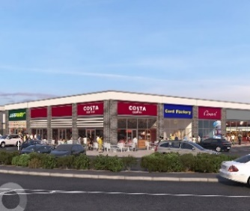 | Saturday 18th Sept  Ploughing Comp  Spectator, Chedzoy  £2  10 to 3pm  Miss Parker | 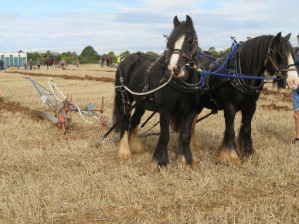 | Sunday 19th Sept  Banger Championships  Mendip Raceway  12 to 8pm  £10  Mr Ashton | 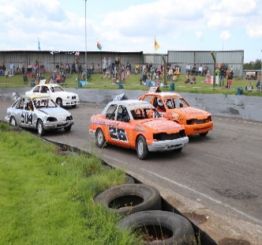
Friday 24th Sept  Timewarp Arcade  Bridgewater  £7:50  18:15 to 20:45  Mr Ingham |  | Saturday 25th Sept |  | Sunday 26th Sept  Helicopter Museum  Weston Super mare  9:30 to 1pm  £9  Ms Warren | 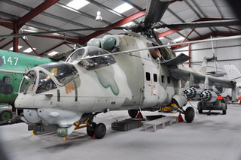
Friday 1st Oct  Bristol Bears v Bath  Ashton Gate  £30  5:30 to 10:30pm  Mr Ingham |  | Saturday 2nd Oct |  | Sunday 3rd Oct  Bowling  Taunton  10 to 1pm  £14.50  Mr Ingham
Friday 8th Oct  Scott Cinema  Yr 10/11  TBC  TBC  Mr Ingham | 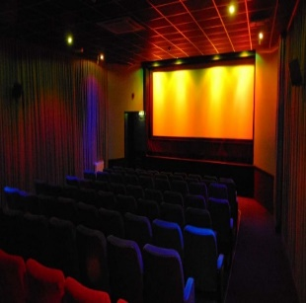 | Saturday 9th Oct  Pumpkin Carving  On Site  ???  ???  Matron or SM | 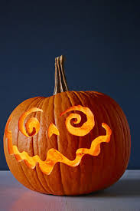 | Sunday 10th Oct  Timewarp Arcade  Bridgewater  £7:50  1:30 to 4:30  Miss Eastham

