October 2021
Dear Parent/Guardian

BRYMORE SKI TOUR TO FOLGARIDA-MARILLEVA RESORT, ITALY
9th - 16th APRIL 2022 (8 days / 7 nights / 6 days skiing or snowboarding)

In March 2020 our annual ski tour was cancelled literally weeks before departure for reasons we all know too well and I am happy to say everyone received a full refund.

So, somewhat later than the usual May launch date…

In April 2022 the annual Brymore Ski Tour will be skiing in the Folgarida-Marilleva Ski Resort in Italy. Folgarida-Marilleva is in the well-known Val di Sole area. It is a wonderful ski resort with an excellent snow record that caters for all abilities, with plenty of easy sunny slopes for beginners and intermediates. Folgarida itself is an attractive purpose-built resort set amongst pine trees.

We will be staying in the Hotel San Camillo, located in Dimaro, just a five-minute shuttle to the new gondola lift in Daolasa. Students will be staying in 2-6 bedded rooms (with an opportunity to choose roommates two weeks before departure once we have the room allocation) all with en-suite, TV and safe. The hotel has comfortable lounges, restaurant, TV room and a heated swimming pool. Breakfast and dinner are self-serve buffet style, hot lunches are provided in mountain restaurants. The hotel is set off the main road but just a few minutes walk into Dimaro, where there will be a regular shopping opportunity. Evening entertainments include bowling and/or ice skating, movie night, games/quiz night, karaoke and movie night as well as our usual presentation evening. I have used our tour company, Visions in Education, for many years and they have always provided a high-quality experience.

The price is £1,320 for skiing or £1,345 for snowboarding, however snowboarding is subject to there being eight boarders of similar ability, which is why we ask for your activity preference and experience in the reply slip below. This price is based on 40 students signing up.

Included in the price are:

- All return transfers from Brymore to a UK airport, flights into Milan and transfers into resort
- Full-board accommodation starting with an evening meal on the day of our arrival, buffet breakfasts and hot lunches in hotel restaurants
- 6 days x 4 hours of skiing or snowboarding lessons by fully qualified instructors and lift pass
- Hire of skis, poles, or board plus helmet and boots
- Evening entertainment package including daily swimming opportunity (our hotel has a pool), bowling/ice-skating, an evening in the nearby World Cup resort of Madonna di Campiglio, an Italian night in a local pizzeria, games/quiz/karaoke/movie night and presentation evening.
- Full travel and medical insurance

A non-refundable deposit of £270 (£295 for snowboarding) is required by return or Friday 12th November 2021, when I shall confirm the booking and flights will be reserved. This is important because we have a limited number of places which will be allocated on a first come, first served basis. A further three payments of £350 on the first of every month (December to February) will be required to secure your son’s place, payable by BACS payment or set up on the school’s on-line payment facility ‘Schools Cash Office’ (Mrs Eastham our Finance Officer will be happy to help with these details).

……/

What is NOT included:

- Passport (each student must have an up-to-date passport with at least six months of validity remaining from date of travel)
- Ski clothing (all students must wear appropriate clothing)
- Pocket money in Sterling and Euros (collected pre-departure, daily bank)
- Ski or snowboarding lessons on a dry slope, approximately ten weeks before the trip - arranged as an evening activity for beginners. (Unfortunately, this is not optional for beginners and usually costs £120 for a course of 6 x 2-hour lessons)

All cheques should be made payable to Brymore Academy or by BACS payment (reference ‘Ski’). Please note that payments are non-refundable in the event of your son withdrawing (or being withdrawn by the school) from the trip. Disinclination to travel is unfortunately not covered by our insurance. However, in such an event we will do our best to sell the place to another student.

Should the trip be cancelled due to COVID, the school will not be able to refund any money. However, should travel be cancelled by the UK Government for COVID reasons, or if travel to the destination country is not advised by the Foreign, Commonwealth & Development Office (FCDO), Visions in Education (VIE our tour operator) will issue a full refund. This guarantee only applies if the whole group is cancelled, it does not apply for individuals who, after booking, decide to cancel their trip. Under these circumstances regular booking conditions would apply (please contact me if you would like VIE’s full terms and conditions of booking).

PLEASE ALSO NOTE:

The main aim of our ski tour is to ski or snowboard - an exhilarating but physically demanding sport, sometimes in challenging conditions. The ski tour is a school activity and school rules apply, so standards of behaviour need to be exemplary. While exciting and enjoyable, activities such as skiing/snowboarding can be dangerous if simple instructions are not followed. Safety is also of paramount importance and your son’s behaviour at school will determine their place on the trip.

If you would like your son to take part in the ski tour, please complete the attached form and return it to the school together with a cheque for £270/£295 made payable to “Brymore Academy” (or payable by BACS payment or set up on the school’s on-line payment facility ‘Schools Cash Office’- and again, Mrs Eastham our Finance Officer will be happy to help with these details), no later than Friday 12th November 2021.

Should you have any questions please do not hesitate to contact me at school or via email, ian.ashton@brymoreacademy.co.uk

Yours sincerely
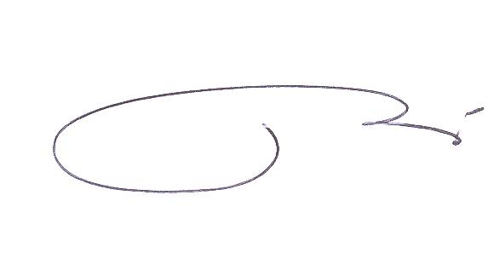

Ian Ashton
Ski Party Leader
Head of Maths & Galsworthy House

