January 2022

Dear Exhibitor

After the successful run of Open Days that have been held on our grounds in June over a large number of years, and with our two-year hiatus due to the global pandemic we are now getting ready for and delighted to announce the next one for 2022!

We shall be holding the Open Day and Country Fair on Saturday 25th June 2022 and we would very much like you to be a part of it.

Prompt return of the enclosed form will not only ensure we have a space for you, but that if you have somewhere specific you would like your stand then we are more likely to be able to accommodate this request, although cannot guarantee this. We politely request you read the additional notes at the bottom of the form in order to comply with the terms set out within it.

As with all of our events there will be county wide publicity, along with use of internet and social media advertising and when we confirm your booking we will send you posters for distribution.

Should you have any questions or queries then please do not hesitate to contact me through email or via Brymore on 01278 652369.

Yours faithfully

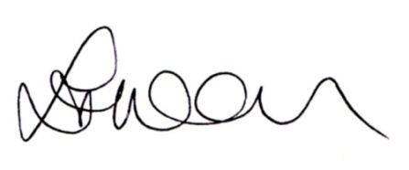
Lorraine Warren
Lorraine.Warren@brymoreacademy.co.uk

Enc

