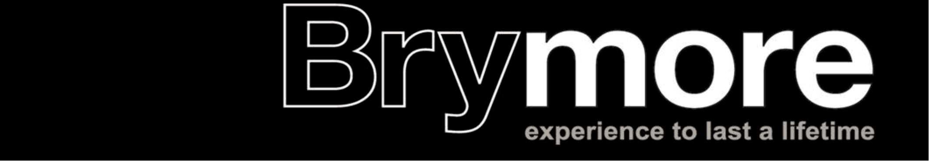

BRYMORE ACADEMY OPEN DAY 2022

Saturday 25th June 2022 // 10.30 am - 5.00 pm // Brymore

Interesting Vehicle Exhibitor Form

Please complete and return this form, and any payment, to:
Lorraine Warren, Brymore Academy, Cannington, Somerset, TA5 2NB by 1 June 2022
Vehicles are welcome free of charge or donations can be made to cover the costs of the day with cheques payable to Brymore Academy.
 | Title | First Name | Surname

Name
Address

Town & County
Post Code
Email
Telephone Number
Name and type of vehicles (including registration number):

Number of spaces required:
Confirmation of setting up time
Friday 24th June 3.00pm - 5.00pm Saturday 25th June // 8.00am – 09.30am
Number of vehicle permits required:

PTO
Please indicate advertising options should you require them in our A5 Open Day colour brochure (charges are to cover printing costs).
Full page £40
Half page £25
Quarter page £20

Please note:
- Should you wish to make a donation towards the cost of the running of this event (which we make no profit from) then please enclose cheques, plus any advertising costs as above, payable to Brymore Academy.
- All vehicles/exhibits must be set-up by 09.30am. For health and safety reasons the set-up times must be adhered to, please indicate on this form your chosen timings. We will not be accepting exhibits onto the site after 09.45am.
- Please ensure you include a copy of your Public Liability Insurance with this form on return.
- Further copies of this form are available on our website www.brymoreacademy.co.uk or can be posted to you if you contact the school office on 01278 652369.
- If we do not receive the above information by 1 June 2022 at midday then we are unable to accept your vehicle on site for this event due to risk assessment planning.
- Vehicles will not be permitted to leave the site until 5.15pm at the earliest or until the main ring has completed all activities; whichever is later.
Please sign in this box to confirm you have read and agree to adhere to the above conditions:

For any questions please contact Lorraine Warren on 01278 652369 or email: Lorraine.warren@brymoreacademy.co.uk

I have included my public liability insurance document with this form
[Grab your reader’s attention with a great quote from the document or use this space to emphasize a key point. To place this text box anywhere on the page, just drag it.]

