Weekend Activities Term 2b March 2022
Friday 4th Mar  Superstars of Wrestling  Chard Guildhall  17:45 to 22:00  £16  Ms Helps |  | Sunday 6th Mar  Hollywood Bowl  Taunton  13:30 to 17:00  £14.50  Mrs Warren
Friday 11th Mar  Card Making  19:00  Mrs Mexsom and Miss Helps |  | Sunday 13th Mar  Scott Cinema  Bridgwater  TBC £7.50  Mrs Rushbrook
Friday 18th Mar  TimeWarp Arcade  18.15 to 20.45  £7.50  Ms Helps |  | Sunday 20th Mar  Minehead Beach and Arcade  13:30 to 17:00  £1 plus spending money  Mrs Rushbrook | 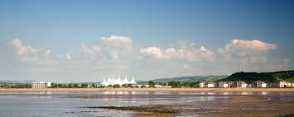
Friday 25th Mar  Quiz Night  Reid House  19:00 to 20:00  Mrs Mexson |  | Sunday 27th Mar  Exeter Chiefs v Tigers  Sandy Park  13:30 to 19:00  £23  Mrs Webb/Ms Hoogenboom
Friday 1st Apr  Fobsa Bingo  Doors open 18:00  Eyes down 18:30  School Hall  Duty Staff | 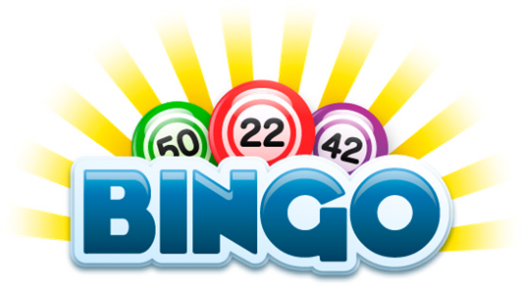 | Sunday 3rd Apr  Shopping  Bridgwater Retail Park  £1  TBC  IA | 