hele

BRYMORE ACADEMY

ANTI-BULLYING POLICY

Created by: Luke Winter
Date: May 2022
Review date: May 2023
Signature of Chair of Governors | 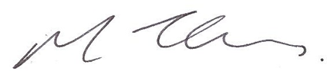  Signature of Headteacher

Contents
Introduction 3
Types of Bullying 3
Signs and Symptoms 4
Responding to a report of bullying 4
Education and Training 4
Appendix 1 – Responding to a concern/disclosure of bullying flowchart 5
Appendix 2 – Behaviour Statement Form 6
Appendix 3 – Witness Statement Form 7

Introduction

Bullying can be defined as ‘behaviour by an individual or group, repeated over time, that intentionally hurts another individual or group either physically or emotionally.
It can take many forms (for instance, cyber-bullying via text messages, social media or gaming, which can include the use of images and video) and is often motivated by prejudice against particular groups, for example on grounds of race, religion, gender, sexual orientation, special educational needs or disabilities, or because a child is adopted, in care or has caring responsibilities. It might be motivated by actual differences between children, or perceived differences.

Bullying also involves an imbalance of power between the perpetrator and the victim. This could involve perpetrators of bullying having control over the relationship which makes it difficult for those they bully to defend themselves. The imbalance of power can manifest itself in several ways, it may be physical, psychological (knowing what upsets someone), derive from an intellectual imbalance, or by having access to the support of a group, or the capacity to socially isolate. It can result in the intimidation of a person or persons through the threat of violence or by isolating them either physically or online.

Low-level disruption and the use of offensive language can in itself have a significant impact on its target. If left unchallenged or dismissed as banter or horseplay it can also lead to reluctance to report other behaviour. At Brymore Academy we ensure early interventions are put in place to help set clear expectations of the behaviour that is and isn’t acceptable and help stop negative behaviours escalating. Keeping Children Safe in Education (2016) defines bullying as a form of abuse, ‘peer abuse’. Stopping violence and ensuring immediate physical safety is our school’s first priority, but emotional bullying can be more damaging than physical; the school will make judgements about each specific case.

Types of Bullying

Bullying can be:

- Emotional including isolation of others by a refusal to co-operate with them and exclusion, being unfriendly, excluding, tormenting (e.g. hiding books, threatening gestures), deliberately excluding from social groups or an activity by refusal to sit next to/ talk to/ work/ co-operate with others. Emotional bullying can also include malicious rumours, e-mails or text messages, and exclusion from play/discussions etc. with those whom they believe to be their friends.
- Physical including the threat of physical harm, intimidation through physical gestures and actions, jostling, serious fighting, pushing, kicking, spitting, hitting, punching or any use of violence, use of weapons/threatening use of weapon (or any object which could be used as a weapon), the abuse of personal property, taking or hiding belongings, deliberately destroying or damaging work or possessions or removing personal property.
- Verbal including name-calling, sarcasm, spreading rumours, making snide comments, teasing, humiliating others, threatening others, inciting others to humiliate and threaten others.
- Written including spreading rumours by writing or printing unkind or malicious messages and pictures on paper.
- Cyber not occurring face to face but rather through electronic means including, but not limited to, social networking sites, internet and intranet sites, email, instant messaging, by mobile phone including through text messages and phone calls, photographs both real and manipulated.
- Racist including bullying directed at individuals of a certain race, culture, ethnicity, language, faith, community, national origin or national status. The distinctive feature of racist bullying is that the victim is attacked not as an individual but as the representative of a family, community or group. This is an area where schools are required to keep statistics about incidents.
- Cultural including focusing on and/or playing off perceived cultural differences or similar.
- Sexist covering a wide range of behaviour from name calling to physical sexual assault. It is the use of sexual language or negative stereotyping on the basis of gender.
- Sexual including unwanted or inappropriate physical contact or sexual innuendo.
- Homophobic including bullying directed towards people who are openly gay, bisexual, are perceived as gay, or show characteristics. Heterosexual young people subject to homophobic bullying are less reluctant to report it as this may enforce the stereotypical way that they are already viewed by others so sensitivity and positive support is required for victims.
- Religious including attacking faith, belief, religious practice or custom.
- Special Educational Needs and Disability including remarking upon, drawing attention to, or discriminating against persons with physical disabilities or learning difficulties or other identified special educational needs such as emotional and behavioural disabilities (EBD) and Specific Learning Difficulties (SLD) - Dyslexia, Dyscalculia and Dyspraxia.

All young people should be able to attend school without any fear of being bullied. Bullying is not tolerated at Brymore Academy and all accusations are taken seriously and dealt with. We consider the pastoral care of our young people to be of prime importance. During the school day this role largely rests with teachers and support staff. During boarding time this responsibility is passed to the Boarding team.

Signs and Symptoms

A young person my indicate be signs and behaviour that they are being bullies. All adults should be aware of these possible signs and investigate further if a student:

Is frightened of walking to or from school | Attempts or threatens suicide or absconds
Doesn’t want to go on the school/public bus | Cries themselves to sleep at night or had nightmares
Begs to be driven to school | Feels ill in the mornings
Changes their usual routine | Begins to do poorly at school
Is unwilling to go to school (school phobic) | Comes home with clothes torn or books damaged
Begins to truant | Has possessions that get damaged or ‘go missing’
Becomes withdrawn, anxious or lacking in confidence | Asks for money or starts stealing money
Starts stammering | Has food or money constantly go missing
Has unexplained cuts or bruises | Is bullying siblings or other students
Becomes aggressive, disruptive or unreasonable | Stops eating
Is frightened to say what is wrong | Gives improbable excuses for any of the above
Is afraid to use the internet or mobile phone | Is nervous and jumpy when cyber messages are received

These signs and behaviours could indicate other problems and concerns, but bullying should be considered as a possibility and should always be investigated. Students are encouraged to share their concerns with staff and using Whisper. Any concerns are passed to the DSL.

Responding to a report of bullying

All staff at Brymore Academy will be vigilant and endeavour to be alert to and respond to bullying behaviours. The flowchart in Appendix 1 details how staff should respond to any concerns or reports of bulling in the school.
Appendix 2 and 3 provide the templates used to record investigations into bullying behaviours.

Education and Training

As part of the PSHRE curriculum at Brymore Academy students are educated on the issues of bulling. Assemblies and the tutorial programme also tackle these issues to continue to address the key messages. The Behaviour Manager is responsible for the delivery of PSHRE and the tutor programme helping to develop a whole academy approach to tackling bulling.
Whole staff and specific training is given. Staff are expected to lead by example demonstrating the positive values they wish to see in others.

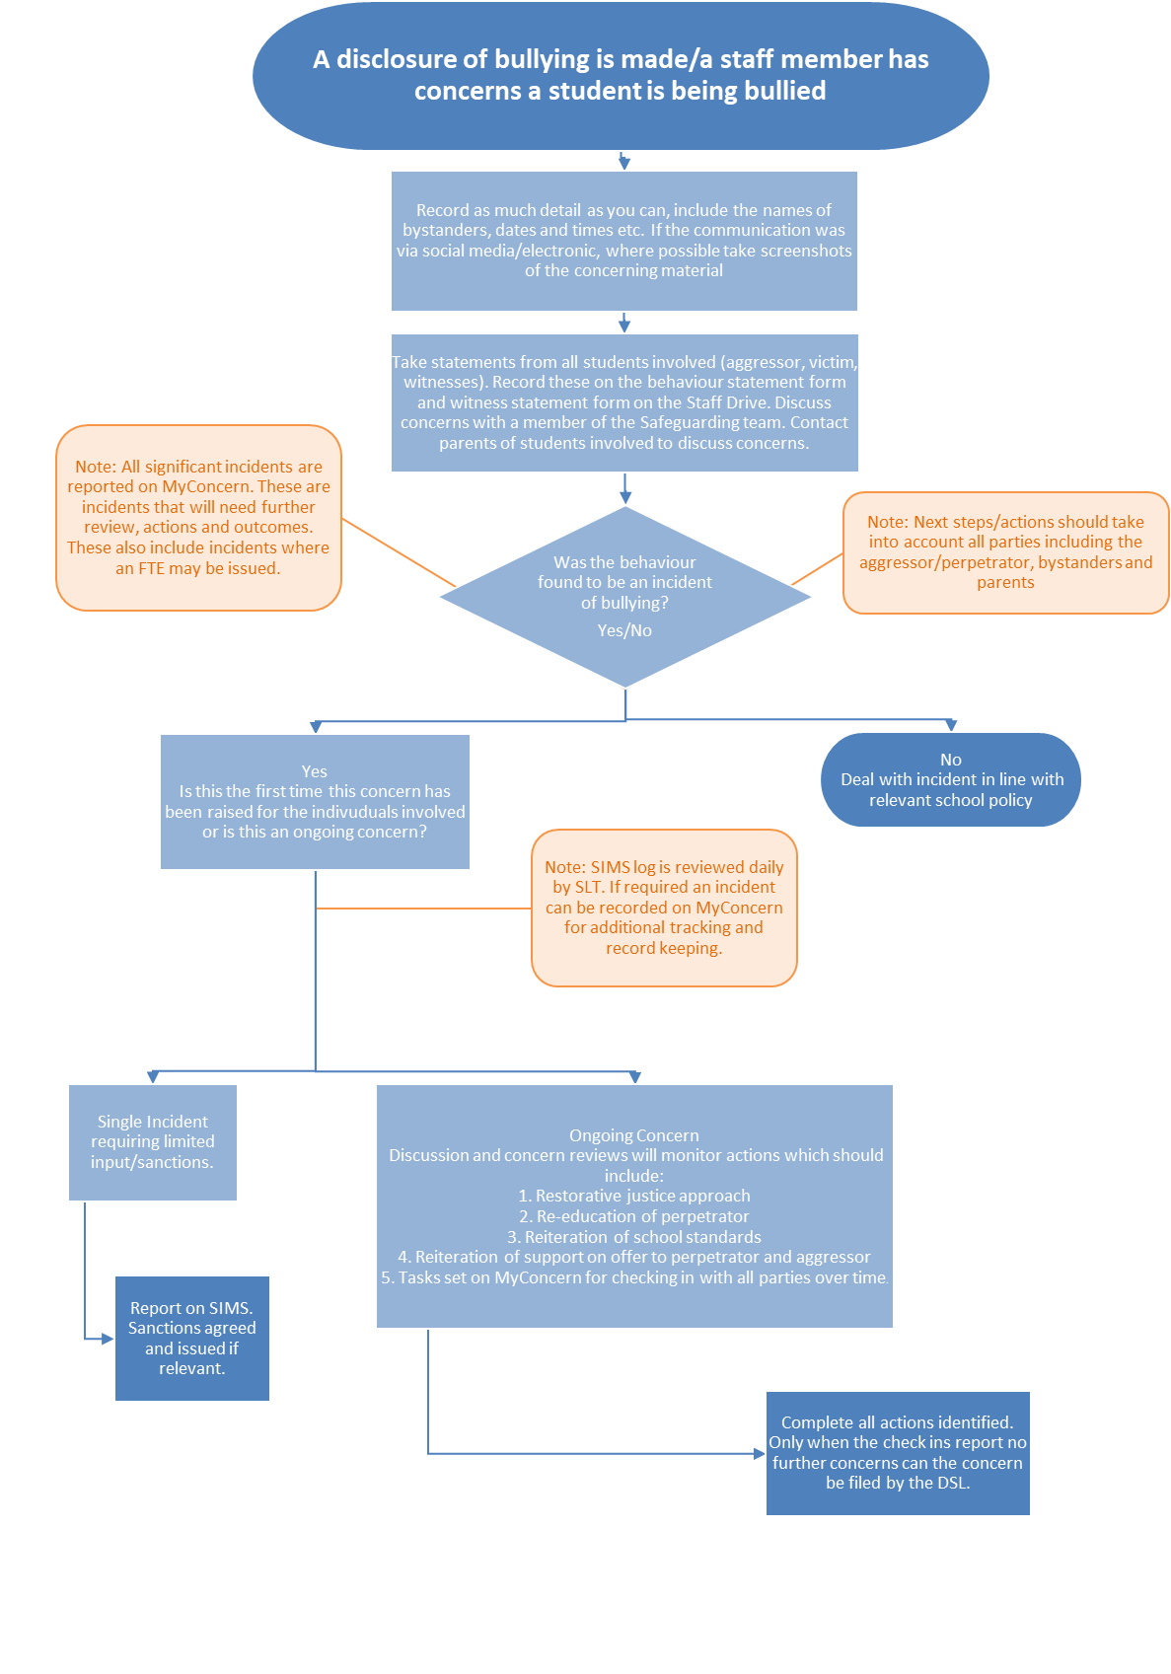
Appendix 1 – Responding to a concern/disclosure of bullying flowchart

Appendix 2 – Behaviour Statement Form

Name

Tutor Group
Where did this incident happen?

When did it happen?

Who else was there?

Details of incident

Date and time statement taken

Statement taken by?

Appendix 3 – Witness Statement Form

Brymore Witness Statement

Staff Name investigating-

Date and time of statement written-

Student Name- Student Signed-

Date and time of incident-

Scribed (written for you)- Y or N (Please circle)

Who?…

When?…

Where?…

What?…

Why?…

