Special Educational Needs SEN/D Information Report

An overview in how we support students with Special Educational Needs or Disabilities at our Academy

Introduction

Brymore really does offer a unique learning experience
Academic success is achieved through a practical curriculum, purpose built facilities and an emphasis on traditional values. We are a state boarding school for boys aged between 11 and 17, which means the education is free and we are open to day pupils.
Students often achieve higher academically than they would elsewhere, however we pride ourselves on the development of the student as a whole where hard work, manners and respect are instilled so that employers, members of the public and parents alike often comment 'You can always recognise a Brymore boy. That is why Brymore truly does offer 'an experience to last a lifetime’.

Brymore is a mainstream school. We aim to ensure that:
- Staff have high aspirations for every child, celebrating individual differences in ability, aptitude and skills. We endeavour to meet all individual need, providing opportunities for all students to reach their full potential.
- Students with learning difficulties are able to access their entitlement to a broad, balanced and relevant curriculum as part of the whole school community.
- We identify and assess children with SEN/D as early and as thoroughly as possible using the revised Code of Practice (2015).
- Part of our transition process involves contacting the previous school, either by phone call or visit.
- We maintain up to date knowledge of current SEN/D good practice and methodology in order to offer support and training in these areas to all staff in the school.
Our SEN/D provision aims to fulfil the expectations of the Core Standards – Somerset’s published expectations for all settings regarding the provision of SEN/D.
The Somerset SEN/D Local offer is accessible at:
Parental views
- ‘You have always supported me’ and ‘kept me on the straight road’ Student, finished in 2021.
- ‘My son wouldn’t have got to year 9 without the love and support of everyone. He would have struggled in a larger school. I know that academically and emotionally he will continue to thrive here” Parent, 2021
Here at Brymore we welcome student and parental views.
Core Standards
Quality First Teaching underpins the Core Standards and all educational provision. With Quality First Teaching, student’s needs are met in the classroom through highly focussed and well planned personalised teaching with high expectations for all learners. The Core Standards describes the entitlement of children and young people with Special Educational Needs and Disabilities in early years settings, schools and further education in Somerset. The five key aims of the standards are:
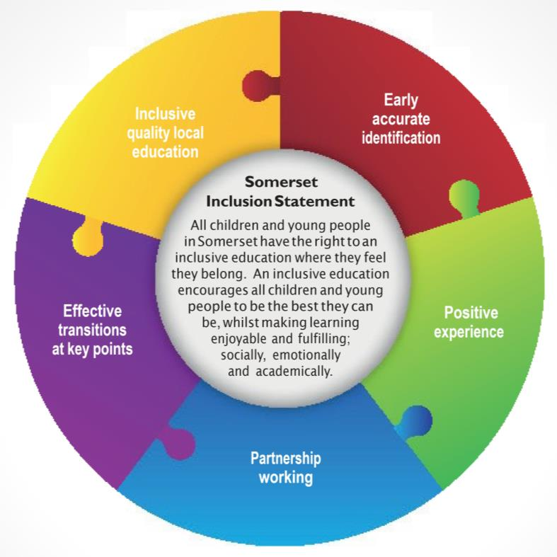

For further information on the Somerset Core Standards: https://www.somersetchoices.org.uk/family/information-and-advice/core-standards-for-education
How will the school know if my child needs extra help?
There are four types of Special Educational Needs and Disabilities (SEN/D), decided by the Department for Education (DfE):
- Communication and interaction
- Cognition and learning
- Social, mental and emotional health
- Sensory or physical
If your child has SEN/D, then their needs will fit into one or more of these areas. The Academy’s provision for SEN/D is defined as support which is, ‘additional to or different’ from that which is available to all children. We recognise that children make progress at different rates.
When identifying a child as having SEN/D we would consider the following:
• Liaison with previous school
• Your child is performing significantly below expected age related expectations of their peer group
• You as parent/carer have raised concerns
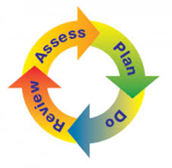
• Your child’s teacher(s) have raised concerns
• Liaison and advice from external agencies, e.g. physical health diagnosis from paediatrician

A Graduated Approach
The SEN/D (0-25 years) Code of Practice (2015) sets out that schools/academies/ colleges should develop a Graduated Approach – a cycle of assessment, planning and reviewing their actions in detail and with increasing frequency to identify the best way of obtaining adequate progress for children/young people.
Staff, SENDCo and other professionals will follow the sequence of assess, plan, do, review to ensure your child’s changing needs are met. This means your child may be removed from the SEN register if appropriate but, if needed, can be re-added at a later date. The Code of Practice highlights the Assess, Plan, Do, Review cycle as a strategy used to both identify and further support SEN/D students. The four part cycle of, ‘Assess, Plan, Do and Review’ provides a thorough understanding of your child’s needs and outcomes following intervention.
Through the application and transition process:
The application form asks your son’s school to inform us of any SEN/D he has. You will be asked to complete a timeline of key events that have occurred in your son’s life to support us with understanding his journey so far. Your son will also tell us of his likes and dislikes.

Every boy is interviewed before being offered a place at Brymore. You will be interviewed separately to your son. If your son has SEN/D, Ms Kim Hartley the SEN/DCo or Ms Dawn Carter, who is 2 i/c Learning Support will attend the interview to gather more information from you and him which will support his arrival and transition here.
In the spring and summer term, before your son starts at Brymore, we liaise closely with feeder schools usually via telephone or email to ensure that we have an accurate picture of his current needs. We attend Annual Review and planning meetings in feeder schools where possible (for local students with complex needs) and can arrange individual transition visits for your son here if needed.

All new boys are invited to attend our Induction event towards the end of the summer term prior to their arrival in September. Your son will join us for 1 and a half days. The purpose of this Induction is for your son to gather a flavour of the Brymore experience. He will meet key staff who will be looking after him and the other boys in his year group. He will take part in activities and we will complete some online tests in literacy and numeracy to give us an accurate baseline of his ability. This helps us to plan his teaching groups and support for his arrival in September.
In school:
Once your son starts at Brymore, we will continue to monitor his literacy and numeracy and social and emotional wellbeing which helps us to identify if he needs any additional support. Teaching staff are responsible for monitoring the progress of boys in their lessons and can raise concerns with the Learning Support Team, if they feel a boy is not making sufficient progress and requires additional support. This can start the graduated response cycle.

Learning Support staff meet regularly and will make informal observations of boys in lessons. Any concerns they may have are shared.
What should I do if I have concerns about my child?
If you tell us that you think your child has a SEN/D, we will discuss this with you and investigate – we will share with you what we find and agree with you next steps and also what you can do to help your child.
If there are concerns that your child has SEN/D in the first instance they may be added to a cause for concern list. This will mean that extra support is put in place and the impact of that support will be closely monitored. If after this support your child is identified as having a SEN/D, their name will be added to the SEN register. We recognise that your child’s needs may change over time and provision will reflect that. Parents will be informed if their child is placed on, or removed from the SEN/D register.
How will the school support my child?
Our SENDCo oversees all support and progress of any student requiring additional help across the academy. Support and intervention varies and will be based on your child’s individual needs.

Support and intervention at our school includes; Teacher input, (Quality First Teaching). For your child this would mean:
- Teachers having the highest possible expectations for your child and all students.
- Teaching is built on what your child already knows, can do and can understand.
- Specific strategies (which may be suggested by the SENDCo) are in place to support your child to learn.
- Teacher(s) will have carefully checked on your child’s progress and will have decided that your child has a gap or gaps in their understanding/learning and needs some extra support to help them make the best possible progress.
Staff will receive appropriate training to meet your child’s needs.
Specific group or individual work: Intervention which may take place in the classroom or a group room and be implemented by a teacher or a teaching assistant.
Specialist intervention overseen by outside agencies: this means your child has been identified by the SENDCo as needing some extra specialist support in school from a professional outside the school. This may be from Local Authority support services, such as the Autism and Social Communication Team, Learning Support Team, Education Psychology Service etc. Parental permission will be sought before contacting an outside agency. The specialist professional will work with the school and your child to understand their needs and make recommendations as to the ways your child is given support.

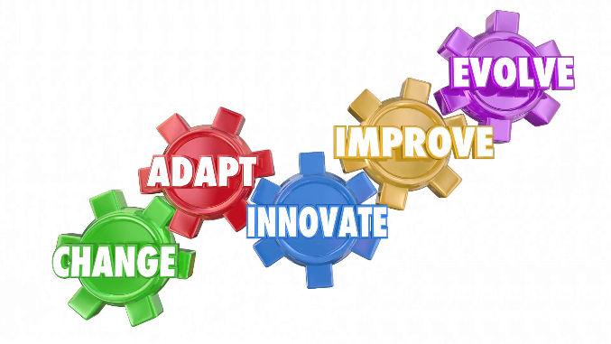

What specialist services and expertise are available to support your child?
We work closely with external agencies that support individual children’s needs within our academy.
These may include: GP, School Nurse, Educational Psychologist, Paediatrician, Speech and Language Therapist, Occupational Therapist, the Learning Support Service, the Autism and Social Communication Advisory Service, the Physical Impairment and Medical Support Service (PIMSS), the Child and Adolescent Mental Health Service (CAMHS). We also work with a range of further services including GetSet Services and Children’s Social Care.
If it is decided that your child may benefit from support from a specialist service then they will be referred by the SENDCo. Before this referral an Early Help Assessment meeting will take place where the available help will be discussed.

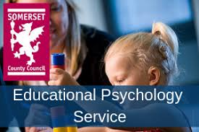

How is the curriculum adapted or made accessible to my child?
We pride ourselves on our unique curriculum and specialist facilities which are often the reason why boys and parents choose us for their education. In addition to this we place a great deal of emphasis on developing the whole child. Boys are expected to help run the school through garden and farm duties which promote our 3 Rs (Resilience, Resourcefulness and Responsibility). We encourage boys to take advantage of the many activities available outside of lessons (available for parents to view each week on our Parent Bulletin). Boys are encouraged to keep fit through regular fitness sessions and Chads Hill (our 3 mile run). These activities help to develop your son’s self-esteem, self-belief and confidence which then spill over into his academic studies.

All staff seek to challenge all boys to make the best possible progress and work closely with any additional staff in their lesson to meet the needs of the boys. Our small class sizes mean that boys receive greater individual attention and support in their learning.
At the end of Y9, we identify those boys who may need additional support in their examinations and invite a specialist in who assesses them for Access Arrangements. This is completed on an individual basis and may entitle your son to one or more of the following: extra time, a reader or scribe for examinations until the end of Y11.

At Brymore, your son will also:

Know their current levels and grades and an understanding of their next steps to make progress.
Be able to use a writing frame to scaffold and extend their written work.
Use Triple Impact Marking strategies - receive regular feedback (oral and written) to identify their areas of success and their next steps.
Understand the boundaries and expectations within the classroom.
Have smaller class sizes. On average there are 19 boys in a class. In lower sets, this number is normally around 12.

In practical lessons, there are additional subject specialist technicians meaning that an average staff to student ratio of 1:5 is achieved.
In lower sets, a TA is often present in addition to the class teacher and will support boys.
Y7 Forest School lessons in our own woodland.

Prep (homework) sessions that are led by your son’s houseparent or a member of the boarding team to work with him where appropriate. All boarders (and out boarders who are in on feeding duty) attend prep Monday to Friday for one hour each night. Prep is available to all out boarders who wish to attend.

A Homework Club provided by the learning support team between 4 and 5pm Monday – Thursday, providing additional support to those students who need it.
Education Health Care Plan (EHCP)
When a child is demonstrating a significant cause for concern or their learning need is more complex and persistent than can be met by the interventions already put in place, a statutory assessment will be considered. If statutory assessment is agreed by Somerset County Council SEND team, further assessments are completed and reports collated from outside agencies to assess level of need. If evidence demonstrates a significant SEN/D need, an EHCP will be written by Somerset County SEN/D team. Parental permission will be sought when requesting statutory assessment.
How will the school’s resources be allocated and matched to my child’s special educational needs?
We ensure that all children with special educational needs are provided for to the best of the academy’s ability with the funds available. The budget is allocated on a needs basis. The students who have the most complex needs are given the most support.
How will the decision be made about what type and how much support my child will receive?
The SENDCo and teaching staff will discuss your child’s needs and what support would be appropriate. Different children will require different levels of support in order to help them make progress and achieve their potential.
How will the school assess what impact the support has had on my child?
- We aim that your child’s education should be a partnership between parents and teachers therefore we aim to communicate with you regularly. You will have an opportunity to meet your child’s class teacher(s) and/or the SENDCo termly at parents’ evenings to discuss your child’s needs, support and progress.
- If your child is identified as having a Special Educational Need or Disability you will be invited to a review meeting. At this meeting the SENDCo, relevant staff involved with your child and any other professionals involved in your child’s care will review your child’s progress and agree next steps.
- If your child receives help from an outside agency, for example Autism & Communication or Learning Support Service, the process of APDR will be followed (see page 4)

What opportunities will there be to discuss my child’s progress and who will explain share my child’s needs and progress to me?

- Each half term, you will be sent a data report that shows you how your son is performing in each subject as well as his effort levels.
- You will receive a tutor report once a year followed by a Parent Consultation evening where you can meet individual staff and discuss his progress.
- If your son has an EHCP, you will be invited to attend an Annual Review meeting.
- You can meet informally with key staff at our school events.
- You will be informed of the progress that your son has made on completion of a literacy based SEN/D intervention.
- You are welcome to contact staff at any point in the academic year for a discussion of your son’s progress.
- The half termly newsletter and weekly parent bulletin will keep you updated of any activities and extra support sessions for your son.
- If your son is in year 10 or 11 you will receive a Course Information booklet that details ways of supporting him in each subject as well as outlining the content of the qualification each term.
- When your son is in year 11, you will be invited to attend our Raising Achievement days in English and Maths so that you can support him with revision when he is at home. We also provide packs of work for him to complete at key times.
- Your son will be asked to complete regular My Maths and Educake homework which you can view with them.
How will you help me to support my child’s learning?
Staff and the SEN/DCo can offer advice and practical ways that you can help your child at home.
If necessary, parents can be provided with a home/school communication book which your child will bring home daily so that comments from parents and the teacher(s) can be shared. Regular communication between key staff supporting your child, and home, is always encouraged.
Recommendations from external agencies e.g. speech and language therapist, will be shared with you so that strategies can be implemented at home and school. This may be in the form of a therapy care plan.
If you require any information the Learning Support and Pastoral Teams would be able to direct you.

What is the pastoral, medical and social support available to ensure my child’s overall well-being?
We have a caring, understanding ethos and are an inclusive academy; we welcome and celebrate diversity, and believe that high self-esteem is crucial to children’s well-being. As a nurturing school, all our vulnerable pupils are known to all staff.
Medical support:
We have a team of Matrons who are on site from breakfast through to bedtime. They support boys who might be ill and can organise them an appointment at Cannington Health Centre. They co-ordinate the administration of any prescribed medications and liaise with parents where necessary. They keep key staff in boarding and pastoral care informed of any individual issues each day. Matrons also support boys who may have a physiotherapy programme to follow.

Pastoral support:
Pastoral support is provided through the Vertical Tutoring system and the behaviour policy. In cases where a boy has been excluded more than once, a Pastoral Support Plan will be implemented and external agencies may be involved to avoid permanent exclusion.
There are many opportunities for your son to make a positive contribution through leadership including: peer mentoring in the boarding house, form captain, Head of Department in Agriculture and Horticulture and through the prefect and senior prefect student leadership in Y11. All boys will be taught how to show visitors around the site and will be used to complete this important role. This might be to show around prospective boys and their families, interview candidates or other visitors. Part of our recruitment and interview process involves a student panel who devise and pose questions to candidates and then feedback to the staff before final decisions are made. Boys can also put themselves forward to be elected on to the Academy Council or the various groups that meet (House Improvement Team, Food group). We hope that by providing boys with these opportunities, they will be able to develop the 3 Rs and make a positive contribution to the life of the academy.

Each morning, we hold a staff briefing where key information about boys is shared with teaching, support and boarding staff.

Social support:
A list of the interventions to develop social skills is provided on page 15.

How will my child be included in activities outside the classroom including day and residential trips?
At Brymore, we pride ourselves on the inclusive nature of the school and vast range of activities offered throughout curriculum and boarding time. We aim for all students to be included on school day trips and residential stays. We will provide necessary adaptions, having consulted with you, to ensure that this is successful.

All boys are expected to complete garden and farm duties and additional support is planned for boys who may find aspects of this difficult.
The academy offers an annual Ski trip and trip to Iceland and has taken boys to France on a summer holiday residential. These trips are open to all.

Activities Week is run at the end of each year and all boys take part in a range of physical and mental challenges. If your son has a complex medical, physical or social need, his access to these events will be carefully planned to ensure that he is able to take as full a part as possible. You will be involved in any relevant discussions.

A risk assessment is carried out prior to any off-site activity to ensure everyone’s health and safety will not be compromised. In the unlikely event that it is considered unsafe for a child to take part in an activity we will always explore different options to try and include the child.
How does the academy manage the administration of medicines and personal care?
We have a policy regarding the administration and management of medicines on the school site.

If a child’s health care needs are longer term, a medical or health care plan will need to be put in place. This will be done by health care professionals, parents and the SEN/DCo. Staff receive regular training regarding conditions and medication affecting individual children so that all staff can manage a medical situation should the need arise.

If a child requires personal care, a Personal Care Plan will be in place and staff will have undergone the appropriate training to undertake this level of care.

The school makes sure all staff understand their duty of care to children and young people in the event of an emergency.
All staff feel confident in knowing what to do in an emergency. This school understands that certain medical conditions are debilitating and potentially life threatening, particularly if poorly managed or misunderstood.
This school understands the importance of medication and care being taken as directed by healthcare professionals and parents. http://brymoreacademy.co.uk/about/policies-new-page/ - follow the link to our policy page.
What support is there for behaviour, avoiding exclusion and increasing attendance?
Brymore Academy has developed a range of flexible responses to meet the emotional and social needs of the students. There are a range of strategies in place in pastoral, learning support and curriculum areas that focus on enabling the individual to secure excellent attendance and achievement.

Excellent conduct is expected at Brymore. This includes positive behaviour and that individuals take responsibility for their actions and accept the consequences of their actions.

Behaviour management is a team approach and every member of staff has a professional responsibility to their colleagues to support each other by applying the academy’s code of conduct consistently and with certainty. Persistent low level disruption is not acceptable and staff must promote positive behaviour. Students, who persistently disrupt the safe, caring and nurturing environment of Brymore including in the classroom, around the site or in the boarding houses must be dealt with promptly. Every member of staff has the authority to discipline students regardless of time and place. Consistency around the site is just as important as in the classroom; the staff’s responsibility for good order and discipline extends to every part of the academy day and every interaction with a student.

It is in the interests of better life chances for our students that we emphasise the importance of school attendance for individual educational outcomes and develop systems and support that maximise the attendance of all students. All students are expected to attend regularly and be punctual. This establishes good working habits. Students who attend regularly achieve better results than those who do not.

Which interventions take place in school to support your child?
The academy offers a variety of interventions which support your child’s development academically, emotionally and socially. Staff are trained to deliver specific interventions to meet a range of needs.
Not all boys who need interventions are on the SEN register, we also have a Pastoral team who support boys with any mental health needs. The day staff are complemented by the boarding staff and any work done is communicated between all teams.

Intervention/Support | Criteria for a student to require this intervention.
Rapid Maths | For students assessed by the maths department (through standardised maths tests) as needing support in a key area of numeracy.  Monitoring progress: through assessment at the end of the intervention.
Forest School | All year 7 students receive this as part of a rotation carousel with Agriculture and Horticulture.
Group reading | An intervention designed to improve reading and comprehension skills
Spelling detectives | A programme aimed at students in year 7-8 to improve their spelling.
Talkabout | For students in need of support in their social communication skills and interaction with other students. This programme may be recommended by one of our advisory teachers following assessment.
‘The Den’ | Available for a minority of students who may experience significant anxiety in unstructured times when not in lessons. Manned by the Learning Support team.
Supervision between lessons | Available for students who may have temporary or permanent physical access needs or students who require intensive support when not under the direct instruction of a teacher.
Individual Literacy Intervention (ILI) | A bespoke literacy program, focused on the needs of each individual child.
Emotional Literacy Support Assistant (ELSA) | To help students gain an understanding and build on their emotional literacy.
Talkabout | An intervention designed to help children with their social and relationship skills.

There are other interventions that we run, however these are the main ones.
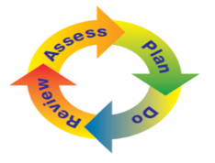
Interventions are bespoke and personalised to meet a child’s individual need. If you require any more detail on the above interventions please contact the school SEN/DCo. We follow the format of Assess, Plan, Do, Review (APDR) which is a holistic approach to meeting a child’s needs.

How accessible is the academy environment?
Physical access:
- The teaching block is on the ground floor as is the Dining Hall. Two of the boarding houses have a disabled lift access to the upper floors. A ramp is used to access the steps leading to the Library and neighbouring classrooms. There are disabled shower and toilet facilities in two of the boarding houses.

English as additional language:
- Boys for whom English is their second language are referred to EMAS for assessment and support is then put in place.
- An interpreter can be requested to support communication between a family and the academy where necessary.

How will the academy prepare and support my child when joining/transferring to a new school or moving to a new class?
Leaving Brymore to attend another secondary setting:
- If your son moves to another secondary setting, we will liaise with the SEN/DCo to ensure that they have an accurate picture of his SEN/D. If the new setting is local, we may be able to support your son by attending a transition meeting or visit where this is deemed appropriate.

Leaving Brymore to attend college or further education and training:
- As your son moves up into the older year groups, we invite local colleges to attend our annual Parent Consultation meetings so that you can pick up a prospectus and talk to their representative if you wish.
- Boys are taken to local college open evenings if they express an interest.
- The academy runs an annual Goals and Opportunities evening where boys and parents can get more information on careers and local colleges.
- In PSHE lessons, boys are taught how to write their CV, complete application forms and letters of application and prepare for an interview.
- In Year 11 boys will receive a mock interview from a visiting professional where they will present their CV and receive feedback on their performance.
- Local colleges may attend Brymore and meet with the SEN/DCo to discuss the needs of boys moving to them. For colleges further afield, this information is passed on via email, telephone or through the completion of college paperwork.
How will the school involve my child in their education?
As a school, we operate parent consultation evenings, which the boys are welcome to attend. They all have a tutor and have regular meetings with them to make sure that everything is going well.
There is also a Student Council where the boys get to give their views and opinions on all school matters.
Within the SEN/D department we send out student and parental questionnaires so that we can measure the success of the homework club and SEN/D provision.

How are the School Governors involved, and what are their responsibilities?
The SEN/DCo reports to the Governors termly to inform them about the progress of children with SEN/D; this report does not refer to individual students and confidentiality is maintained at all times. The SEN/DCo informs Governors of any recent changes in SEN/D policies both nationally, locally and also school based.
We have a named “SEN/D Governor” who keeps the Governing Board informed. The SEN/D Governor is Mrs April Lee.
What should I do as a parent if I think my child may have special educational needs?
Talk to us – in the first instance contact your child’s Class Teacher/tutor; if you still have concerns you can contact the school SEN/DCo (Special Educational Needs/Disabilities Coordinator). Look at our Special Education Needs and Disability policy, our Accessibility Plan and the county local offer, all available on the school website for further details of support provided.
Somerset SENDIAS is an organisation that provides independent advice and support for families.
Phone: 01823 355578 Email: info@somersetSEN/Dd.org.uk
Who should I contact if I am considering whether my child should join the school?
Contact the School Office to arrange a meeting with a senior member of the leadership team. If your child has a special education need or disability, contact the SEN/DCo who will discuss how the school could meet your child’s needs.
Phone: 01278 652369 Email: office@brymoreacademy.co.uk
SEN/DCO: Ms Kim Hartley
Contact details: 01278 652369 Brymore.SEND @brymoreacademy.co.uk
SEN/D Governor: Mrs April Lee
If unfortunately you feel unhappy about decisions or provision for your child, the complaints procedure is:
http://brymoreacademy.co.uk/wp-content/uploads/2018/11/Complaints-Policy.docx
Useful Websites
• €Hearing Impairment: www.ndcs.org.uk www.signature.org.uk
• €Autism: www.autism.org.uk www.autismsomerset.org.uk
• €Vision Impairment: www.somersetsight.org.uk www.rnib.org.uk • www.sompar.nhs.uk/what-we-do/children-and-young-people/parent-carer

The Local Offer provides information on the services available for children and young people with Special Educational Needs and Disabilities (SEND) aged between 0 to 25, and how to access them.
https://www.somerset.gov.uk/education-and-families/somersets-local-offer/
Glossary:
SEN/DCo | Special Educational Needs and Disabilities Co-ordinator
SEN/D | Special Educational Needs and Disabilities
Learning Support Team | Group of support staff line deployed and managed by the SEN/DCo to support the needs of students with SEN/D
LSA | Learning Support Assistant
HLTA | Higher Level Teaching Assistant (qualification)
Statement  Educational Health Care Plan | A legal document written and maintained by the Local Authority to outline the educational needs and provision of students with most complex SEN/D.  EHCP are the new documentation that will replace statements in the next three years.
High Needs Funding | In Somerset, SEN/DCos can apply for additional funding to meet the needs of the most complex students in an annual audit or at specific points within the year. High Needs funded students will not necessarily have a statement/EHCP
Vertical Tutoring | A pastoral system that tutors small numbers of students from each year group with one tutor allowing the tutor to devote more time to specific year groups at key times and greater mixing between year groups.
Quality First Teaching | This is what all students should receive in their lessons across the academy.
SEN/D support | A stage of the SEN/D Code of Practice that identifies students who may have gaps in their learning or SEN/D needs and require support that is different from other students.
Pastoral Support Plans (PSPs) | A plan that is agreed following more than one fixed term exclusion that sets clear targets and identifies any support that may be necessary.
Individual Education Plans (IEPs) | At Brymore the needs of our most complex students are outlined for staff in a support plan that includes background information, educational interventions, boarding support and any other relevant information.
Looked After Children | Children in the care of the Local Authority
Personal Education Plan (PEP) | A meeting of professionals that reviews the educational needs of a Looked After Child every six months and sets targets.
CATs | Cognitive Ability Tests assess a student’s ability to use words, numbers and their problem solving skills and provide us with a useful baseline.
EAL | English as an Additional Language

