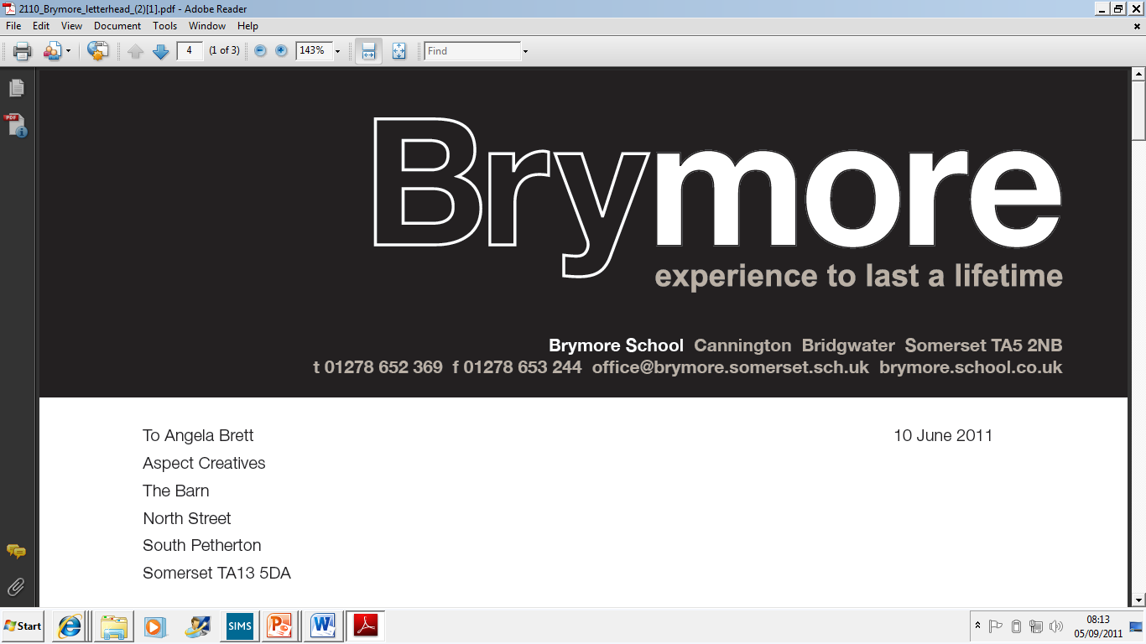

1.COMPLAINTS POLICY (Exams)
2024/25

This policy is reviewed annually to ensure compliance with current regulations

Approved/reviewed by
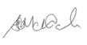
Date of next review | November 2025

Key staff involved in the policy
Role | Name(s)
Head of centre | Stefan McHale
Exams officer | Lisa Gardner

Purpose of the policy
This policy confirms Brymore Academy compliance with JCQ’s General Regulations for Approved Centres (sections 5.3, 5.8) in drawing to the attention of candidates and their parents/carers its written complaints which will cover general complaints regarding the centre’s delivery or administration of a qualification.

Grounds for complaint
A candidate (or his/parent/carer) may make a complaint on the grounds below (this is not an exhaustive list).
Teaching and learning
- Quality of teaching and learning, for example
  - Non-subject specialist teacher without adequate training/subject matter expertise utilised on a long-term basis
  - Teacher lacking knowledge of new specification/incorrect core content studied/taught
  - Core content not adequately covered
  - Inadequate feedback for a candidate following assessment(s)
- Pre-release/advance material/set task issued by the awarding body not provided on time to an exam candidate
- The taking of an assessment, which contributes to the final grade of the qualification, not conducted according to the JCQ/awarding body instructions
- Candidate not informed of his centre assessed marks prior to marks being submitted to the awarding body
- Candidate not informed of his centre assessed marks in sufficient time to request/appeal a review of marking prior to marks being submitted to the awarding body
- Candidate not given sufficient time to review materials to make a decision whether to request a review of centre assessed marks
- Candidate unhappy with internal assessment decision (complainant to refer via Mr McHale to the centre’s internal appeals procedure)
- Centre fails to adhere to its internal appeals procedure
Access arrangements and special consideration
- Candidate not assessed by the centre’s appointed assessor
- Candidate not involved in decisions made regarding his access arrangements
- Candidate did not consent to record their personal data online (by the non-acquisition of a completed candidate personal data consent form)
- Candidate not informed/adequately informed of the arrangements in place and the subjects or components of subjects where the arrangements would not apply
- Exam information not appropriately adapted for a disabled candidate to access it
- Adapted equipment/assistive technology put in place failed during exam/assessment
- Approved access arrangement(s) not put in place at the time of an exam/assessment
- Appropriate arrangements not put in place at the time of an exam/assessment as a consequence of a temporary injury or impairment
- Candidate unhappy with centre decision relating to access arrangements or special consideration (complainant to refer via Mr McHale to the centre’s internal appeals procedure)
- Centre fails to adhere to its internal appeals procedure
Entries
- Failure to clearly explain a decision of early entry for a qualification to candidate (or parent/carer)
- Candidate not entered/entered late (incurring a late entry fee) for a required exam/assessment
- Candidate entered for a wrong exam/assessment
- Candidate entered for a wrong tier of entry
Conducting examinations
- Failure to adequately brief candidate on exam timetable/exam regulations prior to exam/assessment taking place
- Room in which exam held did not provide candidate with appropriate conditions for taking the exam
- Inadequate invigilation in exam room
- Failure to conduct exam according to the regulations
- Online system failed during (on-screen) exam/assessment
- Disruption during exam/assessment
- Alleged, suspected or actual malpractice incident not investigated/reported
- Eligible application for special consideration for a candidate not submitted/not submitted to timescale
- Failure to inform/update candidate on the accepted/rejected outcome of a special consideration application if provided by awarding body
Results and Post-results
- Before exams, candidate not made aware of the arrangements for post-results services and the accessibility of senior members of centre staff after the publication of results
- Candidate not having access to a member of senior staff after the publication of results to discuss/make decision on the submission of a review/enquiry
- Candidate request for return of work after moderation and work not available/disposed of earlier than allowed in the regulations
- Candidate (or parent/carer) unhappy with a result (complainant to refer via exams officer to awarding body post-results services)
- Candidate (or parent/carer) unhappy with a centre decision not to support a clerical re-check, a review of marking, a review of moderation or an appeal (complainant to refer via Mr McHale to the centre’s internal appeals procedure)
- Centre fails to adhere to its internal appeals procedure
- Centre applied for the wrong post-results service/for the wrong script for a candidate
- Centre missed awarding body deadline to apply for a post-results service
- Centre applied for a post-results service for candidate without gaining required candidate consent/permission

Raising a concern/complaint
If a candidate (or his parent/carer) has a general concern or complaint about the centre’s delivery or administration of a qualification he is following, Brymore Academy encourages him to try to resolve this informally in the first instance. A concern or complaint should be made in person, by telephone or in writing to the head of centre.
If a complaint fails to be resolved informally, the candidate (or his parent/carer) is then at liberty to make a formal complaint.
How to make a formal complaint
- A formal complaint should be submitted in writing by completing a complaints form
- Forms are available from the examinations officer and also Appendix 1
- Completed forms should be returned to Head of Centre
- Forms received will be logged by the centre and acknowledged within 5 working days
How a formal complaint is investigated
- The head of centre will further investigate or appoint a member of the senior leadership team (who is not involved in the grounds for complaint and has no personal interest in the outcome) to investigate the complaint and report on the findings and conclusion
- The findings and conclusion will be provided to the complainant within 3 school weeks
- In the event it takes longer, the complainant will be kept informed

Internal appeals procedure
Following the outcome, if the complainant remains dissatisfied and believes there are clear grounds, an appeal can be submitted.
- Any appeal must be submitted by following the centre’s internal appeals procedure and completing an internal appeals form
- Forms received will be logged by the centre and acknowledged within 5 calendar days
- The appeal will be referred to Head of Centre.
- The Head of Centre will inform the appellant of the final conclusion.

Complaints form | FOR CENTRE USE ONLY
 | Date received
Please tick box to indicate the nature of your complaint | Reference No.
Name of complainant
Candidate name (if different to complainant)
Please state the grounds for your complaint below:

If your grounds are lengthy, please write as bullet points; please keep to the point and include relevant detail such as dates, names etc. and provide any evidence you may have to support what you say
If necessary, continue on an additional page if this form is being completed electronically or overleaf if hard copy being completed
Detail any steps you have already taken to resolve the issue(s) and what you would consider to be a good resolution to the issue(s)

Complainant signature: Date of signature:
- Complaint against the centre’s delivery of a qualification
- Complaint against the centre’s administration of a qualification
This form must be completed in full - an incomplete form will be returned to the complainant.
Complaints log
On receipt, all complaints are assigned a reference number and logged. Outcome and outcome date is also recorded.
Ref No. | Date received | Complainant name | Outcome | Outcome date

