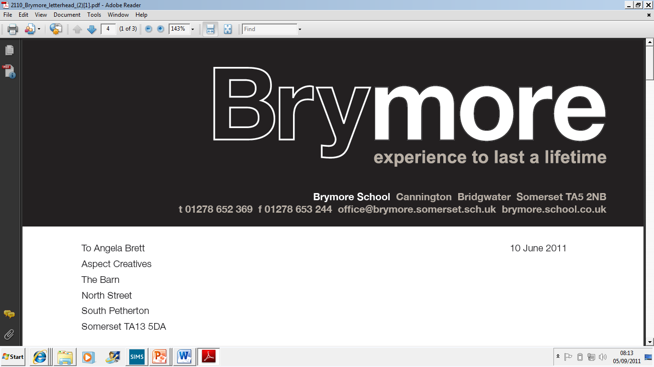

10. PROCEDURE TO VERIFY THE IDENTITY OF ALL CANDIDATES (Exams)
2024/25

This policy is reviewed annually to ensure compliance with current regulations

Approved/reviewed by

Date of next review | November 2025

Key staff involved in the policy
Role | Name(s)
Head of centre | Stefan McHale
Exams officer | Lisa Gardner
This procedure is reviewed and updated annually to ensure that procedures to verify the identity of all candidates that are entered for examinations or assessments at Brymore Academy are managed in accordance with current requirements and regulations.
References in this procedure to GR and ICE refer to the JCQ publications General Regulations for Approved Centres and Instructions for conducting Examinations

Contents
Key staff involved in the procedure 2
Purpose of the procedure 3
Process to check candidate identity 3
Internal candidates 3
Private candidates 3
Procedures to verify candidate identity at the time of the examination/assessment 3
Roles and Responsibilities 4
The role of the exams office/officer 4
Additional responsibilities: 4

Purpose of the procedure
The purpose of this procedure is to confirm that Brymore Academy :
- verifies the identity of all students that it enters for examinations or assessments (GR 5.6)
- has processes in place to be satisfied that that all candidate identities have been checked (GR 5.6)
- has written procedures in place to verify the identity of all candidates at the time of the examination or assessment (GR 5.9)

Process to check candidate identity

Internal candidates
The identity of students on roll at Brymore Academy is checked as part of the initial registration process. (GR 5.6)

The process is:
- The relevant Local Education Authority (LEA) will notify school of Year 7 admissions and details.
- Parents/Carers are contacted by the school. Admissions form is completed for all admissions and a copy of birth/adoption certificate is requested.
- Primary School may also send through a CTF with student details.
- Data collection sheet issued annually, to correct and update details held on MIS system.
- Exam entries are made using the details on the MIS system.

Private candidates
The identity of students (private candidates), not on roll at a centre but who may be accepted to take examinations, must be checked by a verification process which involves photo-ID. (GR 5.6)

At Brymore Academy:

- Candidates are asked to complete a 'Private Candidate Entry Form' with all personal details and details of examinations being taken
- Photographic proof of identification is asked for in the shape of driving license or passport
- Evidence is retained on file.
- Our policy is not to normally accept private candidates

Procedures to verify candidate identity at the time of the examination/assessment
Invigilators are able to establish the identity of all candidates sitting examinations by following the arrangements in place to carry out adequate checks. (ICE 16.1)

The arrangements at Brymore Academy are:

- The use of desk cards that contain internal candidate's photographs,
- A senior member of centre staff (approved by the head of centre, who has not taught the subject being examined) will be present at the start of the examination to assist with the identification of candidates
- Once the exam has started the invigilator along with the attendance register will walk around and check the identity of each candidate

The following measures are also in place:
- A private/external candidate or a transferred candidate who is not known to the centre will be asked to show photographic documentary evidence to prove that they are the same person who entered/registered for the examination/assessment, e.g. passport or photographic driving licence (ICE 16.2)
- Invigilators will be informed of those candidates with access arrangements and made aware of the access arrangement(s) awarded (ICE 16.4)

Roles and Responsibilities

The role of the exams office/officer

- Through training, ensure invigilators are aware of the procedures for verifying the identity of all candidates at the time of the examination or assessment. (ICE 16.1)
- The exams officer will produce a photo list of all candidates sitting exams which will be kept in the exam boxes provided for each room.

- Prior to the examination, inform a private/external candidate or a transferred candidate who is not known to the centre that they must show photographic documentary evidence to prove that they are the same person who entered/registered for the examination/assessment, e.g. passport or photographic driving licence. (ICE 16.2)
- Prior to the beginning of the examination, brief invigilators on those candidates with access arrangements and make them aware of the access arrangement(s) awarded (ICE 16.4)

Additional responsibilities:
Invigilators need to check candidate identity marries up with their allowed access arrangement/s

- Details of a candidate’s access arrangements are on their ID desktop card.
- Access arrangements sheet are produced and attached to exam registers which shows what access arrangements entitlements a candidate has been awarded.

