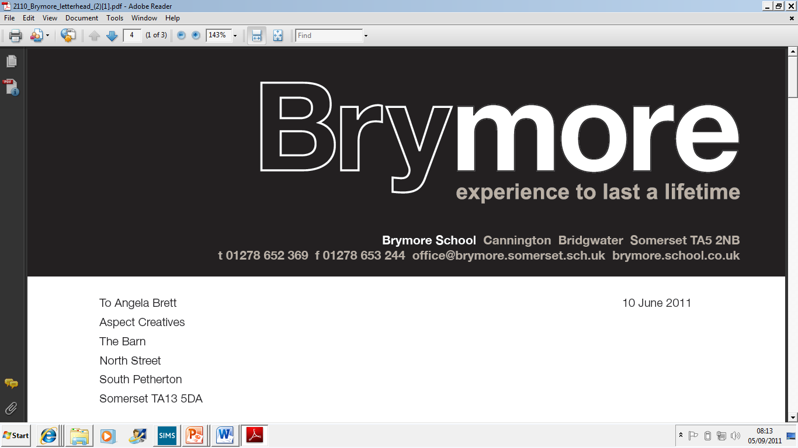

11. PROCEDURE TO DEAL WITH CANDIDATES’ REQUESTS FOR ACCESS TO SCRIPTS, CLERICAL RE- CHECKS, REVIEWS OF MARKING, REVIES OF MODERATION AND APPEALS TO THE AWARDING BODIES (Exams)
2024/25

This policy is reviewed annually to ensure compliance with current regulations

Approved/reviewed by

Date of next review | November 2025

Key staff involved in the policy
Role | Name(s)
Head of centre | Stefan McHale
Exams officer | Lisa Gardner

These procedures are reviewed and updated annually to ensure that Brymore Accademy deals with candidates‘ requests for access to scripts, clerical re-checks, reviews of marking, reviews of moderation and appeals to the awarding bodies in accordance with current requirements and regulations.
Reference in these procedures to GR and PRS refer to the JCQ publications General Regulations for Approved Centres and Post-ResultsServices

Contents
Key staff involved in the procedure 2
Introduction 4
Access to Scripts (ATS): 4
Reviews of Results (RoRs): 4
Appeals: 4
Purpose of the procedures 4
The arrangements for post-results services 4
Dealing with requests 5
Candidate consent 5
Submitting requests 6
Dealing with outcomes 6
Managing disputes 6

Introduction
Following the issue of results, awarding bodies make post-results services available.

The JCQ post-results services currently available are detailed below.

Access to Scripts (ATS):
- Copies of scripts to support reviews of marking
- Copies of scripts to support teaching and learning

Reviews of Results (RoRs):
- Service 1 (Clerical re-check) - This is the only service that can be requested for objective tests (multiple choice tests)
- Service 2 (Review of marking)
- Priority Service 2 (Review of marking) - This service is only available for externally assessed components of GCE A-level specifications (an individual awarding body may also offer this priority service for other qualifications)
- Service 3 (Review of moderation) - This service is not available to an individual candidate

Appeals:
- The appeals process is available after receiving the outcome of a review of results

Purpose of the procedures
The purpose of these procedures is to confirm how Brymore Academy deals with candidates‘ requests for access to scripts, clerical re-checks, reviews of marking, reviews of moderation and appeals to the awarding bodies in compliance with JCQ regulations (GR 5.13).

Details of these procedures are made widely available and accessible to all candidates by:
- The candidate handbook
- The academy website

The arrangements for post-results services
- Candidates must be made aware of the arrangements for post-results services prior to the issue of results (GR 5.13)
- A review of moderation cannot be undertaken upon the work of an individual candidate or the work of candidates not in the original sample (PRS 4.3)
- The appeals process is available after receiving the outcome of a review of results (PRS 5.1)
At Brymore Academy:
- Candidates are made aware of the arrangements for post-results services prior to the issue of results
- Candidates are also informed of the periods during which senior members of centre staff will be available/accessible immediately after the publication of results so that results may be discussed, and decisions made on the submission of reviews of marking (GR 5.13, PRS 4.1)

Candidates are made aware/informed by:
- The issue of a letter
Full details of the post-results services, internal deadline(s) for requesting a service are provided by the Exams Officer.

Dealing with requests
- All post-results service requests from internal candidates must be made through the centre (GR 5.13)

At Brymore Academy the process to request a service is by completing the consent form for Review of Results or Access to Scripts.

Candidate consent
- Candidates must provide their written consent for clerical re-checks, reviews of marking and access to scripts services offered by the awarding bodies after the publication of examination results (GR 5.13
Brymore Academy will:
- Acquire written candidate consent in all cases before a request for a clerical recheck, a review of marking or an access to scripts service is submitted to the awarding body
- Acquire informed candidate consent to confirm the candidate understands that the final subject grade and/or mark awarded following a clerical re- check or a review of marking, and any subsequent appeal, may be lower than, higher than, or the same as the result which was originally awarded
- Only collect candidate consent after the publication of results
- Retain consent forms from candidates for at least six months following the outcome of a clerical re-check or review of marking or any subsequent appeal (PRS 4.2
- Retain consent/permission forms from candidates to request and use their scripts for at least six months (PRS 6.2)

Submitting requests
Brymore Academy will:

- Submit requests electronically for clerical re-checks, reviews of marking, reviews of moderation and access to scripts by the published deadline(s) in accordance with the JCQ publication Post-results services (GR 5.13)
- Submit requests for appeals in accordance with the JCQ publication A guide to the awarding bodies’ appeals processes (GR 5.13)
- Confirm the awarding body's acknowledgement of receipt of a review of results request prior to the deadline for submission of post-results services and regularly check the progress of the request online (PRS 4.5)

Dealing with outcomes
Brymore Academy will:
- Ensure outcomes of clerical re-checks, reviews of marking, reviews of moderation and appeals are made known to candidates as soon as possible (GR 5.13)
Candidates will be notified by:
- being emailed a copy of the decision from the awarding body

Managing disputes
At Brymore Academy any dispute/disagreement will be managed in accordance with the internal appeals procedure to manage disputes when a candidate disagrees with a centre decision not to support a clerical re-check, a review of marking, a review of moderation or an appeal (GR, section 5.13).

