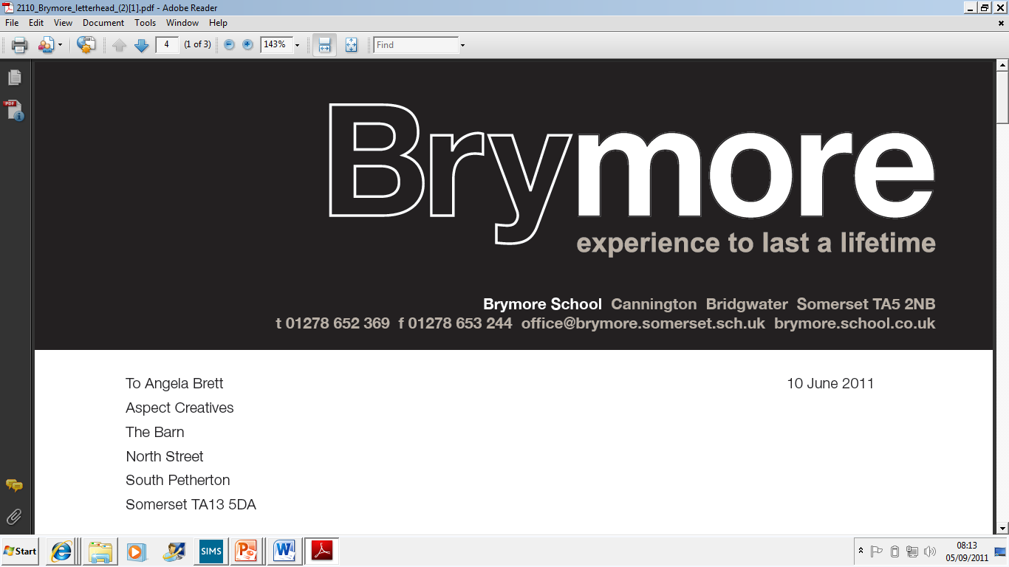

12. PROCESS TO CHECK THE QUALIFICATIONS OF THE CENTRE’S ASSESSOR (Exams)
2024/25

This policy is reviewed annually to ensure compliance with current regulations

Approved/reviewed by
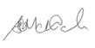
Date of next review | November 2025

Key staff involved in the policy
Role | Name(s)
Head of centre | Stefan McHale
Exams officer | Lisa Gardner

Purpose of the Process
The purpose of this policy is to define the process to be followed to check the qualifications of the Centre's Assessor(s).

The Head of Centre will check that the centre’s specialist assessor’s qualifications meet the JCQ required levels. The SENCo & AHT Inclusion will monitor that the assessment process is correctly carried out. (AA 7.3)

- An appropriately qualified psychologist registered with the Health & Care Professions Council (HCPC)

- A specialist assessor with a current SpLD Assessment Practising Certificate, awarded by BDA.

- A specialist assessor with the post-graduate qualification in individual specialist assessment at or equivalent to Level 7, including at least 100 hours relating to individual specialist assessment.

Brymore Academy currently uses one assessor:

Mr T Griffin (Bridgwater & Taunton College Trust – assessor) who has the following qualification:
- Certificate of Psychometric Testing, Assessment & Access Arrangements (CPT3A), Equivalent to Level 7

A copy of their certificate is held on file electronically and a hardcopy within the exam officer filing cabinet.

