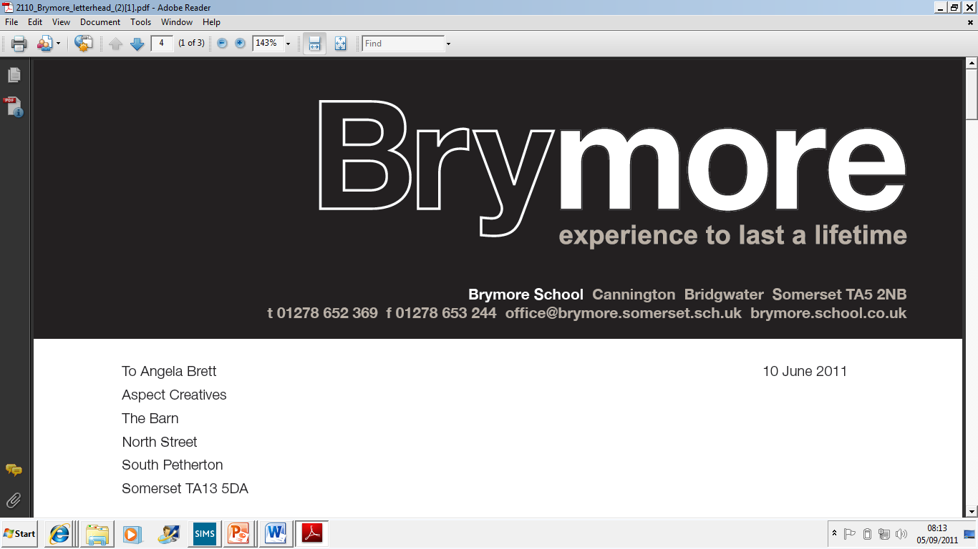

13. CHILD PROTECTION & SAFEGUARDING POLICY (Exams)
2024/25

This policy is reviewed annually to ensure compliance with current regulations

Approved/reviewed by
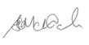
Date of next review | November 2025

Key staff involved in the policy
Role | Name(s)
Head of centre | Stefan McHale
Exams officer | Lisa Gardner

Purpose of the policy
This policy details how Brymore Academy, in relation to the management, administration and conducting of examinations and assessments, ensures that the moral and statutory responsibility to safeguard and promote the welfare of children is met.
The policy also details how staff are trained and supported to be alert to, and report, the signs of abuse and neglect and how they will follow centre procedures to ensure that children receive effective support, protection, and justice.
The procedures contained in this policy apply to all staff associated with the management, administration and conducting of examinations and assessments at Bridgwater College Academy.

Policy aims
- To provide all exams-related staff at Brymore Academy with the necessary information to enable them to meet their safeguarding and child protection responsibilities
- To ensure consistent good practice
- To demonstrate the commitment with regard to safeguarding and child protection to pupils/students, parents/carers and other partners when taking examinations and assessments at Brymore Academy
- To contribute to the wider centre Child Protection and Safeguarding Policy

Section 1 – Roles and Responsibilities
Designated safeguarding lead (DSL)
DSL (and any deputies) will take lead responsibility for child protection and safeguarding in relation to examinations and assessments. The DSL will offer advice, support and expertise in all matters relating to child protection and safeguarding in relation to examinations and assessments, etc.
Exams officer
The Exams Officer will support the DSL as directed, and undertake all relevant training etc.
Other exams staff
Invigilators and other facilitators of access arrangements will undertake training as directed by the DSL, report child protection and safeguarding issues/concerns in line with centre processes/policy etc.

Section 2 – Staff
Recruitment
Brymore Academy ensures that only ‘suitably qualified and experienced adults’ are employed in the management, administration and conducting of examinations and assessments. This is supported by the safer recruitment process which includes:
- completing an application form which includes their employment history and explains any gaps in that history
- providing two referees, including at least one who can comment on the applicant’s suitability to work with children
- providing evidence of identity and qualifications
- verifying their mental and physical fitness to carry out their work responsibilities
- verifying their professional qualifications, as appropriate
- carrying out further additional checks, as appropriate, on candidates who have lived or worked outside of the UK, including (where relevant) any teacher sanctions or restrictions imposed by a European Economic Area professional regulating authority, and criminal records checks or their equivalent
- asking for written information about previous employment history and check that information is not contradictory or incomplete. We will seek references on all short-listed candidates, including internal candidates, before interview. We will scrutinise these and resolve any concerns before confirming appointments.
- if offered employment, be checked in accordance with the Disclosure and Barring Service (DBS) regulations as appropriate to their role. This will include:
  - an enhanced DBS check and a barred list check for those including unsupervised volunteers engaged in Regulated Activity
  - an enhanced DBS check without a barred list check for all volunteers not involved in Regulated Activity but who have the opportunity of regular contact with children
  - ensuring that this member of staff has a subscription to the DBS Update Service (where relevant)
- if offered employment, provide evidence of their right to work in the UK
- be interviewed by a panel of at least two school leaders/governors, if shortlisted]
DBS check information
All information on the checks carried out on those who are employed solely for the purpose of periodic exams-related activity, such as external invigilators/facilitators, will be recorded in the centre’s single central record (SCR). Copies of these checks, where appropriate, will be held in individuals’ personnel files.
Existing staff
All existing staff are being moved to the DBS update system.
If there are concerns about an existing member of staff’s suitability to work with children, all relevant checks will be carried out as if the individual was a new member of staff. This action will also be taken if an individual moves from a post that is not regulated activity to one that is.
Anyone who has harmed, or poses a risk of harm, to a child or vulnerable adult will be referred to the DBS:
- Where the ‘harm test’ is satisfied in respect of the individual (i.e., that no action or inaction occurred but the present risk that it could was significant)
- Where the individual has received a caution or conviction for a relevant offence
- If there is reason to believe that the individual has committed a listed relevant offence, under the Safeguarding Vulnerable Groups Act 2006 (Prescribed Criteria and Miscellaneous Provisions) Regulations 2009
- If the individual has been removed from working in regulated activity (paid or unpaid) or would have been removed if they had not left

‘Break in service’
To comply with ‘break in service’ regulations, all external invigilators/facilitators will be required to register with the DBS Update Service on an annual basis and provide consent for the designated senior member of staff in charge of safeguarding arrangements to carry out an online check to view the status of their existing enhanced DBS certificate. This will not apply to any invigilators who meet the ‘frequency test’ at Brymore Academy – e.g., working 3 or more times in a 30-day period, or attending the centre at least every 3 months for training, updates etc.
By registering with the Update Service, these staff will be permitted to attend on any day during an exam series (providing they can supply an updated Disclosure Certificate and ID) without the need for additional checks or any additional attendance at Brymore Academy.
Agency staff
Written notification will be obtained from any agency or third-party organisation that it has carried out the necessary safer recruitment checks that we would otherwise perform. A check will also be performed to confirm that the person presenting themselves for work is the same person on whom the checks have been made.

Section 3 – Supporting staff
All exams’ staff at Brymore Academy are made aware of the good practice guidelines and staff code of conduct in relation to child protection and safeguarding.
They are informed and updated on the contents of the centre Child Protection and Safeguarding Policy by training sessions, online information, hard copy information.
Training/information delivered
Date delivered | Details of training/information delivered | Audience (e.g. invigilators, access arrangements facilitators etc.)
December 2025 | Safeguarding Update from the Safeguarding Lead/ Deputy DSL. | Invigilators & access arrangements facilitators

Section 4 – Areas covered
All exams staff will be trained/updated to ensure that they are complying with the centre policy on child protection and safeguarding.

Section 5 – Reporting
The process for staff to report issues/concerns relating to child protection and safeguarding is:
To the safeguarding team as soon as possible
If a member of staff needs to make a complaint/report a colleague or other adult who works with children (whistleblowing), they should report it to the Head of Centre.

Section 6 - Protocols for one-to one support/supervision
Where staff are engaged in invigilation/facilitation and/or centre supervision on a one-to one basis with a candidate the following protocols should be followed.
Summoning immediate assistance in case of any concern
The Exams Officer will be summoned by means of mobile phone allowed when in a one to one situation or if they are not in the exam room.
Leaving the examination room temporarily
Where a member of staff may accompany a candidate requiring a toilet break, the member of staff should first check the facility is empty, the candidate is left unaccompanied at the entrance to the facility/the entrance to the cubicle) etc.
Where a member of staff may accompany a candidate who is feeling unwell the Exams Officer will be summoned by means of mobile phone allowed when in a one to one situation or if they are not in the exam room.
References
Keeping children safe in education www.gov.uk/government/publications/keeping-children-safe-in-education--2

Check someone's criminal record as an employer www.gov.uk/dbs-check-applicant-criminal-record
DBS Update Service www.gov.uk/dbs-update-service
DBS Checks for Schools www.onlinedbschecks.co.uk/job-sectors/dbs-checks-for-schools/

