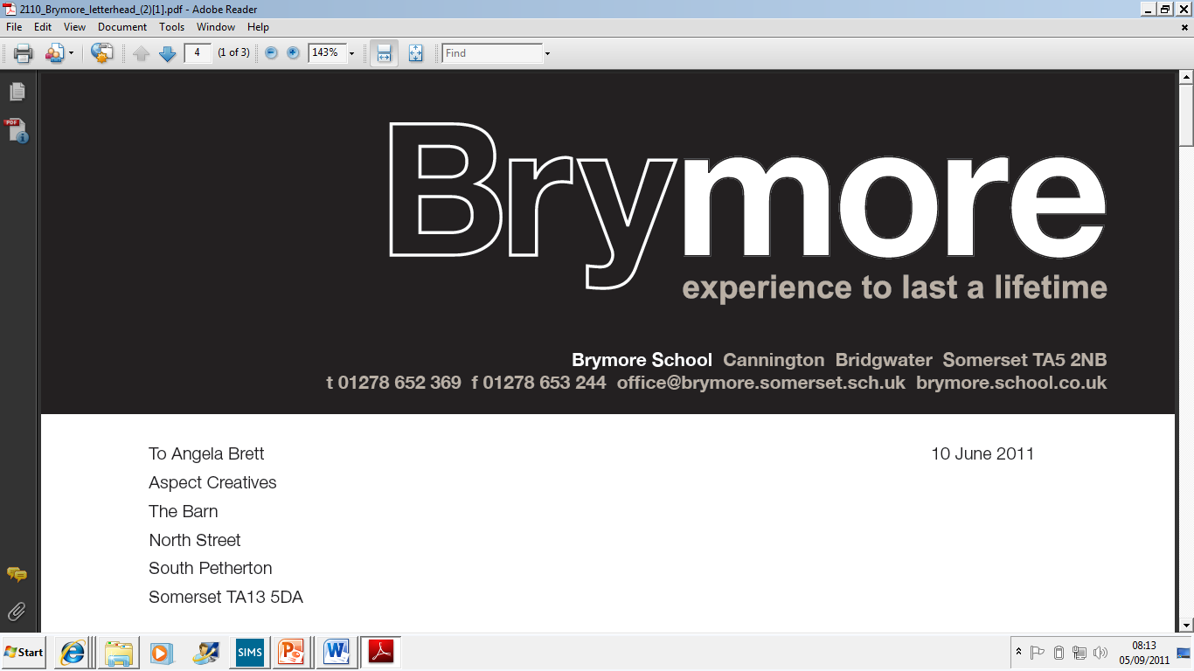

2.CONFLICT OF INTEREST POLICY (Exams)
2024/25

This policy is reviewed annually to ensure compliance with current regulations

Approved/reviewed by
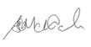
Date of next review | November 2025

Key staff involved in the policy
Role | Name(s)
Head of centre | Stefan McHale
Exams officer | Lisa Gardner

Contents
Key staff involved in the Conflict of Interest Policy 2
What does this policy affect? 4
Purpose of the policy 4
Procedure for planning and managing conflict of interests 5
The process 5
Responsibilities 5
Appendix 1 – Conflict of interest Log 7

What does this policy affect?

It is the responsibility of the head of centre to ensure that Brymore Academy has a written conflicts of interest policy in place available for inspection. This policy confirms Brymore Academy:

Manages conflicts of interest by informing the awarding bodies, before the published deadline for entries for each examination series, of:

- any members of centre staff who are taking qualifications at their own centre which include internally assessed components/units
- any members of centre staff who are teaching and preparing members of their family (which includes step-family, foster family and similar close relationships) or close friends and their immediate family (e.g. son/daughter) for qualifications which include internally assessed components/units and maintains clear records of all instances where:
- exams office staff have members of their family (which includes step-family, foster family and similar close relationships) or close friends and their immediate family (e.g. son) being entered for examinations and assessments either at the centre itself or other centres
- centre staff are taking qualifications at their own centre which do not include internally assessed components/units
- centre staff are taking qualifications at other centres (GR 5.3)

It is the responsibility of the head of centre to ensure that Brymore Academy has a written conflicts of interest policy in place available for inspection. This policy confirms that Brymore Academy:

Manages conflicts of interest by informing the awarding bodies, before the published deadline for entries for each examination series, of:
- any members of centre staff who are taking qualifications at their own centre which include internally assessed components/units
- any members of centre staff who are teaching and preparing members of their family (which includes step-family, foster family and similar close relationships) or close friends and their immediate family (e.g. son/daughter) for qualifications which include internally assessed components/units and
maintains clear records of all instances where:
- exams office staff have members of their family (which includes step-family, foster family and similar close relationships) or close friends and their immediate family (e.g. son/daughter) being entered for examinations and assessments either at the centre itself or other centres
- centre staff are taking qualifications at their own centre which do not include internally assessed components/units
- centre staff are taking qualifications at other centres (GR 5.3)

Purpose of the policy
A process is in place to collect any conflict of interest information for the current academic year from all centre staff to identify and manage any conflicts of interest in relation to exams.

Procedure for planning and managing conflict of interests

The process

A declaration of conflict interest form is sent electronically to all centre staff in advance of any formal examinations taking place in the centre. Completed forms must be returned in prior to the examinations starting. The purpose of this policy is to confirm how Brymore Academy manages conflicts of interest under normal delivery arrangements in accordance with the regulations.

There is a conflict of interest log, any potential conflicts declared are recorded on this log (appendix 1). The relevant awarding bodies are informed (where required) of specific conflicts of interest before the published deadlines for entries for the exam series' by identifying and following the individual awarding bodies process. The agreed measures/protocols taken/put in place to mitigate any potential risk to the integrity of the qualifications affected are recorded on the log and the affected member of staff informed of these measures/protocols.

Responsibilities

Head of centre

- Ensure conflicts of interest are managed according to the requirements (GR 5.3)
- Ensure clear records are maintained and that the records include details of the measures taken to mitigate any potential risk to the integrity of the qualifications affected (GR 5.3)
- Ensure the records are available where they may be requested by a JCQ Centre Inspector and/or awarding body staff (GR 5.3)
- Ensure the records are retained until the deadline for reviews of marking has passed or until any appeal, malpractice or other results enquiry has been completed, whichever is later (GR 5.3)
- Ensure that entering members of centre staff for qualifications at this centre is as a last resort in cases where the member of centre staff is unable to find another centre
- Ensure that proper protocols are in place to prevent the member of centre staff having access to examination materials prior to the examination and that other centre staff are briefed on maintaining the integrity and confidentiality of the examination materials
- Ensure that during the examination series the member of centre staff is treated in the same way as any other candidate entered for that examination, does not have access to examination materials and does not receive any preferential treatment (GR 5.3)

Senior Leaders

- Ensure that centre staff are aware of the requirement to declare any interest - Ensure that declarations are recorded/logged as potential conflicts of interest

Exams Office/officer

- Ensure the process for collecting declarations of interest is undertaken
- Identify and follow the awarding body's administrative process for submitting details of members of staff who are:
  - Taking qualifications which include internally assessed components/units at their own centre
  - Teaching and preparing members of their family (which includes step-family, foster family and similar (close relationships) or close friends and their immediate family (e.g.

son) for qualifications which include internally assessed components/units (GR 5.3)
- Retain the records of the measures taken to mitigate any potential risk to the integrity of the qualifications affected until the deadline for reviews of marking has passed or until any appeal, malpractice or other results enquiry has been completed, whichever is later (GR 5.3)

Appendix 1 – Conflict of interest Log

Date recorded | Staff name & job title(s)/role(s) | Conflict of interest (COI) | Measures taken/protocols in place to mitigate any potential risk to the integrity of the qualifications affected

The records may be inspected by a JCQ Centre Inspector and/or awarding body staff. They might be requested in the event of concerns being reported to an awarding body. The records must be retained until the deadline for reviews of marking has passed or until any appeal, malpractice or other results enquiry has been completed, whichever is later.

Conflict of interest (COI) | Measures taken/protocols in place to mitigate any potential risk to the integrity of the qualifications affected
(As a last resort where unable to find another centre) Taking a qualification(s) at this centre which includes an internally assessed component/unit  □ COI declared to relevant awarding body before the published deadline for entries (for each affected examination series) | - prevent the member of centre staff having access to confidential examination/assessment materials prior to exam(s)/assessment(s)  - brief other relevant centre staff on maintaining the integrity and confidentiality of exam/assessment materials  - ensure the member of centre staff is treated in the same way as any other candidate entered for that qualification, does not have access to examination materials and does not receive any preferential treatment
Teaching and preparing a member of family (which includes step-family, foster family and similar close relationships) or close friends and their immediate family (e.g. son/daughter) for a qualification(s) which includes an internally assessed component/unit  □ COI declared to relevant awarding body before the published deadline for entries (for each affected examination series) | - make every effort to avoid situations where a candidate is assessed by a person who has a close personal relationship with the candidate  - ensure the member of centre staff is not solely involved in making assessment decisions for the affected candidate for any internally assessed component/unit  - ensure the marked work will be submitted for moderation whether or not it is part of the moderation sample
A member of exams office staff and has a member of family (which includes step-family, foster family and similar close relationships) or close friends and their immediate family (e.g. son/daughter) being entered for examinations and assessments at this centre or another centre | ensure that the member of exams office staff does not have unaccompanied access to confidential examination materials (for example, question papers, pre-release materials, answer scripts etc.  - ensure that another person is present for particular administrative arrangements relating to the candidate’s exams/assessments
Taking a qualification at this centre which does not include internally assessed components/units | prevent the member of centre staff having access to confidential examination materials prior to exam(s)  - brief other relevant centre staff on maintaining the integrity and confidentiality of examination materials  - ensure the member of centre staff is treated in the same way as any other candidate entered for that qualification, does not have access to examination materials and does not receive any preferential treatment
Taking a qualification at another centre | ensure the member of centre staff does not have access to confidential examination materials for the same awarding body qualification if this is delivered in the centre

8

