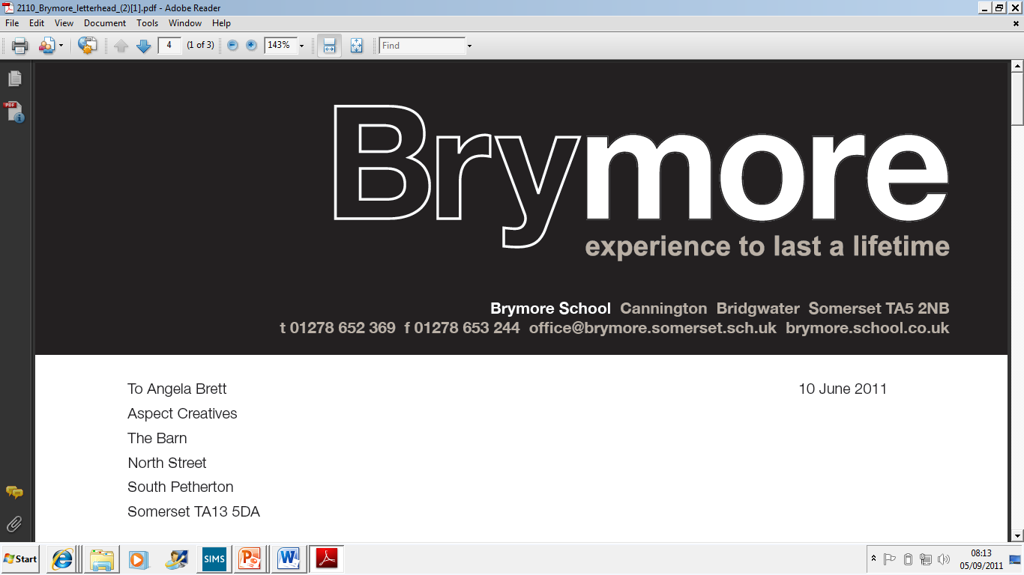

5.MALPRACTICE POLICY (Exams)
2024/25

This policy is reviewed annually to ensure compliance with current regulations

Approved/reviewed by
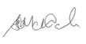
Date of next review | November 2025

Key staff involved in the policy
Role | Name(s)
Head of centre | Stefan McHale
Exams officer | Lisa Gardner

Contents
Key staff involved in the conduct of non-examination assessments 2
What does this policy affect? 3
Purpose of the policy 4
Procedure for planning and managing conflict of interests 4
The process 4
Informing and advising candidates 4
Identification and reporting of malpractice 5
Reporting suspected malpractice to the awarding body 5
Communicating malpractice decisions 6
Appeals against decisions made in cases of malpractice 6
Responsibilities 6

What does this policy affect?

What is malpractice and maladministration?

‘Malpractice’ and ‘maladministration’ are related concepts, the common theme of which is that they involve a failure to follow the rules of an examination or assessment. This policy and procedure use the word ‘malpractice’ to cover both ‘malpractice’ and ‘maladministration’ and it means any act, default or practice which is:
- a breach of the Regulations
- a breach of awarding body requirements regarding how a qualification should be delivered
- a failure to follow established procedures in relation to a qualification which:
  - gives rise to prejudice to candidates
  - compromises public confidence in qualifications
  - compromises, attempts to compromise or may compromise the process of assessment, the integrity of any qualification or the validity of a result or certificate
  - damages the authority, reputation or credibility of any awarding body or centre or any officer, employee or agent of any awarding body or centre - Suspected Malpractices Policies and Procedures 1 (SMPP 1)

Candidate malpractice

‘Candidate malpractice’ means malpractice by a candidate in connection with any examination or assessment, including the preparation and authentication of any controlled assessments, coursework or non-examination assessments, the presentation of any practical work, the compilation of portfolios of assessment evidence and the writing of any examination paper. (SMPP 2)

Centre staff malpractice

'Centre staff malpractice’ means malpractice committed by:
- a member of staff, contractor (whether employed under a contract of employment or a contract for services) or a volunteer at a centre; or
- an individual appointed in another capacity by a centre such as an invigilator, a Communication Professional, a Language Modifier, a practical assistant, a prompter, a reader or a scribe (SMPP 2)

Suspected malpractice

For the purposes of this document, suspected malpractice means all alleged or suspected incidents of malpractice. (SMPP 2)

Purpose of the policy
To confirm Brymore Academy:
- has in place a written malpractice policy which covers all qualifications delivered by the centre and details how candidates are informed and advised to avoid committing malpractice in examinations/assessments, how suspected malpractice issues should be escalated within the centre and reported to the relevant awarding body (GR 5.3)

Procedure for planning and managing conflict of interests

The process

In accordance with the regulations Brymore Academy will:

- Take all reasonable steps to prevent the occurrence of any malpractice (which includes maladministration) before, during and after examinations have taken place (GR 5.11)
- Inform the awarding body immediately of any alleged, suspected or actual incidents of malpractice or maladministration, involving a candidate or a member of staff, by completing the appropriate documentation (GR 5.11)
- As required by an awarding body, gather evidence of any instances of alleged or suspected malpractice (which includes maladministration) in accordance with the JCQ publication Suspected Malpractice - Policies and Procedures and provide such information and advice as the awarding body may reasonably require (GR 5.11)

Brymore Academy has in place:

- Robust processes to prevent and identify malpractice, as outlined in section 3 of the JCQ publication Suspected Malpractice: Policies and Procedures. (SMPP 4.3)
- This includes ensuring that all staff involved in the delivery of assessments and examinations understand the requirements for conducting these as specified in the following JCQ documents and any further awarding body guidance:
  - General Regulations for Approved Centres; Instructions for conducting examinations (ICE); Instructions for conducting coursework; Instructions for conducting non-examination assessments; Access Arrangements and Reasonable Adjustments; A guide to the special consideration process; Suspected Malpractice: Policies and Procedures; Plagiarism in Assessments; AI Use in Assessments: Protecting the Integrity of Qualifications; A guide to the awarding bodies’ appeals processes (SMPP 3.3.1)

Informing and advising candidates

The candidates are informed in assemblies of what Malpractice is and how it can affect them in line with current JCQ policy guidance (Suspected Malpractice Policies and Procedures).
For any assessments that could be affected by the use of AI, the teaching staff will inform the candidates of the regulations of if/when AI technology can be used, and also the consequences of its misuse. Staff have been directed towards the AI Use in Assessments: Protecting the Integrity of Qualifications guidance.
Candidates are informed of the ‘Warning to Candidates’ and ‘Unauthorised Items’ posters which are also outside all exam rooms. The Suggested wording for invigilators’ announcements at the beginning of written examinations also details what can and cannot be done in the exam environment and is read out at the beginning of every exam.

Identification and reporting of malpractice

As soon as suspected malpractice is suspected during the exam process, the Exams Officer is made aware and discusses with the witness of what occurred and logs this on the appropriate JCQ form and gets it signed by the witness. The candidate is then informed of the incident and the potential impact that it may have on their results. They are asked if they agree with the statement and if they would like to add a statement.
The checklist on Form M1 is followed for candidate malpractice.
The checklist on Form M2/M3 is followed for centre/staff maladministration/malpractice.

Reporting suspected malpractice to the awarding body

- The exams officer or head of centre will notify the appropriate awarding body immediately of all alleged, suspected or actual incidents of malpractice, using the appropriate forms, and will conduct any investigation and gathering of information in accordance with the requirements of the JCQ publication Suspected Malpractice: Policies and Procedures (SMPP 4.1.3)
- The head of centre will ensure that where a candidate who is a child/vulnerable adult is the subject of a malpractice investigation, the candidate’s parent/carer/ appropriate adult is kept informed of the progress of the investigation (SMPP 4.1.3)
- Form JCQ/M1 will be used to notify an awarding body of an incident of candidate malpractice. Form JCQ/M2 will be used to notify an awarding body of an incident of suspected staff malpractice/maladministration (SMPP 4.4, 4.6)
- Malpractice by a candidate discovered in a controlled assessment, coursework or non- examination assessment component prior to the candidate signing the declaration of authentication need not be reported to the awarding body but will be dealt with in accordance with the centre’s internal procedures. The only exception to this is where the awarding body’s confidential assessment material has potentially been breached. The breach will be reported to the awarding body immediately (SMPP 4.5)
- If, in the view of the investigator, there is sufficient evidence to implicate an individual in malpractice, that individual (a candidate or a member of staff) will be informed of the rights of accused individuals (SMPP 5.33)
- Once the information gathering has concluded, the head of centre (or other appointed information- gatherer) will submit a written report summarising the information obtained and actions taken to the relevant awarding body, accompanied by the information obtained during the course of their enquiries (5.35)
- Form JCQ/M1 will be used when reporting candidate cases; for centre staff, form JCQ/M3 will be used (SMPP 5.37)
- The awarding body will decide on the basis of the report, and any supporting documentation, whether there is evidence of malpractice and if any further investigation is required. The head of centre will be informed accordingly (SMPP 5.40)

Communicating malpractice decisions

Once a decision has been made, it will be communicated in writing to the head of centre as soon as possible. The head of centre will communicate the decision to the individuals concerned and pass on details of any sanctions and action in cases where this is indicated. The head of centre will also inform the individuals if they have the right to appeal. (SMPP 11.1)

Appeals against decisions made in cases of malpractice

Brymore Academy will:
- Provide the individual with information on the process and timeframe for submitting an appeal, where relevant
- Refer to further information and follow the process provided in the JCQ publication A guide to the awarding bodies' appeals processes

Responsibilities
Head of centre

- notify the appropriate awarding body immediately of all alleged, suspected or actual incidents of malpractice
- review and sign any Malpractice cases prior to submission
- ensure that where a candidate who is a child/vulnerable adult is the subject of a malpractice investigation, the candidate’s parent/carer/ appropriate adult is kept informed of the progress of the investigation (SMPP 4.1.3)
- pass on details of any sanctions and action in cases where this is indicated

Senior Leaders

- Ensure that centre staff are aware of the requirement to adhere to the examinations regulations, instances that class as Malpractice and the Malpractice process

Exams Office/officer

- Complete the administrative process for any cases of Suspected Malpractice
- Identify and follow the awarding body's administrative process for malpractice
- Retain the records of any cases of Malpractice

