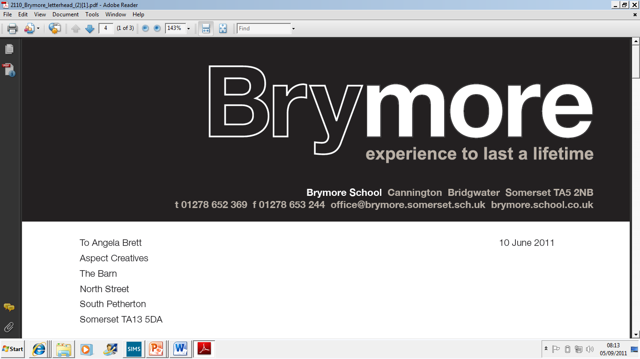

7.WORD PROCESSOR POLICY (Exams)
2024/25

This policy is reviewed annually to ensure compliance with current regulations

Approved/reviewed by
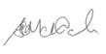
Date of next review | November 2025

Key staff involved in the policy
Role | Name(s)
Head of centre | Stefan McHale
Exams officer | Lisa Gardner

This Policy is in addition to the Exams Policy and it follows the guidelines set out by the JCQ and is updated accordingly.

Use of a Word Processor will be considered for candidates with:

- A learning difficulty which has a substantial and long term adverse effect on their ability to write legibly
- A medical condition
- A physical disability
- A sensory impairment
- Illegible handwriting where their writing is incomprehensible to anyone unfamiliar with it
- Slow handwriting but high typing speed

In all cases the use of a word processor must reflect the candidate’s normal way of working within the centre and be appropriate to the candidate’s needs.

The use of a word processor will not be granted to a candidate because he prefers to type, or because they use a laptop/PC at home.

The SENCo/Access Arrangements Co-ordinator will make arrangements for candidates that request to word process examinations if:

- The candidate has a medical, physical or sensory disability, or learning difficulty that requires the use of a word processor. A supporting letter or report will be supplied as appropriate.
- The SENCo/Access Arrangements Co-ordinator has made an assessment based on handwriting speed and legibility. Writing speed should be clearly below average and/or handwriting illegible.
- The SENCo/Access Arrangements Co-ordinator has made an assessment based on planning and organisational problems when writing by hand. This may be supported by teacher evidence.
- The candidate has been given the provision to word process examinations in their previous school and there is evidence (1 to 3 above) that such a facility is still appropriate.
- A teacher has provided evidence of illegible handwriting.

Procedure for examinations where a Word-Processor is used
Candidates will be provided with a login and will have been logged into the computer before the start of the examination.

The candidates will have the spell/grammar check disabled and use Word. Access to spell check is determined by the SENCo/Access Arrangements Co-ordinator on assessment of the candidate’s spelling, and is an access arrangement granted in the place of a scribe.

Every effort is made to ensure that candidates cannot access spell check, their own drive or the internet during exams. If a candidate is found trying to get around these settings, this constitutes malpractice and will be reported to the Awarding Body.

Candidates must not use their own computer/laptop for exams but will use a school supplied laptop or PC with appropriate software installed.

- Candidates are responsible for frequently saving their work during the exam time. Boys must be reminded to ensure that their name, centre number, candidate number, the date, the exam title and the unit/component code appear on each page as a header or footer: e.g. John Smith, 63219/8001, 06/06/2023, Combined Science, 1SC0/1BF
- Each page of the typed script must be numbered, e.g. page 1 of 6.
- Invigilators must remind boys to save their work at regular intervals. This will ensure that if there is a complication or technical issue, the boy’s work is not lost.
- In order to make marking easier for examiners, boys should use a minimum font size of 12pt and double spacing.
- When typing answers boys must either be connected to a printer so that a script can be printed or have the facility to print from a portable storage medium – we use memory sticks. This must be done after the exam is over. The boy must be present to verify that the work printed is his own. Word processed scripts must be attached to answer booklets.
- At the end of the exam the invigilator will endeavour to print remotely via the staffroom print, if the system isn’t working then invigilators must bring all boys, memory sticks and answer booklets to the office for printing and verification.
- It is the candidate’s responsibility to check that all pages are printed. They will sign all pages, indicating that they are happy that the pages are complete and hand the entire document and answer booklet to the invigilator/Exams Officer.

