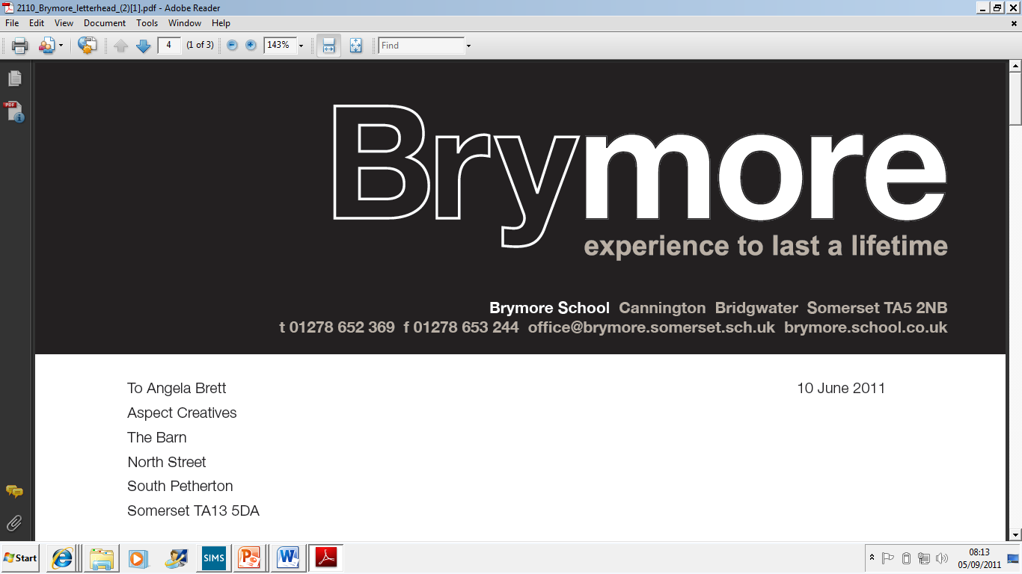

8.ESCALATION PROCESS (Exams)
2024/25

This policy is reviewed annually to ensure compliance with current regulations

Approved/reviewed by

Date of next review | November 2025

Key staff involved in the policy
Role | Name(s)
Head of centre | Stefan McHale
Exams officer | Lisa Gardner

Purpose of the process

In terms of internal governance arrangements, it is the responsibility of the head of centre to ensure that Brymore Academy has in place a written escalation process should the head of centre, or a member of the senior leadership team with oversight of examination administration, be absent.

This process confirms the main duties and responsibilities to be escalated.

This process also supports Brymore Academy being able to confirm to an awarding body the external governance arrangements so that the awarding body has confidence in the integrity of centre activities such as the delivery of qualifications and the conducting of examinations and assessments.

Before examinations (Planning)
In the event of the absence of the head of centre or the member of senior leadership with oversight of examination administration, responsibility for implementing JCQ regulations and requirements relating to activity prior to examinations will be escalated to Head Teacher.
- To support understanding of the regulations and requirements, the following JCQ publications will be referenced:
- General Regulations for Approved Centres
- Instructions for conducting examinations
- Access Arrangements and Reasonable Adjustments
- Instructions for conducting coursework
- Instructions for conducting non-examination assessments
- Suspected Malpractice – Policies and Procedures
- A guide to the special consideration process
Main duties and responsibilities relate to:
- Third party arrangements
- Centre status
- Confidentiality
- Communication
- Recruitment, selection and training and support
- External and internal governance arrangements
- Delivery of qualifications
- Public liability
- Conflicts of interest
- Controlled assessments, coursework and non-examination assessments
- Security of assessment materials
- National Centre Number Register
- Centre inspections
  - Additional JCQ publication for reference:
  - JCQ Centre Inspection Service Changes
- Policies available for inspection
  - Specific JCQ publications for reference:
  - General Regulations for Approved Centres (section 5)
  - Instructions for conducting examinations (section 25)
  - Access Arrangements and Reasonable Adjustments (section 5)
- Personal data, freedom of information and copyright
  - Additional JCQ publication for reference:
  - Information for candidates – Privacy Notice

Before examinations (Entries and Pre-exams)
In the event of the absence of the head of centre or the member of senior leadership with oversight of examination administration, responsibility for implementing JCQ regulations and requirements relating to entries and exam preparation will be escalated to Head Teacher.
To support understanding of the regulations and requirements, sections of relevant JCQ publications will be specifically referenced including:
- General Regulations for Approved Centres (section 5)
- Instructions for conducting examinations (sections 1-15)
- Access Arrangements and Reasonable Adjustments (sections 6-8)

Main duties and responsibilities relate to:
- Access arrangements and reasonable adjustments
- Entries (including ensuring appropriate controls are in place which allow accurate entries to be submitted to the awarding bodies)
  - Additional JCQ publications for reference:
  - Key dates
  - Guidance Notes for Transferred Candidates
  - Alternative Site guidance notes
  - Guidance notes for overnight supervision of candidates with a timetable variation
- Entries (including ensuring appropriate controls are in place which allow accurate entries to be submitted to the awarding bodies)
- Additional JCQ publication for reference:
  - Guidance Notes – Centre Consortium Arrangements
- Candidate information
  - Additional JCQ publications for reference:
  - Information for candidates documents
  - Exam Room Posters

During examinations (Exam time)
In the event of the absence of the head of centre or the member of senior leadership with oversight of examination administration, responsibility for implementing JCQ regulations and requirements relating to during exam time will be escalated to Head Teacher.
To support understanding of the regulations and requirements, sections of relevant JCQ publications will be specifically referenced including:
- General Regulations for Approved Centres (sections 3, 5)
- Instructions for conducting examinations (sections 16-31)
- Access Arrangements and Reasonable Adjustments (section 8)
- A guide to the special consideration process (sections 2-7)
Main duties and responsibilities relate to:
- Conducting examinations and assessments
  - Additional JCQ publication for reference:
  - Guidance Notes – Very Late Arrival
- Malpractice
- Retention of candidates’ work

After examinations (Results and Post-Results)
As a contingency to enable the prompt handling of urgent issues only, the centre responds to the awarding bodies’ request for information regarding the contact details of a senior member of staff (which might include a personal mobile number and/or email address). This will ensure that any urgent matters which might adversely affect candidates which arise outside of term time, and which potentially put qualification awards at risk, can be addressed by awarding bodies with the support of that member of staff. The head of centre will ensure that this member of staff has the necessary authority to mobilise resources to provide this support, which might include resolving issues within the centre itself (GR 5.3)
In the event of the absence of the head of centre or the member of senior leadership with oversight of examination administration, responsibility for implementing JCQ regulations and requirements relating to after examinations will be escalated to Head Teacher.
To support understanding of the regulations and requirements, sections of relevant JCQ publications will be specifically referenced including:
- General Regulations for Approved Centres (section 5)
Main duties and responsibilities relate to:
- Results
  - Additional JCQ publication for reference:
  - Release of Results notice
- Post-results services and appeals
  - Additional JCQ publications for reference:
  - Post-Results Services (Information and guidance to centres)
  - JCQ Appeals Booklet (A guide to the awarding bodies’ appeals processes)
- Certificates

