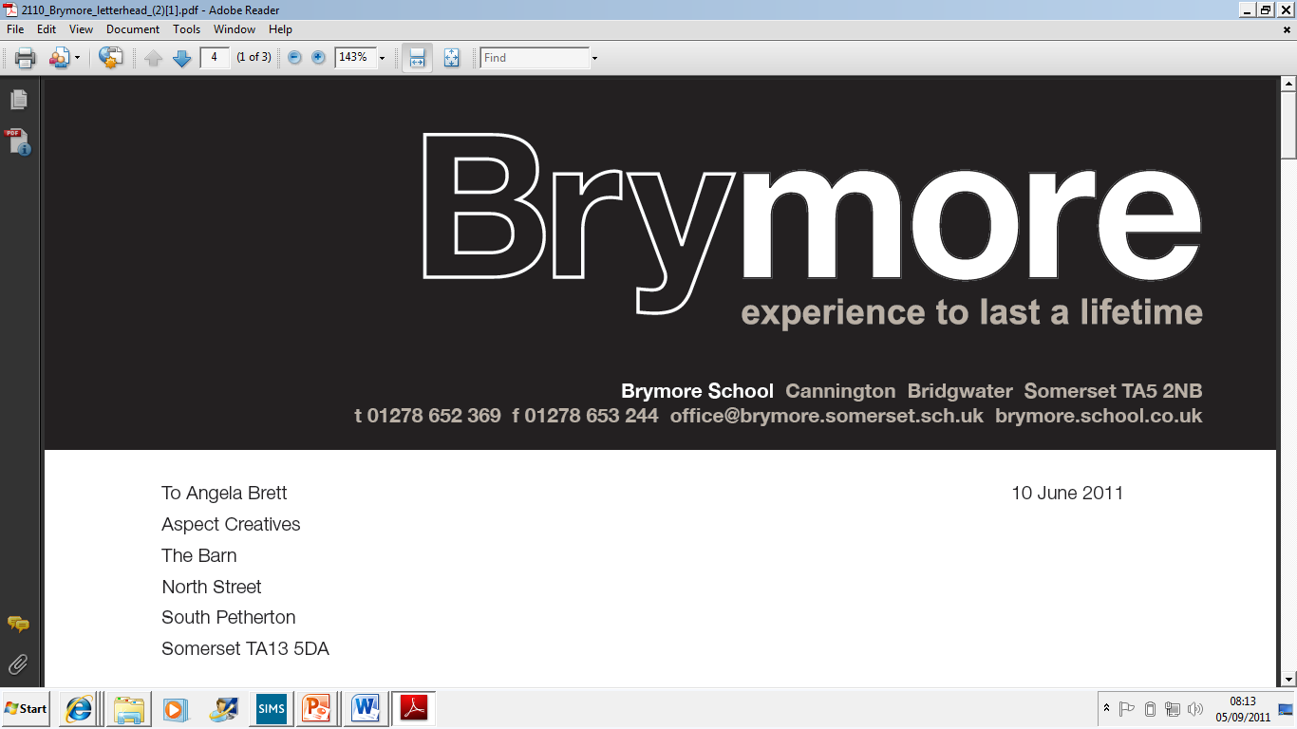

9. EMERGENCY EVACUATION POLICY (Exams)
2024/25

This policy is reviewed annually to ensure compliance with current regulations

Approved/reviewed by
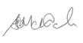
Date of next review | November 2025

Key staff involved in the policy
Role | Name(s)
Head of centre | Stefan McHale
Exams officer | Lisa Gardner

Emergency Evacuation Procedure

Rationale:

The purpose of this policy is to outline the procedure for evacuating the school in the case of fire or other emergencies which require staff and students to be moved from Brymore Academy buildings.

This policy applies to employees, volunteers, parents/carers/students, and people visiting the school site.

Generally, the emergency is an unplanned, sudden or unexpected event or situation that requires immediate action to prevent harm, injury or illness to persons or damage to the school environment. It is a risk to an individual’s health and safety.

Aims:

To provide a safe and secure environment for our students, staff and resources.
To establish protocols and procedures that effectively monitors and manages a potentially dangerous situation.

Implementation:

In the event of an emergency, the Head teacher or member of SLT will make the decision as to whether the school needs to be evacuated.

If the decision is made to evacuate:

Emergency services will be contacted (999)
The fire alarm bell will be sounded.
Students, staff, and visitors to the school will immediately proceed to the Evacuation Area – School field

Office staff will bring with them attendance lists, visitor/staff signing in/out online app.

Teaching staff will secure rooms and supervise students while in the evacuation area.
All staff will check their allocated areas for staff/students/visitors and alert them to the evacuation.

The Head teacher or a member of SLT will notify the appropriate authorities and move to the evacuation area.

At the evacuation area, tutors are responsible for supervising their tutor group and for taking class rolls.

If an exam is underway, invigilators are instructed to take their candidates over the bridge, by the MUGA, into the field along with the attendance register and keep candidates in silence to preserve the security of the exam.

Any students not accounted for should immediately be reported to the Senior Assistant Head. The student’s name will then be checked against an up-to-date absentee list, and then any missing students or staff reported to the Headteacher.

Remain at Evacuation point until advised otherwise by the Headteacher

Exam rooms during emergencies:-
In an emergency the invigilator must take the following action:
- Stop the boys from writing, collect the attendance register
- Advise boys to close their answer booklets and leave all question papers and scripts in the exam room
- Evacuate the exam room in line with Brymore procedures – keep boys in their ‘room groups’ away from all other boys, NO talking.
- Ensure the boys leave the room in silence and supervise them as closely as possible while they are out of the exam room so that there is no discussion about the exam
- Make a note of the time of the interruption and how long it lasted
- Allow the boys the remainder of the working time set for the examination when it resumes.
- Make a full report of the incident and of the action taken, and send to the relevant awarding body.

