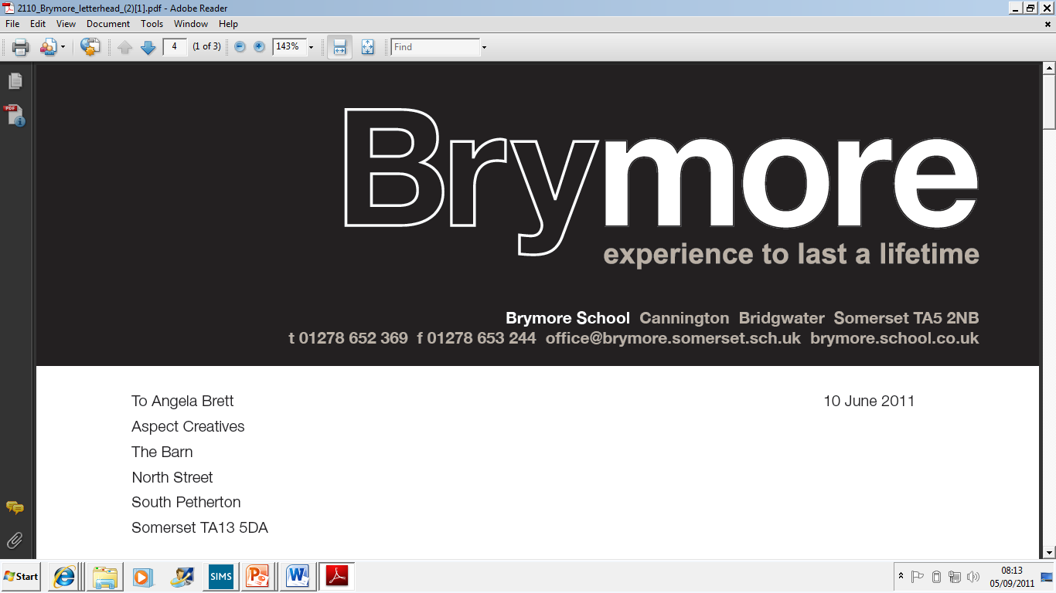

Registration & Certificate Policy (Exams)
2024/25

This policy is reviewed annually to ensure compliance with current regulations

Approved/reviewed by
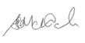
Date of next review | October 2025

Key staff involved in the policy
Role | Name(s)
Head of centre | Stefan McHale
Exams officer | Lisa Gardner

VOCATIONAL QUALIFICATION REGISTRATION & CERTIFICATION POLICY

AIM

1. To register individual students to the correct programme within agreed timescales.
2. To claim valid student certificates within agreed timescales.
3. To construct a secure, accurate and accessible audit trail to ensure that individual student registration and certification claims can be tracked to the certificate which is issued for each student.
4. To ensure that accurate, up to date and auditable centre registration, achievement and certification records are maintained with vocational Awarding Bodies.
5. To ensure that these records are stored securely for a minimum of three years after certification, in line with vocational Awarding Body requirements.

In order to do this, Brymore Academy will:-

- Register each student within the awarding body requirements.
- Register each student on the appropriate programme code, before any assessment activity is completed.
- Provide a mechanism for programme teams to check the accuracy of student registrations.
- Make each student aware of their registration status.
- Inform the awarding body of withdrawals, transfers or changes to student details.
- Ensure that certificate claims are timely and based solely on internally verified assessment records.
- Audit certificate claims made to the awarding body.
- Audit the certificates received from the awarding body to ensure accuracy and completeness.
- Keep all records safely and securely for three years post-certification.

REGISTRATION

All students undertaking vocational qualifications must be registered prior to Awarding Body deadlines in their first year of the qualification. Brymore Academy registers all students for vocational qualifications by the first half term in October, in order to meet these deadlines.

The registration process is as follows:-
- In September of the first year of the qualification all student subject choices are confirmed and any subject and class moves completed.
- In October the Exams Officer starts the registration process. The qualifications to be taken have already been confirmed by teaching staff to the Exams Officer in the previous academic year.
3. The Exams Officer registers students for vocational qualifications by either uploading a spreadsheet to the Awarding Body secure online portal, or by data entry directly into the Awarding Body secure online portal.
4. When confirmation of registration is available the Exam Officer saves this to the Exams folder within the secure drive and forwards the details to relevant teaching staff.
5. If there are any errors or omissions teaching staff communicate this to the Exams Officer.
6. The Exams Officer will enter students for externally set exams and synoptic tests where needed via the Awarding Body secure online portal. Exam/test windows to be used are agreed with Heads of Department in advance.
7. If a student joins the school after registrations have been processed their registration(s) are processed as soon as possible after joining.

WITHDRAWALS

The Exams Officer checks with Heads of Department by 31 January each year to obtain details of any students that should have their vocational qualification registration withdrawn. If so, these are withdrawn according to awarding body requirements.

CERTIFICATION AND UNIT CERTIFICATION

Before certification for students can be claimed the following must be completed:-
- The student must have completed all necessary components of the course to claim full certification. Where a student has not completed all necessary components, it may be possible to claim a unit certificate.
- Any outstanding Internal Verification procedures must have been carried out.
- Any amendments/actions, as identified within the standards verification/EQA report, have been carried out, e.g. the report requires the centre to check other assessments, students to
improve work etc.
The process for claiming student certification is as follows:-
- All grades on the subject based tracker are checked by the lead IV in consultation with
the relevant subject teachers to ensure accuracy.
- The Lead IV and a nominated person within each programme area enter the grades for
each unit on to the centrally held grade tracker.
- The Exams Officer enters the grades for each candidate and each unit into the appropriate area of the Awarding Body secure online portal. The Exams Officer and Exams Assistant check that grades are correct before final submission.
- All certification and unit claims must be processed by Awarding Body deadlines – NCFE’s deadline is 26 May. City and Guilds claims must be processed before the end of the academic year.

ROLES AND RESPONSIBILITIES

The EXAMS OFFICER will:
- Take responsibility for timely, accurate and valid registration, withdrawal and certificate claims for students, according to Awarding Body requirements;
liaise with programme teams to check the accuracy of student registrations;
ensure that certificate claims are timely and accurate, according to information provided by programme teams.
- Inform the Awarding Body of withdrawals or changes to learner details;
audit certificate claims made with the Awarding Body; audit the certificates received from the Awarding Body to ensure accuracy and completeness.

LEAD INTERNAL VERIFIERS will:
- Take responsibility for ensuring that student details held by Awarding Bodies are accurate and that an audit trail of learner assessment and achievement is accessible.
- Liaise with the Exams Officer to check the accuracy of student registrations.
- Ensure that all Schemes of Work and Programmes of Study are drawn up and implemented in accordance with this policy and related documents.

PROGRAMME ASSESSORS will:
- Ensure that programmes are delivered in accordance with Awarding Body guidelines, following the agreed IV schedule and assessment plan; make each student aware of his registration status.

The HEADTEACHER will:
- Ensure that the policy is implemented and report to Governors;
carry out the statutory duties of the Headteacher with regard to the curriculum as defined by the DfE.

The GOVERNING BODY will:
- Carry out the statutory duties of the governing body with regard to the curriculum as defined by the DfE.

