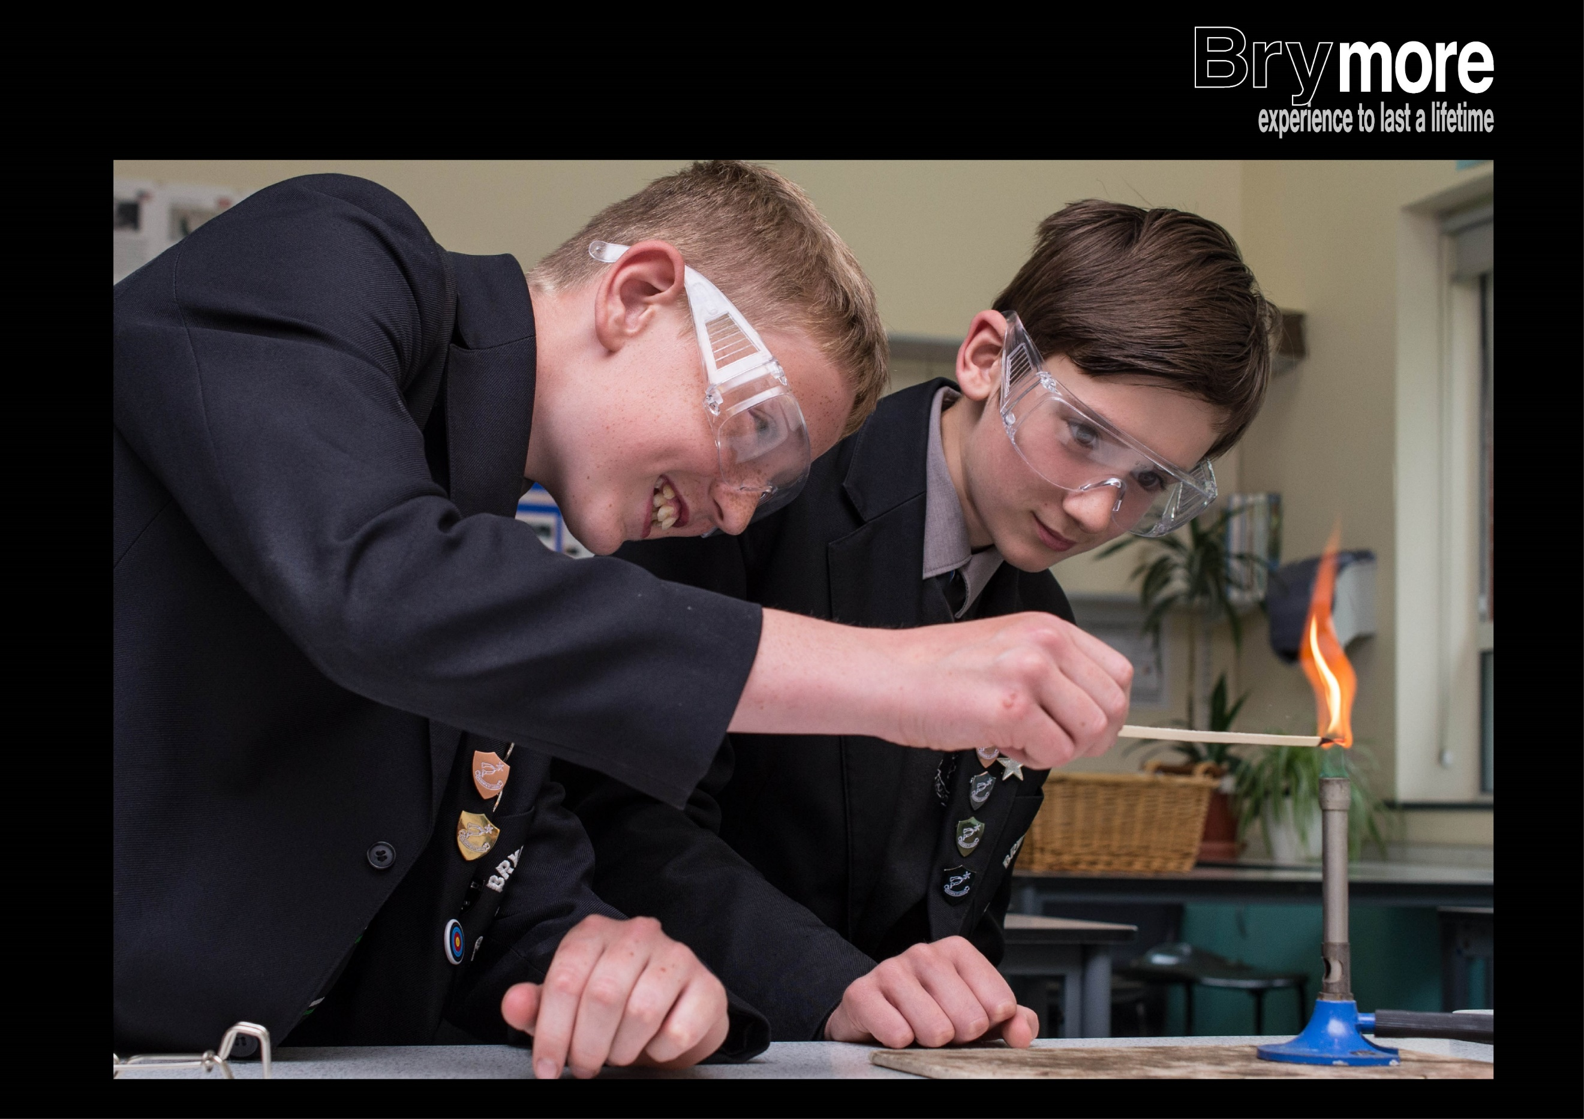

BRYMORE ACADEMY
EPILEPSY POLICY/PROTOCOL

Created by: Mr Rob Watts
Date: June 2025
Approved by Local Advisory Board:
Review date: June 2026
Signature of Chair of Governors | Signature of Headteacher
Date shared with staff:

Brymore Academy recognises that epilepsy is a condition which affects pupils at school. The Academy welcomes all pupils with epilepsy and through the policy pupils will be able to achieve their full potential in all aspects of Academy life. All first aiders will be given training on epilepsy management.
- First aiders should have a clear understanding of what to do in the event of a seizure.
- The Academy works in partnership with the Academy’s Matrons and parents to provide a continuation of care for those pupils who suffer from the condition.
- Staff are informed each year of the pupils at the Academy who have epilepsy. A copy of their Individual Health Care Plans are available on Sims and Medical Tracker
- Advice and further information on individual pupils are available from the Medical Centre.

Epilepsy
Epilepsy is a tendency to brief disruption in the normal electrochemical activity of the brain, which can affect people of all ages, backgrounds and levels of intelligence. It is not a disease or an illness but may be a symptom of some physical disorder. However, its cause, especially in young people, may have no precise medical explanation.

Types of Epilepsy and their Symptoms
Tonic Clonic Seizure (Grand Mal)
The pupil may make a strange cry and fall suddenly. Muscles first stiffen and then relax and jerking and convulsive movements begin which can be quite vigorous. Saliva may appear around the mouth and the pupil may be incontinent. Ensure the safety of the pupil and gently move them away from any dangers and ensure their privacy. Speak calmly to the pupil and stay with them until the seizure has passed.
Complex and Partial Seizures (Temporal Lobe Seizures)
These occur when only a portion of the brain is affected by excessive electrical discharge. There may be involuntary movements such as twitching, plucking at clothing or lip smacking. The pupil may appear conscious but be unable to speak or respond during this form of seizure. Ensure the safety of the pupil and gently move them away from any dangers. Speak calmly to the pupil and stay with them until the seizure has passed.
Absence (Petit Mal)
This can easily pass unnoticed. The pupil may appear to daydream or stare blankly. There are very few signs that a pupil is in seizure. These types of episodes, if frequent, can lead to serious learning difficulties as the pupil will not be receiving any visual or aural messages during those few seconds. Therefore, it is important to be understanding, note any probable episodes, check with the pupil that they have understood what has happened and inform parents.
Teachers can play an important role in recognising a seizure, recording changes in behavioural patterns and frequency.
Procedure for an Epileptic Seizure
Total seizure, Tonic Clonic (Grand Mal)
- Keep Calm – pupils will tend to follow your example. Let the seizure follow its own course; it cannot be stopped or altered.
Serious symptoms
- Cold, clammy skin
- Blue-grey tinge around lips
- Weakness/dizziness
- Rapid shallow breathing
Progress further
- Restlessness
- Aggressiveness
- Gasping for air
- Unconsciousness
Treatment
- Ask the other pupils to leave the room where possible and ask a responsible pupil to fetch a School Matron/ First Aider for assistance
- Note the time the seizure takes place and how long it lasts
- Protect the pupil from harm. Never move the pupil whist convulsing unless they are in immediate danger. If possible, move objects that may cause injury away from the immediate area
- When convulsions have ceased place the pupil on his side - this does not have to be the recovery position but just so that the tongue can fall forward and excessive saliva can drain out of the mouth
- Support the pupil’s head and stay with the pupil until completely recovered
- Talk quietly to the pupil and reassure but do not try to restrain any convulsive movements
Do not put anything into the mouth or offer drinks until fully recovered.
Transfer to the Medical Centre when safe to do so.
- A Matron /First Aider should then make a full assessment of the seizure and note any injuries that may have been sustained.
- Allow the pupil to rest and sleep following the seizure as this may be the first in a cluster of seizures. Ensure they remain on their side.
- Inform the parents and, if a day pupil, arrange for collection.
- If the fit lasts any longer than 5 minutes, call an ambulance immediately.
- It is very important the pupil is assessed at the hospital. A pupil experiencing a first seizure or cluster seizures must be sent to hospital.
- If the ambulance is summoned, then report the seizure in as much detail as you can, especially how long it has lasted.
- In the case of a day pupil, a member of staff should accompany the pupil to hospital and stay with them until the parent(s)/ carer arrive. In the case of a boarding pupil a Matron or member of the Boarding House staff should accompany the pupil to Hospital.

