

BRYMORE ACADEMY

Suitability for Boarding Policy 2024-27

Created by: Stefan McHale
Date: March 2025
Review date: March 2027
Signature of Chair of Governors  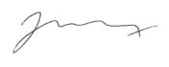 | Signature of Headteacher  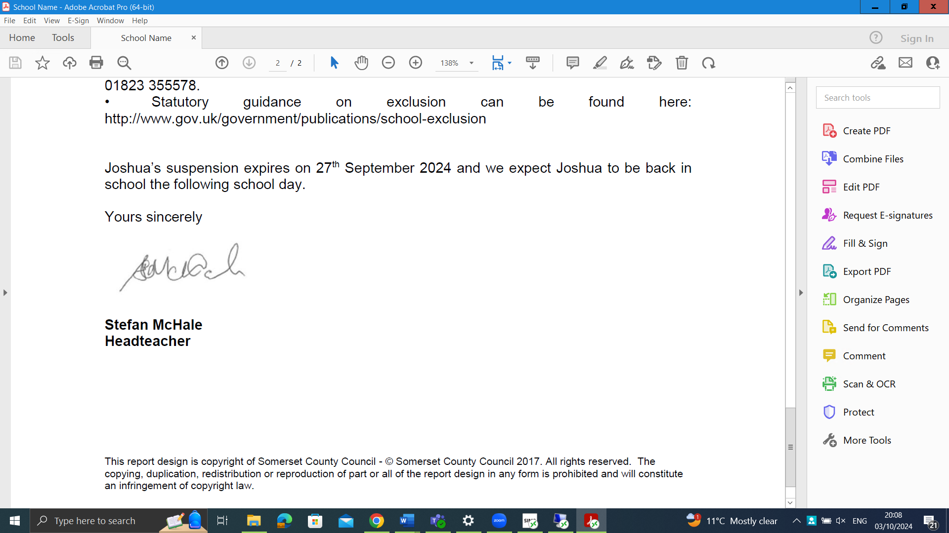

Introduction

As part of Brymore Academy’s Admissions Policy, all Out-Boarders and Boarders must be assessed for suitability for boarding.

In pursuance of their duty to safeguard and promote the welfare of all boarders under section 87 of the Children Act 1989, the Governors will not admit any child to the School as a boarder unless he has satisfied the School that he is suitable to board.

The term ‘suitability for boarding’ applies to both Full Boarding and weekly Boarding.

Suitability for Boarding

The School Admissions Code 2021 states that a maintained boarding school can interview applicants to assess suitability for boarding and must consider the following:

- Does the child present a serious health and safety hazard to other boarders;
- Will the child be able to cope with and benefit from a boarding environment.

Every boarding school is different and has its own individual boarding community and culture. As such, the professionals at Brymore Academy assess suitability for boarding in relation to the School’s own boarding environment.

A child being assessed as suitable to board does not mean that they are guaranteed a place at the School. The School’s Admissions Policy criteria apply.

- Process for Ascertaining Suitability for Boarding

To assess whether a child is suitable to board, the following process is followed:

  - Boarding Applicants

    - On receipt of an application, a confidential character reference is requested and obtained from the child’s current school. If the child has been at their current school for less than two academic terms, a further character reference will be requested from their previous school.
    - A suitability for boarding interview is undertaken with the applicant once the character reference(s) is received. This is an opportunity for a senior member of staff to interview the applicant without the parent/carer being present. If there are no places available, the interview will take place and the child added to the waiting list, should the child be assessed as suitable for boarding.
    - After the reference is received and the interview undertaken, a suitability for boarding decision is reached. If the information obtained from the reference and/or interview raises concerns, or does not satisfy the School to the child’s suitability for boarding, the applicant may be invited for a boarding trial.

Any further relevant information which is submitted by the applicant’s family, or received from the current/previous school and/or the Local Education Authority, will be reviewed and assessed alongside the interview outcome and character reference.

- How a decision on Suitability for Boarding is reached

In determining whether an applicant is suitable to board, Brymore has regard to the questions listed in this section. They form part of the School’s comprehensive assessment as to whether a child a) presents a serious health and safety risk to other boarders and/or b) will be able to cope with and benefit from a boarding environment.

These questions support the School to determine whether the child’s character, behaviour, conduct, physical and mental health are compatible with points a) and b) above.

  - At the application stage:

- Does the child wish to board? How do they feel about boarding?
- Does the child have experience of staying away from home? Did they enjoy the experience?
- Does the child have any difficulty relating to others?
- Has the child ever exhibited any challenging behaviour?
- Has the child had any traumatising or difficult experiences?
- Does the child have any medical needs or a disability which would require adjustment to the boarding accommodation, routine or practice? (this can relate to physical medical needs and/or mental health)

  - At the reference stage:

Some of the application stage questions are once again covered. Additionally, the following questions are asked of the child’s current/previous school:

- Does the child show resilience in unfamiliar settings without their parent/carer?
- Does the child play/work on their own or do they always seek the company of others?
- Has the application for Boarding been discussed with their current/previous school?
- Has the person writing the reference formed an impression of whether or not the child wishes to attend boarding school?
- Does the child have a record of misbehaviour? For example: assault, physical violence, inappropriate sexual behaviour, intimidation of other children, theft or damage to property which may pose a danger to himself/herself or to other pupils in the boarding context?
- Does the child have any social, emotional, medical, mental health or behavioural difficulties?
- Does the child have any significant health issues, either physical or relating to mental health?
- Has the child had any involvement with counsellors or outside agencies?

  - At the interview stage:

At this stage, the assessment is centred on the interviewer’s overall impression of the applicant in relation to suitability for boarding. Questions posed to the applicant by the interviewer are age-appropriate and may be informed by a reference or any information submitted prior to the interview taking place. As well as the answers given by the applicant, the interviewer will consider the child’s body language, eye contact, communication skills, and general conduct at interview and what this may indicate. Areas which are looked at are as follows:

- Confidence
- Social ability/skills
- Listening ability
- Personal values
- Understanding and engagement
- Emotional and psychological traits

Additionally, the interview will explore the following areas:

- Is the child’s bedtime routine and relationship with food compatible to the boarding environment?

The above questions/areas are the foundation and basics of the School’s assessment for suitability for boarding. Should specific concerns be raised at any point during the application process which indicate that an avenue not listed above needs to be explored, the School will do so.

Boarding Trials

In situations where an assessment of a child's suitability for boarding is inconclusive and the School is not satisfied that it can ascertain a child’s suitability via an interview and reference alone, a boarding trial will be offered. The trial period aims to further evaluate the child's compatibility with the boarding environment, whether they would cope and/or benefit from boarding, and addresses any outstanding uncertainties or reservations the School may hold.

This situation may arise due to:

- Concerns are raised during the interview process and/or reference that cannot be adequately addressed or answered by the child, family or previous school.
- Contradictory information is provided by the child, family and/or previous school.
- Observations are made at interview stage that are inconsistent with the information provided by the family and/or the child’s reference.
- Further information is received regarding the child’s character, behaviour, emotional/physical/psychological wellbeing which brings into question their suitability.
- The child has a record or history of behavioural pattern(s) which the family states has improved by the time of the application; however, there is a lack of substantial long-term evidence which supports this claim.

Typically, a boarding trial takes place over three-five days. This may be shorter or longer depending on the severity of the concerns raised which led to a boarding trial being required.

Boarding trials are timed with consideration to existing boarding students, ensuring they cause the least amount of disruption to the existing students’ boarding environment. Boarding trials take place during term time, and are unlikely to take place during the first or last week of term or half terms, or during exam or mock exam periods.

Applicant families are communicated with as soon as possible when a boarding trial decision is made.

- Unsuitability for Boarding

The School takes all due care and consideration when arriving at a decision that a child is unsuitable for boarding. The School assesses all of the information obtained and gathered throughout an application prior to arriving at a decision. Where appropriate to make an informed decision, the School may consult internally with professionals in different departments or externally with relevant agencies or previous schools.

For a child to be deemed unsuitable for boarding one, or a number, of the following decisions has been reached:

- The School has assessed that the child poses a health and safety hazard;
- The School has assessed that the child will not cope in a boarding environment;
- The School has assessed that the child will not benefit from a boarding environment.

  - Reasons for Unsuitability for Boarding

A child may be deemed as unsuitable for boarding for a variety of reasons. Unsuitability for boarding may relate to one-off incidents and/or patterns of behaviour over a period of time despite interventions and support. The list below is not exhaustive, but grounds for unsuitability for boarding may include:

- Child has major behavioural difficulties, such as displaying physical violence, aggression to adults and/or peers, any type of bullying behaviour, sexual misconduct, arson, vandalism, possession of weapons, theft, and/or substance abuse.
- Child’s behavioural difficulties indicate that the child does not/will not follow health and safety rules, such as a record or incident(s) of absconding and truancy.
- Child has mental health concerns which would mean they could not cope in a boarding environment, or it is felt that the boarding environment will be detrimental to the child’s mental health.
- Child cannot safely understand and follow health and safety instructions.
- Child demonstrates a strong aversion to boarding and/or negatively engages with the idea of boarding, displaying high levels of anxiety or unwillingness to be separated from the family.
- Child has undeveloped social skills to an extent which could lead to isolation, problematic peer relations, or inability to access the moral curriculum.
- Child displays character traits such as dishonesty or untrustworthiness to a degree which is a cause for concern.
- Child has significant medical needs which the Academy cannot accommodate in the boarding setting, meaning that the child’s wellbeing would be harmed and they would neither cope nor benefit from the boarding environment.
- Child has a serious physical, behavioural or psychological illness or condition which requires medication for regulation, but the child’s family chooses to ignore, or fails to follow, medical advice.

6.2 Process of Ratification

The initial decision of suitability for boarding is made by the interviewer. This usually happens within 24 hours of the interview taking place.

The Academy may refuse a place on not suitable for boarding grounds even when the number of boarding places offered is below the Published Admission Number. The Academy will not rank applicants on the basis of suitability for boarding. Candidates assessed to be not suitable for boarding will not be added to or kept on a waiting list.

Parents/Carers have no right to an appeal in case of a decision of Unsuitability for Boarding being decided, but can if they wish use the Academy complaints process at Stage 2 of the process.

- Withdrawal of Boarding

The Headteacher has the discretion to withdraw a child’s boarding place.

  - Non-disclosure or Withholding of Information

The Academy reserves the right to end the contract with a family and/or withdraw a boarding place should the family make a serious misrepresentation of facts or circumstances, or withhold important information from the School about the child that is relevant to the provision of boarding by the School or that impacts the child’s suitability for boarding.

Misrepresentation at any point in time, whether by act or omission, may result in a withdrawal of boarding.

7.2 Fixed-term Withdrawal of Boarding

A pupil may have their boarding place withdrawn without reassessment, where the Academy believes a fixed-term withdrawal from boarding would serve as an appropriate sanction or as a necessary step in behaviour management.

7.3 Permanent Withdrawal of Boarding

The Headteacher may in their discretion withdraw the boarding place (either temporarily or permanently), if they consider that a child’s attendance, progress or behaviour (including behaviour outside school) is unsatisfactory and in the reasonable opinion of the Headteacher, the removal is in the Academy’s best interests or those of the child or other children.

Prior to any decision for a permanent withdrawal from boarding the Academy will have exhausted all efforts and support measures available at its disposal and deemed appropriate.
The Behaviour Management Policies set out examples of offences likely to result by the withdrawal of boarding facilities. These examples are not exhaustive, and the Headteacher may decide that withdrawal of boarding for a lesser offence is justified where there has been previous misbehaviour. All aspects of the pupil’s record at the School may be considered.

A withdrawal of boarding, temporary or permanent, does not constitute an exclusion from the School.

