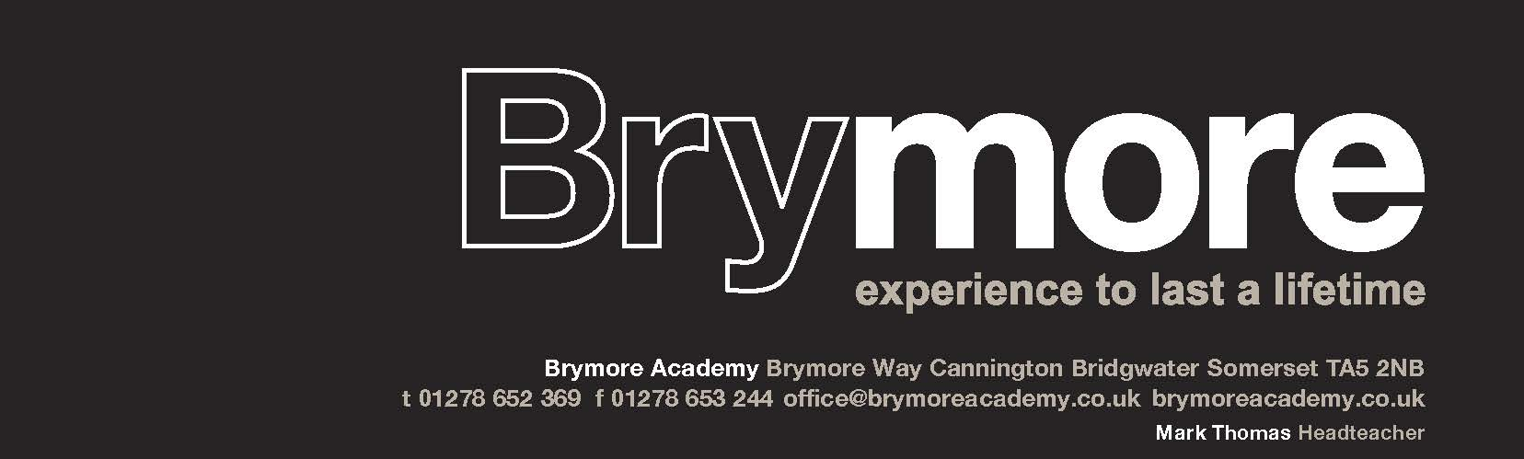
Brymore Academy Cannington Somerset TA5 2NB
Tel: 01278 652369 email: office@brymoreacademy.co.uk website: www.brymoreacademy.co.uk
Stefan McHale, Headteacher

An academy sponsored by Bridgwater & Taunton College Trust

4th July 2025

Dear Parent/Guardian,

I am delighted to be able to update you with some further details about the proposed visit to Cologne at the end of November. We shall be departing Brymore at 1am on Saturday 29th November 2025 with our ferry due to sail at 08:15. We shall be staying at the A&O Cologne Neumarkt Hostel on a half-board basis (breakfast and evening meal). During our stay we have 3 visits lined up. Entry into the majestic Cologne cathedral, a tour of the Chocolate Museum (I suspect you might receive a chocolate gift this Christmas!) and a chance to participate in a Cologne Adventure Trail. This is in addition to actually visiting the stunning Christmas Market! We begin our journey home on Monday 1st December with our ferry sailing at 7pm and our estimated time of arrival back at Brymore will be 1am on Tuesday 2nd December 2025. Obviously, if we are able to catch an earlier ferry we may be able to get back before midnight, which would be more favourable! Students will be encouraged to make contact with parents on the journey home to keep you updated of our progress.

As we continue to fine tune our arrangements, I require the following information at your earliest convenience, please.
- A copy of your son’s passport which should have a minimum of 3 months left on it after our date of departure.
- Any dietary needs and the severity of any allergic reactions.
- Confirmation of two named emergency contact numbers in the unlikely event we need to contact you.
May I take this opportunity to recommend that at the time of travel, your son has a Global Health Insurance Card (GHIC) or a European Health Insurance Card (EHIC), if still valid, with them. This will enable further medical support, should it be needed. Clearly, we hope they will not be required. If you need to obtain a new GHIC, it can be done for free via the NHS, using the following weblink: Applying for healthcare cover abroad (GHIC and EHIC) - NHS

Finally, the payment schedule is as follows. We do have some flexibility on this so please don’t worry, but the final balance on 20th September is the important one.
15th June £50 1st payment
15th July £100 2nd payment
22nd August £100 3rd payment
20th September £100 final payment.

If you have any further queries regarding this trip, please don’t hesitate to contact me matt.ellis@btc-trust.org I do hope you and your family enjoy some quality time together this summer.

Kind regards

Matthew Ellis
Director of Geography

Cologne Christmas Markets 29th Nov – 1st Dec 2025

Student Name________________________________________________________

Emergency Contacts

Emergency Contact 1: Name _____________________________________________

Number______________________________________________________________

Emergency Contact 2: Name______________________________________________

Number_______________________________________________________________

Dietary Requirements
Issue:

Severity of allergy:

