Term 3 Kemp Newsletter

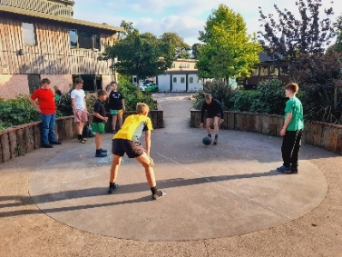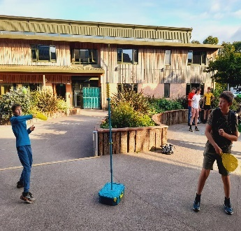It has been a great term in Kemp House as we see many of our boys getting ready to leave and then actually leaving the house for their new boarding house. Being the Summer Term boys have been lapping up the opportunity to go swimming, go out on the field, play manhunt as well as lots more exciting outdoor fun!

Many boys have enjoyed playing traditional outdoor games such as 4square and Curby. Mr Fewtrell is unbeaten at Curby, and it was Mrs Robinson who introduced the boys to 4square. Billy N, Jacob V, Harry Bu, Thomas H, Aubrey P to name a few have enjoyed playing Curby. Meanwhile, Will P, Charlie E, George S, Majeed E-K, Herbie P, Harry W, Jack A, Alfie W, James B, Tico C and Beau J as well as others, have liked playing 4square and are playing most nights. Beau J, Arthur G, James B as well as Will R enjoy the field along with Alfie W, Aubrey P, Bradley P, Will G and Harry Bl. Josh B loves hanging out on the swing especially before prep!

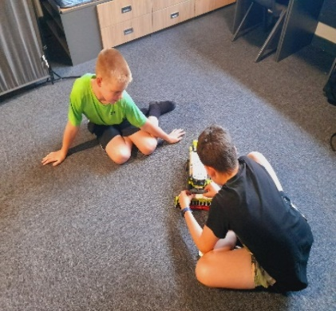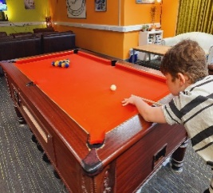The Mentors - Dom S, Elliott B, James A, Harry Bu, Thomas H, Riley N, George M and Ben S all had a pizza night treat for their efforts this year with mentoring.

Charlie P and Mr Fewtrell shared lamping stories while Kurt P entertained everyone with his YouTube videos about electroman! Adam R brought his RC Lego Combine Harvester which he had built and Harry ‘Dangerous’ D beat Mr Fewtrell at pool! Alfie M likes to set up the pool balls for the next person which is super helpful.

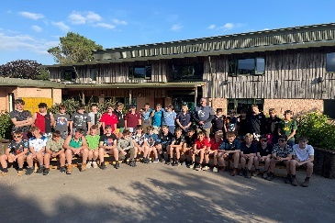

Room reward was won by Bradley P, Aubrey P, Jack A, Tom C, Alfie W and William G for having a super tidy room throughout Term 3a. Pokémon cards has been played by Zephyr M-P, Jack F, Will G and Tico C - they also collect these. We had our House photo which was nice as it was lovely and sunny!

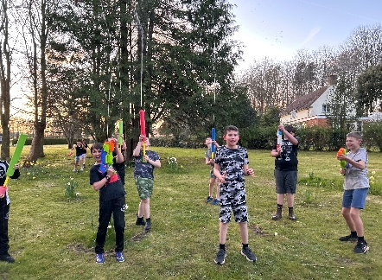The boys have been very good at handing their tech in, with some boys opting to leave collecting until later, so they can play more which is great - water fights have been uber fun! We have noticed more boys playing and having fun.

They have also enjoyed movie night watching Oblivion, to name one film they have been watching. Freddie T likes movie night and is often front and centre!

As we near the end of another great year, we would like to mention a special thank you to George F and Ben G, our Deputy Head of House and Head of House - they have been helpful and amazing. Chris H has also been an excellent help with Will R. All the current Year 9 boys will be sorely missed when they depart Kemp for pastures new!