**School House News Term 3a & 3b 2025**

It is the end of another term and our Year 11’s have participated in numerous focus sessions and now completed all their exams. The boys have taken part in Leavers Service and it was fabulous to celebrate with our eldest boys reflecting on all their successes and achievements as well as to see how much they have grown since Year 7!! It was also lovely to catch up with family members who we don’t often get to see but have been instrumental in supporting the boys throughout their time at Brymore.

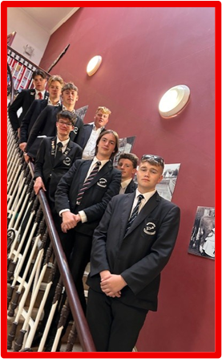Now their time here as students is complete, we will look forward to seeing them when they return for their results on 21st August and of course, for future public events.

With the moving on of Year 11’s there is now capacity for the boys from Reid and Kemp to move up and join us. Transition began in early June when prospective boys come up for a look around the boarding house, meeting us as staff, together with the older boys and getting a feel for the place. The process for room and house changes for the next school year can be tricky as we consider the wants and needs of so many boys, but we do our best to accommodate everyone’s wishes. If possible, the aim is for all boys to be with one person that they have chosen and this year we are pleased to say that we have achieved this. We have 11 boys that have moved from other houses and we are really looking forward to getting to know them all. We are certain that they will be positive additions to the house.

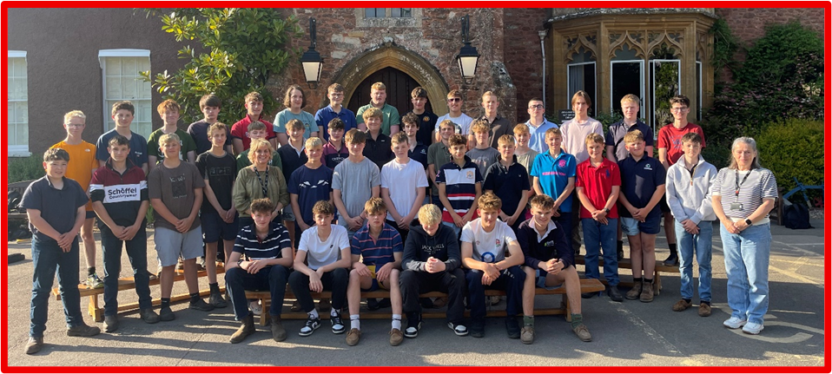

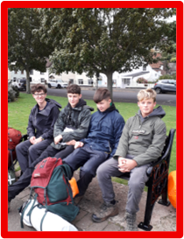Sports Day was a successful one for some of our boys, particularly Arwyn J who won the 100m and 300m. Harry D winning in Long jump and Triple jump as well as Joel C in the 100m.

Also, congratulations are well deserved for some of our other boys who have taken part in the Duke of Edinburgh Awards. Seth H a current Year 11 completed his Silver award, whilst Ethan W and Daniel B in Year 10 are working towards completing theirs in the next few weeks. Their expeditions are planned soon with Daniel going to the New Forest and Ethan is going on the Quantocks. Max W a current Year 9 has just completed his Bronze DofE Award.

Out of School several School House boys have made their mark in the community with Harry S being interviewed by the BBC at the Bath and West Show where he won a rosette for his showing. Will B also deserves commendation for his commitment to cricket and got 93 runs off 42 balls during club cricket and this was a League Record. His commitment to cricket both in and out of school has been admirable and he is always out on the field in the evening encouraging other boys to keep active.

This term also saw the Student Leadership Team established. It began with written applications which the boys worked extremely hard on, there were then 10 boys selected from the year group to give a speech in front of the whole school including students and staff. Several of our boys applied and did brilliantly, talking passionately about Brymore and their contributions here. We in School House are proud of them all, and we are especially delighted to have a School House Head Boy, Ethan W with Deputy Head Boys, Will B and Daniel B and Assistant Head Boys Charlie H and Henry H. We also have Senior Prefects, Ollie W and Freddie W and Prefects, Jacob C and Fred T.

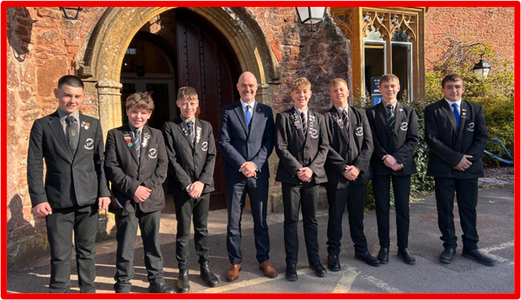

With so many amazing role models in our house this year, we are sure to benefit from their experience of being in Boarding and what is to be a Brymore Boy, hopefully this will encourage our Year 8’s & 9’s to get stuck in and get involved with all that Brymore has to offer and create a smooth transition as they settle in here, as in no time at all, it will be them applying for positions of leadership!

With new leadership happening during the school day, it was also necessary to appoint our new School House, Head of House (HoH) and Deputy Head of House (DHoH) as well as mentors, charity and food reps. The boys in the house together with Ms Hoogenboom and Mrs Webb have chosen Freddie W as HoH and Charlie H as DHoH after a process that involved a written application as well as a vote from both boarding staff and student peers. Our charity rep is Ollie W, and Joel C is rep for food/HIT whilst Jacob C is Senior Mentor with Daniel B to support him looking after our transitioning students.

Charity Rep Ollie

Food & HIT Rep Joel

Senior Mentor Jacob

MentorDaniel

DHOHCharlie

HOH Freddie

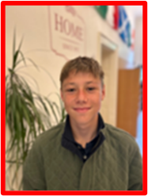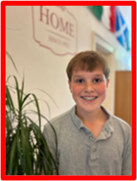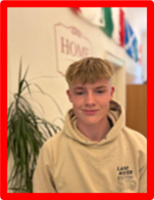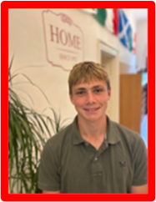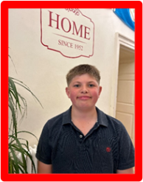

This term also saw the introduction of Tech down time for Year 9’s and the younger years, whilst some of the boys initially were not thrilled about this, they hand in their tech without fuss (although sometimes a little reluctantly). We have noticed though, that if they aren’t choosing to run Chads or do an activity, they can often be found all together in one of the Year 9 rooms catching up and socialising without the intrusion of phones, which overall is a positive thing. It is the tip of the iceberg in terms of reducing dependence on their technology, however we hope that as a school we can encourage better habits and their dependence on technology may be reduced as they start to see the benefits.

Saturday 28th June was Open Day, and a chance for us to showcase what we do here. Preparations began long before the actual day in the grounds, on the farm and within the house. The boys were showing the school animals, with them earning numerous rosettes, with a special mention to Jack I who won Champion in Cattle and 1st in Maiden Heifers and Charlie P 2nd in Ewes and Reserve Champion for Sheep and Matty B for his 1st in the Young Stock Class. There were many more winners from the House but we lost count.

Many people came to look around School House, some new prospective families, large quantities of the general public as well as many “Old Boys” who come to see how school has been upgraded since they were here. It is always a chance for us to be reminded of the School’s rich heritage with so many Old boys passing through… some of which are sending their sons here. We currently have Max W, Will B, Harry R, Sam F, Ethan W, Jack B, Charlie H, Harry A, Henry H and Harry D all with family members who have attended here previously.

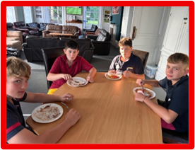The location of School House together with our enjoyment of all things food related, lends itself to creating a café to raise funds during Open Day for our House Charity - The Farmers Community Network. We did this selling waffles and drinks we had assistance from Ollie W in the afternoon, whilst Ms Hoogenboom juggled house tours in the morning and cooked in the afternoon, even Mrs Featherstone was on hand with her chopping skills for the fruit salad. It was exhausting given the demands of the end of term but the result was £200 Raised for our House Charity, FCN. Due to an excessive amount of ingredients left from Saturday the Year 8s and 9s enjoyed Waffles and Ice cream on Monday night.

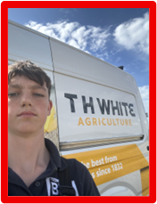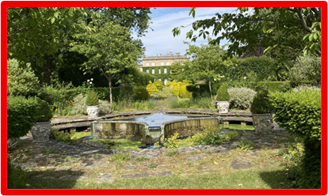During Week 5 of this half term our Year 10’s were away taking part in work experience, which offers numerous benefits to the boys. It gives them insights into the world of work, whilst teaching them valuable skills and clarifying potential career paths. It also helps the boys to develop in confidence and build on such things as teamwork and communication skills. For most it is also an opportunity to get out of the classroom and enjoy more practical labour and all boys were really looking forward to it. Some boys have sent photos of their work experience, Daniel B is in Wales, with a mechanical engineering firm, Henry H is at the Highgrove estate, working in the gardens and Jack working in Thurston with TH Whites, to name a few.

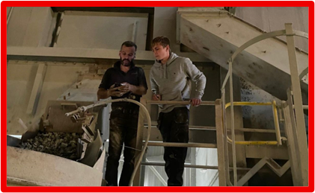

Now with the summer holidays ahead we will be packing down, summer lettings will begin and as we like to keep the house looking as good as it can, painting that was begun during the first half term as part of the regular ongoing upgrade, will be completed.

Overall, it has been a fabulous term, the weather has been warm, the nights longer and boys have enjoyed the field activities and the swimming pool. As a staff team we, together with the boys, are looking forward to the holidays. As always, we have enjoyed ‘doing life’ together as a boarding house. We count it as a huge privilege to be supporting and encouraging your boys throughout their time here at Brymore and we will continue to do so into the next school term, for now we hope you have a fabulous summer holiday, above all, please stay safe.

See you all in September 😊

Ms Hoogenboom, Mrs Webb and the School House Massive 😉

