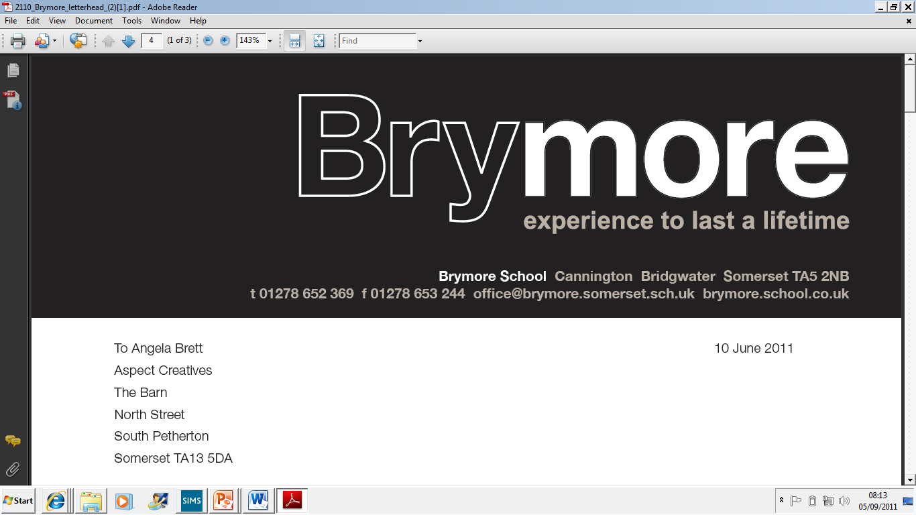

Alternative Room Arrangements Policy (Exams)
2025/26

This policy is reviewed annually to ensure compliance with current regulations

Approved/reviewed by
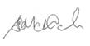
Date of next review | November 2026

Key staff involved in the policy
Role | Name(s)
Head of centre | Stefan McHale
Exams officer | Lisa Gardner

Introduction
Alternative rooming arrangements (for example, a room for a smaller group of candidates with similar needs) is an available access arrangement as defined in the JCQ regulations. This is an arrangement where a candidate with an established difficulty may be eligible to take their examinations in a smaller environment away from the main examination room.

Purpose of the policy
The purpose of this policy is to confirm the criteria when these arrangements may be considered and granted for a candidate at Brymore Academy in compliance with the regulations.

1. Decisions on the awarding of the arrangement
At Brymore Academy, decisions on the awarding of the arrangement are made by:
Lisa Gardner - Exams Officer and Access Arrangements Co-ordinator
Kimberley Hartley-SENCo

Decisions are based on:
- Whether the candidate has a substantial and long-term impairment which has an adverse effect (AARA 5.16)
- The candidate’s normal way of working within the centre (AARA 5.16)
- Ensuring the proposed arrangement does not unfairly disadvantage or advantage the candidate (AARA 4.2.1)
(In accordance with the regulations: A centre must make decisions on appropriate access arrangements for their candidates. Although professionals from other organisations may give advice, they cannot make the decision for the centre. They will not have a working knowledge of an individual candidate’s needs and how their difficulties impact in the classroom and/or in timed assessments. It is the responsibility of the SENCo (or equivalent role within the centre) to make appropriate and informed decisions based on the JCQ
regulations.)
- Nervousness, low level anxiety or being worried about examinations is not sufficient grounds for separate invigilation within the centre.
The use of an alternative room with one-to-one invigilation must only apply where the candidate has a serious medical condition, such as frequent seizures, Tourette’s or significant behavioural issues which would disturb other candidates in the examination room (AARA 5.16)

2. Criteria for the awarding of the arrangement
Alternative rooming arrangements will be considered where the arrangement would prevent a candidate from being placed at a substantial disadvantage and where the following conditions are met:
- The candidate has an established difficulty as defined in section 5.16 of the JCQ's Access Arrangements and Reasonable Adjustments document (ICE 14.18)
- The candidate’s disability is established within the centre and known to relevant staff or a senior member of staff with pastoral responsibilities (AARA 5.16)
- Alternative rooming arrangements reflects the candidate’s normal and current way of working in internal tests and mock examinations (AARA 5.16)
- Where a candidate sits their examinations in a smaller environment away from the main examination room, the regulations and guidance within the JCQ document Instructions for conducting examinations will be adhered to, particularly in relation to accommodation and invigilation arrangements (ICE 14.18)

3. Other rooming arrangements
At Brymore Academy arrangements for seating candidates in rooms separate to the main cohort may be put in place in other circumstances.

As and when applicable, these circumstances include:
- A reading room for those candidates entitled to a reader.
- Scribe rooms for those candidates entitled to a scribe.
- Candidates using a word processor will be seated at the back of the main hall.

