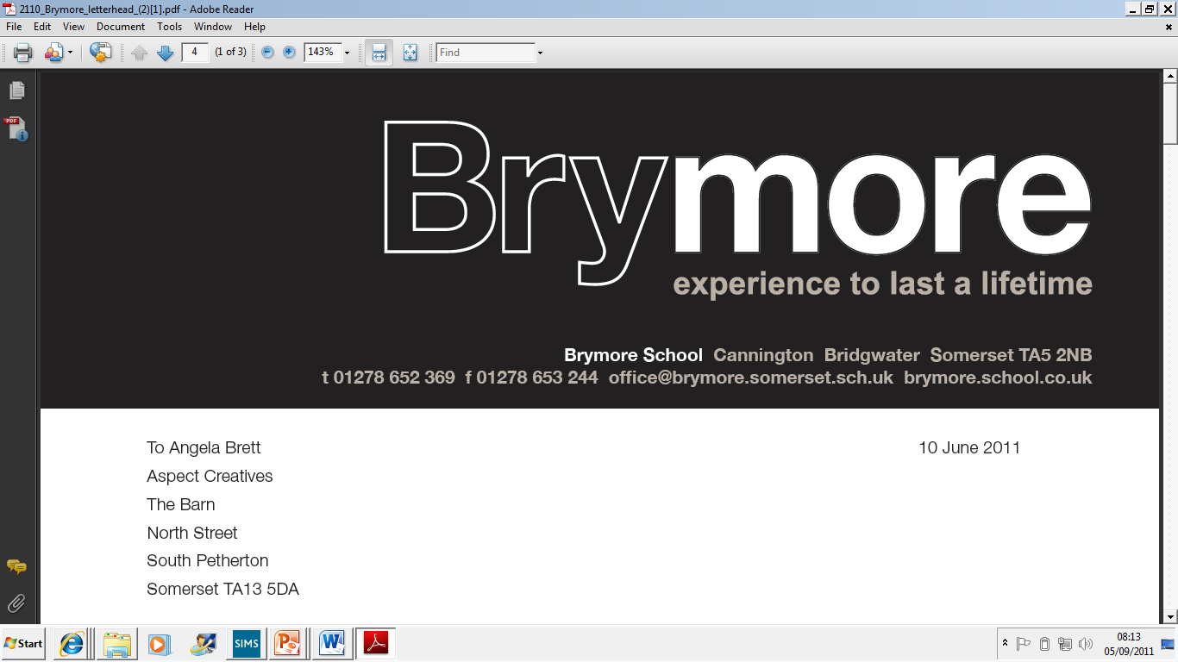

Candidate Absence Policy (Exams)
2025/26

This policy is reviewed annually to ensure compliance with current regulations

Approved/reviewed by
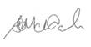
Date of next review | November 2026

Key staff involved in the policy
Role | Name(s)
Head of centre | Stefan McHale
Exams officer | Lisa Gardner

Purpose of the policy
The purpose of this policy is to confirm the arrangements for candidates who are absent from an examination at Brymore Academy.

An absent candidate may subsequently arrive once the exam is underway, becoming a late or very late arrival, at which point Brymore Academy reserves the right to exercise discretion whether to allow a candidate who arrives after the start of the examination to enter the examination room and sit the examination. (See Candidate Late Arrival Policy).

Based upon the circumstances for the absence, and subject to the required conditions being met, an application for special consideration may also be made to the relevant awarding body.

1. Identifying and dealing with candidate absence
A candidate will be considered absent from an examination if:
- The candidate is not present on completion of the attendance register once candidates are seated and have started the examination (ICE 22.5) OR The candidate is not present when a register is taken before candidates are invited to enter the room, under supervised conditions, to start their examination, etc.

Once a candidate is identified as absent from an examination, the following action will be taken:
- The candidate will be contacted as to their whereabouts and as far as possible arrangements made to ensure their immediate arrival

If a candidate fails to sit an examination, the following action is taken:
- A confirmed candidate absence is clearly recorded on the attendance register which is sent to the awarding body/examiner
- The candidate absence is noted on the seating plan by crossing through the candidate details

2. Roles and responsibilities
Overview
It is the responsibility of the following member(s) of staff to deal with candidate absence once it has been identified:
- the exams officer
It is the responsibility of the following member(s) of staff to deal with candidates who are persistently absent from examinations:
• Deputy Head teacher

The role of invigilators
Invigilators will:
- Be informed of the process for dealing with absent candidates through training
- Ensure that absent candidates are clearly indicated on the attendance register (ICE 22.4)

The role of candidates
Candidates will be:
Re-charged any relevant entry fees for unauthorised absence from examinations

3. Special consideration
At Brymore Academy if a candidate is absent from a timetabled written examination for an acceptable reason, the candidate may be eligible for special consideration. This is where an adjustment may be made to the candidate’s grade by the awarding body, providing the following conditions are met:

- The examination is in the candidate’s terminal exam series (SC 4.2)
- The candidate has completed or will be able to complete the required percentage of the assessment to meet the minimum requirements for enhanced grading in cases of acceptable absence (SC 4.5)
- The application for special consideration can be supported by the centre with appropriate evidence authorised by a member of the senior leadership team (SC 6)
It is the responsibility of the following member(s) of staff to deal with special consideration requests and applications:
- The exams officer

