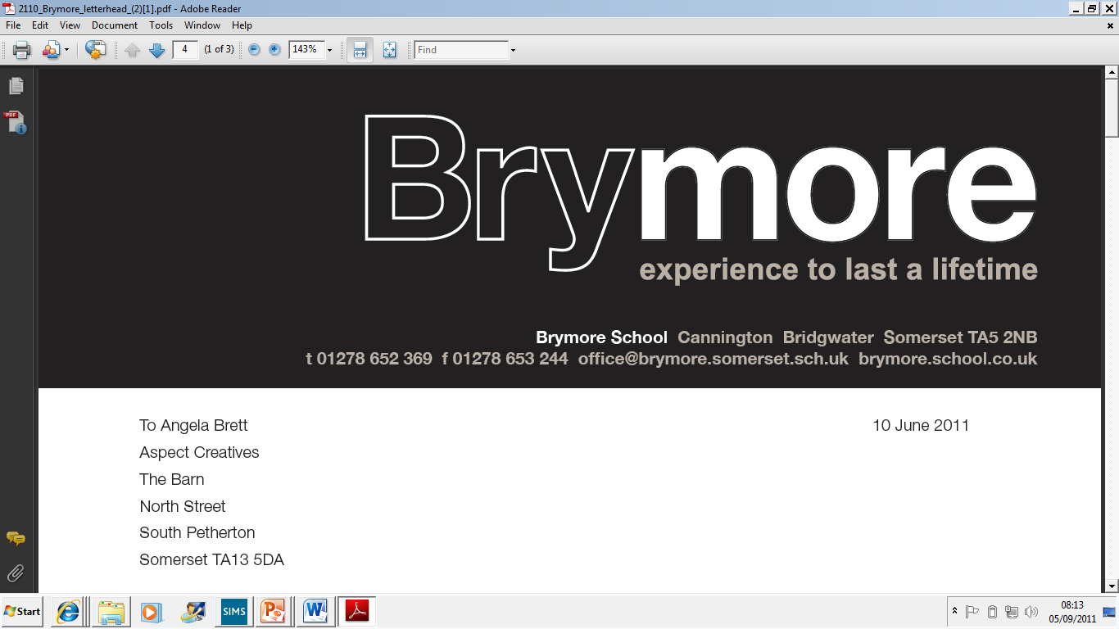

Certificate Issue and Procedure and Retention Policy (Exams)
2025/26

This policy is reviewed annually to ensure compliance with current regulations

Approved/reviewed by
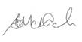
Date of next review | November 2026

Key staff involved in the policy
Role | Name(s)
Head of centre | Stefan McHale
Exams officer | Lisa Gardner
Introduction
Certificates are provided by awarding bodies after examination results have been confirmed. Certificates always remain the property of the awarding bodies.

Purpose of the procedure/policy
The purpose of this procedure/policy is to confirm how Brymore Academy issues examination certificates to candidates and the policy for the retention of any unclaimed/uncollected certificates in compliance with JCQ regulations.

Issue of certificates
Brymore Academy will:
- obtain and maintain accurate candidate contact information to ensure the correct and secure despatch of certificates (GR 5.14)
- distribute certificates to all candidates without delay and regardless of any disputes (GR 5.14)
- not withhold any certificate without prior permission from the relevant awarding body which will only be given in very exceptional circumstances (GR 5.14)
- keep a record of the certificates that are issued (GR 5.14)
- return any certificates requested by the awarding bodies as certificates always remain the property of the awarding bodies (GR 5.14)

The receipt of certificates from awarding bodies and arrangements for the issue of certificates to candidates is managed by the Exams Officer.

Arrangements for the issue of certificates
Certificates are normally issued by collection from the centre or sent via special delivery at the cost of the candidate.

Candidates are informed of the arrangements for the issue of certificates as follows:
- In a letter to parents prior to the exams and in their results service booklet.
Where unable to claim/collect certificates under the normal arrangements
- Candidates may arrange for certificates to be collected on their behalf by providing the exams officer with written or email permission/authorisation. Authorised persons must sign to say they have collected the certificates.
- Candidates/parents have the option to pay for special delivery

Record of issued certificates
- A record of the certificates that have been issued is stored in the exams cupboard for 12 months from the date they have been issued to candidates.
- The record lists the candidates number, awarding body, the qualifications and the exam series.

Retention of certificates
Brymore Academy will:
- retain securely all unclaimed certificates for a minimum of 12 months from the date of issue (GR 5.14)
- destroy any unclaimed certificates after retaining them for a minimum of 12 months (GR 5.14)
- destroy certificates in a confidential manner or may return them to the respective awarding body (GR 5.14)
- retain a record of certificates that have been destroyed for four years from their date of destruction (This record will list the candidate number, the awarding body, the qualification(s) and the examination series) (GR 5.14)
- (where applicable) inform candidates that some awarding bodies do not offer a replacement certificate service and in such circumstances the awarding body will issue a Certifying Statement of Results which will provide an accurate and complete record of results for all qualifications covered by the original certificate (GR 5.14)
The retention of unclaimed or uncollected certificates is managed by the Exams Officer.

Retention policy
- Any unclaimed or uncollected certificates will be retained in the exams cupboard for 12 months from the date of issue.
- After 12 months the certificates will be destroyed in a confidential manner.
- Any certificates destroyed will be recorded and this record will be stored for four years.
- Candidates will be informed that awarding bodies will not offer a replacement certificate service in these circumstances.

