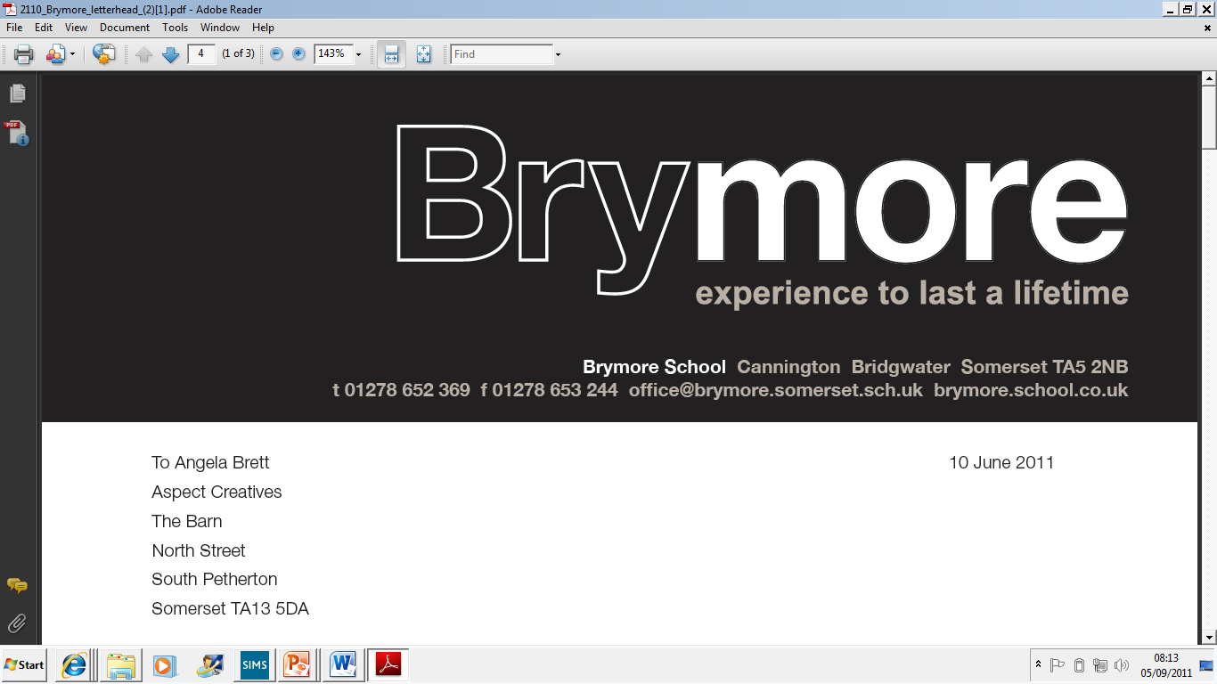

Cyber Policy (Exams)

2025/26

This policy is reviewed annually to ensure compliance with current regulations

Approved/reviewed by
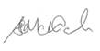
Date of next review | November 2026

Key staff involved in the policy
Role | Name(s)
Head of centre | Stefan McHale
Exams officer | Lisa Gardner

1. Introduction
Brymore Academy is committed to safeguarding its information assets, IT systems, and the personal data of students, staff, and stakeholders from cyber threats. This policy sets out our approach to cyber security, outlines roles and responsibilities, and ensures compliance with relevant UK legislation, including the Data Protection Act 2018, UK GDPR, and Keeping Children Safe in Education guidance.

2. Scope
This policy applies to all staff, students, governors, and any third parties who have access to Brymore Academy's IT systems and data.

3. Roles and Responsibilities
Role | Responsibilities
Head of Centre | Overall responsibility for policy implementation and cyber security strategy.
IT Manager/Team | Implement technical controls, monitor systems, respond to incidents, manage access and updates.
Data Protection Officer | Ensure compliance with data protection law, advise on data handling, and oversee data breaches.
All Staff | Follow this policy, complete annual training, report incidents or concerns promptly within the centre.
Governors | Oversee and review cyber security arrangements and policy compliance.
Students/Users | Use IT systems responsibly and report any concerns.

4. Technical Security Measures
Brymore Academy implements the following security measures, scaled to our size and needs:
- Firewalls and network security controls.
- Anti-virus and anti-malware software on all devices.
- Regular software updates and patch management.
- Secure data backup and tested recovery procedures.
- Encryption for sensitive and personal data.
- Multi-factor authentication (MFA) for critical systems and remote access.
- Secure configuration and monitoring of cloud services (e.g., Office 365, Google Workspace).
- Prompt removal of access for leavers.

5. User Account Management
- Password governance must follow NCSC Guidance:
  - https://www.ncsc.gov.uk/collection/top-tips-for-staying-secure-online/three-random-words
  - https://www.ncsc.gov.uk/collection/passwords/updating-your-approach
- Access control and permissions are based on job roles and reviewed regularly.
- Accounts are promptly disabled when users leave.
- Account activity is monitored and audited.

6. Staff Training and Awareness
- All staff must complete annual cyber security training and annual refresher training.
  - Phishing awareness and social engineering defence training.
  - [Specify any additional training requirements -
    - https://www.ncsc.gov.uk/section/education-skills/cyber-security-Centres#section_17.
- Records of cyber training must be retained for all staff and be available for inspection.

7. Incident Response Plan
- All staff members must report any suspected security incidents or concerns to The head of IT Services immediately.

  - Steps for identifying and reporting incidents:

  - Incident response team: Head of IT Services, Chief Executive Officer, Chief Finance Officer, Data Protection Officer
  - Communication plan for stakeholders – [e.g. relevant awarding body, National Cyber Security Centre (NCSC), etc.]
  - Include referral to awarding organisation(s) (if applicable)
  - Post-incident review process: Conduct a review to identify lessons learned and update procedures if necessary.

