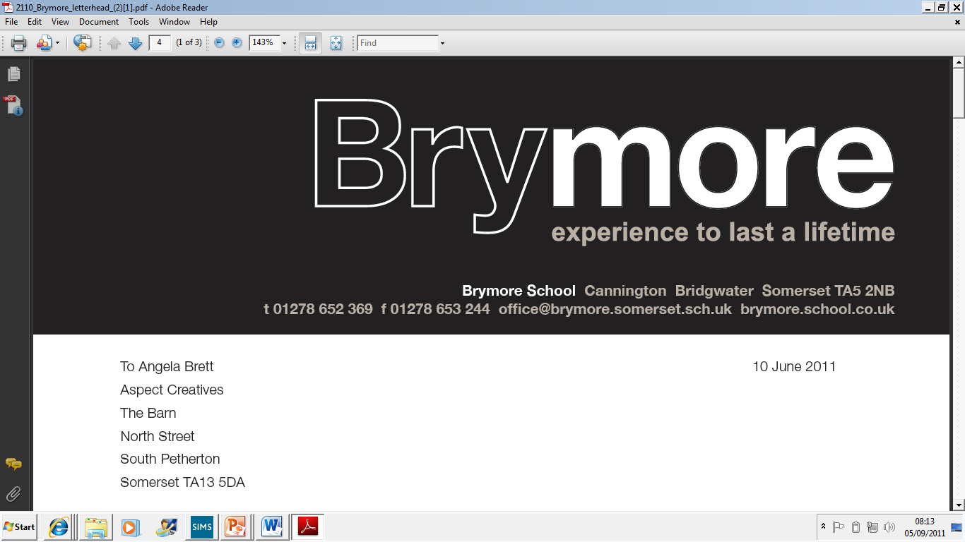

Escalation Process Policy (Exams)
2025/26

This policy is reviewed annually to ensure compliance with current regulations

Approved/reviewed by

Date of next review | November 2026

Key staff involved in the policy
Role | Name(s)
Head of centre | Stefan McHale
Exams officer | Lisa Gardner

Introduction

In terms of internal governance arrangements, it is the responsibility of the head of centre to ensure that Brymore Academy has in place a written escalation process should the head of centre, or a member of the senior leadership team with oversight of examination administration, be absent (GR 5.3).

This process confirms the main duties and responsibilities to be escalated.

This process also supports Brymore Academy being able to confirm to an awarding body the external governance arrangements so that the awarding body has confidence in the integrity of centre activities such as the delivery of qualifications and the conducting of examinations and assessments (GR 5.3).

Purpose of the process

The purpose of the process is to confirm where responsibility will be escalated to ensure continued compliance with JCQ regulations

Before examinations

Planning
In the event of the absence of the head of centre or the member of senior leadership with oversight of examination administration, responsibility for implementing JCQ regulations and requirements relating to activity prior to examinations will be escalated to Head Teacher.
The agreement between the centre and awarding bodies (GR 3)
• Third party agreements
• Centre status
• Confidentiality
• Resilience and contingency arrangements
• Cyber security
• Retention of candidates’ work
• Communication
The responsibility of the centre (GR 5):
Centre management
Recruitment, selection, training and support
• External and internal governance arrangements
• Delivery of qualifications
• Public liability
• Conflicts of interest
• Controlled assessments, coursework and non-examination assessments
• Security of assessment materials • National Centre Number Register and other information requirements
• Centre inspections
•Policies available for inspection Personal data, freedom of information and copyright (GR 6)

To support understanding of the regulations and requirements, the following JCQ documents will be referenced:
• A guide to the special consideration process
• Access Arrangements and Reasonable Adjustments
• AI Use in Assessments: Your role in protecting the integrity of qualifications
• Guidance for centres on cyber security
• Instructions for conducting coursework
• Instructions for conducting examinations
• Instructions for conducting non-examination assessments (GCE and GCSE specifications)
• Instructions for conducting non-examination assessments (Vocational and Technical Qualifications)
• Notice to Centres – Informing candidates of their centre-assessed marks
• Plagiarism in Assessments – Guidance for Teachers/Assessors
• Suspected Malpractice – Policies and Procedures Additional JCQ document for reference: • JCQ Centre Inspection Service Changes

Before examinations

Entries and Pre-exams
In the event of the absence of the head of centre or the member of senior leadership with oversight of examination administration, responsibility for implementing JCQ regulations and requirements relating to entries and exam preparation will be escalated to Head Teacher.

Main areas of compliance relate to:
The responsibility of the centre (GR 5)
- Access arrangements and reasonable adjustments
- Entries (including ensuring appropriate controls are in place which allow accurate entries to be submitted to the awarding bodies)
- Centre assessed work (including that candidates' work is backed-up and considering the contingency of candidates' work being backed-up in the event of IT system corruption and cyber-attacks; ensuring appropriate controls are in place which allow accurate internally assessed marks to be submitted to the awarding bodies)
- Candidate information
Reference information:
To support understanding of the regulations and requirements, sections of relevant JCQ publications will be specifically referenced including:
- General Regulations for Approved Centres (section 5)
- Instructions for conducting examinations (sections 1-15)
- Access Arrangements and Reasonable Adjustments (sections 6-8)

Additional JCQ publications for reference:
- Key dates
- Guidance Notes for Transferred Candidates
- Alternative Site guidance notes
- Guidance notes for overnight supervision of candidates with a timetable variation
- Exam Room Posters
- Information for candidates documents
- Guidance Notes – Centre Consortium Arrangements

During examinations/assessments

Exam time
In the event of the absence of the head of centre or the member of senior leadership with oversight of examination administration, responsibility for implementing JCQ regulations and requirements relating to during exam time will be escalated to Head Teacher.
The centre also has in place a member of the senior leadership team who will provide support and guidance to the examinations officer and ensure that the integrity and security of examinations and assessments is maintained throughout an examination series.
Main areas of compliance relate to:
The agreement between the centre and the awarding bodies (GR 3)
- Retention of candidates’ work
The responsibility of the centre (GR 5)
- Conducting examinations and assessments
- Malpractice
To support understanding of the regulations and requirements, sections of relevant JCQ publications will be specifically referenced including:
- General Regulations for Approved Centres (sections 3, 5)
- Instructions for conducting examinations (sections 16-31)
- Access Arrangements and Reasonable Adjustments (section 8)
- A guide to the special consideration process (sections 2-7)

Additional JCQ document for reference:
• Guidance Notes – Very Late Arrival

After examinations

Results and Post-Results

As a contingency, the centre has at least one senior member of staff (senior designated contact) who is available to manage emergency requests from awarding bodies that are results related during the summer holidays. The National Centre Number Register is provided with the senior designated contact details (this might include a personal mobile number and/or email address). These are the contact details of someone who can be reached in an emergency if the centre is closed over the summer and who can mobilise resources to respond to the issue. (GR 3.18, 5.3)

Responsibility for ensuring compliance will be escalated to the Head of Centre.

Main areas of compliance relate to:

The responsibility of the centre (GR 5)

• Results

• Post-results services and appeals

• Certificates

Reference information:

To support understanding of the regulations and requirements, sections of relevant JCQ documents will be specifically referenced including:

• General Regulations for Approved Centres (5) Additional JCQ documents for reference:

• JCQ Release of results notice

• JCQ Post-Results Services (Information and guidance to centres) • JCQ Appeals Booklet (A guide to the awarding bodies' appeals processes)

