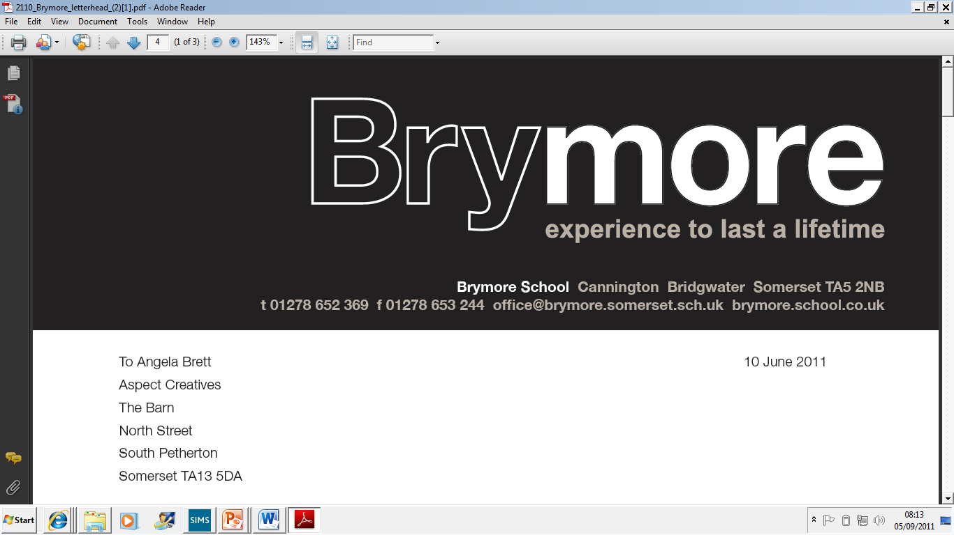

Food and Drinks Policy (Exams)
2025/26

This policy is reviewed annually to ensure compliance with current regulations

Approved/reviewed by
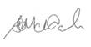
Date of next review | November 2026

Key staff involved in the policy
Role | Name(s)
Head of centre | Stefan McHale
Exams officer | Lisa Gardner

Purpose of the policy
This policy confirms that Brymore Academy reserves the right to exercise discretion whether to allow food and drink in the examination room, and confirms:
• the correct procedures are followed regarding food and drink in the examination room
• appropriate arrangements are in place for the management of food and drink in the examination room

1. Food and drink in the examination room
Food and drink is allowed in the examination room at the discretion of the head of centre (ICE 18.4)

To enable invigilators to check these items quickly and efficiently:
- food brought into the examination room by the candidate must be free of packaging and in a transparent container
- drink bottles must be transparent with all labels removed, which would include transparent, reusable plastic bottles (ICE 18.4)
The following arrangements are applied at Brymore Academy:

Food is only allowed for medical purposes.

2. Roles and responsibilities

The role of the exams office/officer
- Through briefings, ensure candidates are aware of the regulations, and centre-specific arrangements, relating to food and drink in the examination room

- Ensure invigilators are trained and aware of the regulations/centre-specific arrangements relating to food and drink in the examination room

- Escalate any issue or breach of centre-specific arrangements to the relevant senior leader for the application of internal sanction(s)

- Escalate any breach of JCQ regulations immediately to the head of centre (a breach of the regulations constitutes suspected or actual malpractice)

The role of the invigilator
- Be vigilant in the examination room and remain aware of incidents or emerging situations, looking out for malpractice (ICE 20.2)

- Record what has happened and actions taken using an incident log in relation to any breach of regulations/centre-specific arrangements regarding food and drink in the examination room (ICE 20.2)

The role of the head of centre
Report to the awarding body immediately all cases of alleged, suspected or actual malpractice in connection with the examination (ICE 24.3)

