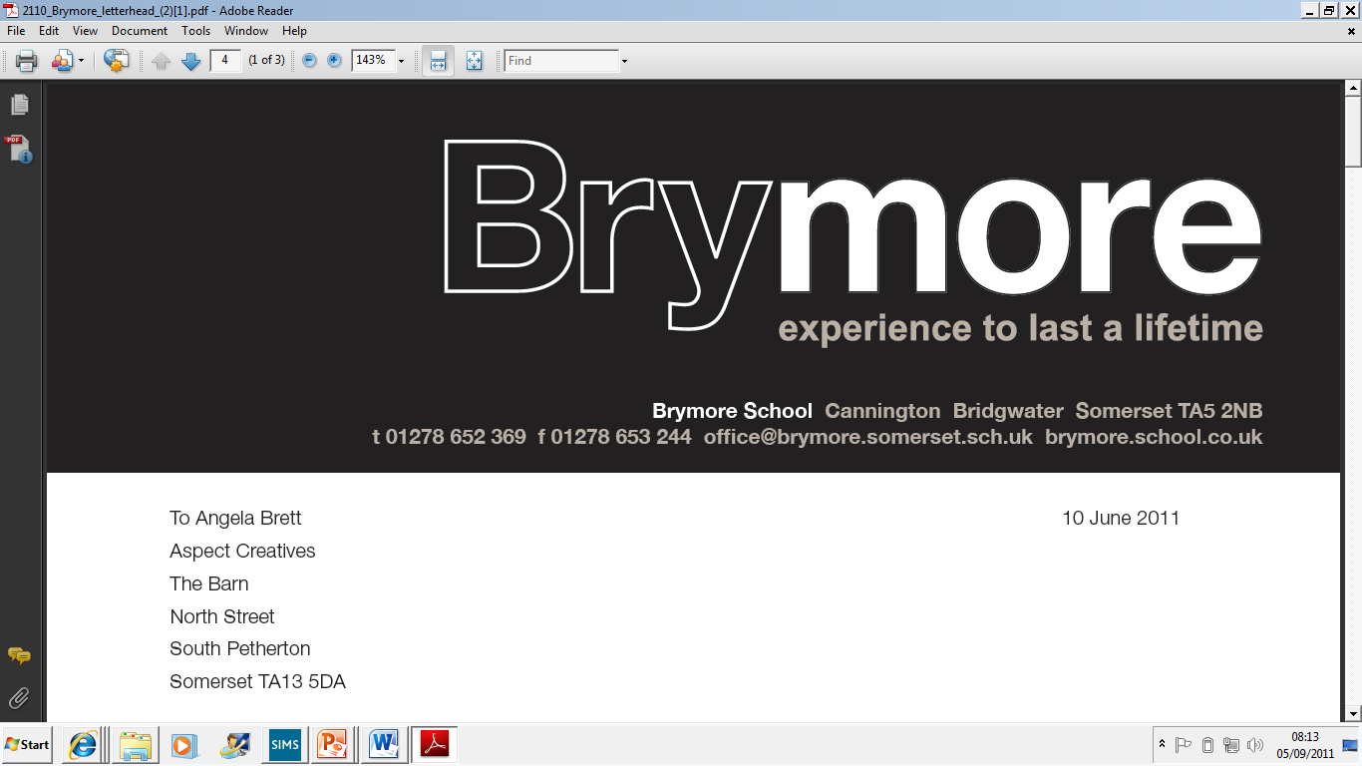

Leaving the Examination Room Policy (Exams)
2025/26

This policy is reviewed annually to ensure compliance with current regulations

Approved/reviewed by
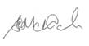
Date of next review | November 2026

Key staff involved in the policy
Role | Name(s)
Head of centre | Stefan McHale
Exams officer | Lisa Gardner

Purpose of the policy
The purpose of this policy is to confirm that candidates leaving the examination room at Brymore Academy is managed in line with JCQ regulations.

This policy confirms:
• the correct procedures are followed in relation to candidates leaving the examination room

Brymore Academy reserves the right to exercise discretion whether to allow extra time to compensate candidates for their temporary absence from the examination room

1. Arrangements for leaving the examination room
- For examinations that last one hour or more, candidates must stay under centre supervision until 10.00am for a morning examination or 2.30pm for an afternoon examination, i.e. one hour after the awarding body’s published starting time for that examination (ICE 23.1)
- For examinations that last less than one hour, candidates must be supervised and question papers must be kept in secure storage until the published finishing time of the examination. (ICE 23.2)
- Candidates who are allowed to leave the examination room temporarily must be accompanied by a member of centre staff. This must not be the candidate’s subject teacher or a subject expert for the examination in question. (ICE 23.3)
- Candidates may be allowed extra time at the discretion of the centre to compensate for their temporary absence. (ICE 23.5)
- Candidates can only leave the examination room where necessary or where supervised rest breaks have been granted by the SENCo. The centre must ensure that candidates who leave the room do not have access to any unauthorised materials. (ICE 23.4)
- Candidates who have finished the examination and have been allowed to leave the examination room early must hand in their script, question paper and any other material before they leave the examination room. Those candidates must not be allowed back into the room. (ICE 23.6)
- At the end of the examination, candidates must hand in their script, question paper and any other material before they leave the examination room. (ICE 23.7)

The following arrangements are applied at Brymore Academy:
When candidates (without a known medical condition/those not approved supervised rest breaks) may be allowed to leave the room temporarily:

- For a toilet break or medical attention/treatment at Matrons. The student will be escorted and supervised at all times by the Exams Officer.
- Candidates who are allowed to leave the examination room temporarily may be allowed extra time to compensate for their temporary absence. (ICE 23.5)
Any time lost will be logged and added onto the end of the finish time.

2. Roles and responsibilities
The role of the exams office/officer
- Through training, ensure invigilators are aware how candidates who may be allowed to leave the examination room temporarily should be managed and recorded

The role of the invigilator
- Ensure a candidate who may be allowed to leave the examination room temporarily is accompanied by a member of centre staff who is not the candidate’s subject teacher or a subject expert for the examination in question (ICE 23.3)
- Record instances on the exam room incident log of candidates who may be allowed to leave the examination room temporarily because they may be feeling unwell or require a toilet break (ICE 20.2)
- Ensure candidates who have finished the examination and have been allowed to leave the examination room early hand in their script, question paper and any other material before they leave the examination room. Ensure those candidates are not allowed back into the room (ICE 23.6)
- At the end of the examination, ensure candidates hand in their script, question paper and any other material before they leave the examination room (ICE 23.7)
The invigilators will record every event on the incident log whatever the circumstance. The timings for any candidate who will be compensated for their temporary absence from the exam room will be noted on the incident log and the candidate will be informed of the amended finishing time with a piece of paper on their desk with their new finish time.

