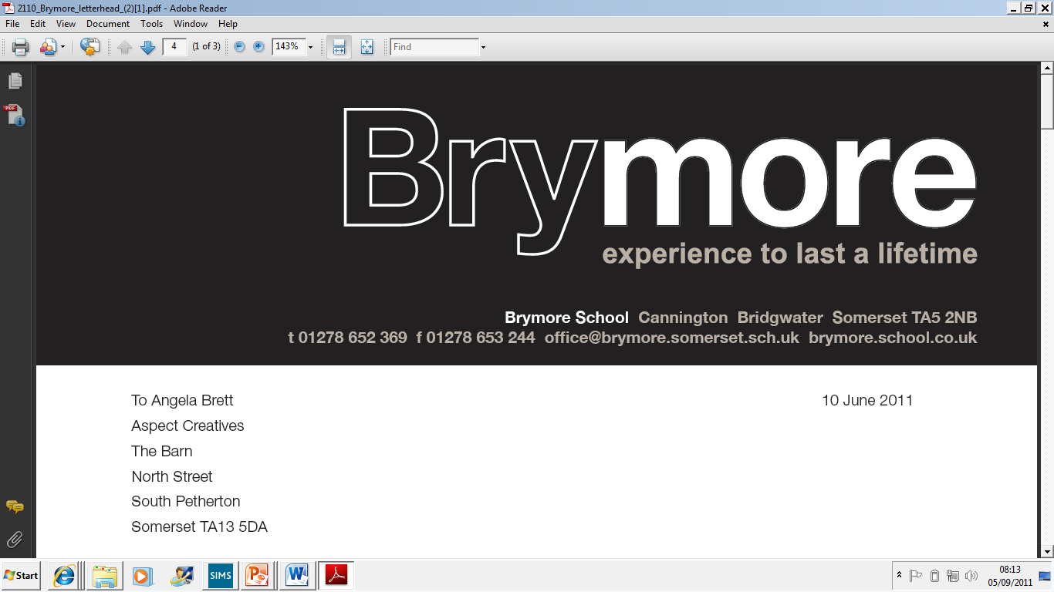

Lockdown Policy (Exams)

2025/26

This policy is reviewed annually to ensure compliance with current regulations

Approved/reviewed by
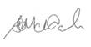
Date of next review | November 2026

Key staff involved in the policy
Role | Name(s)
Head of centre | Stefan McHale
Exams officer | Lisa Gardner

Definitions
For the purpose of this policy, the following definitions should be noted:

Lockdown
This is a protective measure implemented when there is a credible threat to the safety of candidates/students and staff. During a lockdown, individuals are instructed to remain inside the building and seek shelter in a secure location, away from the source of danger.

The purpose of a lockdown is to minimise exposure to potential harm and ensure the safety and wellbeing of everyone on site until the threat has been resolved or emergency services arrive.

Lockdown procedures may be activated in situations including:
- The presence of an unauthorised or suspicious individual on the grounds or within the building
- A violent, aggressive, or abusive parent/carer causing disruption
- A specific threat made against the centre or its occupants

All staff must be familiar with the centre’s lockdown protocol and ensure candidates/students are guided calmly and efficiently to designated safe areas.

Communication with emergency services and internal coordination will be managed by the head of centre or designated safeguarding lead.

Invacuation
This is a safety measure used when there is a potential external threat in the surrounding area. While lockdowns are activated in response to immediate risks within or directly threatening the premises, invacuations are employed when it is safer for candidates/students, staff, and visitors to remain inside the
building due to hazards outside.

Invacuation procedures are designed to ensure that all individuals are brought indoors promptly and remain inside until the external threat has passed or further guidance is provided by emergency services.

An invacuation may be applicable to exam candidates if they have left the exam room in the event of an emergency evacuation (for example, due to a fire alarm).

Examples of situations requiring invacuation include:
- The presence of loose or potentially dangerous animals on the grounds
- Environmental hazards such as gas leaks, smoke, or chemical pollution in the vicinity
- Nearby incidents (e.g. police activity or civil disturbance) that may pose a risk if individuals exit the building

Staff are expected to follow the invacuation protocol calmly and efficiently, ensuring that all
candidates/students are accounted for and safely indoors. The head of centre or designated safeguarding lead will oversee communication and coordination during such events.

Purpose of the policy
This policy details the measures taken at Brymore Academy in the event of a centre lockdown during the conducting of examinations.

Lockdown procedures have been determined by consulting ProtectUK, the Department for Education’s guidance relating to School and college security and Martyn’s Law.

Depending on the nature of the incident, a decision will be made to evacuate, invacuate (an inward evacuation) or use a protected space(s). However, this policy focuses specifically upon the actions, roles and responsibilities during an exams-related lockdown.

The Terrorism (Protection of Premises) Act 2025
Although Brymore Academy is not classified as a high-risk venue under current legislation, we are committed to embedding the principles of Martyn’s Law into our safeguarding and emergency preparedness framework.

These include:
- Risk awareness: Staff being equipped to identify potential threats and recognise suspicious behaviour or activity that may pose a risk to students, staff and visitors
- Emergency planning: Maintaining clear, comprehensive, and regularly reviewed procedures to respond effectively to a range of emergency scenarios
- Rapid response capability: Training staff to act swiftly and appropriately in the event of an emergency to ensure the safety and protection of students, colleagues, and visitors
These principles underpin our broader approach to security and safeguarding, and will be reflected in staff training, policy reviews, and incident management protocols.

Compliance
To ensure that all staff at Brymore Academy are meeting the requirements of the Terrorism (Protection of Premises) Act 2025, the following procedures are in place:

Evacuation (Getting people out of the building)
An evacuation of the exam room will be initiated when it is deemed safer for candidates and staff to leave the
room and the building due to an internal threat such as fire, gas leak, structural damage, or other emergencies. This procedure ensures a swift, orderly, and safe exit to designated assembly points.

Step-by-step procedure:
1. Activation of alarm
The fire alarm or emergency alert system will be triggered manually or automatically.
Invigilators will immediately begin evacuation procedures without waiting for further instruction unless advised otherwise

2. Immediate response
Candidates will be instructed to stop their examination and prepare to leave the exam room in line with
the invigilator’s instructions
Invigilators will lead candidates out of the building via the nearest safe exit, avoiding lifts and blocked routes

3. Use of evacuation routes
- Pre-assigned evacuation routes and exits will be followed
- Invigilators will check the exam room (and any candidates who may have temporarily left the exam room) to ensure that no one is left behind

4. Assembly at designated point
- Invigilators will take candidates to the designated assembly point(s) outside the building
- Registers will be taken promptly to account for all candidates and invigilators
- Any missing candidates will be reported immediately to the senior leadership team or emergency services

5. Communication and co-ordination
The head of centre or designated safeguarding lead will liaise with emergency services and provides updates
- Invigilators will supervise candidates and maintain calm until further instructions are given
6. Re-entry or dismissal
- No one will be permitted to re-enter the building until it has been declared safe by emergency personnel

Invacuation (Moving people to a safe place)
If candidates have been outside of the exam room, for example, for an emergency evacuation, or on a supervised rest break, they will be brought back into the exam room promptly and remain inside until the
situation is resolved. The procedure will include:

1. Initial Alert
- The head of centre or designated safeguarding lead will assess the situation and initiate the invacuation protocol
- A clear announcement will be made via the centre’s communication system (e.g. tannoy, radios, or internal messaging)

2. Movement Indoors
- All outdoor activities (for example, an emergency evacuation or supervised rest break) being undertaken by candidates sitting an examination will be halted immediately
- Candidates will be escorted indoors quickly and calmly, using the nearest safe entry point

3. Securing the Building
- External doors and windows will be closed and secured
- Access points will be monitored to prevent entry or exit until the all-clear is given
4. Internal Safety Measures
- Candidates and staff (invigilators) will remain in the exam room or designated safe area(s) o
- Movement within the building will be restricted unless necessary
- Invigilators will take registers to account for all candidates and report any discrepancies to the exams office/officer (unless instructed otherwise)

5. Communication
- The head of centre or designated safeguarding lead will maintain contact with emergency services and monitor update
- Parents/carers will be informed if appropriate, depending on the nature and duration of the incident

6. All-Clear and Debrief
- Once the threat has passed, an all-clear message will be issued
- Candidates will resume their examination
- The incident will be reported to the relevant awarding body/bodies, and a short debrief may be conducted to review the response and identify any improvements

Lockdown procedure
Where a lockdown is required, the following procedures will be followed at Brymore Academy:

Before an examination
As candidates are entering/waiting to enter the examination room:
Invigilators will:
- instruct candidates to enter the examination room immediately
- instruct candidates to remain silent, hide under desks or sit against a wall/around a corner but not near the door and to ensure mobile phones are on silent and non-vibrate mode
- lock all windows and close any/all curtains/blinds
- switch off all lights
- lock all doors and/or use tables, or any other furniture, to barricade the entrance to the room
- take an attendance register/head count if possible
- (if the threat is a chemical or toxic release) instruct candidates to cover their nose and mouth (their own clothing can be used) and attempt to use anything to hand to seal up cracks around doors and any vents into the room
- where safe/possible, not leave the examination question papers unattended/out of sight
A senior leader/authorised person will be present around the examination room area(s) and where safe/possible, communicate the situation to the exams office/officer (via mobile phone/walkie talkie on silent and non-vibrate mode).

The exams office/officer will collate the information from all examination rooms and forward this to the head of centre immediately.

The head of centre will make informed decisions on alerting parents/carers, awarding bodies and emergency
services.

During an examination
When candidates are in the examination room:
Invigilators will:
- tell candidates to stop writing immediately and close their answer booklets
- collect the attendance register
- make a note of the time when the examination was suspended
- instruct candidates to remain silent, leave all examination materials on their desks and hide under desks
- where safe/possible, communicate (via mobile phone/walkie talkie) the situation to the exams officer (ensuring that all mobile phones/walkie talkies are on silent and non-vibrate mode)
- lock all windows and close any/all curtains/blinds
- switch off all lights
- lock all doors and/or use tables, or any other furniture, to barricade the entrance to the room
- (if the threat is a chemical or toxic release) instruct candidates to cover their nose and mouth (their own clothing can be used) and attempt to use anything to hand to seal up cracks around doors and any vents into the room
- where safe/possible, not leave the examination question papers unattended/out of sight
Where safe/possible, the exams office/officer will collate the information from all examination rooms and forward this to the head of centre immediately.

The head of centre will make informed decisions on alerting parents/carers, awarding bodies and emergency services.

If appropriate, where safe/possible, and following instruction from the appropriate authority, the exams office/officer and/or invigilators will initiate the emergency evacuation procedure.

Where safe/possible, the exams office/officer will collect all examination question papers and materials for safe/secure storage following advice from the appropriate awarding body/bodies.

After an examination
As candidates are leaving the examination room:
Invigilators will:
- stop dismissing candidates from the examination room
- instruct candidates who have left to re-enter the examination room
- instruct candidates to remain silent and hide under desks/tables
- where safe/possible, communicate (via mobile phone/walkie talkie) the situation to the exams officer
- (ensuring that all mobile phones/walkie talkies are on silent and non-vibrate mode) lock all windows and close any/all curtains/blinds
- switch off all lights
- lock all doors and/or use tables, or any other furniture, to barricade the entrance to the room
- (if the threat is a chemical or toxic release) instruct candidates to cover their nose and mouth (their own clothing can be used) and attempt to use anything to hand to seal up cracks around doors and any vents into the room
- where safe/possible, not leave the examination question papers unattended/out of sight
Where safe/possible, the exams officer will collate the information from all examination rooms and forward this to the head of centre immediately.
The head of centre will make informed decisions on alerting parents/carers, awarding bodies and emergency services.

Ending a lockdown
The lockdown will be ended by either:
- the sound of a defined alarm, or
- the identification/authorisation of emergency service officer/senior leader/head of centre entering the examination room
A specific word or phrase may be used to confirm that the instruction to end the lockdown is genuine.

Invigilators will undertake a head count/register and confirm attendance with the exams office/officer/senior leader.

Where applicable and if advised to do so by a senior leader/head of centre, if there is sufficient time (and following JCQ regulations), candidates may be allowed to restart their examination.

Invigilators will:
- ask candidates to return to their desks, remind them they are under formal examination conditions and allow a settling down period
- allow candidates the full working time remaining for their examination
- recalculate the revised finish time(s)
- tell the candidates to open their answer booklets and re-start their examination
- amend the revised finish time(s) on display to candidates
- note how long the lockdown lasted on the exam room incident log (to later inform a report to the awarding body/bodies)

The exams office/officer will:
- safely/securely store all collected exam papers and materials pending awarding body advice/guidance
and where this may be applicable:

- ensure appropriate follow-up is undertaken after the incident, reporting the incident to the awarding body and the actions taken, where this may be applicable
- where this may be applicable, ensure a full report of the incident is produced and retained on file if required by an awarding body
- where this may be applicable, ensure an online application for special consideration is submitted to the relevant awarding body where candidates have been disadvantaged

Where applicable/possible/available, the senior leader/exams office/officer will:
- discuss any alternative examination sittings with the awarding body/bodies
- offer, arrange and provide support services to staff and candidates
At the earliest immediate opportunity, the head of centre will ensure that any breach of question paper security or malpractice is reported to the awarding body.
At the earliest opportunity, the senior leader/head of centre will prepare a communication to parents/carers advising them of events (including relevant actions and outcomes).

Where possible, exams staff and candidates will be invited to attend an assembly lead by the head of centre to discuss the lockdown and offer ongoing support.

- If this is not possible, communications will be provided via a centre text/email/newsletter and information uploaded to the centre website

Roles and responsibilities
The role of the head of centre
- To ensure that vulnerability and space assessments are conducted to:
- Identify specific risks (for example, intruders, violent or aggressive individuals or incidents happening in the local area)
- Consider different times of the day/during an examination when candidates may be more dispersed across the site or away from the exam room (for example, during a supervised rest break, a toilet break)
- Highlight areas centre where an attacker might carry out an attack, and where the easiest places to gain access are
- Assess how many candidates can be accommodated in a particular (safe) area (for example, the exam room)
- Ensure that a dedicated lockdown alarm tone is in place and recognised by all staff and candidates
- Arrange appropriate training for all exams-related staff in evacuation, invacuation and lockdown procedures
- Ensure candidates are aware of the procedures relating to an evacuation, invacuation and lockdown, particularly those arriving late for an examination who cannot access the examination room due to it being locked down
- Ensure all candidates and staff are aware of a possible exit point in case an intruder manages to gain access, or the room becomes unsafe
- Provide written invacuation and lockdown procedures for examination room/invigilator use
- Inform the relevant emergency service(s) immediately in the case of any potential threat to the safety of exams staff and candidates

The role of the senior leader
- Assume responsibility for exams staff and candidates taking examinations during an invacuation/lockdown
- Arrange training/drills for examination candidates on invacuation and lockdown procedures
- Inform parents/carers about the centre’s Lockdown Policy in relation to the conducting of examinations
- Have a presence around examination room areas prior to the start of each examination session
- Liaise with the appropriate authorities and awarding bodies regarding candidates taking examinations during an invacuation/lockdown
- Use the examination room attendance register(s) to compile a list of any candidates not accounted for

The role of the exams office/officer
- Train invigilators in the centre’s invacuation and lockdown procedure(s) (This should also include identifying all access and egress points within exam rooms, an awareness of the design of the locking device within each room and if there is more than one invigilator, whose role it would be to secure the exam room)
- Where safe/possible, liaise with senior leaders/invigilators in all examination rooms during an invacuation/lockdown
- Assist with invacuation/lockdown training for staff and students where applicable to the conducting of examinations

The role of the invigilator
Be aware of the centre’s invacuation/lockdown procedure(s)
Complete attendance registers as soon as possible so candidates can be identified in the event of an invacuation/lockdown

Where safe/possible, to communicate with the exams office/officer during an invacuation/lockdown to confirm the situation in a particular examination room

Where safe/possible, not leave the examination question papers and candidates’ scripts unattended/out of sight

