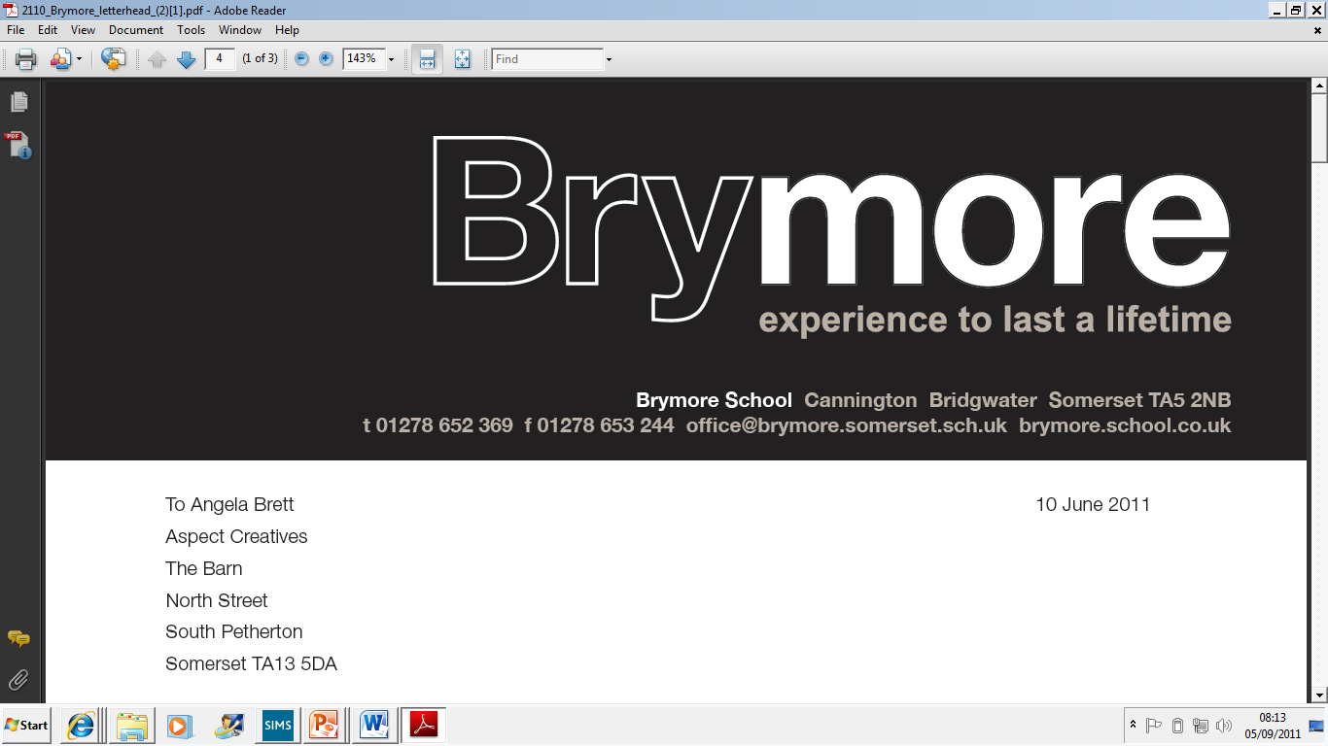

Managing Behaviour Policy (Exams)
2025/26

This policy is reviewed annually to ensure compliance with current regulations

Approved/reviewed by
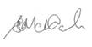
Date of next review | November 2026

Key staff involved in the policy
Role | Name(s)
Head of centre | Stefan McHale
Exams officer | Lisa Gardner

Purpose of the policy
The purpose of this policy is to confirm that candidate behaviour in the examination room at Brymore Academy is managed in line with JCQ regulations.

1. Briefing candidates
To ensure candidates are aware of the standard of behaviour that is required in the examination room, Brymore Academy will:
- ensure the JCQ Information for candidates documents (coursework, non- examination assessments, onscreen tests, social media and written examinations) and awarding body privacy notices are distributed to all candidates whether electronically or in hard copy format prior to assessments and/or examinations taking place. (GR 5.8)
- ensure candidates are also made aware of the content of the JCQ Unauthorised items and Warning to candidates posters (GR 5.8)
- prior to assessments and/or examinations taking place, ensure candidates are briefed to reinforce what they must and must not do when sitting written examinations and/or on-screen tests, and when producing coursework and/or non-examination assessments (GR 5.8)

At Brymore Academy candidates are made aware of JCQ information/briefed by:
• the senior leadership team in an assembly and given a hard copy during their raising achievement session.

2. Candidate malpractice
- ‘Malpractice’, means any act, default or practice which is a breach of the Regulations (SMPP 1.2)
- Suspected malpractice means all alleged or suspected incidents of malpractice (SMPP 2)
- ‘Candidate malpractice’ normally involves malpractice by a candidate in connection with any examination or assessment, including the preparation and authentication of any controlled assessments, coursework or non-examination assessments, the presentation of any practical work, the compilation of portfolios of assessment evidence and the completion of any examination (SMPP 2)
- Inappropriate behaviour by a candidate in the examination room or assessment session is deemed 'candidate malpractice'
- Failure by a centre to notify, investigate and report to an awarding body all allegations of malpractice or suspected malpractice constitutes malpractice in itself (SMPP 1.7)
Examples of inappropriate behaviour/actions that constitute 'candidate malpractice' are provided in the final section of this policy.

3. Instructions for conducting examinations - Malpractice in the examination room
The following requirements are applied at Brymore Academy:
- Candidates are under formal examination conditions from the moment they enter the room in which they will be taking their examination(s) until the point at which they are permitted to leave
- Candidates must not talk to, attempt to communicate with or disturb other candidates once they have entered the examination room. If they do, this must be reported to the relevant awarding body
- Candidates must not open the question paper until the examination begins. If they do, this must be reported to the relevant awarding body (ICE 19.1)
- Where a candidate is being disruptive, the invigilator must warn the candidate that they may be removed from the examination room. The candidate must also be warned that the awarding body will be informed and may decide to penalise them, which could include disqualification (ICE 24.1)
- The head of centre, or authorised members of staff, have the authority to remove a candidate from the examination room but should only do so if the candidate would disrupt others by remaining in the room (ICE 24.1)
- The head of centre must report to the awarding body immediately all cases of suspected or actual malpractice in connection with the examination, including candidates, invigilators and centre staff, using the relevant JCQ forms (ICE 24.3)
- Where candidates commit malpractice, the awarding body may decide to penalise them, which could include disqualification. Candidates should be warned of the possible penalties an awarding body may apply as detailed in the JCQ document Suspected Malpractice: Policies and Procedures (ICE 24.4)
- In cases of suspected malpractice, examination scripts must be packed as normal with Form JCQ/M1 being submitted separately to the relevant awarding body (ICE 24.6)

4. Roles and responsibilities
The role of the invigilator
- Be vigilant and remain aware of incidents or emerging situations, looking out for malpractice (ICE 20.2)
- Warn a disruptive candidate that they may be removed from the examination room (ICE 24.1)
- Record what has happened and actions taken on the exam room incident log (ICE 24.1)
Additional responsibilities:
The role of the exams office/officer
- Ensure that the JCQ Information for candidates documents (coursework, non- examination assessments, on-screen tests, social media and written examinations) are distributed to all candidates whether electronically or in hard copy format prior to assessments and/or examinations taking place and that candidates are also made aware of the content if the JCQ Unauthorised items and Warning to candidates posters (GR 5.8)
- Ensure when conducting examinations that the JCQ Unauthorised items and Warning to candidates posters are displayed in a prominent place for all candidates to see prior to entering the examination room (GR 5.8)
- Where a candidate is being/has been disruptive in the examination room, warn the candidate that the awarding body will be informed and may decide to penalise them, which could include disqualification (ICE 24.1)

Additional responsibilities:
The role of the head of centre
- Where a candidate is seriously disrupting others, makes the decision (or authorised members of staff make the decision) to remove the candidate from the examination room (ICE 24.1)
- Report to the awarding body immediately all cases of alleged, suspected or actual malpractice in connection with the examination, including candidates, invigilators and centre staff, by completing the relevant JCQ forms (ICE 24.3)
Additional responsibilities:
The role of the senior leader
- Ensure support is provided for the exams officer and invigilators when dealing with disruptive candidates in examination rooms
- Ensure that internal disciplinary procedures relating to candidate behaviour are instigated, when appropriate.

