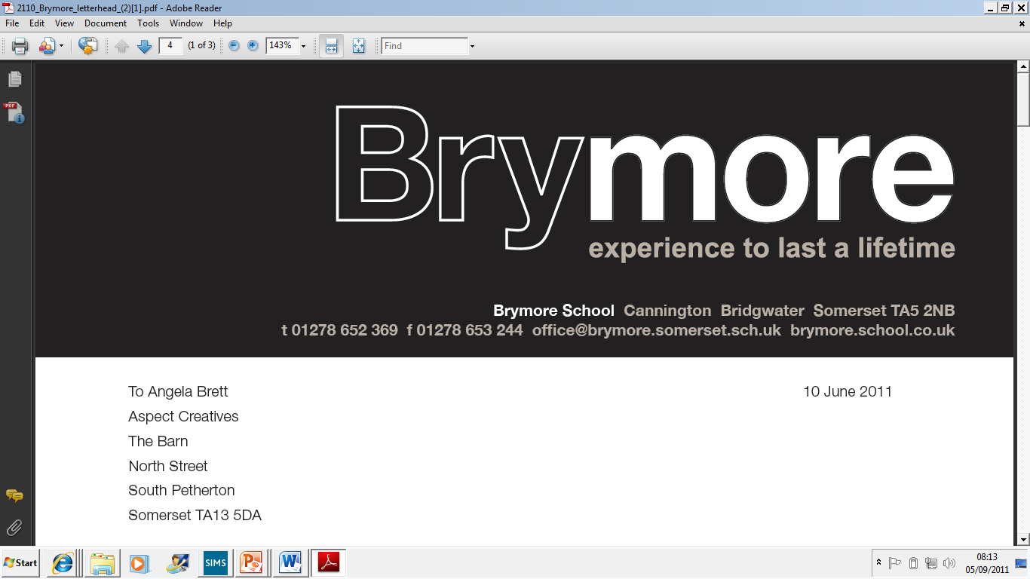

Overnight Supervision Arrangements Policy (Exams)
2025/26

This policy is reviewed annually to ensure compliance with current regulations

Approved/reviewed by

Date of next review | November 2026

Key staff involved in the policy
Role | Name(s)
Head of centre | Stefan McHale
Exams officer | Lisa Gardner

Purpose of the Process
This purpose of this policy is to confirm that Brymore Academy:
- follows the correct procedures when considering the arrangements for a candidate entered for multiple examinations timetabled for the same day
- reserves the right to exercise discretion when considering allowing a candidate to take an examination the following morning
- has appropriate arrangements in place to maintain the security and integrity of the examination(s)
1. Overnight supervision arrangements
When candidates are entered for multiple examinations (three or more examinations) timetabled for the same day and the total duration for those papers is:
- more than six hours for GCE examinations (AS, A2, A-level), including approved extra time allowances and/or supervised rest breaks, or
- more than five and a half hours for GCSE examinations, including approved extra time allowances and/or supervised rest breaks
candidates may, at the centre’s discretion, be allowed to take an examination scheduled for the afternoon session the following morning, including Saturdays. (ICE 8.1)

- These arrangements do not apply where a GCSE candidate has five and a half hours or less of examinations in one day or where a GCE AS or A-level candidate has six hours or less of examinations in one day (ICE 8.3)
- Overnight supervision arrangements should only be applied as a last resort and only once all other options have been exhausted (ICE 8)
- The head of centre must be satisfied with any necessary arrangement for overnight supervision of a candidate and must accept full responsibility for the security of the examination throughout (ICE 8)
- Candidates are not allowed to take examinations on an earlier day than that scheduled on the timetable (ICE 8.1)
- The overnight supervision arrangements must ensure that the candidate does not have advance warning of the content of the examination that is deferred until the following morning. This means the candidate must not meet or communicate with anyone who may have knowledge of the content. This includes email, internet, online streaming services, printed media, radio, social media (including messaging apps), telephone or television (ICE 8.6)
- If the candidate opts to sit all examinations in one day, then the supervised break between each examination can be more than 20 minutes. The supervised break may be conducted in an alternative location within the centre.
Where the supervised break is conducted outside of the examination room, the candidate may revise using their own resources. However, the candidate must not:
- be in possession of an electronic communication or storage device or have access to the internet
- have contact with any candidate who has sat the examination
- be coached by a member of centre staff
A member of centre staff, or an invigilator, must always be in the same room as the candidate. The invigilator must not be the subject teacher for the rescheduled examination. (ICE 8.2)

2. Roles and responsibilities
The role of the head of centre
- Ensure where a candidate takes an examination the following morning, a member of centre staff or an
- invigilator is appointed to supervise the candidate at all times while they are on the premises sitting examinations (ICE 8.4)
- Be satisfied that the arrangements maintain the integrity and security of the examination (ICE 8.8)
- Inform the relevant awarding body immediately of any known or suspected contravention of the arrangements for overnight supervision of a candidate (ICE 8.8)

Additional responsibilities:
The role of the exams office/officer
- Discuss with an affected candidate all possible options to resolve, within the same day, their timetable clash of multiple examinations, only applying overnight supervision arrangements as a last resort and only once all other options have been exhausted (ICE 8)
- Rearrange any examination that cannot be taken in the scheduled afternoon session for the following morning, ensuring if an examination is deferred from Friday afternoon, it is taken the following morning i.e. Saturday morning (ICE 8.10)
- Ensure the JCQ Overnight Supervision and Overnight supervision declaration forms are completed before the overnight supervision is to commence (ICE 8.7)
- Confirm the supervision of a candidate on journeys to and from the centre and overnight may be undertaken by the candidate’s parent, carer or centre staff, determining a method of supervision which ensures the candidate’s wellbeing (ICE 8.5)
- Download the JCQ Overnight supervision declaration form for signing by the candidate, the supervisor and the head of centre (ICE 8.7)
- Inform the parties involved that any infringement of the conditions governing overnight supervision arrangements may lead to the awarding body being unable to accept the script and/or the application of sanctions as detailed in the JCQ document Suspected Malpractice: Policies and Procedures (ICE 8.8)
- Keep all completed forms available for inspection until the deadline for reviews of marking has passed or until any appeal, malpractice or other results enquiry has been completed, whichever is later, and not send to an awarding body, unless specifically requested (ICE 8.8)
- Ensure where a candidate takes an examination the following morning, the candidate is under centre supervision from 30 minutes after the awarding body’s published starting time for the delayed examination and ensure there is no contact with other candidates (ICE 8.4)
- If a candidate is allowed to take an examination on a later day than other candidates at the centre, ensure all copies of the question paper used on the scheduled day of the examination are sealed in an envelope and returned to the centre’s secure storage facility until all candidates have taken the examination (ICE8.11)

