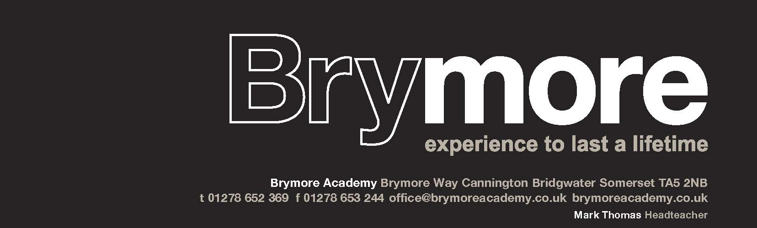
Brymore Academy Cannington Somerset TA5 2NB
Tel: 01278 652369 email: office@brymoreacademy.co.uk website: www.brymoreacademy.co.uk
Stefan McHale, Headteacher

An academy sponsored by Bridgwater & Taunton College

16th January 2026

Dear Parent/Guardian

BRYMORE SKI TOUR TO FOLGARIDA-MARILLEVA RESORT, ITALY
Saturday 12th - 19th December 2026 (8 days / 7 nights / 6 days skiing or snowboarding)

In December 2026 the annual Brymore Ski Tour will again be in the Folgarida-Marilleva ski resort in Italy. Folgarida-Marilleva is in the well-known Val di Sole area, part of the Brenta Dolomites. It is a wonderful ski area with an excellent snow record that caters for all abilities with plenty of easy sunny slopes for beginners and intermediates. Folgarida itself is an attractive purpose-built resort set amongst pine trees, down the valley from the World Cup resort of Madonna di Campiglio, which is connected to our ski area; offering an opportunity for the most advanced skiers to enjoy.

We will be staying in the Hotel Luna, a 4-star spa hotel located in Folgarida village, which offers views of the Dolomites and primarily is a four-minute walk to the gondola lift in Folgarida, so no ski bus in the morning. Students will be staying in 2-4 bedded rooms, all with en-suite, TV, balconies and wi-fi. Breakfast and dinner will be served in their 4-star restaurant with vaulted, wood-beamed ceilings. The spa includes an indoor pool and jacuzzi. Folgarida village is only a few minutes’ walk from the hotel where there will be a regular après-ski shopping opportunity. Evening entertainments include ice skating, a cultural visit to the World Cup resort of Madonna di Campiglio, pizza restaurant, games/quiz night, karaoke and movie night as well as our usual presentation evening. We have found our tour company Max Ski to be great value for money and highly flexible; tailoring the experience to Brymore’s specification every time.

www.hotelluna.it/en/ www.maxski.com

The price is £2,150, for skiing or snowboarding, however snowboarding is subject to there being eight boarders of similar ability, which is why we ask for your activity preference and experience in the reservation form overleaf. This price is based on 48 students signing up and represents great value for money for a ski holiday in a 4-star hotel during the Christmas holidays, that includes six days of ski school, boot and ski rental, lift pass, all-inclusive quality catering - buffet breakfast, hot piste-side lunches, a four course evening meal and action-packed evening entertainments.

This trip fills up quickly and we already have a waiting list from last year. A non-refundable deposit of £350 is required by Friday 30th January 2026, when I shall confirm the booking and the hotel. Places will be given on a first come, first served basis, although Years 8, 9 and 10 are given priority. A further six instalments of £300, (payable on the first of every month March to August) will be required to secure your son’s place. Payment should be made via Arbor, which accepts credit or debit cards. We can also accept cash, BACS or cheque payments (made payable to “Brymore Academy”) Mrs Warton-Browne our Finance Officer will be happy to help with these details and can be reached by calling 01278 655569 or by email Finance@brymoreacademy.co.uk

………/
Included in the price:

- Return transfers from Brymore to a UK airport, flights into Italy and transfers into resort
- Full-board accommodation starting with an evening meal on the day of our arrival, hot & cold buffet breakfasts and hot lunches in a mountain restaurant
- Six days of four hours of skiing or snowboarding tuition by fully qualified local instructors and lift pass
- Hire of skis, poles, or board plus helmet and boots
- Evening entertainment package to include a cultural visit to the nearby World Cup resort of Madonna di Campiglio, daily shopping and swimming, ice skating, pizza restaurant, quiz, karaoke night and our usual presentation evening
- Brymore Ski Tour hoodie
- Full travel and medical insurance

What is NOT included:

- Passport (each student must have an up-to-date passport with at least six months of validity remaining from date of our inbound journey, so valid until at least 19th June 2027)
- Ski clothing (all students must wear appropriate clothing, details will follow)
- Pocket money in Sterling and Euros (collected pre-departure in small denominations)
- Ski or snowboarding lessons on a dry slope, approximately 10 weeks before the trip - arranged as an evening activity for beginners only. (Unfortunately, this is not optional for beginners and usually costs £160 for a course of 4 x 2-hour lessons)

PLEASE NOTE:
The deposit is non-refundable in the event of your son withdrawing from the trip (or being withdrawn by the school). I am sorry but we adhere strictly to this policy unless it is for an injury or medical reason. Disinclination to travel is not covered by our insurance.

The main aim of our ski tour is to ski or snowboard - an exhilarating but physically demanding sport, sometimes in challenging conditions. The ski tour is a school activity and school rules apply, so standards of behaviour need to be exemplary. While exciting and enjoyable, activities such as skiing/snowboarding can be dangerous if simple instructions are not followed. Safety is also of paramount importance and your son’s ongoing behaviour at school will determine their place on the trip.

Your reservation means that your son must attend the Brymore Christmas Carol Service on Friday 11th December, this is not optional and absence on this day would imply they are unfit to travel.

If you would like your son to take part in the ski tour, please complete and return the enclosed form in an envelope For the attention of the Finance Office, no later than Friday 30th January 2026, along with additional enclosures requested. Payment of £350 should be made via Arbor, however, if paying by BACS or cheque then Brymore Academy is the reference/payee.

Should you have any questions please do not hesitate to contact me at school or via email, ian.ashton@brymoreacademy.co.uk

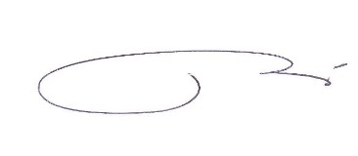
Yours faithfully

Ian Ashton
Ski Party Leader

