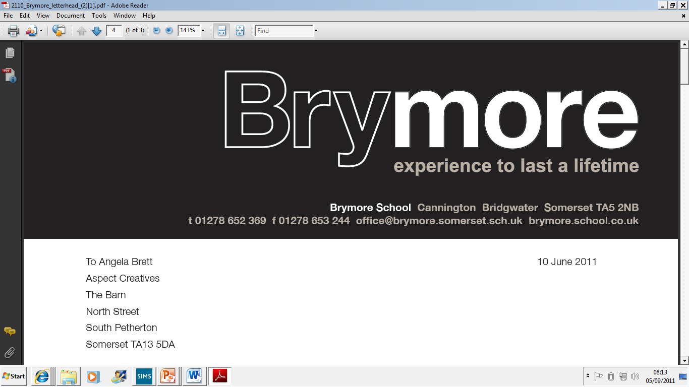
PARENT BULLETIN
Week Beginning: 2nd March 2026 (Week 2)

Items shown in bold are those which are not held on a regular basis

The extra-curricular activities for Spring Term 2b (after school) timetable can be viewed on our website.

Weekend activities are shown in the bulletin below

School Menus (Week 1) Shown at the end of this bulletin

Assembly Theme: Head Boy

Word of the Week: Perusal

ALL WEEK: National Careers Week
Monday | Assembly: Head Boy Presentations (Mr Walby)  Lunchtime Sports Studies Badminton (KS4)  4.00pm Chads Run  5.00pm - 5.30pm Tea: Year 7, 8 & 9  5.35pm - 6.05pm Tea: Year 10 & 11  Reid (full-time bdg): Miss Johnson & Ms Stoddart-Stones  School: Ms Hoogenboom & Mrs Nutt  Kemp: Mr Fewtrell & Mrs McLean  Pastoral Manager: Miss Moore  Head of Boarding: Mr Watts  Deputy Head of Boarding: Mr Bloxham
Tuesday | Tutorial  8.10am - 8.35am Reading catch-up (Room 5)  8.45am Student Council Meeting - Mr Walby (Meeting Room)  Lunchtime Badminton (KS4)  3.00pm Rugby: Year 10 -v- Haygrove @ Brymore  4.00pm Chads Run  5.00pm - 5.30pm Tea: Year 7, 8 & 9  5.35pm - 6.05pm Tea: Year 10 & 11  Reid (full-time bdg): Miss Johnson & Ms Stoddart-Stones  School: Ms Hoogenboom & Mr Bloxham  Kemp: Mr Fewtrell & Mrs McLean  Pastoral Manager: Miss Moore  Head of Boarding: (Day) Mr Watts  Deputy Head of Boarding: Mr Bloxham  EC Co-ordinator: Mr Orr
Wednesday | Assembly: Head Boy Presentations (Mr Walby)  8.10am - 8.35am Reading catch-up (Room 5)  Lunchtime Sports Studies Badminton (KS4)  2.15pm Rugby: Year 9 -v- Bridgwater College Academy @ Brymore  4.30pm - 7.30pm Goals & Opportunities Event (Mrs Featherstone)  4.30pm - 5.15pm Out-boarders/Parents/Guardians  5.30pm - 6.00pm Year 9 Boarders/Parents/Guardians  6.15pm - 6.45pm Year 10 Boarders/Parents/Guardians  7.00pm - 7.30pm Year 11 Boarders/Parents/Guardians  5.00pm - 5.30pm Tea: Year 7, 8 & 9  5.35pm - 6.05pm Tea: Year 10 & 11  Reid (full-time bdg): Miss Johnson & Ms Stoddart-Stones  School: Ms Hoogenboom & Ms Harris  Kemp: Mr Fewtrell & Mrs McLean  Pastoral Manager: Miss Moore  Head of Boarding: Mr Watts  Deputy Head of Boarding: Mr Bloxham  EC Co-ordinator: Mr Orr
Thursday | Extended Tutorial for World Book Day Activities  ALL DAY WORLD BOOK DAY  ALL DAY Land-based Synoptic Practical Day 2  ALL DAY Set Zero trip to Bath Forum (Mr Ashton / Ms Rundle)  ALL DAY Green Futures Trip - Day 4, Wykes Farm, Bruton, Somerset  (Mr Lines) (selected students from Year 9)  8.10am - 8.35am Reading catch-up (Room 5)  8.20am - 9.10am English Breakfast Sessions  Set 1 - Mrs Date (Room 4)  Set 2 - Invited Students Ms Rogers (Room 5)  Set 3 - Mrs Popham (Room 14)  Lunchtime Athletics Club (Invite Only)  3.00pm Quantock Relays, Lydeard Hill, West Bagborough (Mr Williams)  3.00pm Rugby: Year 7 -v- Various @ Brymore  4.00pm Chads Run  5.00pm - 5.30 pm Tea: Year 7, 8 & 9  5.35pm - 6.05 pm Tea: Year 10 & 11  Reid (full-time bdg): Miss Johnson & Ms Stoddart-Stones  School: Ms Hoogenboom & Mr Watts  Kemp: Mr Fewtrell & Mrs McLean  Pastoral Manager: Miss Moore  Head of Boarding: Mr Watts  Deputy Head of Boarding: Mr Bloxham  EC Co-ordinator: Mr Orr
Friday | Assembly: Celebration (Mr McHale)  Lunchtime Circuits Catch-up  1.15pm SSLT Meeting (Mr Walby)  1.30pm The Message - Ms Taylor (Room 14)  2.10pm - 5.00pm SLT Detention Session - Mr McHale (Room 2)  4.05pm Chads Run  5.30pm - 6.00pm Tea: All Boarders  6.00pm - 8.00pm Driving Range, Cannington - £5 (cash) (Mrs McLean)  Reid (full-time bdg): (am) Miss Johnson  (pm) Mr Bloxham & Ms Stoddart-Stones  School: (am) Miss Moore  (pm) Miss Moore  Kemp: (am) Mr Fewtrell  (pm) Mrs McLean  Pastoral Manager: Miss Moore  Deputy Head of Boarding: Mr Bloxham  Overnight Duty: Mr Orr
Saturday | PM Clatworthy Mob Run @ Clatworthy Reservoir, Taunton, TA4 2EJ  6.30pm - 8.00pm Bonfire Evening: Smores & Music, On site - £0 (Mr Orr)  (Age/weight/height details required in advance)  Reid (full-time bdg): Ms Hoogenboom (on call)  Weekend Support: LN????  Reid Overnight Cover: Mr Orr
Sunday | TIME TBC Horse Riding, Cannington College, Cannington - £25 (Ms Long)  3.00pm Chads Run  5.30pm - 6.00pm Tea: All Boarders  Reid (full-time bdg): Ms Hoogenboom  (From 6.00 pm) Miss Johnson  School: (From 6.00 pm) Ms Hoogenboom  Kemp: (From 6.00 pm) Mr Fewtrell  House Tutor: Ms Long  Matron: Mrs Milbank

